In the Eelgrass Bed
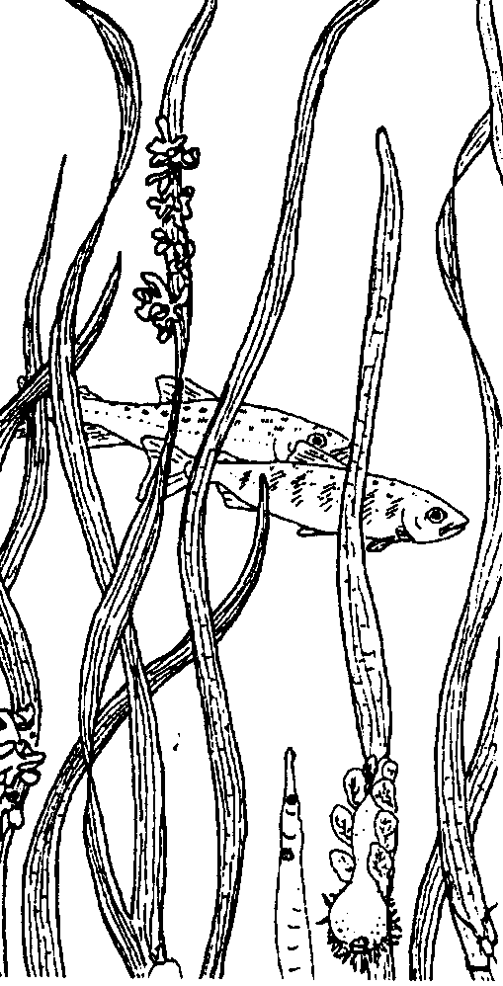
Lesson edited by Phyllis Schmitt, Santa Rosa, CA
original lesson from Discovering Puget Sound by Pat Willits

Key Concepts
1. Estuaries provide the necessary protection and food for the juveniles of many species.
2. Eelgrass is one of the few flowering, aquatic plants that is able to grow fully submerged in saltwater.
3. The food web in an estuary is very dependent on the abundance of decaying plant material (detritus).
4. Juveniles of Dungeness crabs and some salmon species are especially dependent on eelgrass beds for protection and food.

Background

Sea grasses are marine flowering plants that often live totally submerged in the saltwater. Most sea grass species are restricted to the tropical or subtropical regions. Three common sea grasses on U.S. coasts are: turtle grass, eelgrass, and surf grass. Turtle grass is common in quiet waters along most of the Gulf Coast from Florida to Texas. Surf grass is found on both sides of the North Pacific. It can be found in the lower intertidal, subjected to considerable wave and surge action. Eelgrass is widely distributed in estuaries and marine areas along both the Atlantic and Pacific coasts of North America.

Eelgrass meadows are the focus of this lesson. Eelgrass has thin, bright green leaves, sometimes more than a meter long and 3-10 millimeters wide. Its flowers are greenish and inconspicuous; their pollen is released into the water where it is carried about until it wraps its elongated shape around another flower.

A perennial plant, eelgrass forms colonies on sandy or muddy bottoms in quiet bays and salt marshes at and just below the low tide line. These colonies show their greatest growth in spring and summer, dying back during fall and winter. This annual cycle contributes large quantities of decaying organic material (detritus) to nearshore food webs, providing food directly to detritus feeders and indirectly to their predators. Detritus which is not eaten gets mixed into the sand, enriching it until it may eventually be classified as mud. Live eelgrass is food for many animals, including migratory waterfowl. Large numbers of many different species of fish also live in the eelgrass meadows. The mud/eelgrass habitat has complex and highly connected food webs.

Eelgrass is important structurally too; the tangled mass of its roots and rhizomes has a stabilizing and binding effect on the sand and mud in which it grows, reducing wave and current action, and trapping more sediment and detritus. The surface of its leaves provides a place for algae and other organisms to live. Fish such as herring attach their eggs to the leaves. The leaves, through photosynthesis, maintain high dissolved oxygen levels in the quiet waters around them and their shade minimizes temperature fluctuations at low tide.

Eelgrass habitats are particularly susceptible to damage from human developments and activities. Waterborne sediments from on-shore activities shade the eelgrass beds, reducing their growth. Excessive nutrients from fertilized sewage wastes carried in run-off water from the land can cause an overabundance of the algae that live on eelgrass leaves resulting in reduced growth of the eelgrass. In addition, these shallow bays are often proposed for filling and development.

Materials

For the class:

• copies of “In the Eelgrass Bed” worksheet and “The Undersea Meadow” picture sheet (one per student or group of 4)

• map that includes Puget Sound in western Washington State

• 4 copies of each animal fact card

• any available pictures of eelgrass organisms *

* One good source is:
“Padilla Bay National Estuarine Research Reserve Video” (children’s version) Short video including footage of eelgrass beds and their inhabitants. $18.00 Padilla Bay NERR, 1043 Bayview-Edison Rd., Mt.Vernon, WA 98273 (206) 428-1558; fax (206) 428-1491

Teaching Hints

Activity 1: In the Eelgrass Bed

1. Distribute copies of the picture sheet, “The Undersea Meadow”.

2. Group students into working teams of four. Have them work together to list five observations about the eelgrass beds. Have them also generate a list of four questions about the eelgrass beds.
3. Have each group share their list of four questions with the class. The questions might be classified into groups. For example, some of the questions may relate to:
a) the FOOD WEB (who eats what or whom?) in the eelgrass bed;
b) a specific ANIMAL pictured in the eelgrass bed;
c) the EELGRASS plant itself; or
d) potential IMPACTS on the eelgrass bed (from a low tide or people).

4. Explain that this lesson focuses on eelgrass beds located in Puget Sound, in Washington State. Locate Puget Sound on a map. Be certain students understand that eelgrass beds are found in many other coastal areas, too. They are on both the Atlantic and Pacific coasts. Explain that the edge of Puget Sound, where the water and the land meet, is a very beautiful place. In some places big trees grow right to the water’s edge. In others, there are rocky ledges or beaches.

5. Distribute the worksheet, “In the Eelgrass Bed”. Encourage students to seek the answers to their questions from procedure #3 as they read and discuss the worksheet. This may be done as a whole class or you may choose to have students continue working in their group of four to read, answer and discuss the content. (If possible, show pictures or video of the organisms.)

6. Give each study group one of the FACT CARDS. Each group will read the card and share information about the organism described on their card. All students will then color the animal on “The Undersea Meadow” using the descriptions given. NOTE: Some students may need help finding the head of the Black Brant.

7. Direct students’ attention to the questions generated in procedure #3 and discuss information provided during the lesson. Help students determine how they could get answers to any questions that were not answered.

Key Words

bacteria - microscopic one-celled organisms, some of which cause illness

consumers - organisms that cannot make their own food; they eat other organisms

detritus - decaying organic material, such as dead plants and animals and plant and animal waste products

eelgrass - one of the few flowering plants that grows in saltwater. It has long, thin, bright green leaves and inconspicuous blossoms.

estuary - the area where a river meets the sea and is influenced by the tides

phytoplankton - microscopic plants that live in water

pincers - first two legs of a crab bearing the claws

predator - creature that catches and eats other animals

producer - an organism that makes its own food

regenerate - grow back

substrate - a surface on which a plant or animal grows or is attached (e.g.: substrate for eelgrass is a mud bottom.)

Extensions

Begin planning the estuary model. A decision can be made as to which type of estuary habitat, or what part of the estuary will be the focus of the project: mangrove swamp, mudflat, bay, slough, salt marsh, eelgrass bed, etc. Students could begin designing and making plants and animals from paper, cardboard, salt dough, and found items (junk).

Answer Key

1. Eelgrass is a flowering plant that grows underwater in Puget Sound.

2.and 3. (coloring)

4. Other animals which can regenerate body parts include: seastars, worms and sea cucumbers in the sea and lizards (tail) on land.

5. Red Fringe seaweed producer eelgrass producer
fish consumer crab consumer

6. There are 17 brooding anemone (3 adults, 14 young) in the eelgrass bed.

7. The crabs are feeding on clams and other small animals.

8. The clams are feeding on phytoplankton and some detritus.

9. Estuaries are a good place for young crabs to grow because they provide an abundance of food and good shelter from predators.
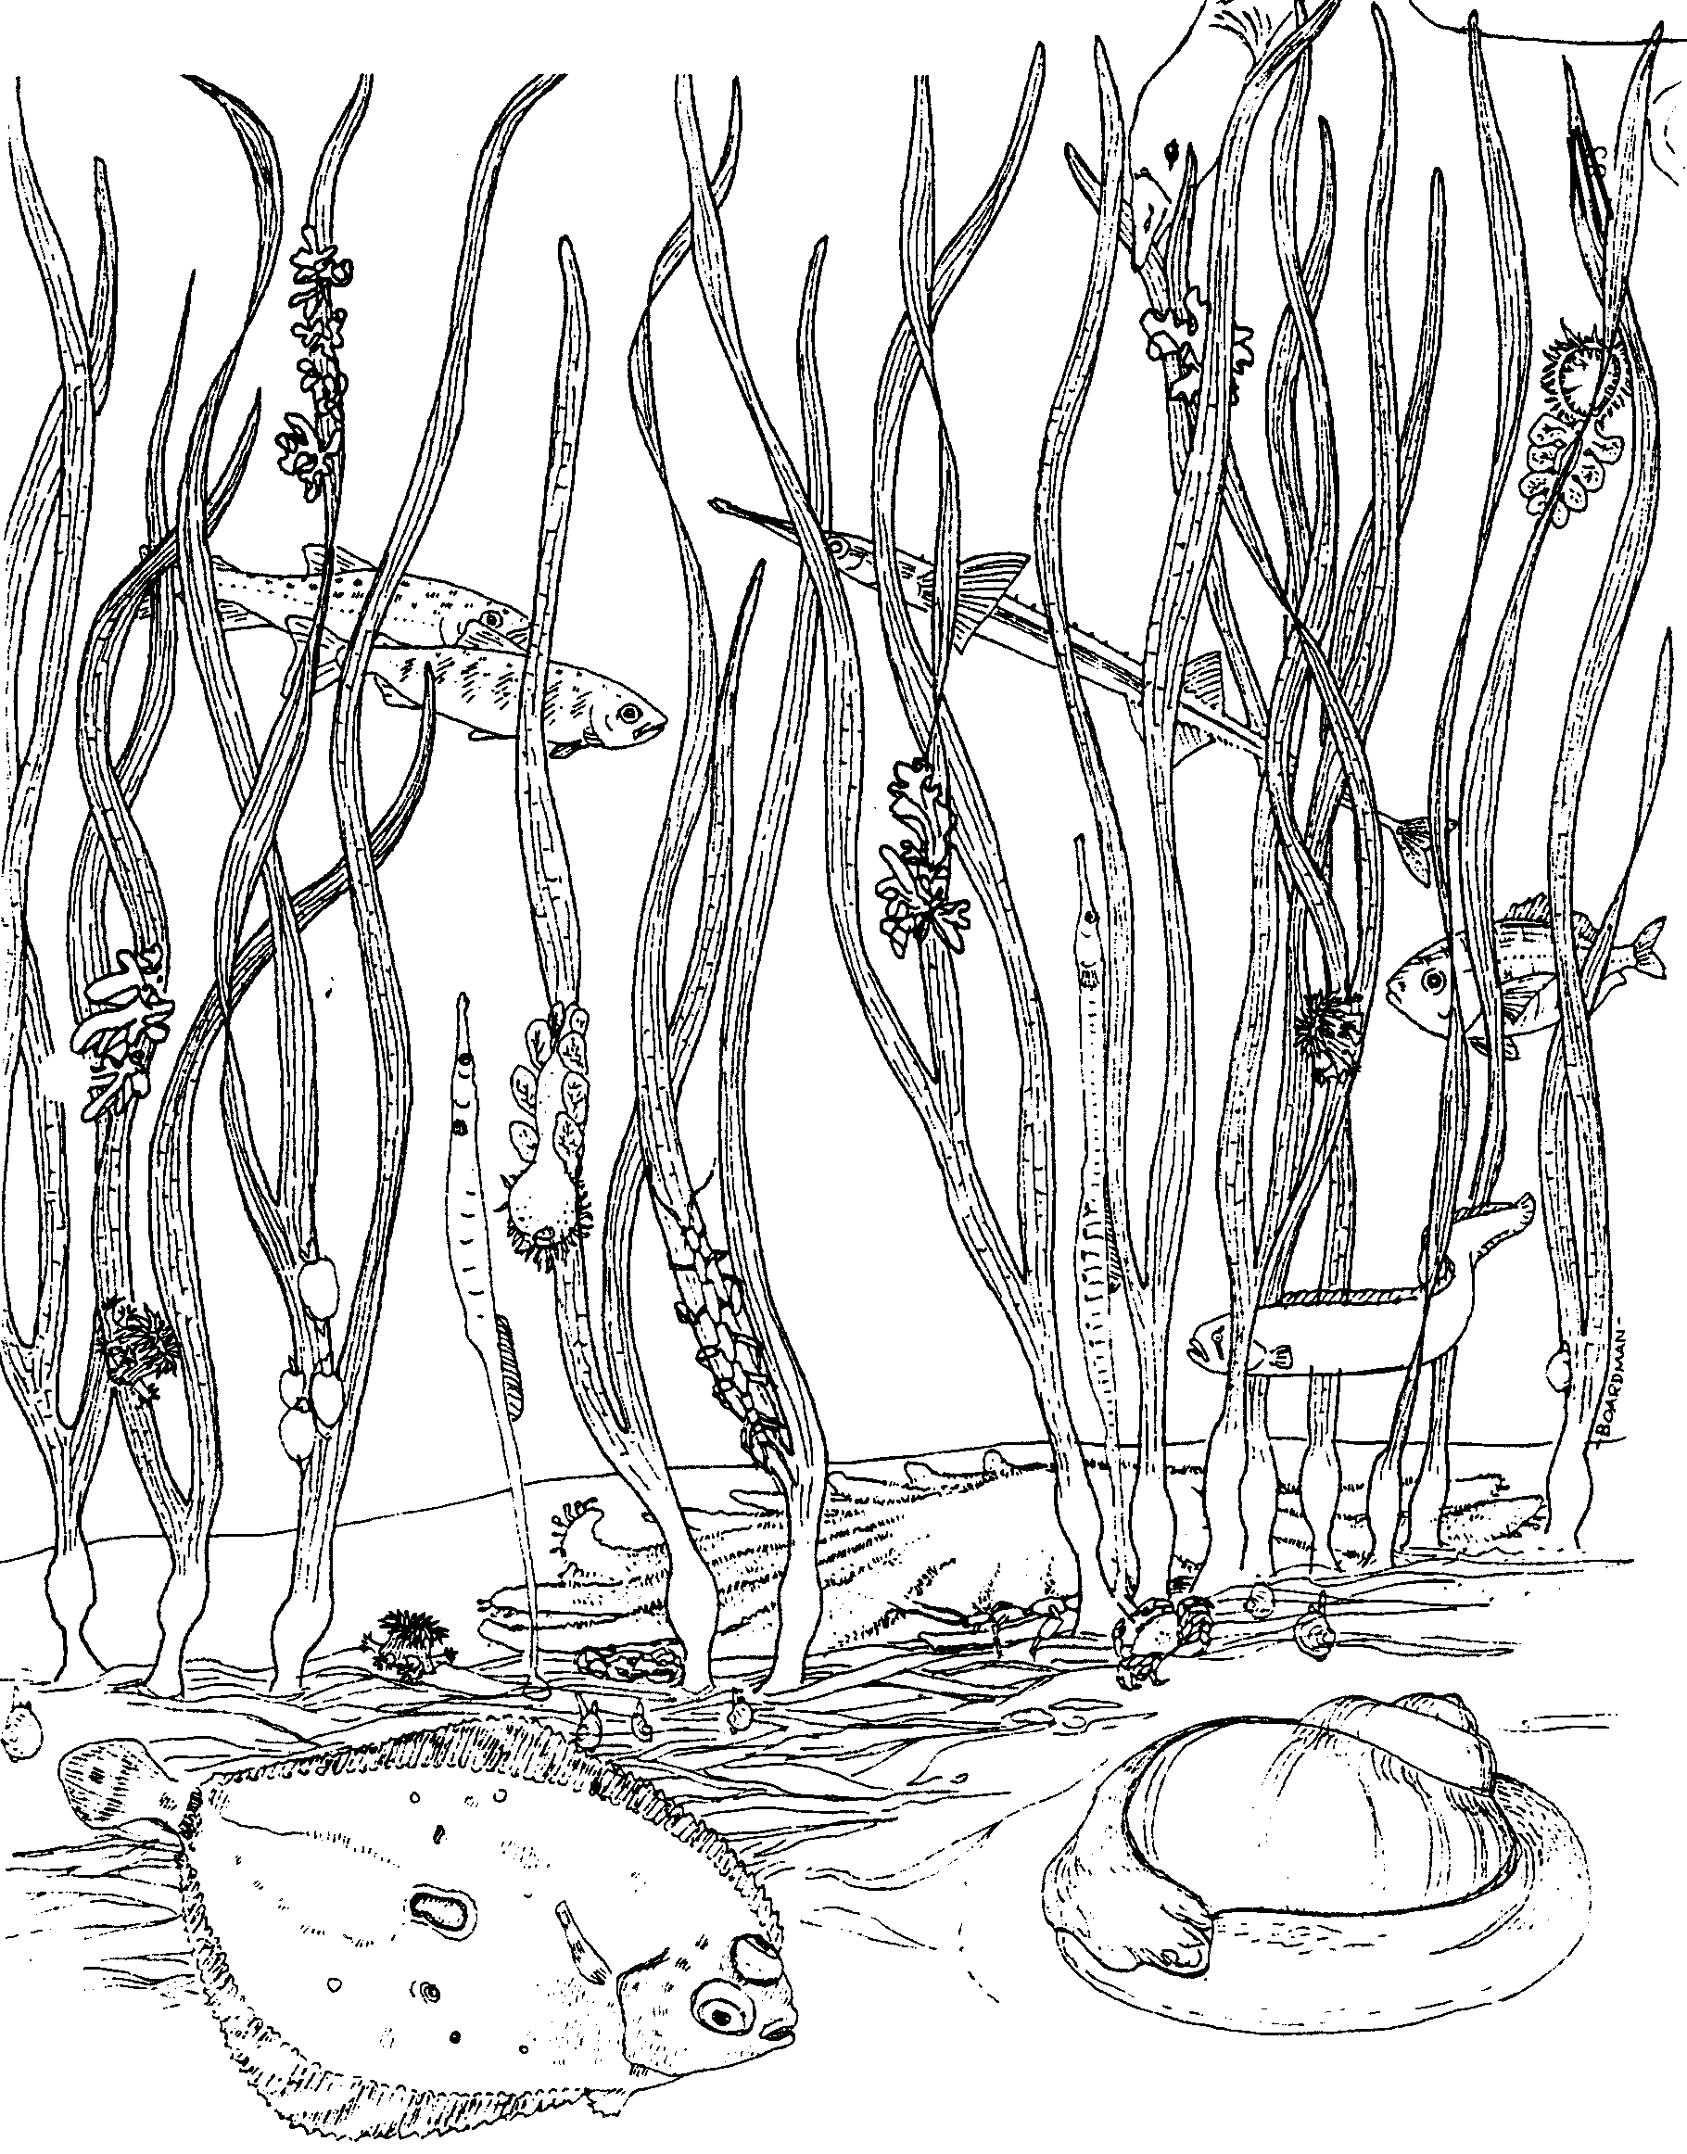
Activity Sheet - The Undersea Meadow

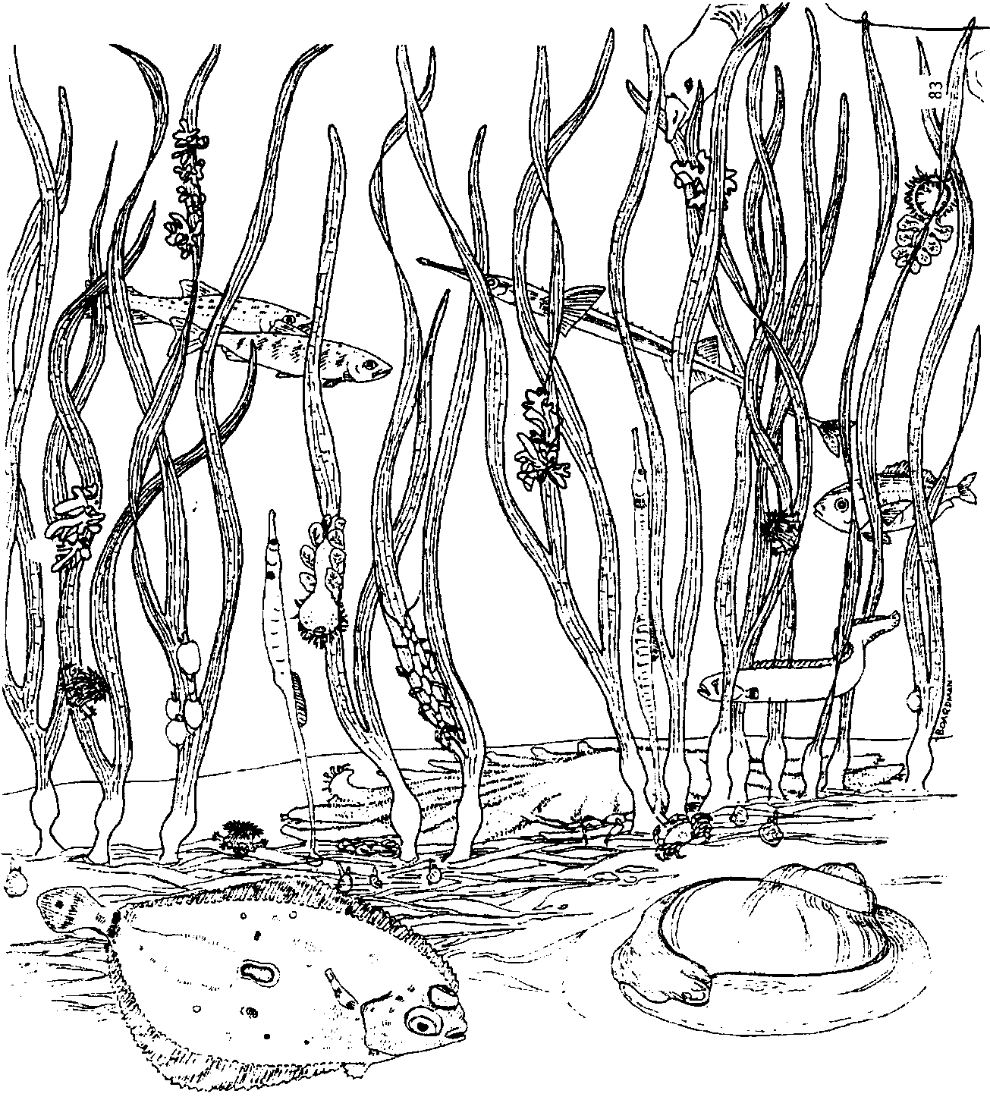
In the Eelgrass Bed

Eelgrass grows in saltwater. It is not a seaweed. It is a flowering plant with roots and a stem. Lots of eelgrass plants grow together. The many stems and roots keep waves from carrying away the sand or mud. In spring and summer, eelgrass plants grow well. In fall and winter, they die back. Eelgrass can be found all along our Atlantic and Pacific coasts.

1. What is a flowering plant that grows in saltwater?

Lots of plants and animals live in eelgrass. Red Fringe, is a dark red seaweed. It is very thin. Red Fringe grows on the edge of the green eelgrass. It does not feed on the eelgrass, though. It makes its own food. A plant that makes its own food is called a producer.

2. Return to the sheet, “The Undersea Meadow”. Color the eelgrass green. Color the Red Fringe seaweed dark red.

Bacteria and tiny animals live on the eelgrass leaves. Eelgrass is home to skeleton shrimp. They look a little like a walking stick or a preying mantis. Skeleton shrimp eat detritus (deh-TRY-tus). Detritus is the dead plants and animals on the bottom.

3. Find the skeleton shrimp in the eelgrass. (HINT: There are two). Color them green.

Small fish eat skeleton shrimp. The small fish hide in the eelgrass beds from the animals that eat them. Animals that eat other animals are called consumers. Consumers cannot make (produce) their own food.

Dungeness crabs live in the eelgrass. They find food there. The thin green leaves help them hide. A crab has an interesting body. Its head, neck, and chest are one hard shell. The crab’s shell is like a suit of armor. Its eyes are on stems. It has eight legs and two big pincers. A crab uses its legs for walking. It uses its pincers to catch and eat food. The pincers also protect it from enemies. These pincers are very powerful. They can even break a person’s finger. Crabs will sometimes fight among themselves. If a leg or pincer is broken off, a new one will grow back.

4. What other animals can grow back missing body parts?

5. Here are some living things. Which are consumers? Which are producers?
Circle the producers.
Underline the consumers.

Red Fringe seaweed eelgrass

fish crab

Other interesting animals live in the eelgrass. One is the brooding anemone (uh-NEM-oh-nee). An anemone has eggs inside its body. The eggs hatch inside the body. Then they glide down the side of the parent. They attach themselves near the base of the parent. They grow until they are big enough to leave. Then they begin life on their own.

6. Find the brooding anemone. They look like little haystacks with smaller haystacks coming off their base. How many brooding anemones are in the eelgrass bed?

Color the brooding anemones greenish brown.

Living underneath the eelgrass are tiny clams. They eat tiny plants called phytoplankton. They also eat some detritus. Young crabs eat the clams and other small animals. Most of these crabs are very small too. They find plenty of food and a place to hide under the eelgrass.

7. Find the young crabs. What are the crabs feeding on?

Color the young crabs grayish-brown.

8. Find the tiny clams. What are they feeding on?

Also color the tiny clams grayish-brown.

Eelgrass beds are most often found in estuaries. An estuary is formed where a river meets the sea. Young crabs live in estuaries. They also live in the open ocean. Those in estuaries grow bigger and faster.

9. Why is an eelgrass bed in an estuary a good place for a young crab to grow?

Black Brant
Fact Card
What does it look like? The black brant is a small dark goose. It has a white ring around its neck. Brants weigh up to four pounds. They are about 63 centimeters (25 inches) long.
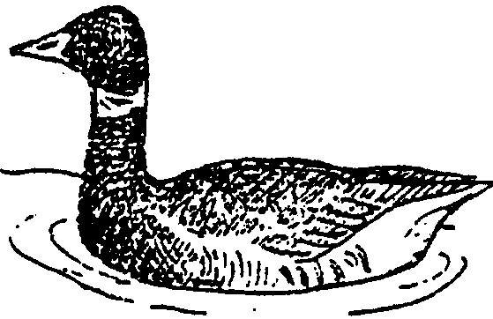
Where does it live? Brants fly farther north than any other goose. They lay their eggs north of the Arctic Circle. During the winter and early spring, large numbers of Brant feed in coastal eelgrass beds.

What does it eat? The favorite food of the black brant is eelgrass. Brant swim above the eelgrass. They dip their heads into the water to pull off leaves with their bills. Brant also eat some seaweeds.

Interesting facts: Brants do not have teeth. To help grind their food they eat small stones. The stones stay in their GIZZARD (GIZ zerd). The gizzard is a grinder.

Hooded Nudibranch
Fact Card
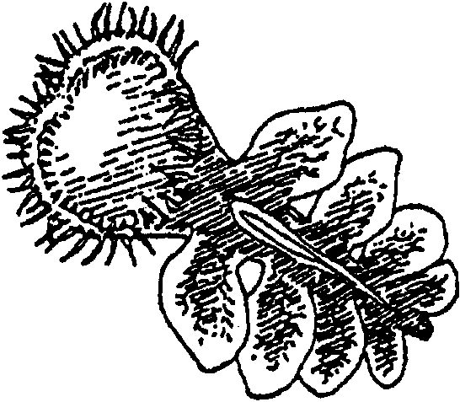
What does it look like? The hooded nudibranch is a snail without a shell. It is sometimes called a sea slug. It has a hood which covers half of its body. The hood has tentacles around its edge. Hooded nudibranchs are yellow, brown or olive green. They can grow to over 10 centimeters (4 inches) long.

Where does it live? It lives on the leaves of eelgrass. They are found from California to Alaska.

What does it eat? Its favorite food is tiny animals called plankton. To feed it holds on to a leaf of eelgrass. Then it swings its hood downward. The hood closes if anything touches its inside. The tentacles connect. The food is trapped. The hood squeezes the food into the mouth of the nudibranch.

What eats it? Kelp crab sometimes eat hooded nudibranchs.

Interesting facts: The hooded nudibranch can swim. It can also trap air bubbles in its hood and float.

Bay Pipefish
Fact Card
What does it look like? The slim, green Bay Pipefish looks like an eelgrass leaf. They can grow to about 30 centimeters (13 inches) long. They look like a straightened out sea horse. As a matter of fact, they are relatives of the sea horse!

Where does it live? Bay Pipefish live in eelgrass beds. They can easily hide in the leaves. Sometimes they wrap their bodies around eelgrass leaves. Sometimes they use their fins to hold themselves next to eelgrass leaves. They look just like another leaf.

What does it eat? Bay Pipefish have tiny mouths. They don’t open very wide. And they don’t have any teeth. They use their mouth like a straw. They suck in seawater. Plankton that may be in the water are eaten.

Interesting facts: Males carry the fertilized eggs in a pouch. When the eggs hatch, the young swim out. They are about 2 centimeters (3/4 inch) long when they hatch.

Shiner Perch
Fact Card
What does it look like? From the side, the shiner perch looks plump. From the front, it looks very thin. Shiner perch are always very shiny. Sometimes they have black and dark yellow bars. They can grow to be about six inches long.
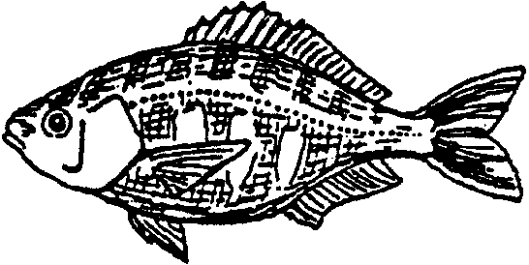
Where does it live? Shiner perch live in eelgrass beds. They swim among the leaves. They also live around piers and pilings in salt water.

What does it eat? Young shiner perch eat plankton. Older ones eat mussels, seaweeds, and barnacles.

Interesting facts: Shiner perch eggs develop inside the female. After six months, the young fish hatch INSIDE the female. They come out of her body tail first. They are about 6 centimeters (2 inches) long when born.

C-0 Sole
Fact Card
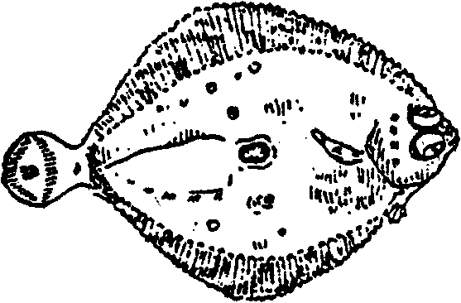
What does it look like? The C-O sole is a flat fish. It lives on the bottom. C-O sole always lie with the same side down. Both of its eyes are on the “up” side. The eyes stick out more than the eyes of most fish. Sometimes it is called the “Popeye sole”. It can grow to be 35 centimeters (14 inches) long. It is dark brown or black on its upper side. Its lower side is creamy white.

Where does it live? The C-0 sole lives in shallow water when it is young. It likes to live in eelgrass beds. It lies on the bottom between the plants. When it is older, it may live in much deeper water.

What does it eat? The C-O sole eats worms, clams and shrimp.

Interesting facts: When a C-O sole is just hatched, its eyes are like those of other fish. It has one eye on each side of its head. But as it grows, one eye slowly changes place. It moves over to the other side of the head. After this happens, the fish settles to the bottom. It lives with its blind side down. It spends the rest of its life that way.

Dungeness Crab
Fact Card
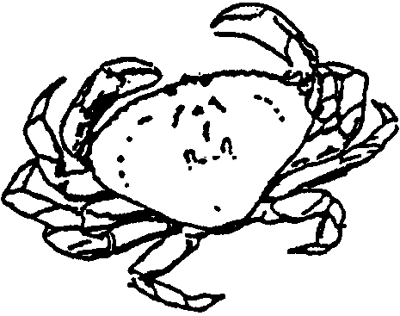
What does it look like? A Dungeness crab is brownish-gray. It has a large pair of pincers and four pairs of pointed legs. Its eyes are on stalks. They are on the front of the body between the pincers. Dungeness crabs can grow to about 20 centimeters (8 inches) across.

Where does it live? Dungeness crabs live in salt water along the Pacific Coast. They like to live where there is a sandy bottom. Many Dungeness crabs live in eelgrass beds. They walk around between the plants. Sometimes they hide in the sand with only their eyes sticking up.

What does it eat? Their favorite food is small clams. They chip the clam shells open with their pincers.

What is it eaten by? Humans eat Dungeness crabs. So do seals and sea lions, octopuses, some kinds of fish, and gulls.

Interesting facts: The “shell” of a crab is really its skeleton. Unlike our skeleton, the crab’s is on the outside. The shell does not grow. When the crab grows it sheds its shell and puts on a new, bigger one.

Sunflower Star
Fact Card
What does it look like? The sunflower star is a seastar. Its arms come out of its center like spokes on a wheel. It can have more than 24 arms, or rays. It can move faster than any other seastar. It is much larger than other seastars. It is also much softer. Sunflower stars are tan, orange, purple, or pink. They can grow to be 80 centimeters (32 inches) across.
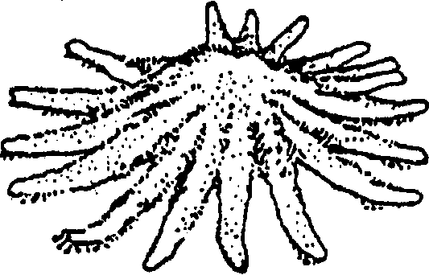
Where does it live? Sunflower stars live along the Pacific coast. They may be found in shallow or deep water. They live on rocky, sandy, or gravel bottoms. In eelgrass beds, they glide around between the plants.

What does it eat? Their favorite foods are sea urchins and scallops. They also eat worms, chitons, snails, hermit crabs, sea cucumbers, and other seastars.

What is it eaten by? Alaskan King crabs and sun stars eat sunflower stars.

Interesting facts: A large sunflower star has over 15,000 sucker tube feet. The tube feet help it to move faster than any other seastar. They can move up to three meters per minute. Some tidepool animals move very fast to get away from the sunflower star. This keeps them from being eaten!

Moon Snail
Fact Card
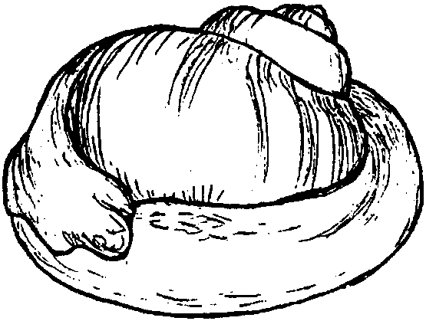
What does it look like? The moon snail is a very large snail. It grows to be about 12 centimeters (5 inches) in height. Its gray body is much bigger than its white shell. The body sometimes almost wraps around the shell. The snail squeezes water out of its body to make it smaller. Then its body will fit inside its shell.

Where does it live? Moon snails live along the Pacific coast. They like the protected sandy bottoms of eelgrass beds. Moon snails usually plow under the surface of the sand.

What does it eat? Moon snails eat clams, snails, mussels, and oysters. A moon snail has a tongue like a file. It files a hole through the shell of its food. It then sucks the flesh out.

Interesting facts: Moon snails find their food by its smell. When a moon snail hunts it burrows back and forth through the sand. They can smell clams about 15 centimeters (6 inches) away. They can smell clam meat up to two meters away.

