Time and Tides
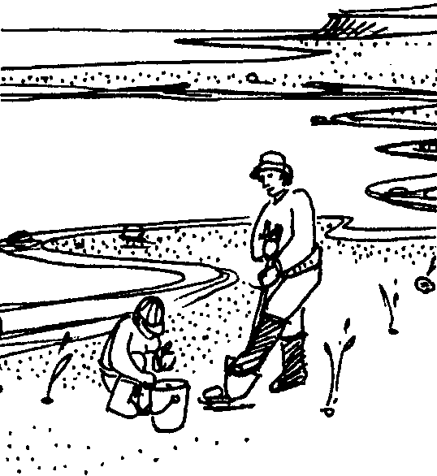

Key Concepts
1. Tides change over time in a predictable and regular manner.
2. Tides vary daily in time and height.
3. Daily tides vary from location to location on the earth.

Background

Background material can be found in the preceding activity, "Tide's In/Tide's Out".

Materials
For the class:
• copies of the student worksheet, "Time and Tides"

Teaching Hints
Tides are an integral part of knowledge of the sea. Yet, tides are often a difficult concept to grasp. "Time and Tides" introduces tidal movement and tidal differences using the 24 hour clock.

The idea of a 24 hour clock may be brand new to most of your students. For reinforcement, use the 24 hour clock in your classroom. Try writing your daily schedule using the 24 hour clock, etc.

Consider the concept of computing time differences using the 24 hour clock. Keep in mind that the first two digits of a time expression represent hours, and that the last two digits refer to minutes. Minutes amounting to 60 or more must be converted to hours. If subtracting minutes and "borrowing" becomes necessary, remember that when you "borrow" from the second digit you are borrowing sixty minutes. Similarly you can go back into the next day and "borrow" 24 hours. Recall that the times and heights of tides vary with time. The activity does not have a year listed but it is wise to remind students that not every May 31, for example, has the same tides. Also emphasize that tides differ from location to location on the earth.

The last portion of the activity may be omitted, done as a class activity, or assigned as homework.

Key Words
height - distance from bottom to top
midnight - 12:00 A.M.; the middle of the night
minus tide - tidal level lower than the average of past tides which we arbitrarily call "zero tide"
plus tide - tidal level higher than the average of past tides which we arbitrarily call "zero tide"
tide table - a chart which gives the predicted times and heights of tides for each day for a particular coastal location

Answer Key
A.M. - P.M. CLOCK 24 HOUR CLOCK

1. 7:52 A.M. 0752 hours
2. 7:52 P.M. 1952 hours
3. 10:00 A.M. 1000 hours
4. 10:00 P.M. 2200 hours
5. 3:30 P.M. 1530 hours
6. 5:15 P.M. 1715 hours
7. 12:00 Noon 1200 hours
8. 12:00 Midnight 2400 hours or 0000 hours
9. 12:04 A.M. 0004 hours

24 HOUR CLOCK A.M. - P.M. CLOCK

10. First high tide 0208 hours 2:08 A.M.
11. First low tide 0909 hours 9:09 A.M.
12. Second high tide 1532 hours 3:32 P.M.
13. Second low tide 2103 hours 9:03 P.M.

TIDE 24 HOUR CLOCK A.M. - P.M. CLOCK HEIGHT OF TIDE

14. First Low Tide 0114 1:14 A.M. 0.5 feet
15. First High Tide 0731 7:31 A.M. 10.4 feet
16. Second Low Tide 1315 1:15 P.M. 3.1 feet
17. Second High Tide 1921 7:21 P.M. 11.8 feet

18. The highest tide occurs at 1921 hours or 7:21 P.M.
19. The lowest tide is the first low tide.
20. The lowest tide occurs at 0114 hours or 1:14 A.M.
21. For August 29, the range of tides is 11.3 feet (i.e. 11.8 foot highest high tide - 0.5 foot lowest low tide).
22. Answers may vary. The second low tide might be the best choice because of the early morning time of the lower first low tide. However, some organisms are only exposed at the lowest tides, therefore, the first low tide would be the best. Use this as an example of how human activities can be influenced by the tides.
23. Answers will vary according to the tides found in local newspapers.

Time and Tides
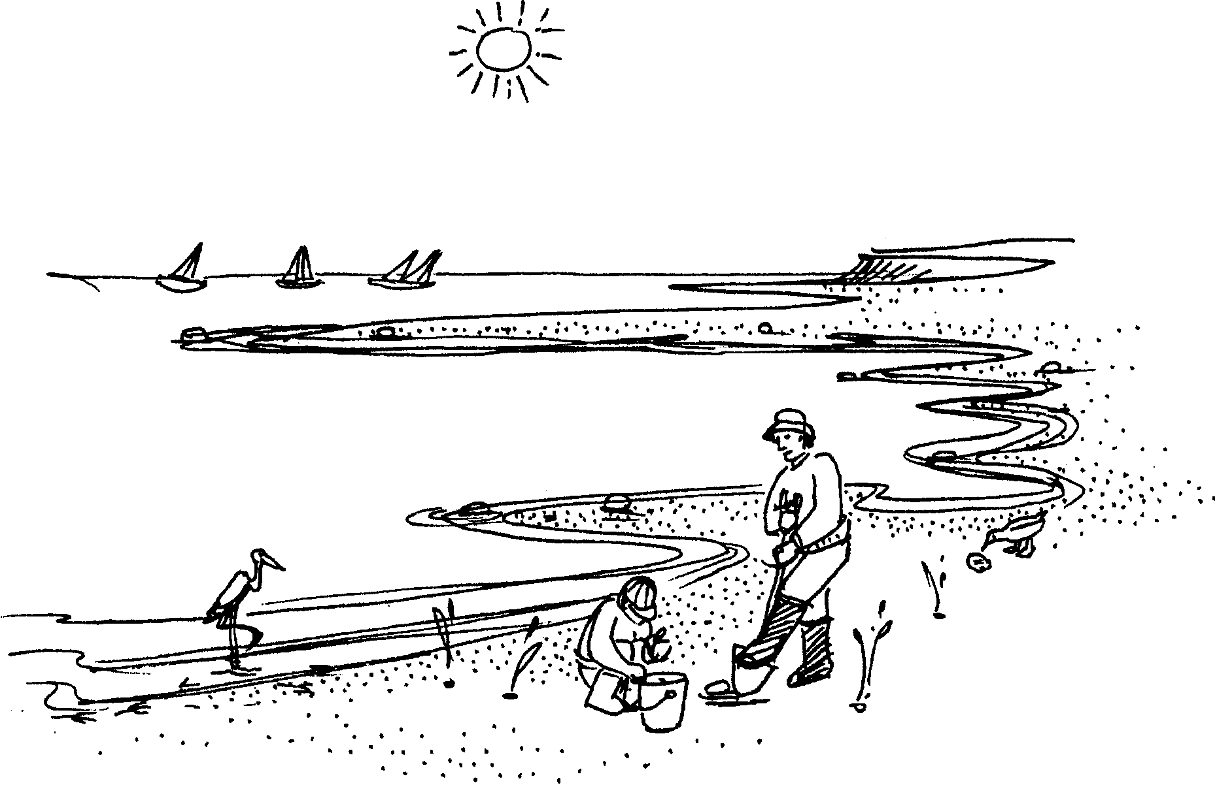

Many people work at, or visit, estuaries and the coast. They need to know when the high tides and low tides occur. Some ports have water deep enough for larger boats or ships only at high tide. Some kinds of fish move into the intertidal areas to feed at high tide.

Sometimes people wish to study or watch creatures in a bay or salt marsh. These animals are easier to see at low tide. When would be the best time for harvesters to gather clams or oysters? These people choose the low tides. They look up the times in a tide table. Tide tables give the predicted time and height of tides. The time and height of tides varies from place to place. Tide tables are written for a specific location.

Many tide tables are written using the 24 hour clock. When using the 24 hour clock we do not use the terms A.M. and P.M. The day begins at midnight and runs for 24 hours. Time is expressed in “hundreds”. For instance, 8:00 A.M. would be read “eight hundred hours” and written 0800.

It gets a little trickier with P.M. For example, 1:00 P.M. is written 1300. Remember, 12:00 noon is 1200 (twelve hundred hours) so the hour after that is 1300 or “thirteen hundred hours”. To change P.M. times to the 24 hour clock we simply ADD 12 hours.
Try your skill. Change the following times to the 24 hour ocean scientist’s clock:
A.M. - P.M. CLOCK 24 HOUR CLOCK

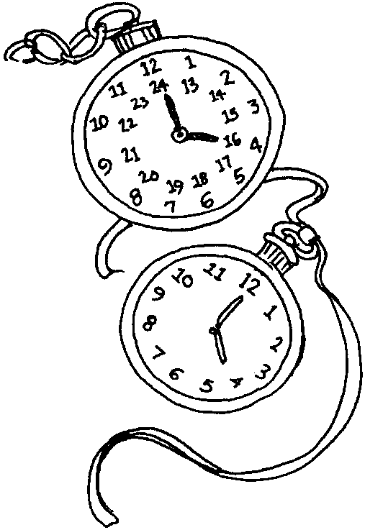
1. 7:52 A.M. 0752 hours

2. 7:52 P.M.

3. 10:00 A.M.

4. 10:00 P.M.

5. 3:30 P.M.

6. 5:15 P.M.

7. 12:00 Noon

8. 12:00 Midnight

9. 12:04 A.M.

Have you mastered the 24 hour clock? Let’s take a look at the tides for May 31. Use the tides below. Find out the time of the high and low tides on the A.M. - P.M. clock.
24 HOUR CLOCK A.M. - P.M. CLOCK
10. First high tide 0208 hours
11. First low tide 0909 hours
12. Second high tide 1532 hours
13. Second low tide 2103 hours

Daily tides are compared to past tides. Tides are sometimes higher than the average of past tides (plus tides). Tides are sometimes lower than this average (minus tides). Minus tides are written with a minus sign(-) before the number. The number gives the tidal change in feet.
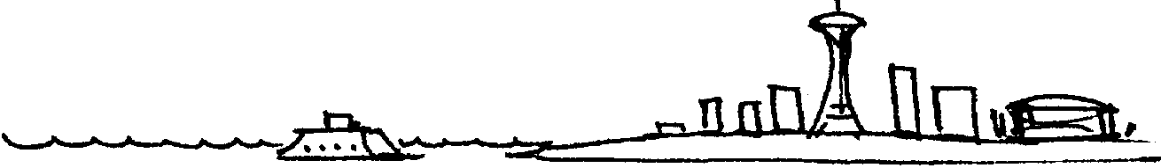
Below are the tides for August 29 at Seattle, Washington. Change the 24 hour clock times to A.M. - P.M. clock times.

TIDE 24 HOUR CLOCK A.M. - P.M. CLOCK HEIGHT OF TIDE
14. First Low Tide 0114 0.5 feet
15. First High Tide 0731 10.4 feet
16. Second Low Tide 1315 3.1 feet
17. Second High Tide 1921 11.8 feet
18. At what time does the highest tide occur?

19. Which tide is the lowest tide?

20. At what time does the lowest tide occur?

21. The range of tides is the difference (subtract) between the highest high tide and the lowest low tide. For August 29, what is the range of tides?

22. a. Look at the four August 29 tides. Which would you choose for visiting the estuary to observe low tide creatures?

b. Why did you choose that tide?

23. If you live near the ocean, find the tide table in a daily paper. What are the times and heights of tomorrow’s tides?

TIDE TIME (24 Hour) TIME (A.M. - P.M.) HEIGHT OF TIDE

When is the lowest low tide?

When is the highest high tide?

Next time you go to the beach, be sure to find out when the high and low tides will occur. HAVE FUN!

