Tide's In/Tide's Out

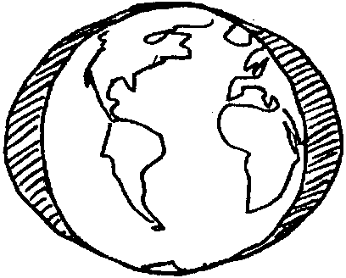
Key Concepts
1. The flow of the tides, rising and falling, produces the energy for mixing in estuaries.
2. Tides change over time in a predictable and regular manner.
3. Tides vary daily in time and height.

Background

Tidal Action
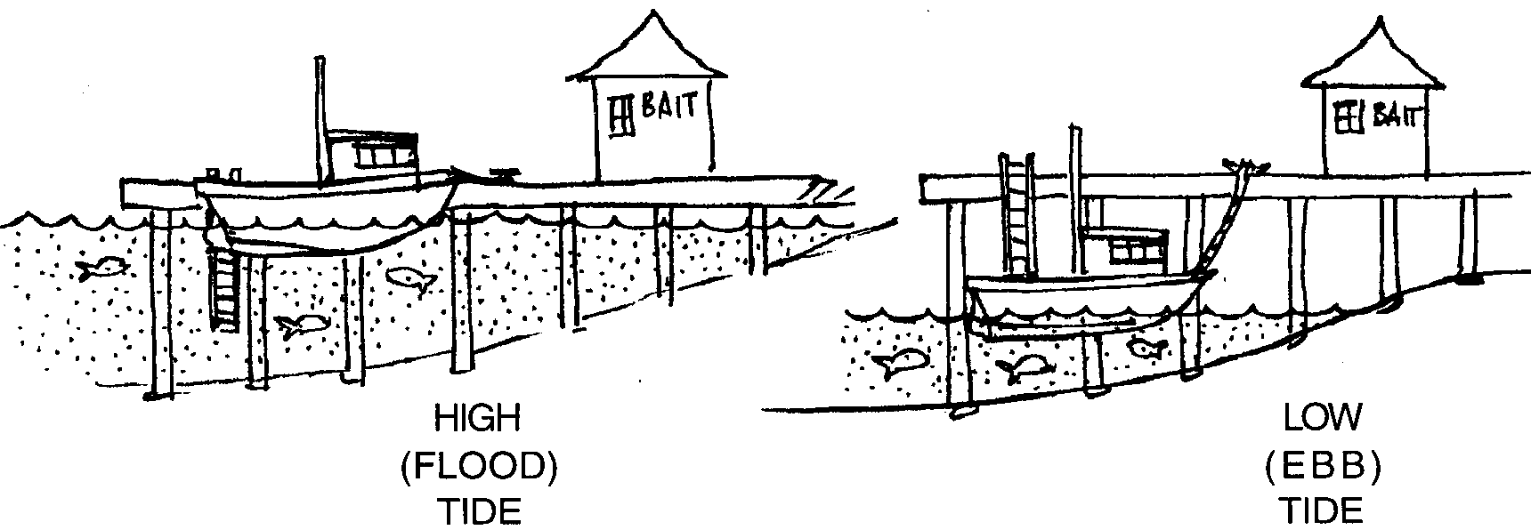
Tides are the daily rise and fall of the sea level along the shore. If you live near the saltwater, you may have seen the motion. Sometimes rocks and parts of the beach are covered with water. Other times these same areas are not covered. What you are seeing are the tides. When the water level is high, more of the beach is covered with water. The beach may appear to be a very small or narrow beach. This is called high tide. When the water level is low, less of the beach is covered with water. The beach appears to be larger or wider. This is called a low tide.

In most coastal areas of the United States, the tidal rises and falls occur twice each 24 hours and 50 minutes (referred to as a lunar day). In some places both high tides reach about the same height and both low tides drop to about the same level in a tidal cycle. In other areas, the two high tides are not the same height, nor are the low tides equal.

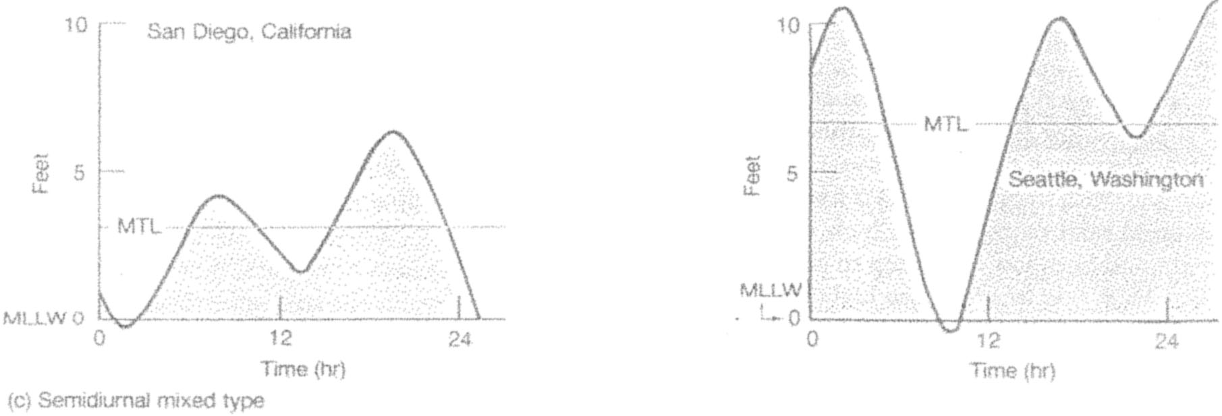

In some coastal areas, like the Gulf of Mexico, there is a pattern of only one high tide and one low tide each lunar day.
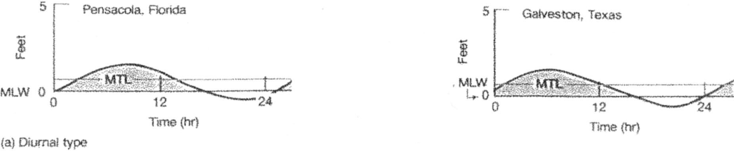

The difference between the high tides and the low tides may be only a few inches. However, it may be as much as 40 feet. Tide types and ranges vary from one coastal area to another.
What Causes the Tides?
The background information that follows is intended for your use and reference. Causality of the tides is very difficult for most primary students (adults, too!) to grasp due to the abstract concepts involved.
Observation of beaches at high and low tide and understanding how tidal action affects inhabitants of the intertidal are more appropriate concepts for primary students.
The tides we see are largely a result of gravity. The moon and the sun exert attractions on the waters of the earth. Even though the moon is much smaller, the moon, because it is so close to the earth, exerts the major pulling force on the water causing a great bulge in the ocean directly under it. This tidal bulge tends to follow the moon as it orbits around the earth. The centrifugal force from the earth’s rotation creates a second bulge in the ocean on the opposite side of the world.
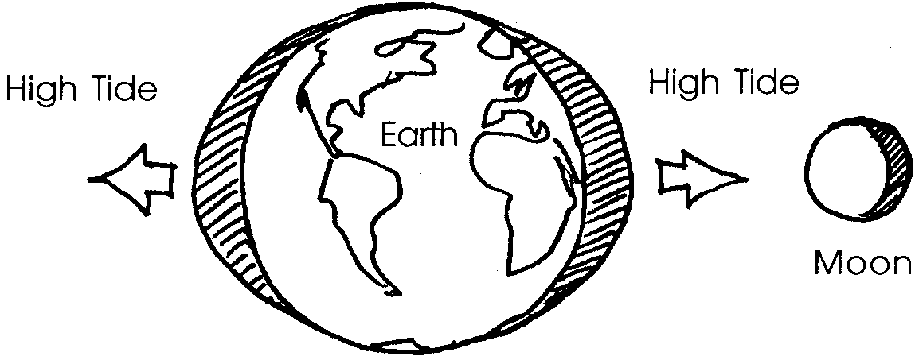

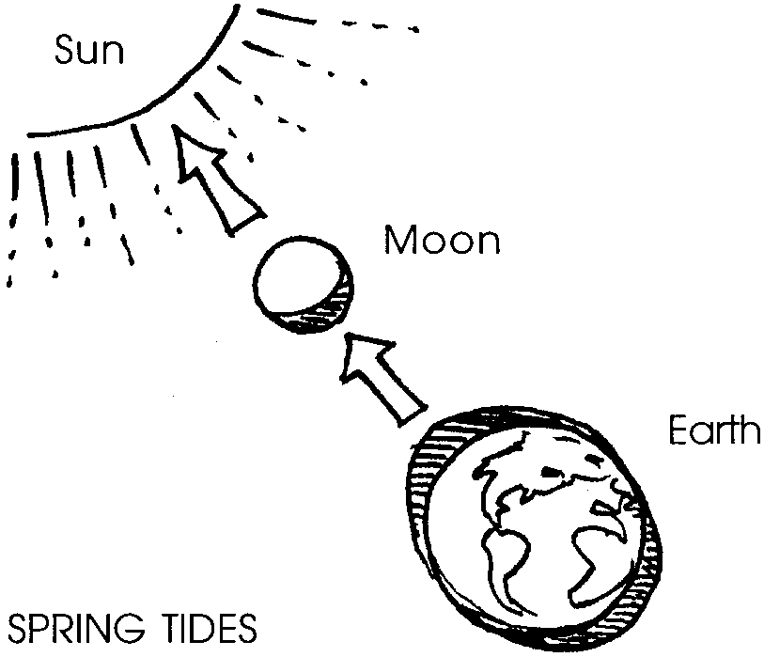
The effect of the sun is to increase or decrease the size of the bulge created by the moon. Twice every 28 days the sun and the moon are in line with each other. At this time, the combined pulling forces of both the sun and the moon on the earth produce the highest rise in water levels along our coasts. These tides are called spring tides. Spring tides occur all year long. The term “spring” comes not from the season but rather from the “springiness” of the water movement.

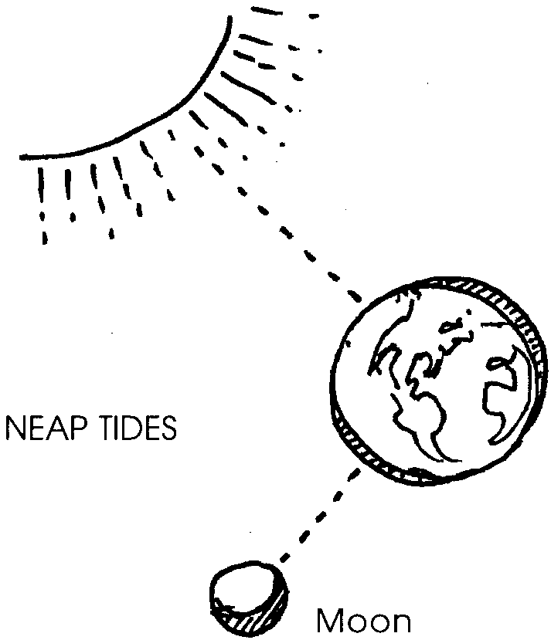
Twice every 28 days the moon is at right angles to the sun. The attraction of the moon for the earth cancels out the sun’s attraction for the earth. At these times, there is the smallest rise in water levels. We call these tides neap tides.
Tides influence the shape of and appearance of coastlines. They also greatly influence the assemblage of plants and animals found in tidal areas. The subject of intertidal zonation (the distribution of plants and animals in relation to the duration of periods of alternate submergance and exposure) is a fascinating one introduced in the lessons which follow.

Materials

For each student or pair of students:
• copies of “Tide’s In/Tide’s Out” activity pages (dock template and daily tide charts; Mon. - Fri.)
• scissors
• blue crayon

Teaching Hints
This activity presents the notion of tides as the regular rise and fall of sea level along the shore. If your students have observed tides, “Tides In/Tide’s Out” will help them move from concrete observations of tidal movement to the abstraction presented in this activity. If your students have not had first hand knowledge of the tides, the activity provides an introduction which would benefit from any supplementary visual materials available to you.
The activity is designed to help students understand that, in most coastal areas of the United States, the tide comes in and goes out twice in a 24 hour period, and that tides vary daily in time and height. If the beaches you live near have only one high and low tide a day, this activity should be modified to simulate the tides your students observe. These daily tide charts were constructed from an actual tide chart of Puget Sound.
They are intended to represent an arbitrary week. Therefore, Monday’s chart will not necessarily represent every Monday’s tide changes. If a tide chart is available, new daily tide charts can easily be constructed to represent the time of actual tide changes during the unit of study.
In this activity, tide heights are determined by overlaying the dock template on the desired daily tide chart and aligning the clock cutout over the desired time. The tidal height is seen in the third cutout located next to the tide gage indicator on the piling. It may be useful to make overhead transparencies of the activity page to use during instruction.

1. Lead students in these steps to construct the dock template:

a. Fold dock drawing in half on the dashed (-----) line.

b. Cut out the three slash-marked ( /////) sections on the dock drawings. Open up the paper when completed.

c. Cut the top part of the paper off at the dotted (........) line.

2. Have students use a blue crayon to color the whole area below the tide curve; representing the height of the water. Adding color to each of the tide graphs (Mon. - Fri.), has proven to be very helpful.
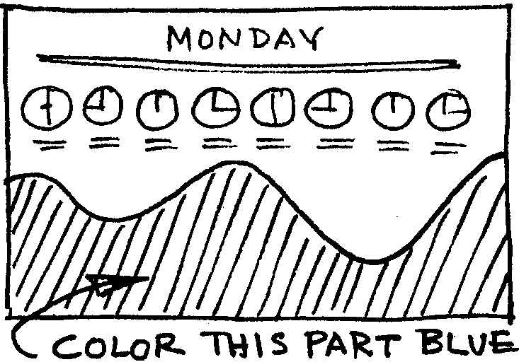

3. To find the height of the tides using the tide charts:

a. Lay the dock drawing on the tide chart for Monday.

b. Line up the clock cut-out over 12:00 noon.

c. Read the height of the water on the tide gage indicator on the piling. Note: This is the long, skinny cut-out next to the piling. (The height of the tide at 12:00 noon on Monday is +9 feet.)

4. Ask questions like:

What will be the height of the tide at noon on Tuesday? (+7 feet)

What time is the highest tide on Thursday? (about 9:00 a.m.)

What time is the lowest tide on Tuesday? (12:00 midnight)

How many times does the tide come in each day? (two)

How many times does the tide go out each day? (two)

5. The daily tide charts can be posted end to end to show a continuous week’s tides.
Key Words

chart - a diagram or table showing information

dock - a platform at a shore where boats and ships are unloaded

height - the distance from top to bottom

highest - the topmost point of anything; in this case, the farthest reach inland of tidal waters

lowest -the greatest depth of anything; in this case, the greatest pulling back of tidal waters from land

tide - rise and fall of the sea level along the shore

tide gage indicator - markings on a post that indicate the height of tidal waters

Extensions

1. Examine tide charts in the newspaper, on calendars or in tide chart booklets available at many bait shops and other businesses in coastal areas.

2. Students can share their own experiences with tides. Determine whether they understand the difference between waves and tides.

3. Later lessons will provide study of the effects of tidal action on organisms. Plans might begin for a project to illustrate these effects in a large model (like a piling) or a folding chart.

4. Help set the mood with poems such as “The Tide in the River” by Eleanor Farjeon or the following story from the native people of Northern British Columbia.

Why the Tides Ebb and Flow

In this Tahtlan story from Northern British Columbia, Raven perceives the abundance that the coastal waters could provide for the people, if only they had access to what lived under the water. In the beginning, though, there were no tides. Raven had to fix things so that the tides would ebb and flow. It turns out that a man is sitting on a rock so that the water won’t all drain away into a hole into the earth. By making his perch uncomfortable, Raven convinces the old man that he would be better off sitting only half the time, thus, the tides thereafter have come and gone twice a day. The action of the tides still makes estuaries some of the most productive areas on the face of the earth.

This happened long ago when the people were learning how to live in the world. The people had no food. They were starving.

One day when Raven was out on the ocean in his canoe, following along the shores and beaches, he saw fish swimming under the water. He saw crabs crawling, mussels lying in their beds, little clams sticking their necks out. Starfish rambled around on their strange circular advance.

“The people could eat these things if they could get them,” said Raven.

Raven, culture hero of all Northwest Pacific Coast peoples, was fixing up the world and teaching people how to live. He thought all people should have enough to eat. He was the one who fixed the earth so it would not tip. He put a big piece of ice across the north of it, and since then it has not tipped. Raven fixed the world and taught the people everything.

The people could eat these things if they could get them, he kept thinking, but the water is too deep.

Raven paddled along, paddled along, wondering what to do. Then he saw a great big man sitting on the shore.

“What are you doing there?” said Raven.

“Sitting,” said the man.

“Why?”

“If I get up the ocean will go dry,” said the man. “So I sit.”

The man was sitting on a hole in the earth. If he got up, the ocean poured into the hole.

“Get up and let me look,” said Raven.

“No,” said the man. He would not budge.

So Raven grabbed him by the hair and pulled him up. Sure enough, there was a bottomless hole in the earth, and when the man stood up, the ocean waters poured and roared into it.

Raven slid a sharp stone alongside the hole with his foot. When the man sat down, the stone jabbed him and he jumped up. Raven slipped another sharp-pointed stone under him, so that when the man sat, this hurt worse, and the man leaped into the air again.

While this was going on, the waters poured into the hole; the ocean receded, and the beach was uncovered.

Yes. The people can get food here, Raven decided.

“From now on,” said Raven to the man, “you must stand up twice every day, long enough to let the waters recede as far as they are now, so that the people may find food.”

“All right,” said the man. “All right.”

Thus it is that the tides began to ebb and flow and people gathered seafood on the shores.

“Why the Tides Ebb and Flow” from How the People Sang the Mountains Up by Maria Leach. Copyright © 1967 by Maria Leach.
Used by permission of Viking Penguin, a division of Penguin Books USA Inc.
