The Great Boat Float

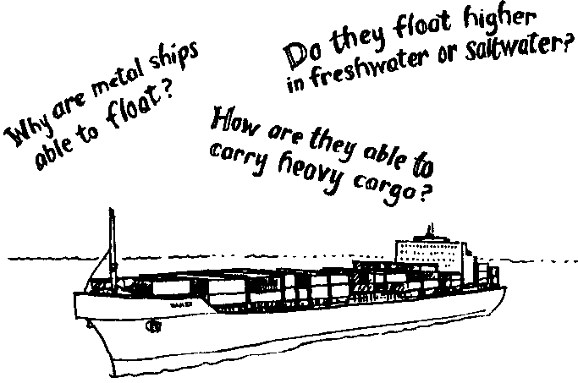
Key Concepts
1. Objects float differently in fresh and saltwater.
2. The shape of an object affects its ability to float.

Background

Background information for “The Great Boat Float” is found in the preceding activity, “Plimsoll Floats”

Materials

For each family group:
• copies of “The Great Boat Float” activity pages
• aluminum foil
• small nails, marbles, pebbles, or paper clips which can be used as weights, or “cargo,” for boats
• sharp pencil
• ruler
• scissors

Teaching Hints

A natural sequel to “Plimsoll Floats,” “The Great Boat Float” is designed as a take home activity. The activity was developed by the Virginia Institute of Marine Science, School of Marine Science, College of William and Mary, under a National Science Foundation grant and is included here so that you may involve your students’ families in the science activities occurring in your classroom.
By way of preparation, read the activity and give your students a little background information related to the activity. Stress the fun they can have making the discoveries as a family and alert your students to the format for recording their observations.
Plan to spend a little time talking about the activity as a follow-up back in the classroom. This will not only cement the concepts but will provide positive reinforcement for students.

Key Words

bow - front of a boat

buoyancy - ability to float in liquid or air

buoyant - having the ability or tendency to float in liquid or air

cargo - the load carried by a boat; freight

gravity - force of attraction between massive bodies; the earth’s gravity tends to pull objects toward the earth’s center.

observation - something seen or noticed

overloaded - carrying too much weight

Plimsoll mark - lines on a ship which indicate how low it can safely ride in the water; load-limit

transportation - moving something from one place to another, especially over long distances

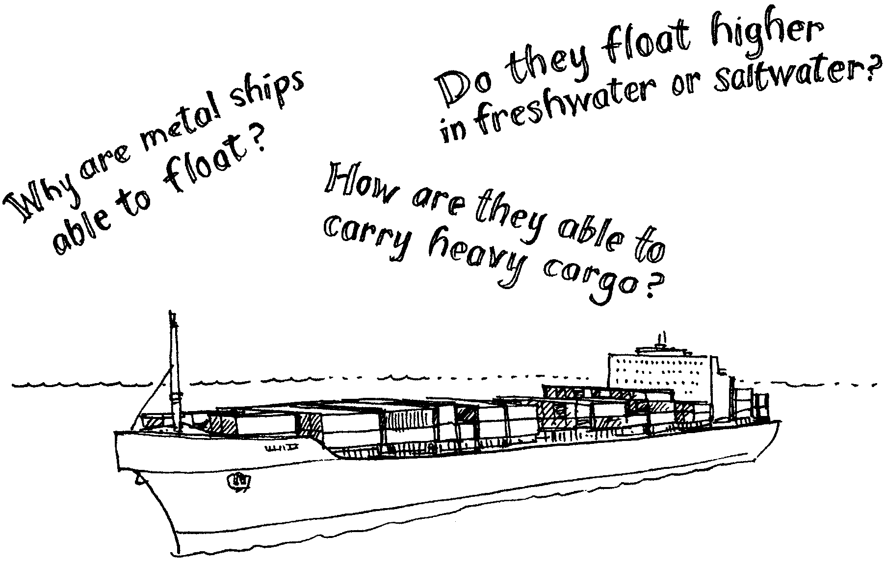
The Great Boat Float

In this activity you will work together, conducting experiments with boats. Make a boat building contest! Whose boat will carry the most cargo? Let’s get started, and good luck!

Preparation
1. You will need:
• aluminum foil
• small nails, marbles, pebbles, or paper clips which can be used as weights, or “cargo,” for boats
• sharp pencil
• ruler
• scissors

2. Fill a sink with at least 4-6 inches of water.

Action
1. Gather your family together. Explain that you are going to hold a boat building contest. Each person will build a boat. The boat which carries the most “cargo” will be the winner.

2. Give each member of your family a six inch by six inch square of aluminum foil. Think what design the boat must have in order to float. Then build your boats!

3. Place each boat in the water. Test it to see if it floats. If it does not, try building another boat. Continue until everyone has a boat which floats.

4. Float the boats. One at a time, place small objects in the boats. You might use paper clips, nails, pebbles, etc. Compare how much cargo each boat can hold. Why is it important that everyone use the same type of weight?

5. Observe how many objects each boat can hold and still float. Record your findings in Table 1.

6. Not happy with your boat? Try another design. Make and test your new boat. Record these results in Table 1.

7. Take the boats out of the water and empty them. Turn the boats over. Obtain a needle or pin. Carefully punch several small holes in the boat bottom. Punch from the outside of the boat to the inside. Return the boats to the water one at a time. Did each one float? Does the water come in through the holes? Record your findings in Table 1.

8. Are your boats still afloat? Replace the “cargo” objects in your hole-filled boats one at a time. Observe how many items the boats can hold and still float. Record your findings in Table 1.

9. Take your boats out of the water and empty. Again, turn the boats over. This time, punch several larger holes in your boat. Use the sharpened point of a pencil. Punch from the outside of the boat to the inside.

10. Repeat step 8 and record the results in the table.

More Things To Do

Preparation
1. Try using a different material to build the boats. As a family, build two boats that are exactly alike. Be sure to make them out of the same material. These are good materials to use: Styrofoam pieces, heavy cardboard, plastic, wax paper.
2. Obtain two containers (tubs, pans or buckets). Fill one with water. Fill the other with one of the liquids from this list: cooking oil, vinegar, soda pop, syrup, saltwater (mix about 1/4 cup of salt for each quart of water or 1 cup of salt for each gallon of water).

Action
1. Use Table 2 of the Observation Sheet. Record the names of the people who built the boats. Record the materials used to make the boats. Record the liquids used to float the boats.

2. Place the first boat in the water. Place the second in the other liquid. Did they float? If they do not, try building another type of boat. Continue until you make a pair of boats which float.

3. Begin placing “cargo” in the boats one at a time. How many items is each boat able to hold and still float? In which liquid are they able to carry more cargo? Record your findings (observations) in Table 2.

Afterwards - To Discuss As A Group
Water and other liquids push up on the objects put in them. This upward force is called buoyancy. At the same time the earth’s gravitational force tries to pull the objects down. This downward force is called gravity.

If something sinks in water, gravity is greater than buoyancy. The force pulling down is greater than the force pushing up. When something floats, buoyancy is greater than gravity. The force pushing up is greater than the force pulling down. If an object has the ability to float, it is buoyant.

The more dense (heavier) the liquid, the greater its upward force. For example, saltwater is more dense than freshwater. Saltwater has a greater upward force (buoyancy) than freshwater. Objects are more buoyant (float better) in saltwater.

The buoyant effect of water is important. It makes all types of ocean, river and lake transportation possible. Ships float because the force of gravity pulling the ship down is less than the force of the water pushing the ship up. This may seem hard to believe. Ships are made of steel and weigh many thousands of tons. Remember though, ships have air spaces.

Empty ships ride high in the water. When loaded with heavy cargo, they ride low in the water. Overloaded boats sink too deeply in the water. This can be dangerous. Water may come over the sides of the boat. When this happens, the weight of the boat increases. Water, which is heavier than air, replaces the air in the boat. If too much water enters in the boat, it sinks. Did this happen to any of your boats?

A “Plimsoll mark” is found on all large ships. This mark shows proper loading in fresh or saltwater. Saltwater has a greater upward force (buoyancy) than freshwater. Objects are more buoyant (float better) in saltwater. Shippers must remember this. What might happen to a ship fully loaded in the ocean and sent to the Great Lakes? It could sink. This is the last thing shippers want.

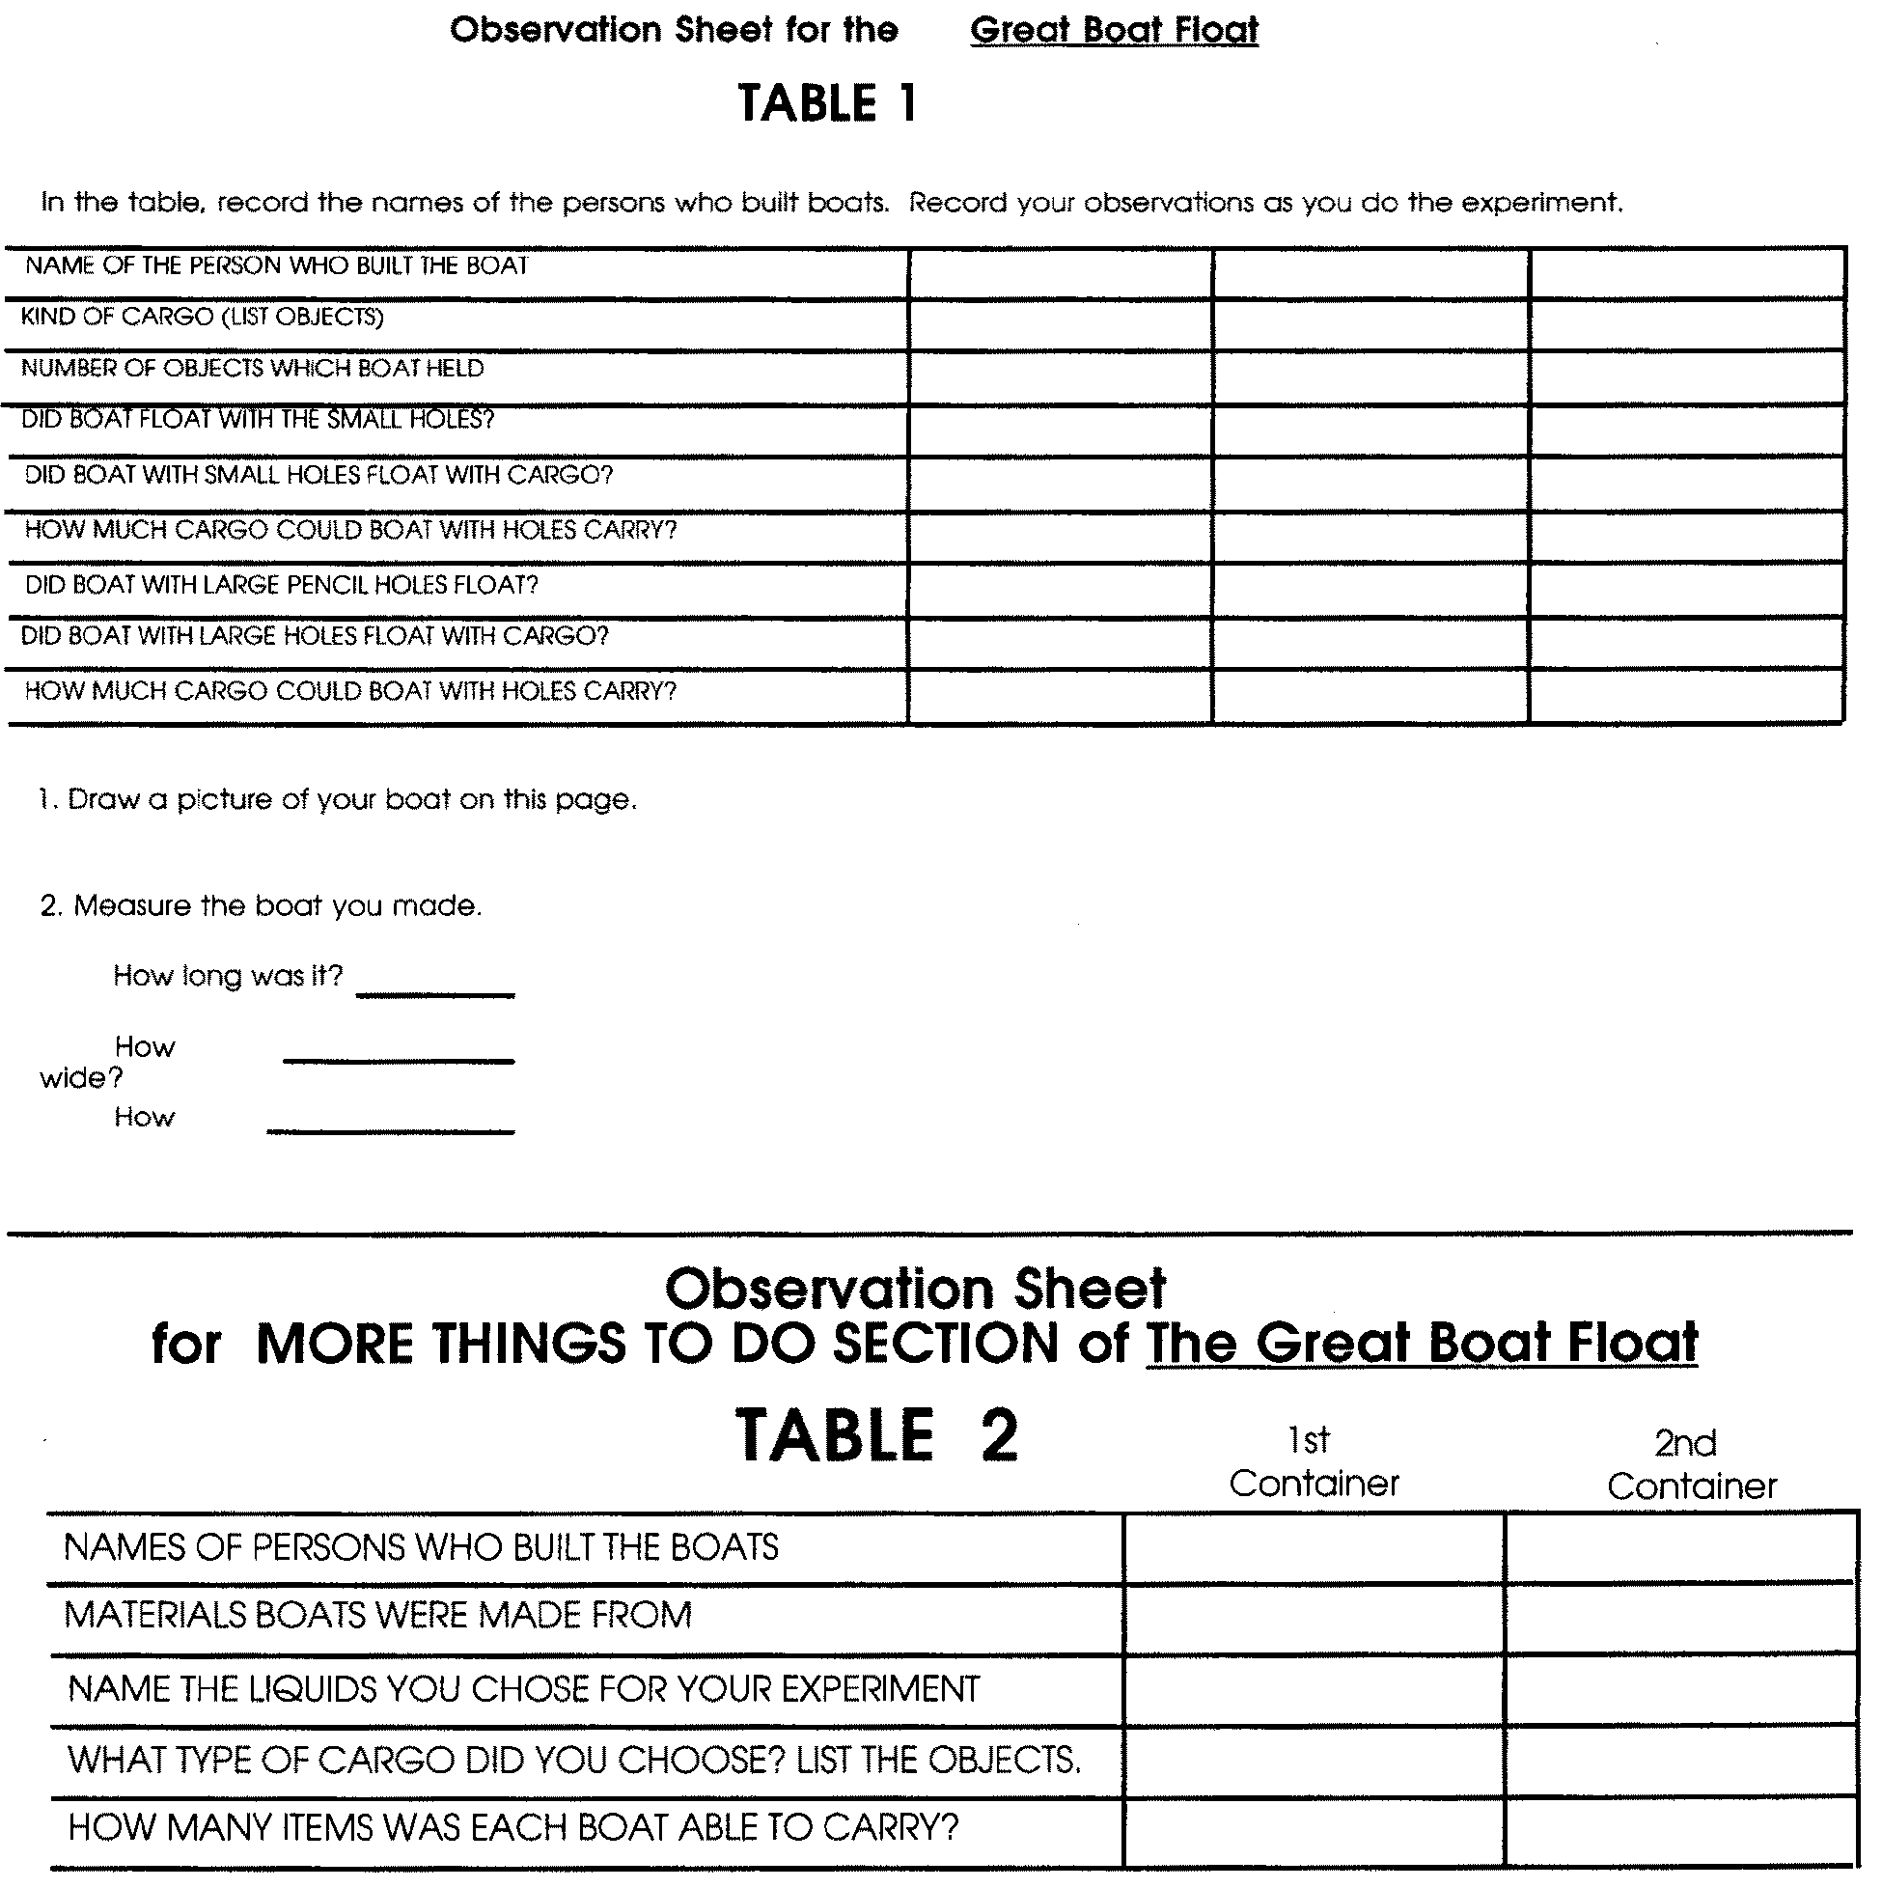
Thought and Disscussion
1. In which liquid did the boat float better? (was able to carry more cargo?)

2. Why?

3. Did these boats float better in water than the aluminum boats?

4. Do you think this was due to the design of the boat or the material you used to build it?

5. What experiments could you do to answer question 4? Write your answer on the back of this page.

