Plimsoll Floats

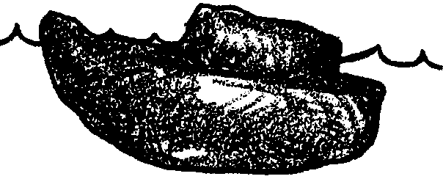
Key Concepts
1. Objects float differently in fresh and saltwater.
2. The shape of an object affects its ability to float.

Background

Why does an object float? Any object placed on the water’s surface will sink just far enough to move aside, or displace, a weight of water equal to that of the object. Water and other liquids push up on the objects put in them. This upward force is called buoyancy. At the same time the earth’s gravitational force tries to pull the objects down. This downward force is called gravity.
If something sinks in water, gravity is greater than buoyancy. The force pulling down is greater than the force pushing up. When something floats, buoyancy is greater than gravity. The force pushing up is greater than the force pulling down. If an object has the ability to float, it is buoyant.
The more dense (“heavier”) the liquid, the greater its upward force. Saltwater is more dense than freshwater. Because of the salt dissolved in the water, a given volume of saltwater weighs more than the same volume of freshwater. As a result of the greater density of the saltwater displaced, an object will float higher in saltwater than in fresh. In fact, some objects, like a fresh egg, will float in saltwater but sink in fresh. Saltwater has a greater upward force (buoyancy) than freshwater. Objects are more buoyant (float better) in saltwater.
The buoyant effect of water is important. It makes all types of ocean, river and lake transportation possible. Ships float because the force of gravity pulling the ship down is less than the force of the water pushing the ship up. This may seem hard to believe. Ships are made of steel and weigh many thousands of tons. Remember though, ships have air spaces.
Empty ships ride high in the water. When loaded with heavy cargo, they ride low in the water. Overloaded boats sink too deeply in the water. This can be dangerous. Water may come over the sides of the boat. When this happens, the weight of the boat increases. Water, which is heavier than air, replaces the air in the boat. If too much water enters in the boat, it sinks.
A “Plimsoll mark” is found on all large ships. This mark shows proper loading in fresh or saltwater. Saltwater has a greater upward force (buoyancy) than freshwater. Because objects are more buoyant (float better) in saltwater, a ship can hold more cargo in saltwater than in freshwater.
Materials

For each group of four students:
• set of “Plimsoll Floats” activity cards
• clear plastic container (dish pan, plastic shoe box or similar container )
• plasticine clay (about 1/4 to 1/2 pound); Use OIL-based clay, only, or it will dissolve in water!
• marbles (about 20; can be shared with other groups); or any similar standard, water-resistant weight to act as cargo
• large paper clips (1/4 of a box; can be shared with other groups)
• salt (1 cup)
• water
• sponges, paper towels for clean-up

Teaching Hints

“Plimsoll Floats” is a problem-solving activity designed to provide students with a chance to answer the questions: “Why do boats float?” and “Does a boat float differently in saltwater than in freshwater?”
The activity pages are designed to be made into individual task cards. These cards can be used again if students record responses on a separate piece of paper. The cards allow students to derive the essential components of the law of displacement.
Caution your students to look carefully for differences in the waterline and carrying capacity of their boats. In activity 5, if there is no difference observed with the marbles, suggest students use large paper clips. They usually provide observable differences.
Distribute materials and let the floating begin. Allow time for a culminating discussion to help students derive the principals of displacement and flotation from their observations.
The six activities which follow spring from ideas originally appearing in the Elementary Science Study Clay Boats unit (Educational Services Incorporated, Watertown, MA, 1966, Developmental Teaching Edition).

Key Words

bow - front of a boat

charts - a diagram or table showing information

clay - firm, pliable, fine-grained earth compass rose - symbol on a map indicating North

float - to remain suspended on the surface of a liquid without sinking

port - left side of a ship, when one is facing forward

sink - to descend below the surface of a liquid

starboard - right side of a ship, when one is facing forward

stern - back of a ship

Extensions

1. Read aloud the poem “Homemade Boat” by Shel Silverstein or “My Boat” by Jack Prelutsky.

2. Research historic ships and boats.

3. Explore the topic of submarines.

4. Share stories, poems, songs, music and art about ships and the people associated with them.

5. On the playground map out the dimensions of some famous ships like the Mayflower, Columbus’s ships, etc.

6. Tour a ship.

7. Plan a boat trip. Bon voyage!

Answer Key

The answers to many of the questions on the six activity cards depend upon the observations made by your students and, hence will vary.
Some of the expected results follow. Be sure to discuss variations from the expected. These discussions should focus on the quality of the observation, reasons why observed differences could have occurred, and changes which could be made when performing the activity again to test the suggested reasons for the differences .

Activity 4

The waterline will move up the side of the boat as the marble people are added. The pencil mark (representing the old waterline) will go underwater.
Activity 5

One would expect the boat to carry more marble people in saltwater than in fresh. It is possible, however, that because of the relatively large size of the marbles, your students will find the boat carries the same number of marbles. Suggest they try large paper clips to see if there is a difference in fresh and saltwater.

Activity 6

The new waterline will be lower than the first one made in #4 because the boat floats higher out of the water.
It is expected that your students will find that boats in freshwater float lower than boats in saltwater and can carry less weight before they sink. Discuss any variations from these expectations in terms of the observations made by your students.
A Plimsoll mark has a line for freshwater and one for saltwater because the ship can carry more weight in saltwater than in fresh. It would be possible to overload a boat simply by moving a loaded boat from salt to freshwater.

Plimsoll Floats - Activity Cards

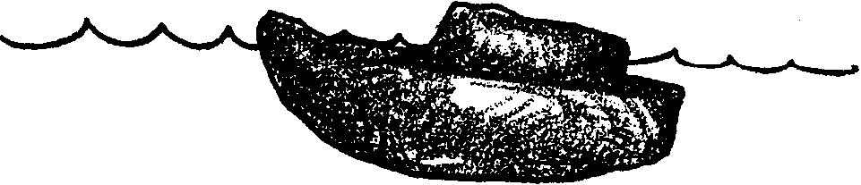
Plimsoll Floats
Activity 1

Get a hunk of clay.
What do you think will happen if you drop the clay in water?

TRY IT!
What did happen to the clay when you dropped it in the water?

Shape a piece of clay so that it will float.

Record the different ways in which you tried to make the clay float.
Circle the ways that worked.

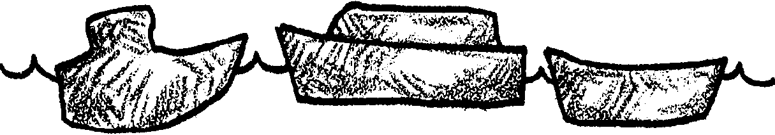
Plimsoll Floats
Activity 2

Divide your piece of clay into three equal pieces. Make three clay boats with different shapes.

Try floating the three boats.

For each boat, draw a picture that shows its shape. Write a sentence about each boat. Circle the drawing of the boat which floats best.

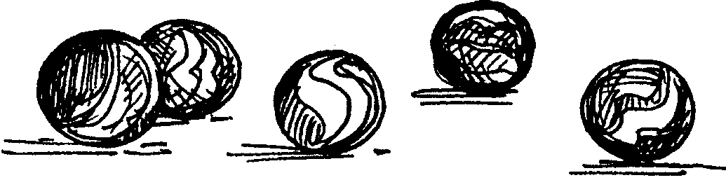

Plimsoll Floats
Activity 3

Get 10-20 marble “people”. Float your best boat from #2. Count to see how many marble people you can add before the boat sinks. Record the number of marble people your boat can carry without sinking.

How can you change your boat so that it will carry more marble people? TRY IT! Record how you made your boat better.


Plimsoll Floats
Activity 4

Re-float your best boat from #2. Use a pencil to make a mark at the waterline. The waterline is the place where the water meets the side of the boat.

What do you think will happen to the waterline if you add marble people?

TRY IT! Record what happened.

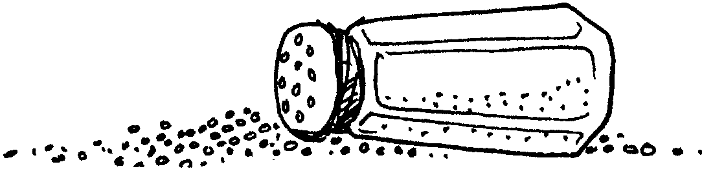

Plimsoll Floats
Activity 5

Get a cup of salt. Pour the salt into the water in the plastic container. Stir the water until the salt dissolves.

Float your best boat from #2. Count how many marble people you can add before the boat sinks. Record the number of marble people your boat can carry without sinking.

Did your boat carry more, less, or the same number of marble people in saltwater than in freshwater?

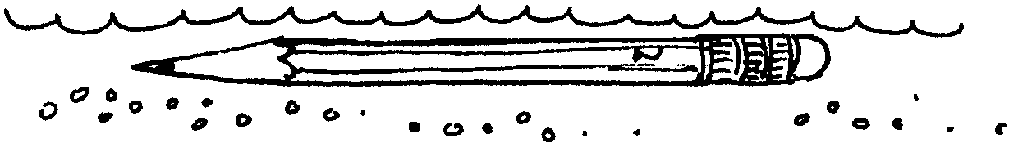
Plimsoll Floats
Activity 6

Re-float your boat from #2. Again, use a pencil to make a mark at the waterline when it is in saltwater. Is your new waterline higher or lower than the one you made in #4?

From your observations, how would the same boat float in fresh and saltwater?

From your observations, can boats in freshwater carry more or less cargo before they sink.

Lord Plimsoll’s mark is useful to tell when a ship is overloaded. Why does the mark have lines for both freshwater and saltwater?

