Where Rivers Meet the Sea
Lesson edited by Phyllis Schmitt, Santa Rosa, CA
from “The Layered Look” in Discovering Puget Sound
written by Laurie Dumdie

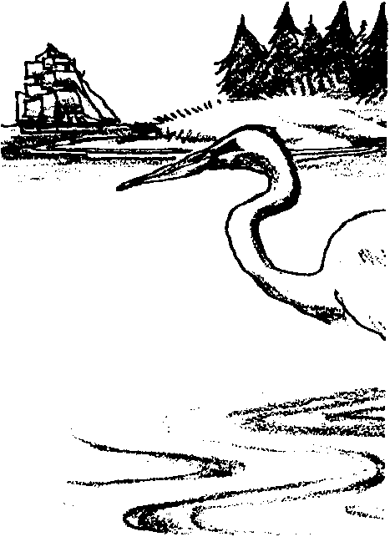
Key Concepts
1. An estuary is an inlet where freshwater from a river, stream, or creek meets and mixes with the saltwater of the sea.
2. Stratification occurs in estuaries where fresh and saltwater meet, with freshwater tending to flow above saltwater.
3. Stratification of salt and freshwater can retain nutrients in the estuary where they remain to be used by estuarine organisms.
4. Pollutants get trapped in the same manner in which nutrients are retained in the estuarine system.

Background

What is an Estuary?
In the strictest sense of the definition, an estuary is “a protected embayment with freshwater inflow from its land end and tidal exchange on its seaward side, where fresh and saltwater mix”. Most of the well-known estuaries are located at the mouths of major rivers. These brackish waters make up the bays, sounds, fjords, deltas, inlets and sloughs of the coasts.

An estuary is also a place where plants, animals and people are vitally linked with each other. Estuaries provide habitats for countless organisms largely due to the huge quantity of nutrients available in an estuary. For thousands of years estuaries have been attractive places for humans to settle. Estuaries provide safe harbors on transportation routes for trade and commerce, recreational opportunities, and extremely rich fisheries. Fertile farmland often surrounds the estuary. Human use and development of an estuary can negatively affect the delicate ecological balance.

Water Movement in an Estuary
Estuaries are highly dynamic environments. An estuary’s circulation, water exchange with the ocean, and current patterns are determined by the tides, flow of the freshwater source, and the shape of the inlet. Freshwater entering the estuary from streams and rivers is lighter or less dense than saltwater and tends to float and flow over the top of seawater. As a result, at the mouths of rivers there is often a two-layer water system. The surface water is almost fresh, brackish water formed from the mixing of freshwater and saltwater while the bottom water is quite salty. In rivers, where very large amounts of freshwater are discharged, a salt wedge may be formed. This is a wedge-shaped, bottom layer of seawater, which is pushed up the estuary along the river bottom with each flood tide creating a strongly stratified estuary.

Other types of estuaries have various degrees of vertical stratification determined by the speed of the tidal currents, the rate of freshwater addition, the bottom topography and the average depth of the estuary. For example, an estuary like Chesapeake Bay is a well-mixed estuary. Strong tidal currents distribute and mix the seawater throughout the shallow estuary. In a well-mixed estuary the net flow is seaward at all depths. Puget Sound, on the other hand, is a partially-mixed estuary. It is a deeper bay with both strong tidal flows and relatively high rates of freshwater discharge. In a partially-mixed estuary, the brackish surface layer flows toward the sea, while the more dense, seawater enters below the mixed surface water. These estuarine circulation patterns are complicated when islands and channels, which can divert and recirculate much of the flow, are present.

An important physical characteristic of an estuary is this ability to exchange water with the open ocean. Exchange helps cleanse the deep basins of the estuary and prevent them from becoming naturally stagnant from organic decay. Exchange also plays a critical role in governing the fate and effects of contaminants that enter the estuary.

Materials

For the class:
• map which includes nearest estuary and the rivers which flow into it
For each group of 4:
• one clear container, shoe box size (preferably with straight sides)
• food coloring (preferably, red and blue)
• one paper cup
• straight pin
• salt
• teaspoon
• water
• paper towels
• “Where Rivers Meet the Sea” activity sheet
• sheet of white paper (optional)

Teaching Hints

1. Provide the definition of an estuary and locate, on a map, the nearest estuary, or a significant estuary that some of your students may have visited. Ask students if they have ever visited an estuary. What was it like? Record their descriptions of sights, sounds, and smells in an estuary.

2. Return to the map to identify the ocean that is the source of saltwater in the estuary. Locate some of the rivers or streams that flow into the estuary, bringing freshwater. Reinforce that the rivers or streams bring freshwater to the salty ocean water. If you have enough maps available, have students work in groups of four to locate and mark the rivers or streams that empty into the estuary.

3. Group students into working teams of four. Distribute an activity sheet to each of the groups. Refer to the diagram of the equipment setup. Remind them to gently pull the pin out of the cup. Have students predict by asking:

What do you think will happen when the freshwater runs into the saltwater? (Have students record predictions on the activity sheets.)

Have students complete the activity, recording what they observe.

(Note: If students have difficulty seeing the movement of the colored water, a piece of white paper placed behind the model lets them see the action more clearly.)

4. When all groups have completed the activity, ask:

How did the results of this activity compare with your predictions?

The fresh water entering the estuary brings freshwater to the saltwater. What else does the freshwater carry to the estuary? (This question will be investigated in more detail in a later lesson, but is included here to get students thinking, as they watch the model, about the kinds of things the freshwater carries into the estuary: sediments from the watershed, nutrients and organic matter from the decay of plants and animal matter in the watersheds, pollutants from the watershed that affect water quality and the health of sediments.)

Key Words

brackish - a mixture of fresh and seawater

current - a body of water flowing in a definite direction

estuary - a semi-enclosed arm of the sea where incoming seawater is mixed with freshwater coming from rivers, streams or creeks draining the land

flood tide - a rising tide

salinity - refers to the concentration of salts dissolved in water

salt-wedge - intrusion of saltwater along the bottom; in an estuary, the wedge moves upstream on high tide and seaward on low tide

stratification - the process of arranging in layers (strata)

watershed - a geographic region that drains water (and everything water carries) into a stream, river system or body of water. A watershed includes hills, bottom land, and the body of water into which the land drains (which can be an estuary).

Extensions

1. Repeat the activity with the addition of rocks or other “island obstacles” on the bottom of the container to study the effects of an uneven bottom surface.

2. There is no better way to learn about an estuary then by being in one and observing it personally. Take a field trip to an estuary.

• Take along hand lenses, small containers for collecting animals to observe at the estuary (remember to return all organisms), clipboards, paper and pencil, field guides, etc.

• Students can make lists of the plants and animals they see, including animal signs like animal tracks or droppings.

• Study samples of different soils. Are there any insects or small animals?

• Dress appropriately for wet, muddy conditions, and bring along the first aid kit.

• REMIND STUDENTS NOT TO PICK PLANTS OR TAKE ANIMALS FROM THE ESTUARY.

3. Before the class visits an estuary you might prepare a “bingo” card to help focus their attention. Items might include:

• draw an animal that (swims in with the tide), (eats ), (lives in/on )

• I saw: (bird standing on one foot), (insect, snail, salt marsh grass, ), (seastar moving), (open anemone tentacles),(closed anemone), (animal tracks), (nest),(animal hole), (bird feeding), (bird with long, skinny bill), (litter)

• human-made sound, animal sound

4. Take the next step: TURN AWARENESS INTO ACTION. Participate in Adopt-a-Beach programs as a class or maybe even a Saturday Family Club.

Answer Key

7. Freshwater will usually float over the top of the saltwater when the two meet.

8. Freshwater meets saltwater in estuaries.

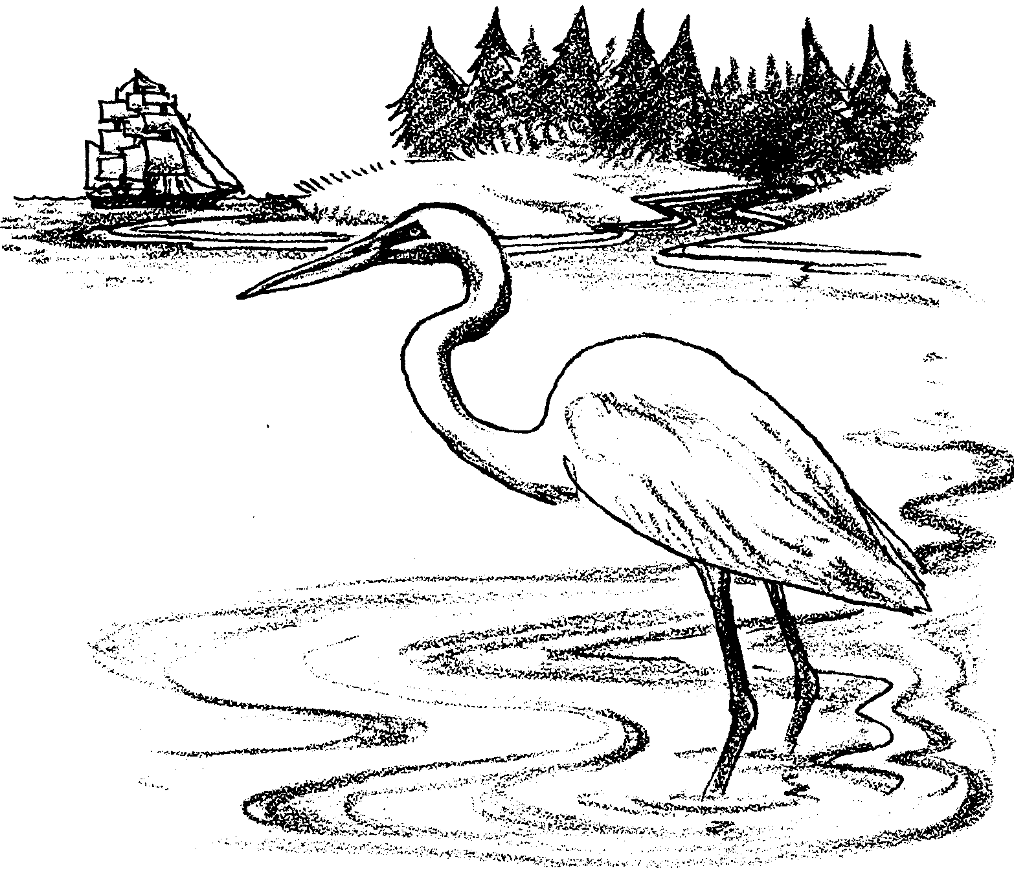
Where Rivers Meet the Sea

Prediction: Observe the set-up below. What do you predict will happen when the pin is removed from the cup and the freshwater flows into the saltwater?

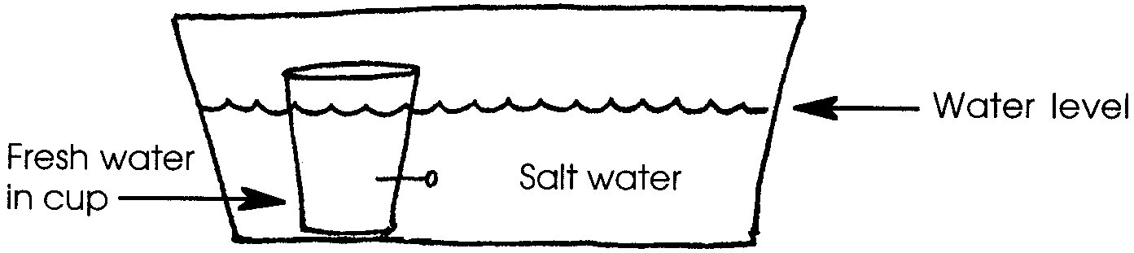
Write your prediction in the space below.

1. Obtain one paper cup and a clear plastic container. The paper cup will represent a river. The clear container will represent an estuary. A pin hole in the cup will provide the water current from the river.

2. Place 12 drops of food coloring in the cup. Fill the cup full with cold, freshwater. Water from the tap is fine for this activity.

3. Obtain a straight pin. Stick the pin in the cup half way between the top and the bottom. LEAVE THE PIN IN THE CUP. Place the cup at one end of the container.

4. Place 4 teaspoons of salt in the clear container. Fill the container with cold, freshwater to a depth about one inch below the top of the cup. Stir to dissolve the salt. Make certain the saltwater is above the pin in the cup.
Your setup should look something like the drawing above from which you made your prediction.

5. Wait until the water in the container has stopped moving. Wait at least a minute. To start the “river” flowing into the estuary, gently and slowly pull out the pin. Try not to disturb the water. Observe the results. (Hint: Have your eyes at the level of the water.)

6. After 5 minutes, make a drawing showing the location of the freshwater in the model.

7. Write a sentence describing what happens when freshwater meets saltwater.

8. In the real world, where does freshwater meet saltwater?
