Zones of the Ocean Mural
Lesson by Pat Williams, Eugene, OR

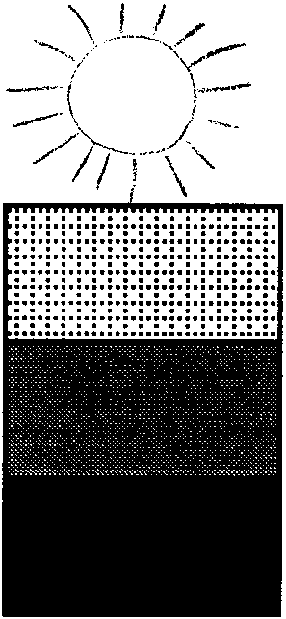
Key Concepts

1. The ocean can be divided into zones determined by the amount of light present.
2. Because of the abundance of plankton in the surface waters, most marine life is found near the surface of the ocean.

Background

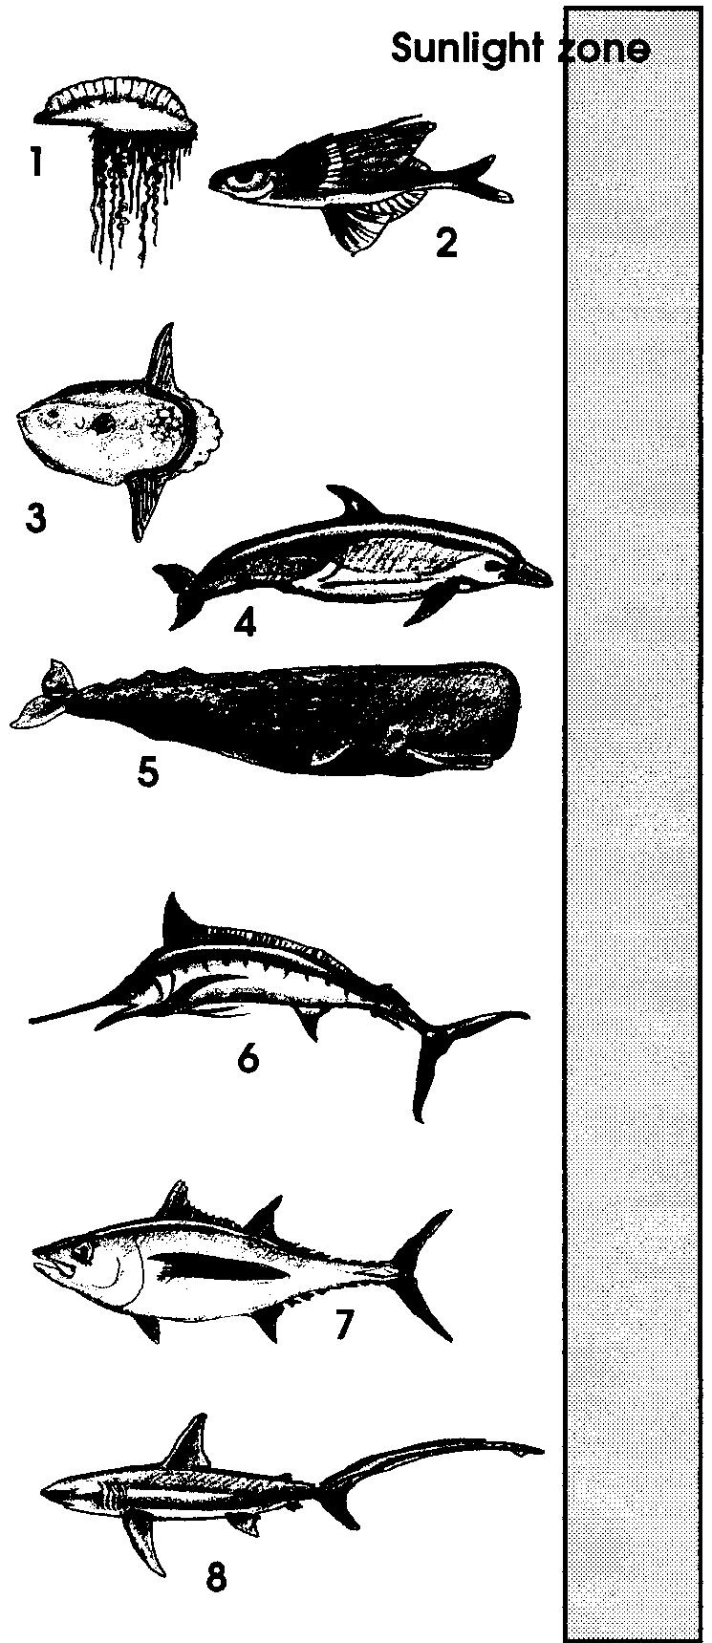
Marine plants and animals live in zones which are defined by the amount of light present. Most marine life is found near the ocean surface. This top layer, called by some the sunlight zone, is where most of the sunlight filters through. The sunlight zone is generally considered to be the top 300 feet of the ocean, with its maximum depth extending to about 600 feet in some areas. It is home to more than 90 percent of all known marine species.

The reason that most species are found in the sunlight zone is the presence of billions of plankton. Plankton are plants and animals that drift and float through the water at the whim of tides and currents. The plants are known as phytoplankton, while the animals are called zooplankton. Most plankton are microscopic. As the base of most of the ocean’s food webs, practically every animal in the ocean is dependent on plankton. Phytoplankton use the sun’s energy to produce their own food through photosynthesis. They, in turn, are food for the zooplankton, which is eaten by larger animals, which are eaten by still larger animals, etc., etc. Without the sun, there could be no plankton; without the plankton, there would be no base from which almost all other food chains in the marine ecosystem derive.
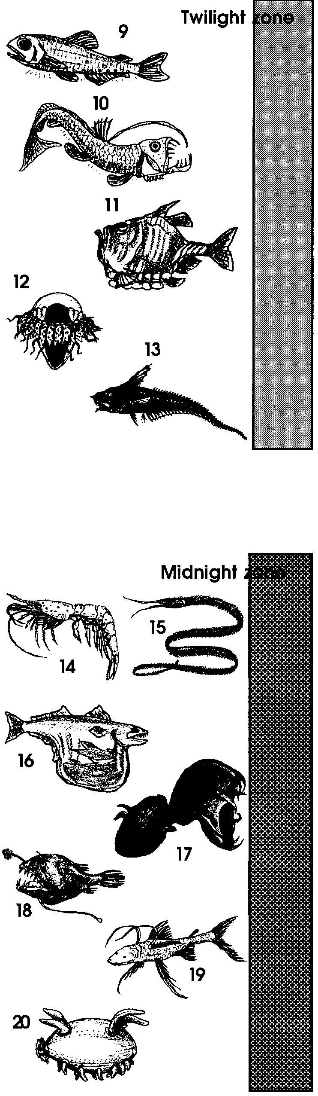
The next zone, deeper and below the sunlight zone, is the twilight zone. Barely lit, these waters are a place of shadowy images. It is a world without plants, with fewer and smaller animals which rely on pieces of dead plants and animal remains that float down from above. Bioluminescence, the ability of an animal to produce light, is characteristic of some animals in this zone. The twilight zone extends from about 300 feet to about 3000 feet in depth.

The deepest and darkest zone, the deep sea or midnight zone, lies from below depths of 3000 feet to the deepest ocean floor. With the exception of areas near thermal vents, this is a cold, near-freezing world. Total darkness and pressures that may exceed two tons per square inch help create a harsh environment. Although the area takes up close to three quarters of the total ocean, it is estimated that only one percent of ocean species live in the midnight zone. Fish in the deep sea have low metabolic rates and unusual appearances. They grow slowly and live for a long time, swimming or hovering above a floor of ooze. Many of these fish are scavengers, relying on the few dead remains which filter down from above. Others are predators, eating the scavengers or each other.

Materials

For the class:

• “Life in the Zones of the Ocean” overhead transparency

• butcher paper, 8 to 12 ft. long - one each: black, dark blue, light blue

• tempera paints, brushes, smocks

• fluorescent paint (optional)

• reference materials

• construction paper, art supplies for creating animals

• newspaper or plastic to protect surfaces

Teaching Hints

“Zones of the Ocean Mural” provides a whole class project which enables students to dramatically present the varied habitats of the ocean. The activity, which may take 2-4 days, is a favorite because most children love to paint and they are very intrigued by the names of the three zones of the ocean: the sunlight zone, the twilight zone, and the deep sea or midnight zone.

Preparation

1. Duplicate the “Ocean Zones Student Information Cards” for use as reference materials during mural construction. As available, gather additional reference materials such as What’s Under the Sea? by Solveig Paulson Russell and The Sea, (1961) from Life Nature Library series. (The latter includes a wonderful 3-page pull out of the ocean zones.)

2. Recruit some adult helpers to assist students with their taping and painting of the ocean zones.

Procedure

1. Introduce the activity by using the “Life in the Zones of the Ocean” overhead transparency to highlight the information contained in the Background section above. Explain that the class will be making a mural depicting the various animals found in each zone.

2. Organize your class into three “ocean zone” committees.

3. Explain to the class that each group will use butcher paper and tempera paints to make a mural representing one of the three zones of the ocean (i.e., sunlight zone, twilight zone, and deep sea or midnight zone). Distribute the butcher paper to each group: the light blue butcher paper serves as the base for the sunlight zone, the dark blue for the twilight zone, and black for the deep sea or midnight zone.

4. Demonstrate how to wipe brushes loaded with paint on the edges of containers so paint won’t drip down, or puddle on, the mural.

5. Have each group use tempera to paint the “water” (colored butcher paper) for their zone. Be sure that they choose paints similar in color to their butcher paper. To paint the “water”, you may choose to hang the butcher paper on a suitably sized wall - outside walls often work great, if weather permits. Be sure to put newspaper around the edges of the paper to protect school walls. If you can’t hang the paper, the floor of a gym or all-purpose room can provide an area big enough for all groups to create at the same time. Where ever you work, make sure you use tarps or lots of newspaper underneath.

6. As the “water” dries, have students make the fish, etc. that are appropriate for their zone. Be sure your reference materials are available for student use.

7. After the “water” dries, have students add their fish, etc. in the appropriate places within their zone.

8. Display the three individual zone murals and have each group explain to the others how they chose their animals and plants and what life is like in their zone.

9. Combine the separate murals into one large “Zones of the Ocean” mural.

Key Words

midnight zone - an ocean zone, defined by the amount of light present, which extends from below depths of 3000 feet to the deepest ocean floor

sunlight zone - the surface of the ocean where most of the sunlight filters through; generally considered to be the top 300 feet of the ocean

twilight zone - an ocean zone, defined by the amount of light present, which extends from about 300 feet to about 3000 feet in depth

Extension

1. Have students include in their mural the seals and sea lions assembled in “Who Are Those Pinnipeds?” and any whales they may have created in “The Oceans As Whale Habitat”.
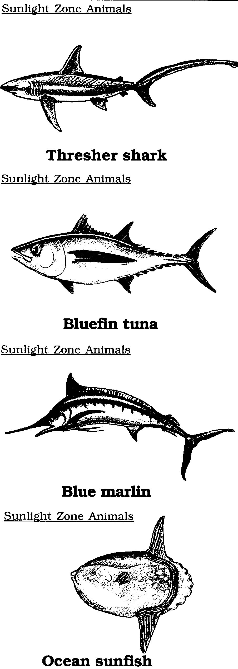
Zones of the Ocean Mural - Ocean Zones Student Information Cards
Thresher shark
My back is brown.
My belly is white.
I can be 16 feet long.
I may weigh 500 pounds.

Bluefin tuna
My back is dark blue.
My belly is white.
I can be 14 feet long.
I may weigh 1,800 pounds.

Blue marlin
My back is blue.
My belly is white.
I can be 14 feet long.
I may weigh 1,000 pounds.

Ocean sunfish
I am gray or brown.
I can be 15 feet long.
I may weigh over 2,000 pounds.

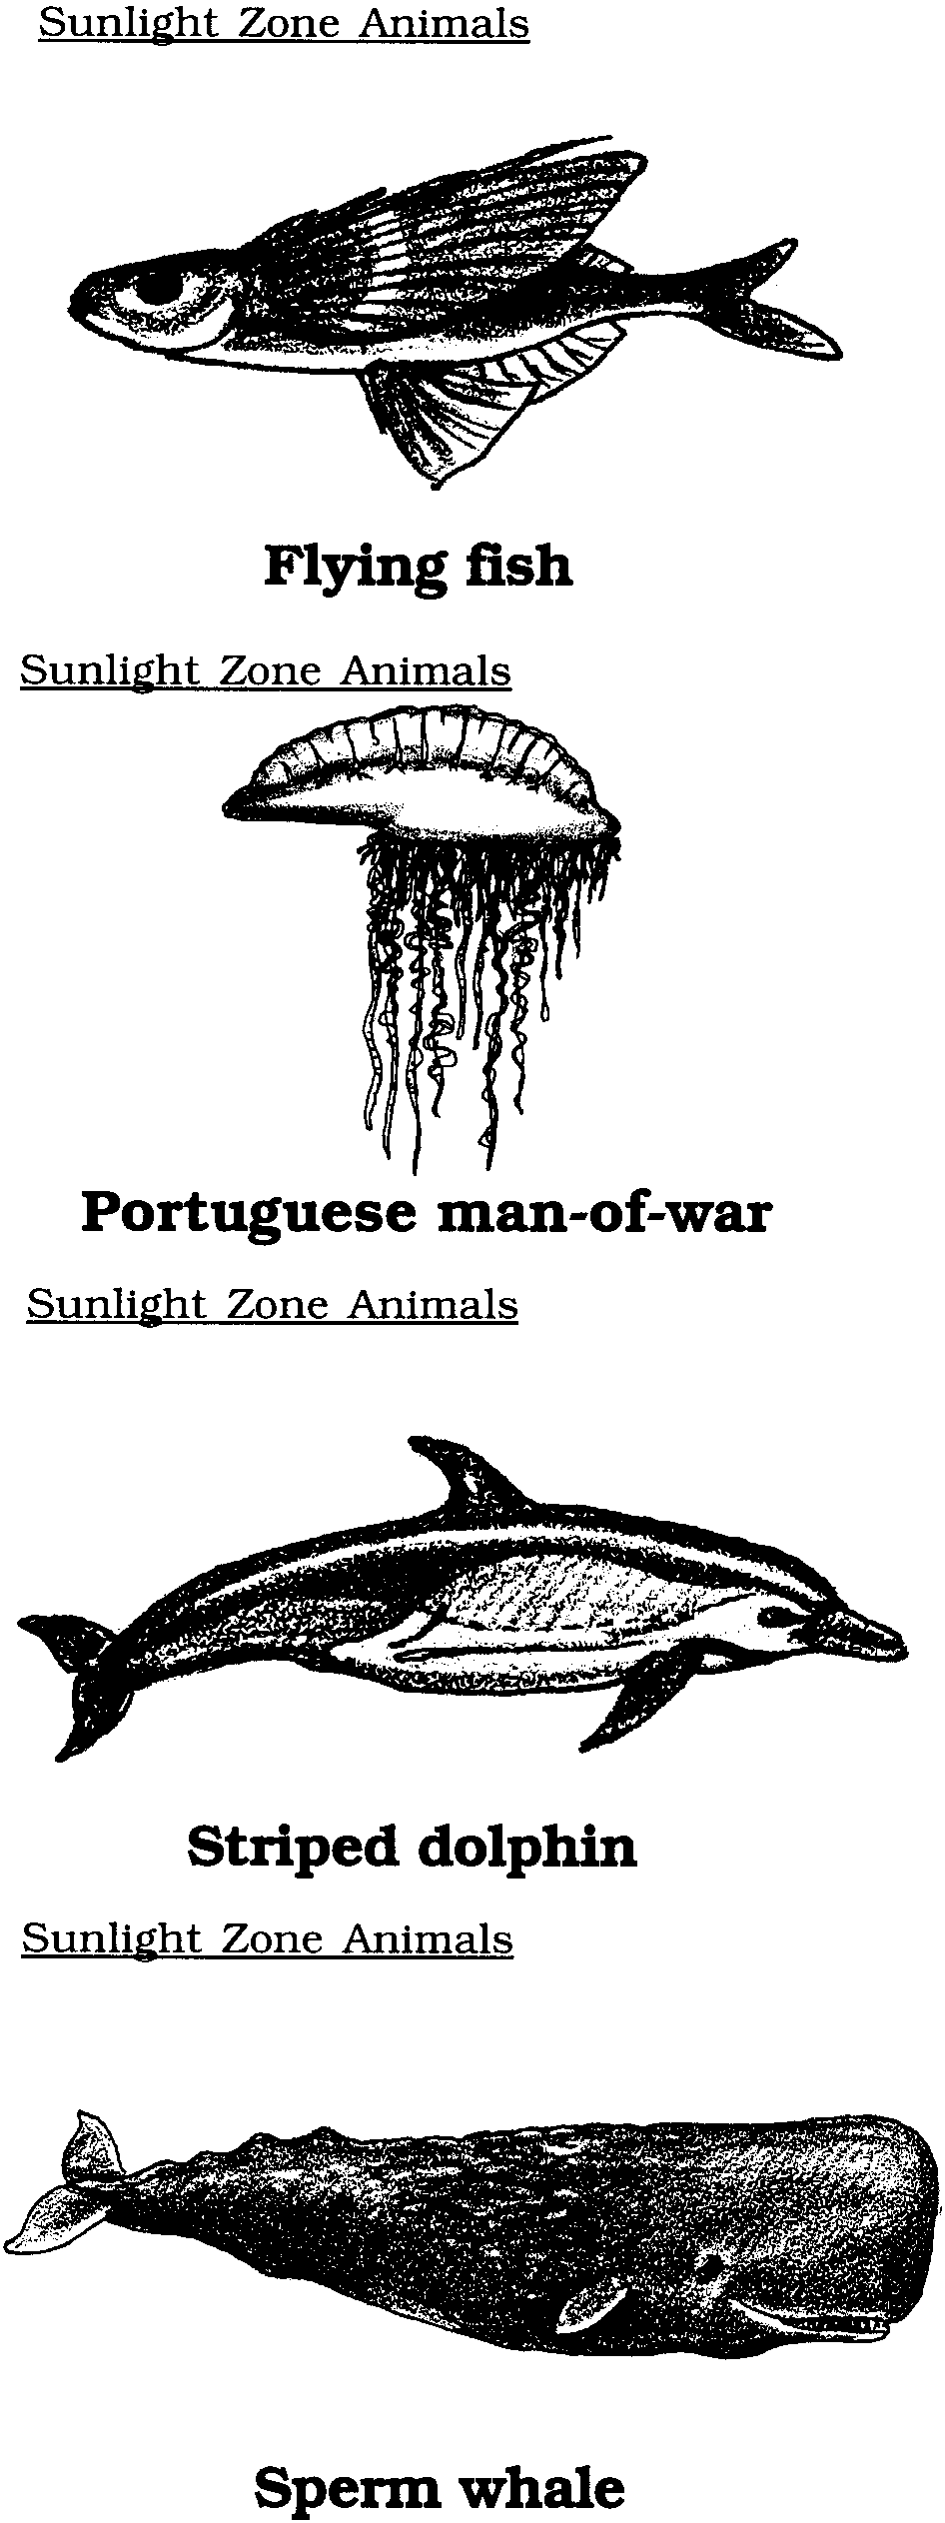
Zones of the Ocean Mural - Ocean Zones Student Information Cards
Flying fish
I am silver.
I only grow to be 9 inches long.
I weigh about 1 pound.

Portuguese man-of-war
My body is purple.
My tentacles are white.
I can be over 100 feet long.

Striped dolphin
My back is dark blue.
My belly is white.
I can be 8 feet long.
I eat small fish.

Sperm whale
I am gray or black.
I can be 56 feet long.
I may weigh 43 tons.
(86,000 pounds!)

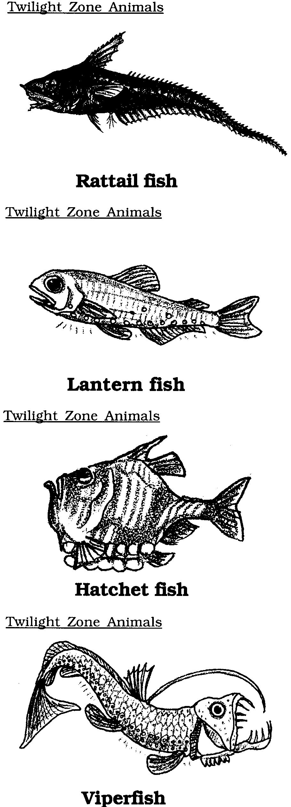
Zones of the Ocean Mural - Ocean Zones Student Information Cards
Rattail fish
I am gray.
I can be 2 1/2 feet long.
I eat lantern fish.

Lantern fish
I am brown or gray.
I am spackeled with many lights.
I only grow to be 2 to 3 inches long.
I weigh less than 1 pound.
I may weigh 500 pounds.

Hatchet fish
I am silver.
I have lights along my belly.
I only grow to be 3 to 4 inches long.
I weigh less than 1 pound.

Viperfish
I am black.
I have lights along each side.
I can be 10 inches long.

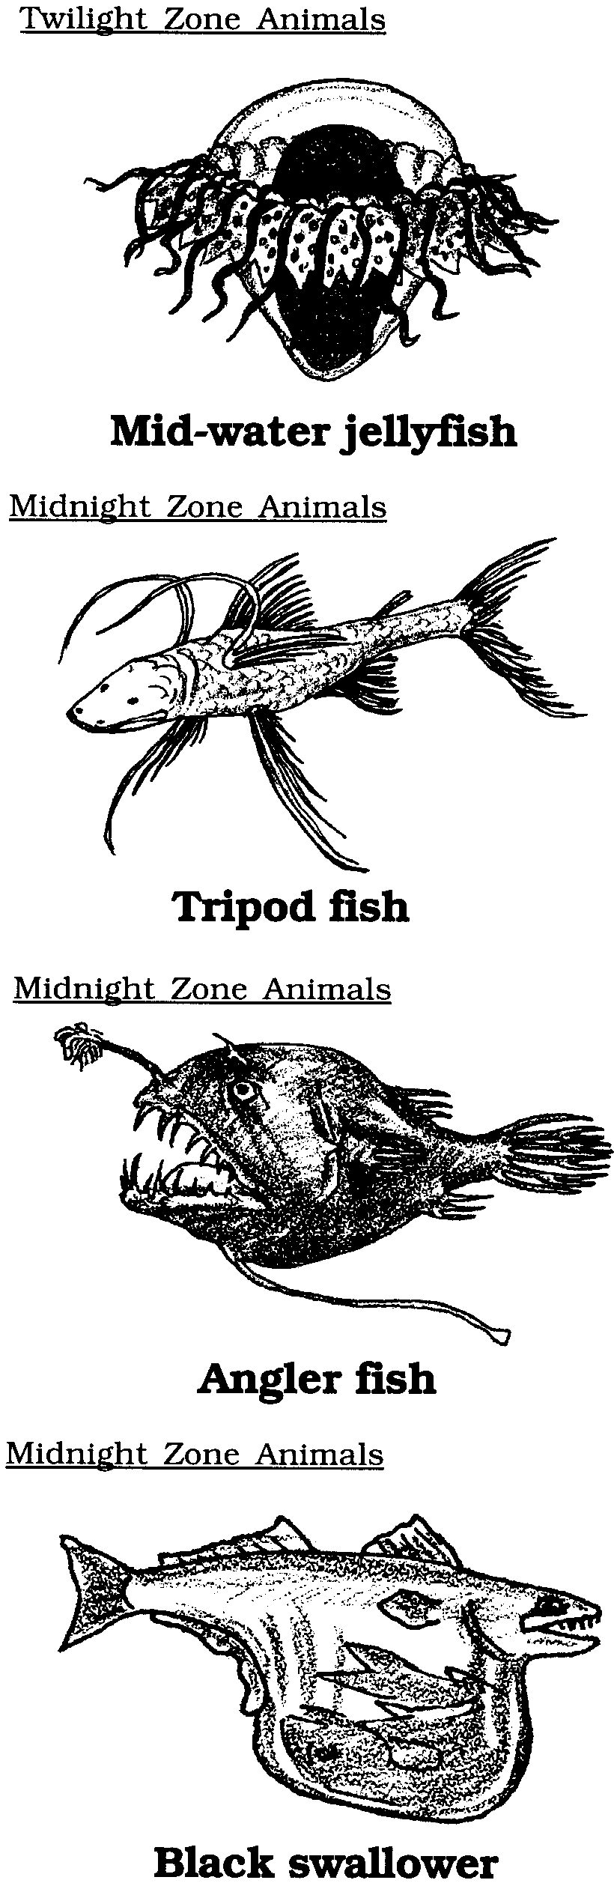
Zones of the Ocean Mural - Ocean Zones Student Information Cards
Mid-water jellyfish
I am maroon and white.
I grow to be 3 inches wide.

Tripod fish
I am dark brown.
I can be 12 inches long.
My fins hold me above the mud.

Angler fish
I am black.
I grow to be 3 to 6 inches long.
I weigh less than 1 pound.

Black swallower
I am black.
I can be 6 inches long.
I weigh less than 1 pound.

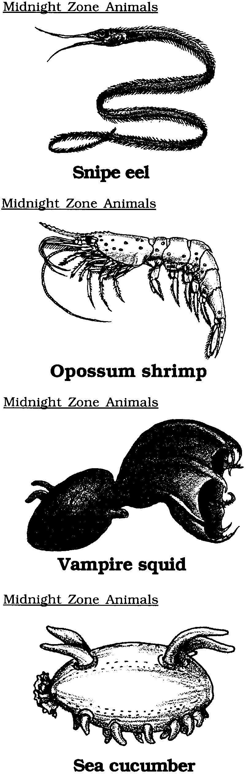
Zones of the Ocean Mural - Ocean Zones Student Information Cards
Snipe eel
I am brown.
I can be 4 1/2 feet long.
I eat plankton.

Opossum shrimp
I am red.
I can be 6 inches long.
I weigh less than 1 pound.

Vampire squid
I am black.
I am speckled with small lights.
I can be 8 inches long.
I weigh less than 1 pound.

Sea cucumber
I am dark violet.
I can be 12 inches long.
I weigh less than 1 pound.

