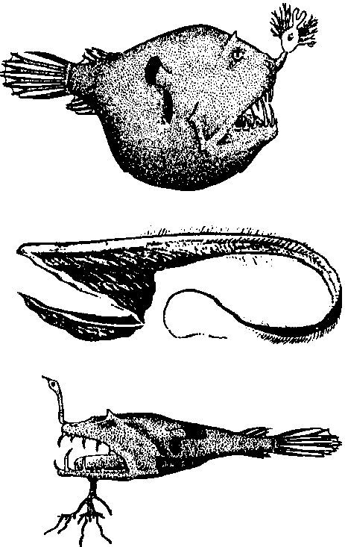
Creatures of the Deep Sea
Lesson by Laura Erickson, Poulsbo, WA

Key Concepts
1. Most of the water in the oceans could be characterized as the deep sea.
2. The creatures that live in the deep sea are adapted to the dark, pressure, cold, and scarcity of food in this environment.
3. Scientists use deep sea submersibles to explore the deep sea.

Background

For almost all of its vast extent, the deep sea is a very dark and cold environment. Just how deep is the “deep sea”? It is incredibly deep; the Mariana Trench is about 11,000 meters (about 36,000 feet) deep, 2000 meters deeper than Mount Everest is tall!

Although about half of the Earth’s surface lies 3,000 or more meters below water, the deep ocean is a fairly new area of study for scientists. In 1977, the ALVIN, a specially designed submersible, first entered this area of permanent darkness. ALVIN can dive to 4,000 meters (about 13,000 feet). For a point of reference, large submarines dive to about 1,000 meters (about 3,280 feet), while scuba divers have gone to a record depth of 133 meters (about 436 feet). For an idea of what these depths mean, consider this: The TITANIC is under about 4,000 meters of water. In order to explore the TITANIC, ALVIN had to descend for about two and a half hours!

The pressure of the water is so great at depths below 1,000 meters that it would crush a regular submarine. All of the animals that live in the deep sea must contend with these incredible pressures.

Beside being a “high pressure” environment, the deep sea is a very dark and very cold environment. (The deep sea thermal vents found along areas of extreme geologic activity are an exception to this statement with regard to temperature.)

Darkness poses real problems for life as we generally think about it. The depth at which light penetrates the ocean varies greatly. However, very little light reaches below 260 meters (about 853 feet) anywhere in the ocean. Recall that sunlight is the original source of energy for photosynthesis. Most of the life in the ocean, then, is ultimately dependent on sunlight. Phytoplankton and algae capture solar energy and then are food for zooplankton, fish and so many other animals of the sea.

It would seem, then, that because of the lack of light, there would be no organisms to begin food chains, no source of energy and no flow of nutrients. This is almost true, no plants live in the deep sea. Without sunlight for phytoplankton or seaweeds, it seemed there could be no life at all in the deep sea. Scientists long thought of these regions as dark and lifeless.

This made sense to everybody...except that every once in awhile, fishermen trawling for their catch or oceanographers on research vessels would dredge up bizarre fish from deep waters. What could these animals be eating?

The answer is found nearer the surface. When surface organisms die, their bodies decompose. The resulting decayed organic material, called detritus (dee-try-tus), sinks. One can see this falling detritus in videos filmed on submersibles exploring the deep sea. It looks so much like falling snow that biologists call it “marine snow”. Detritus is like “slightly used food”. There’s still some energy and some nutrients stored in that marine snow. The animals that live in the dark waters of the deep ocean make a living feeding on the marine snow.

Adapted to the dark, pressure, cold, and scarcity of food of the deep sea environment, many of these animals look as if they could be in a science-fiction movie. At first, people thought the strange appearances of the fish might be a result of bringing them to the surface; the fish never survived the drastic temperature and pressure changes of the trip up from the depths. Now, with the development of submersibles, biologists have visited these creatures in their own habitat and brought back footage of bizarre beings that inhabit the deep, dark, cold waters.

In particular, deep sea fish have caught our imagination. Though the deep sea fish tend to look fierce, most, but not all, are quite small. Their fierce appearance comes from adaptations that allow them to eat anything that comes their way in the sparsely populated waters. Many have sharp fang-like teeth to hold prey. Many have greatly expandable stomachs and jaws that unhinge to allow them to swallow prey larger than themselves. Some have photophores, pockets of bioluminescent bacteria, that they may use as fishing lures to attract prey close to their hungry mouths. For example, the lanternfish, which has rows of phosphorescent spots along its sides, looks like a miniature ocean liner with all its portholes illuminated.



Photophores may also function as identification tags so fish can find others of their species in order to reproduce. Special adaptations for reproduction must be important in an unlighted sea where fellow fish may be few and far between. The male anglerfish, for example, is much smaller than the female, and attaches to the female, literally feeding off her blood. In return, he provides sperm to fertilize her eggs.

The anglerfish also has a unique way of catching its prey. Attached to its head just above the mouth, an anglerfish has a thread-like line with a light at the end of it. The light dangles like a bit of shining bait. The anglerfish swims with its mouth open, ready to snap up any small fish that is attracted to the shining “bait”.

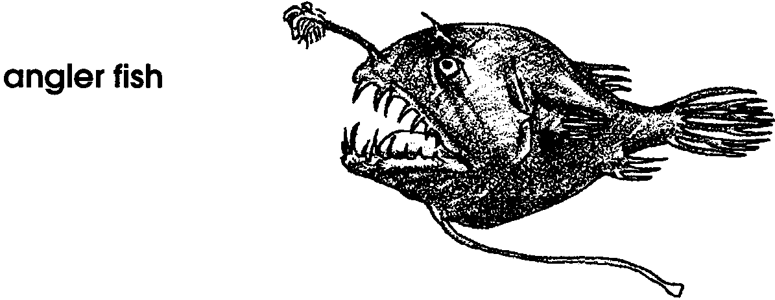

The scarcity of food makes energy conservation a high priority for deep sea fish. Since large fish require correspondingly large amounts of energy to survive, most of the fish are small. Also, most of the deep sea fish are passive hunters, waiting for a meal to swim by; active hunting consumes more energy.

While we have much to learn, our knowledge of deep sea life has been greatly expanded by the use of a variety of mechanical devices from bathyspheres to deep submersible vehicles like ALVIN. The depth range of the various underwater technologies is graphically shown on the following diagram.

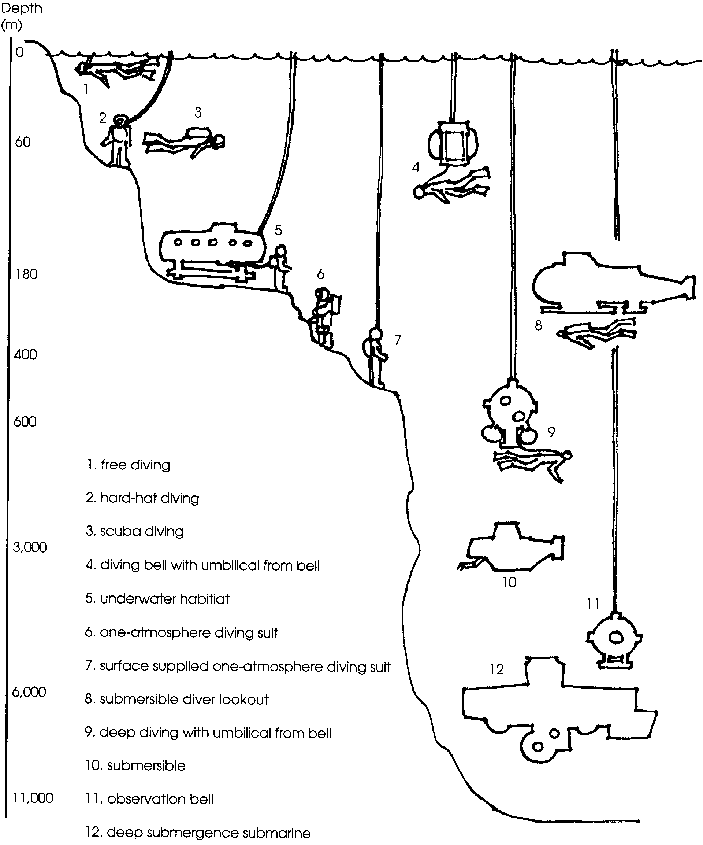

Materials

Part 1: Deep Sea Creature Adaptations

For the class:

• pictures of deep sea fish and other creatures

• scissors and construction paper

• non-toxic, glow-in-the-dark paint

Part 2: Making a Deep Sea Submersible

For the class:

• pictures or video footage of a deep sea submersible (see FOR SEA CD-ROM resources and A Day Under Water in the bibliography)

• pictures of deep sea fish and other creatures

• construction paper, clay, pens, markers, scissors, egg cartons, empty plastic eggs, etc., plus any other crafts materials that your students can use creatively

Teaching Hints

In “Creatures of the Deep”, students create models of deep sea fish and then construct a deep sea submersible to learn more about the adaptations found in animals living in the deepest parts of the world ocean.

Part 1: Deep Sea Creature Adaptations

In Part 1, students design and construct a deep sea fish, including the application of non-toxic glow-in-the-dark paint. Good resources for pictures of deep sea fish and other creatures include: Creatures That Glow, by Joanne Barkan, which provides glow-in-the-dark pictures of deep sea creatures; “Ranger Rick”, January, 1984; and the Monterey Bay Aquarium Education Department video collection, which has excellent footage of deep sea creatures (see bibliography for details).

Materials

For the class:

• pictures of deep sea fish and other creatures

• scissors and construction paper

• non-toxic, glow-in-the-dark paint

Procedure

1. Show students an assortment of pictures of deep sea fish and other creatures. As you do, discuss characteristics of these creatures, including their:

• pattern of lights (often used to attract food or mates)

• feeding adaptations (many of the fish have large mouths and large teeth; some can eat fish that are larger than themselves).

One of your students is bound to ask, “What makes these animals glow? Batteries?” Explain that inside the light producing organs (called photophores) of these animals, there is a concoction of chemicals. (Sometimes the chemicals are actually inside bioluminescent bacteria found within the light producing organs.) When the animal desires to “turn itself on” the chemicals and oxygen are mixed and a pulse of light results. The light, which is quite striking, varies in color from green to red and is referred to as “cold light”, since no heat is released in its production.

2. Give each student a sheet of paper and have each design a fish that would live in the deep sea. Encourage students to think about the characteristics you’ve discussed as a class. Caution students to be careful when they add light to their fish - too much light may make a fish easy prey to another fish. When students have designed their fish and decided where the fish should glow, have them apply non-toxic glow-in-the-dark paint to these areas.

3. Hang the deep sea fish from the ceiling in your classroom or display them around the room. If possible, darken the room and watch them glow. (The classroom will need to be very dark for best viewing of the glowing fish.) Discuss which fish are easiest to see and why that may be the case.

4. Have students write a story about their fish living in the deep sea. Encourage them to address:

What would your fish see?

What would your fish spend its time doing?

How would your fish feel to be in total darkness except for the occasional light of another fish?

Part 2: Making a Deep Sea Submersible

In Part 2, students build a model of a deep sea submersible to learn more about the adaptations found in animals living in the deepest parts of the world ocean.

Materials

For the class

• pictures or video footage of a deep sea submersible (see FOR SEA CD-ROM resources and A Day Under Water in the bibliography)

• pictures of deep sea fish and other creatures

• construction paper, clay, pens, markers, scissors, egg cartons, empty plastic eggs, etc., plus any other craft materials that your students can use creatively

Procedure

1. Show pictures or video footage of a deep sea submersible, like ALVIN. Talk about what it would be like to go down in a deep sea submersible to explore a ship wreck, such as that of the TITANIC. Ask students,

What would a submersible need to be able to go deep into the ocean?

Help the class list that a submersible would need to be...

• strong to withstand the pressure of the water. (ALVIN is made out of two inch thick titanium, a metal as strong as steel, but lighter. It is also sphere-shaped so that the pressure squeezes equally from all directions.)

• heavy so that it would sink, but light enough to come back up to the surface. (ALVIN carries steel weights so that it will sink, and then leaves them at the bottom of the sea so that it will float to the surface.)

• able to move. (ALVIN has propellers to move it forward at about three to five miles per hour.)

• able to light up an area for study. There is no sunlight in the deep sea. (ALVIN has a number of lights. It also uses sonar and other equipment to “see” bottom features.)

• able to pick up animals and rocks. (ALVIN has two mechanical arms that can each lift 100 pounds. These arms are used to pick up specimens and to explore the deep sea habitat.)
• able to hold passengers. (ALVIN is able to take two scientists and one pilot. There is not much room. All three people sit in a very cramped area with three small portholes for viewing. ALVIN has a bright red hatch where her passengers climb aboard for their deep sea voyage.)

• able to take pictures. (ALVIN has a number of cameras on board. At a cost of $12,000, or more, per dive, recording the trip for further study is important.)

2. Challenge students to build a model of a deep sea submersible. You may elect to have students work in groups or individually. Encourage creativity. One way to begin this project is by having students create a drawing of their model submersible, labelling the parts and making lists of materials they will need to complete the project.

3. When completed, have students present their models to the class, telling about the important features of the submersible.

4. Compare the models the students made with deep sea fish. Ask questions such as:

What are the similarities?

How does your submersible move? How does the fish move?

How does your submersible find its way around? How does the fish?

Key Words

ALVIN - a submersible used to explore the deep sea; home port is Woods Hole, Massachusetts

bioluminescence - the emission of light from living organisms

submersible - a specially designed submarine for deep sea explorations

Deep Sea Creature Picture Cards

The Deep Sea Picture Cards provide drawings and descriptions of assorted deep sea animals which may be used to augment, or in lieu of, other resources. You may wish to make transparencies of these cards for use in the class discussion in Part 1. The Deep Sea Picture Cards can be found in the Resource File for this lesson.

