Deep in the Ocean, the Pressure's On
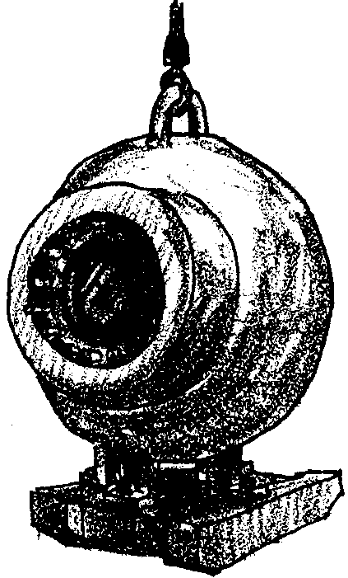
Edited by Jan Bieber, Federal Way, WA and
Laurie Dumdie & Laura Erickson, Poulsbo, WA

Key Concepts
1. Pressure is caused by anything that has mass.
2. The great depths of the ocean combined with the substantial mass of water causes tremendous pressures on the bottom of the deep ocean.

Background

The great depths of the ocean, combined with the substantial weight of water, causes tremendous pressures on the bottom of the deep ocean. Just what is pressure?

Pressure is caused by anything that has mass. Even ordinary air, the atmosphere that surrounds the earth, has mass. Mass is the stuff of things that never changes. Consider this, if you put yourself on a balance and someone put weights on the other side of the balance, we would be finding out how much mass you measured. (Remember, on a balance we try to equal both sides.) You may be thinking that this sounds like measuring weight. Well, yes. But, no, it isn’t.

If you travel in outer space, your mass (the stuff you are made of), stays the same, but we know your weight changes considerably! So, what is weight? Let’s say we attached a freshly caught salmon to a hand scale and the pointer went to 32 pounds. Nice size salmon! To understand the concept of weight, consider what is going on inside the hand scale. If we were to pry the scale open to see what was happening inside, we would find a spring with a pointer attached to it. The salmon is pulling the spring down. Gravity is pulling the fish down! So weight is really referring to the measured pull of gravity on mass. If you are unaccustomed to using the term mass, take a look at a physical science book, any elementary school text will be just fine. Review some of the activities that you might do with your students using balances and hand scales.

If you could cut out a square inch column of the earth’s atmosphere and put it on a scale, you would discover that it would measure 15 pounds. If you were to put it on a balance, it would also measure 15 pounds. At sea level, mass and weight are the same.

This also means that at sea level a mass of almost 15 pounds is pressing against every square inch of your body all the time. You don’t feel this pressure because the air in your lungs, and in the other hollow parts of your body and the fluid in your cells, has the same pressure as the atmosphere.

But water pressure is greater than air pressure. If you dive under only five or six feet of water, you can easily feel its mass pressing against your ears. The deeper you go, the greater the pressure becomes. Under 200 feet of water, the pressure on your body would be about 100 pounds for every square inch. In the great depths of the ocean, pressures over one ton per square inch of surface area are not uncommon. These pressures make life on the ocean bottom difficult. In fact, until about 100 years ago, scientists thought that no life existed in the deepest parts of the ocean. The British Challenger expedition showed the fallacy of this theory.

Animals that live in the great depths have evolved special adaptations to deal with the great pressure of this environment. The fish and other organisms that live at the depths of the ocean are not at all bothered by the pressure. This is because the water which fills every body cavity and the water solution which fills every cell, exert the same pressure as the water in which the animal lives; the pressure inside their bodies is equal to the pressure on the outside. As long as the pressures remain the same, the animals are in no danger.

Materials

Part 1: Milk Carton Experiment

For each student or team of 2:

• empty milk carton or plastic jug (quart or half-gallon)

• a compass point, craft needle or similar sharp object

• ruler (metric)

• masking tape (about 12 inches)

• water

• sink or large container to collect water, unless done outside

• “Deep in the Ocean” student activity sheets (optional)

Part 2: Pile Them On

For the class:

• 3 student volunteers

Part 3: Pressure Bag

For the class:

• large garbage can filled with water

• large garbage bag
Teaching Hints

In “Deep In the Ocean, the Pressure’s On”, students conduct experiments with water in a milk container to understand the increase of pressure with depth in the ocean. Next, a pile of students is created to simulate the increased pressure on animals as the water gets deeper. In the last experiment, students use a garbage can and liner to feel the increase in pressure with depth.

Part 1: Milk Carton Experiment

In Part 1, students use a milk container to conduct experiments to help them understand the relationship between pressure and depth in the ocean. Two approaches to these activities are provided. Stepwise instructions are provided in the “Procedures” section below which allow you to direct the progress. Alternatively, the “Deep in the Ocean” student activity pages provide similar instructions should you choose to have students read and complete the instructions themselves. Consider the capabilities and dynamics of your class and choose accordingly.

Materials

For each student or team of 2:

• empty milk carton or plastic jug (quart or half-gallon)

• pencil

• a compass point, craft needle or similar sharp object

• ruler (metric)

• masking tape (about 12 inches)

• water

• sink or large container to collect water, unless done outside

• “Deep in the Ocean” student activity sheets (optional)

Preparation

1. Since water will be flowing from the milk cartons, this experiment has the potential for being a bit messy. You can eliminate most of these concerns by doing this experiment on the playground. Otherwise, have a good supply of paper toweling on hand.

2. The holes in the milk carton should be uniform in size. The compass point is suggested because it makes a hole with a diameter which offers little interference to the water flow. Any sharp-pointed object that meets these criteria will work. Large craft needles work well. If you plan to use the same carton over and over, it is best to use a plastic jug, since the holes maintain their shape better than in a paper carton.
Procedure
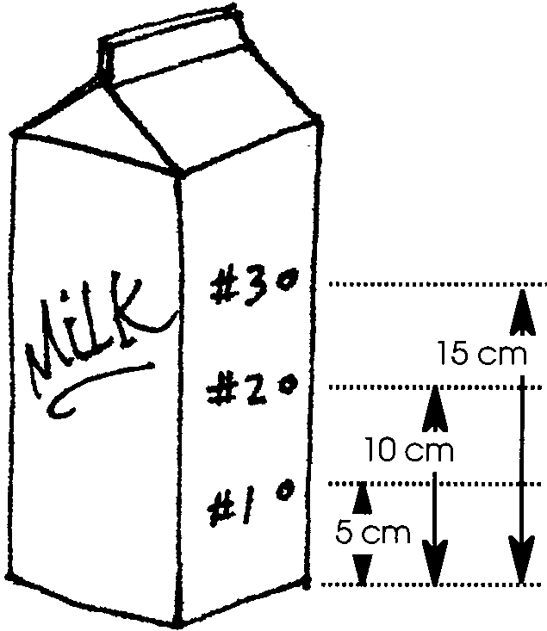
1. Have students use a ruler and pencil to draw a vertical line in the middle of one of the sides of a milk carton. Have them mark three places on this line:

• first mark at 5 centimeters from the bottom

• second mark at 10 centimeters from the bottom

• third mark at 15 centimeters from the bottom.

2. Have students use the compass point or similar sharp object to punch a hole at each of the three marks.

3. Explain that the milk carton will be filled with water. Ask students to predict what will happen when the carton is filled with water. You might have them draw a picture to show how they predict the water will flow out of the holes.

4. Have them place a strip of masking tape over the holes in the carton and fill the carton with water.

5. Be sure that students are in a place where the water can flow freely out of the carton, either onto the ground or into a sink or other container. Give them a signal to rip the tape off the holes to observe how the water flows out of the carton. Ask students questions like:

Does the water come out of all the holes?

Out of which hole does the water squirt out the farthest?

Out of which hole does the water squirt out the closest to the carton?

6. Discuss results and observations with students. You may wish to have students draw the results of their experiment and compare the results to their predictions. Explain that the water squirts out because it is pushed. The water above pushes on the water below. Ask,

Which hole had the most water above it?

What can be said about the water coming from the bottom hole?

Explain that the water at the bottom has the most pressure. Pressure pushes down on the carton bottom too. It also pushes down on things that live on the ocean bottom. In the deep ocean, pressure is great. A fish has more than the weight of a car pushing on each square inch of its body.

Part 2: Pile Them On

In Part 2, a pile of students is created to simulate the increased pressure on animals as the water gets deeper.

Materials

• 3 student volunteers

Procedure

1. Select three students from the class.

2. Ask the first student to lay on the floor, face down.

3. The second student will carefully lay on top of the first student.

4. The third student will lay on top of the second student.

5. Ask questions like:
What does it feel like to be the first student?
To which hole in the milk carton does he/she compare?
What does it feel like to be the second student?
To which hole in the milk carton does he/she compare?
What does the top student feel?
To which hole in the milk carton does he/she compare?

Explain that this is similar to what a diving fish feels. The deeper the fish dives, the greater or “heavier” the pressure upon its body. Many fish and other organisms live under great pressure.

Part 3: Pressure Bag

In Part 3, students use a garbage can and liner to feel the increase in pressure with depth.

Materials

For the class:

• large garbage can filled with water

• large garbage bag
Preparation

1. Have students help fill up an empty classroom garbage can with water. This is best done outside.

Procedure

1. One at a time, have students place their arm inside a big garbage bag and place their covered arm in the filled garbage can. Hold on to the top of the bag so that no water gets into the bag.

2. Have students describe the pressure they feel. It is amazing how even in this small amount of water one can feel a difference in pressure.

Key Words

adaptation - any alteration in the structure or function of an organism or any of its parts that results from natural selection and by which the organism becomes better fitted to survive and multiply in its environment

mass - a measure of the quantity of matter a body contains

pressure - the exertion of force upon a surface by an object, fluid, etc., in contact with it; force per unit area

square inch - a unit of area measurement equal to a square measuring one inch on each side

weight - the force with which a body is attracted to the earth or some other field of gravitation; equal to the mass of the body times the local acceleration of gravity; commonly taken as a measure of mass when considering a body in a region of constant gravitational acceleration

Answer Key

“Deep In the Ocean” student activity sheets

4. a. Yes, the water falls out of all the holes.

b. The water from the bottom hole should squirt out the farthest.

c. The water from the top hole should squirt out the least or shortest distance.

d. The bottom hole (#1) has the most water above it.

e. Student diagram illustrates results.

f. Answers will vary depending upon student predictions.

Deep In the Ocean, the Pressure's On
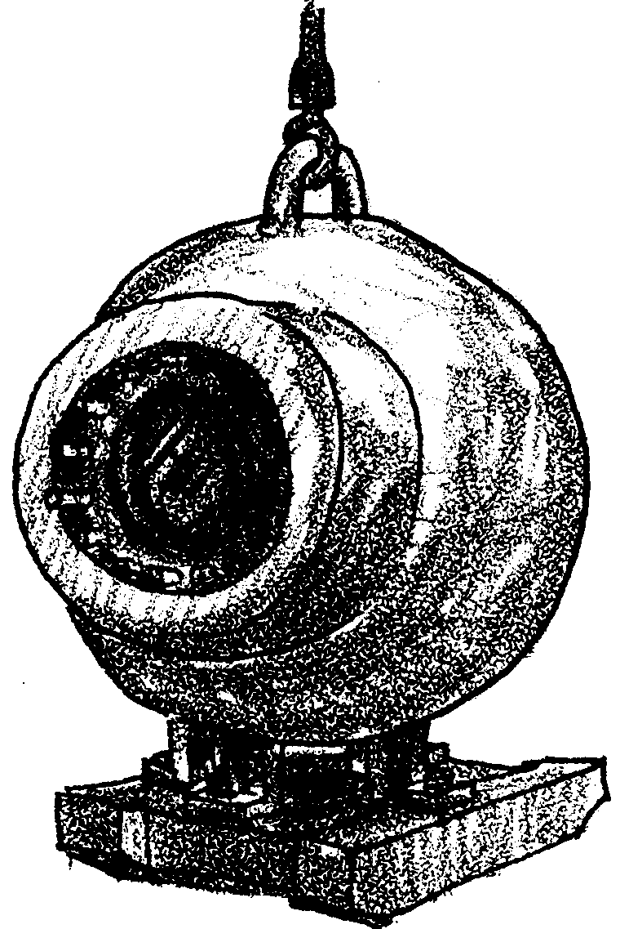

How does it feel on the ocean bottom? Let’s see what we can learn.

Materials:
empty milk carton
pencil
compass point
ruler
masking tape
water
sink or wash tray
Procedure:

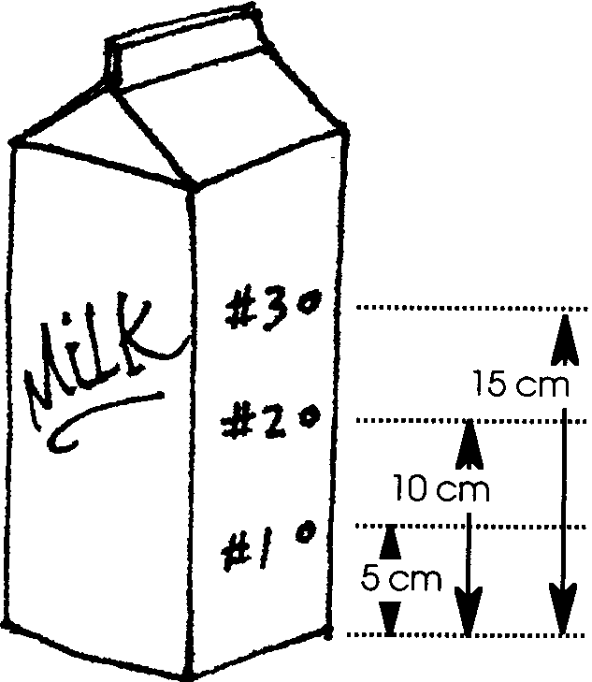
1. Use your ruler and pencil. Make a straight line down one side. Measure three places on the side of the carton. Make the first mark at 5 centimeters from the bottom. Make a second mark at 10 centimeters from the bottom. Make the third mark at 15 centimeters from the bottom.

2. Poke a hole at each of the marks you made. Use the compass point. Make the holes all the same size. Be careful to keep the holes in a straight line. Use a pencil to number each hole like the picture.
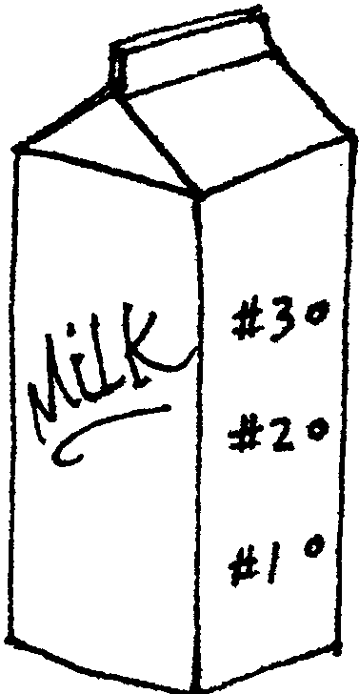
3. What do you think will happen when the carton is filled with water? Draw a picture to show how you predict the water will flow out of the holes.

4. Place a strip of tape over the holes.

5. Put the carton in the wash tray. Fill the carton with water. Remove the tape. Watch the water.

a. Does the water come out of all the holes? .

b. Which water squirts out the farthest? .

c. Which water squirts out the least? .

Water squirts out because it is pushed. The water above pushes the water below.

d. Which hole has the most water above it? .

e. Draw a picture of your milk carton. Show how far out the water squirted at each hole.

f. How did the experiment compare with your prediction?
.

We say the water at the bottom has the most pressure. Pressure pushes down on the carton bottom too. It also pushes down on things that live on the ocean bottom. In the deep ocean, pressure is great. A fish has more than the weight of a car pushing on each square inch of its body.

