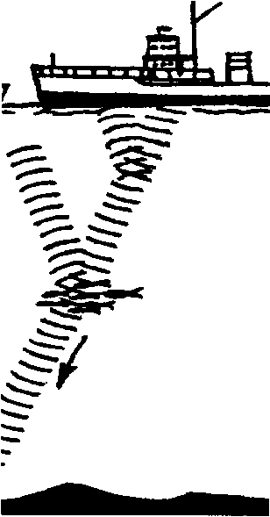
Exploring the Sea Floor
Lesson by Pat Williams, Eugene, OR
and Laura Erickson, Poulsbo, WA

Key Concept
1. The sea floor has forms similar to those found on the land.

Background

While humans have been traversing the surface of the ocean for thousands of years, it has only been within the last half century that we have been able to say with any reasonable certainty how the bottom of the ocean looks. After World War II, echo-sounding and sonar equipment became more widely available to oceanographers. These devices were a vast improvement over mechanical sounding with a lead line, a technique which had changed little from the time the first sailor dropped a marked and weighted rope over the side of his boat. Modern depth sounding tools have permitted us to map the bottom with considerable ease and accuracy.

So, just what do we know about the ocean depths? The ocean floor has shapes much like the land above water. The ocean floor has mountains, valleys, deserts, hills, volcanoes, and plains, all covered with water, sometimes to a depth of several miles.
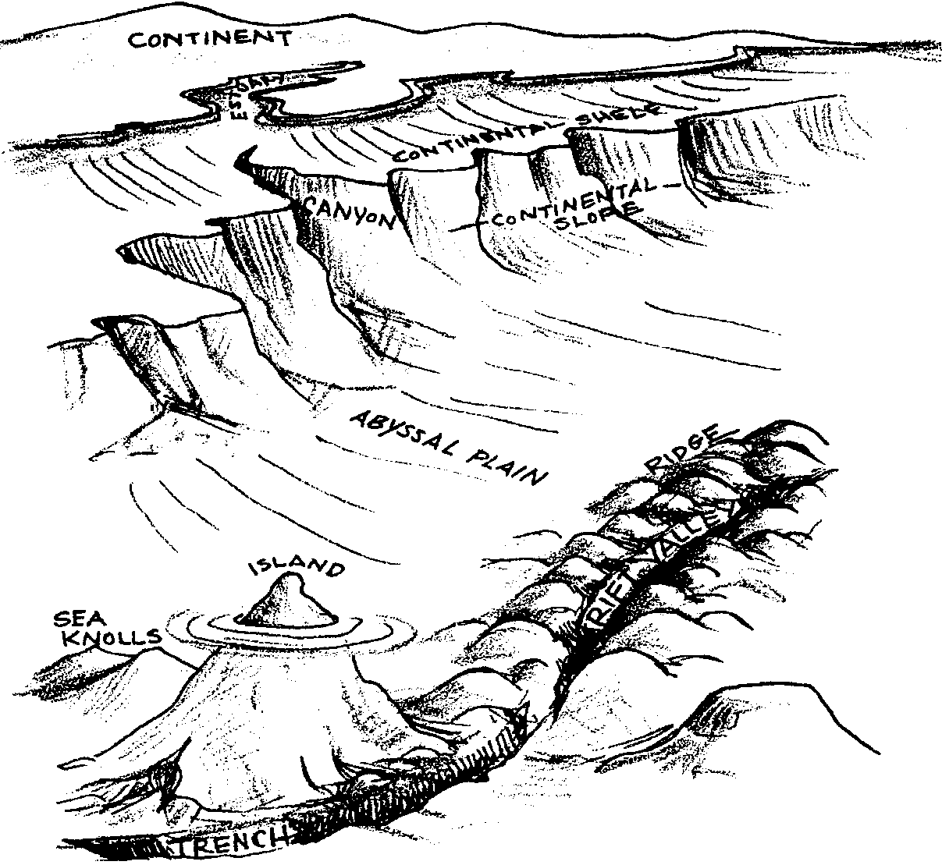

Starting at the edge of land and moving to deeper water, scientists recognize several distinct underwater regions. First, the continental shelf, where the ocean meets the continents, is a gentle sloping of land out into the ocean. It is rich in sediments. The shelf area is where most upwelling occurs. Rising currents along the shelf bring nutrients from the depths of the ocean into upper regions of the ocean and provide the basis for the food chain. Because the upwelling occurs in the shelf area, most of the ocean’s plant and animal life is concentrated in this area.

The change from the continental shelf to the deep ocean floor begins with an area called the continental slope. The slope is a region of abrupt drop and change in depth. Some of the slope has canyons and gorges. Some of the canyons are bigger and deeper than the Grand Canyon. Sediments which roll down the slope accumulate and create hill-like rises on the ocean floor. This area of the ocean floor is called the continental rise.

The continental rise leads to the area of the ocean floor known as the abyssal plain. This is a wide, gently rolling plain which covers more than 60% of the sea floor. The ocean here is generally dark and cold, and the sea floor is covered with a thick sediment of fine shell remains, residue from dead plants and animals, and sediments that have run off the land.

The general flatness of the ocean plains are sometimes broken by abyssal hills and seamounts. Abyssal hills are less than 3,300 feet high, while the taller seamounts are steep-sided volcanoes; sometimes piercing the surface of the ocean to form islands. For example, the Hawaiian Islands are the tops of seamounts. In fact, the highest mountain on earth (measured from its base to its top) is Mauna Kea, whose top is 33,000 feet above the ocean floor.

The mid-ocean ridge and rise systems are a series of great continuous underwater volcanic mountain ranges, running through every ocean. If the slopes of these ranges are steep, they are ridges and if the slopes are gentle they are called rises. The longest mountain range on earth is the Mid-Atlantic Ridge, which is approximately 10,000 miles long.

The plains can also be intersected by trenches. The deepest spots on earth are the trenches. The Marianas Trench, located in the Pacific Ocean east of the Philippines, is the deepest spot on earth. There the ocean floor is about 6 miles below the surface.

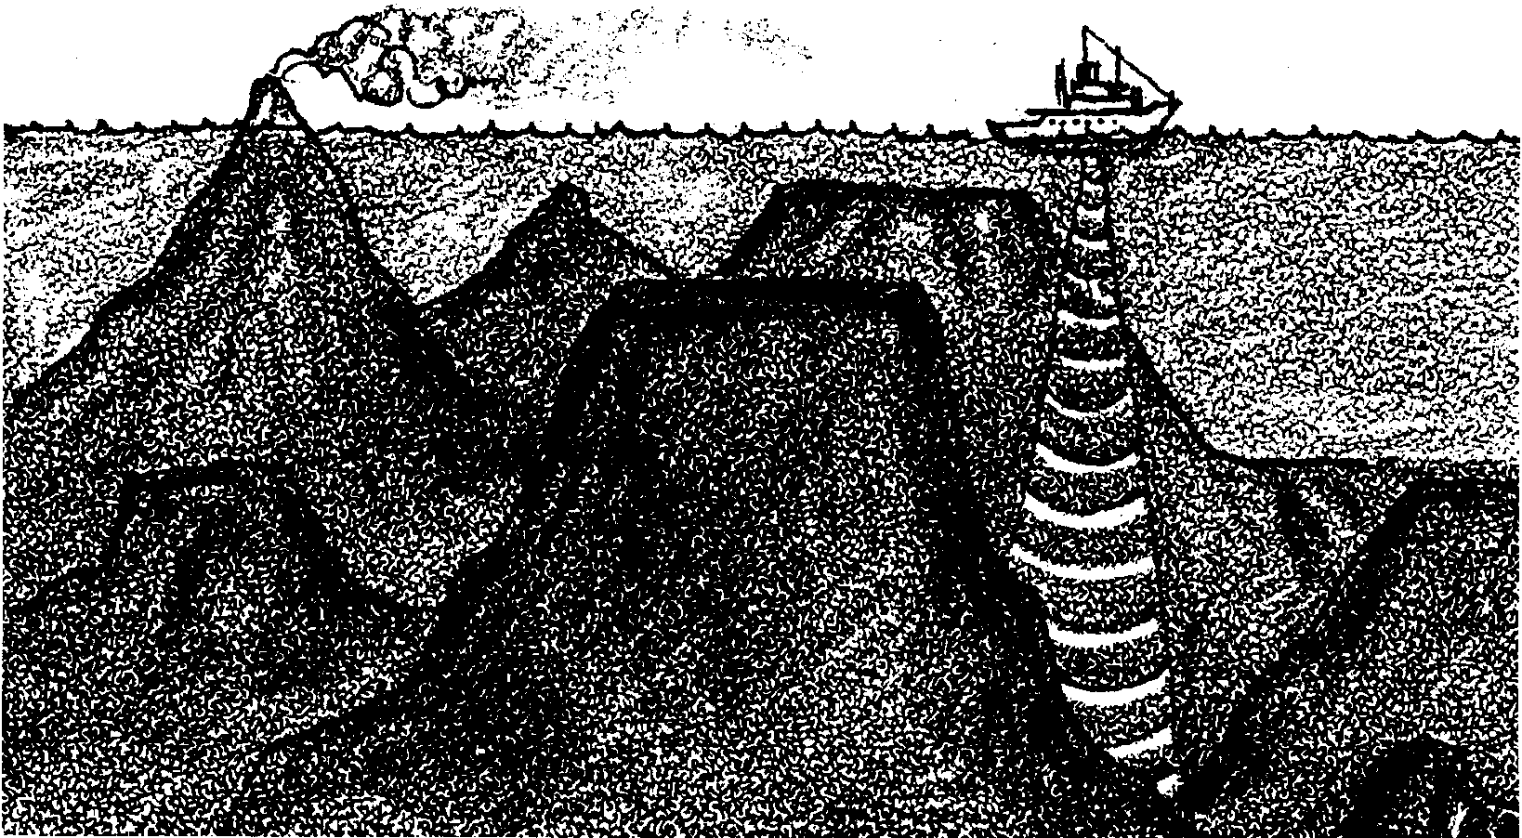
Of course, all of this topography is hidden from our view, covered by a layer of water. Because of the great depths, oceanographers cannot see the bottom where they are working. Instead, they have determined the shape of the ocean floor by measuring the depth of the water. They have had to sense the bottom by “feel”, first by using a marked and weighted rope or line, then by using a technique called “echo sounding”. Echo sounders are sonar devices on a ship’s hull that send out regular and frequent sound pulses. These pulses travel through the water, bounce off the ocean bottom, and return to the surface where they’re picked up by underwater microphones.

Computers then calculate water depth by measuring the time it takes for the sound to return. Scientists are able to tell different landmarks by the depth of water. Today, satellites are providing additional tools such as radar and digital imaging to provide increasingly detailed maps of the ocean floor.

Materials

Part 1: Making the Ocean Floor Model

For the class:

• the book, The Magic Schoolbus on the Ocean Floor (see bibliography)

• water to fill students’ models (tinted very light blue with food coloring)

• overhead transparency, “On the Ocean Floor”

For each pair of students:

• rectangular plastic or metal pan (about the size of a shoe box, clear plastic is ideal)

• oil-based clay (use clay that will NOT fall apart in water)

• construction paper flags (for labelling)

• toothpicks
Part 2: Soundings of An Ocean Floor Model

For the class:

• large clear plastic tub

• misc. waterproof materials and objects

• water

• heavy string with a weight on the end

• newspaper or plastic to cover tables

Teaching Hints

In “Exploring the Sea Floor”, students build models of the landforms at the bottom of the ocean, gaining a sense of the many mountains, valleys, plains, and volcanoes to be found there. The models are created in a pan and then filled with blue water to simulate the ocean that covers the sea floor. A technique for taking “soundings” (measuring the depths) of their sea floor follows.

Part 1: Making the Ocean Floor Model

In Part 1, students use waterproof clay to create models of the ocean floor.

Materials

For the class:

• the book, The Magic Schoolbus on the Ocean Floor (see bibliography)

• water to fill students’ models (tinted very light blue with food coloring)

• overhead transparency, “On the Ocean Floor”

For each pair of students:

• rectangular plastic or metal pan (about the size of a shoe box, clear plastic is ideal)

• oil-based clay (use clay that will NOT fall apart in water)

• construction paper flags (for labelling)

• toothpicks

Procedure

1. If available, read the book, The Magic Schoolbus on the Ocean Floor, for a fun and motivating introduction to concepts presented in this lesson.

2. Display the “On the Ocean Floor” transparency and briefly discuss the labelled features, using the information in the Background section above as a guide. To reinforce the ideas presented, you may wish to “build” a model of the ocean floor by providing a group of students with signs labelled with the various ocean floor features and then having the rest of the class help you to correctly arrange the students in order of increasing depth.
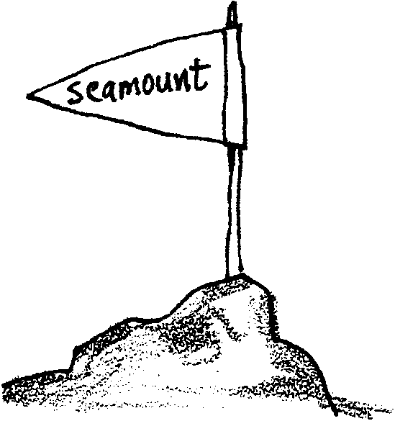
3. Have students use OIL-BASED clay to build a model of the ocean floor in a pan. Include some of the features discussed. You may choose to have students label some of the features with construction paper flags mounted on toothpicks.

4. Have students fill their model with blue water to simulate the ocean that covers the sea floor.

Part 2: Soundings of An Ocean Floor Model

In Part 2, students measure the depth of a model sea floor by taking “soundings”. This is a fun, wet activity that shows how oceanographers have been studying the sea floor for a long time.

Materials

For the class:

• large clear plastic tub

• misc. waterproof materials and objects

• water

• heavy string with a weight on the end

• newspaper or plastic to cover tables

Procedure

1. Have students collect waterproof objects that could form the bottom of a model ocean. Use rocks, bowls, cups, etc. A one liter soda bottle filled with water works well to demonstrate an island. Place these objects inside a large clear plastic tub. Fill the tub with water. Be sure that everything in the tub sinks or is anchored down so that you do not have a floating ocean bottom.

2. Have the students look at the model through the sides of the tub. They will see different heights and depths of the sea floor.

3. Students may wish to take “soundings” of their sea floor. Demonstrate this by tying a weight to the end of a string. Mark the string every 5 cm. with a permanent marker. Have a student lower the string into the water until she feels it touch bottom. She should then grasp the string at the mark just above the water surface and lift the string back out of the water. She then counts the marks from the weight to her hand to determine how many centimeters of water covered the ocean floor at the location sampled.

Key Words

abyssal plain - flat floor of the ocean basin extending seaward from the base of the continental slope and continental rise

bathymetry - the measurement of the depths of oceans, seas, or other large bodies of water

continental rise - gentle slope formed by sediments deposited at the base of a continental slope

continental shelf - the zone bordering a continent; from the line of permanent immersion to the depth where there is a steep descent

continental slope - the steep downward slope from the continental shelf break to depth

hydrography - the science of the measurement, description, and mapping of the surface waters of the earth

mid-ocean ridges - long, narrow elevations of the ocean floor

seamount - volcanic peak that rises at least 1000 m. from the ocean floor

trench - long, deep, steep sided, depression of the ocean floor

Extensions

1. Lead a visualization of the ocean floor. Here’s how. Have the children close their eyes. Suggest they imagine themselves in scuba gear walking down the beach, into the ocean, down the continental shelf (looking up to see all the fish), stopping at the edge of the continental slope and looking down the cliff, carefully working themselves down (whew!), over the rise, etc.

2. Have pairs of children take turns leading each other on a trip over the ocean floor.

3. Read the book, A Hole in the Ocean, by Jasper Tomkins (see bibliography).

4. Have students draw fish shapes on bright construction paper. Each student should make two. One pattern should be much larger than the other. On the large fish shape have students write their own “fish tales” about visiting the bottom of the ocean. On the smaller shape have students print a title for their story. Display the story fish on a bulletin board, keeping the title fish in an envelope attached to the board. Challenge students to match the stories with their titles.
On the Sea Floor - overhead transparency
