If Humans Lived in the Sea
Lesson by Pat Rutowski, Monterey, CA

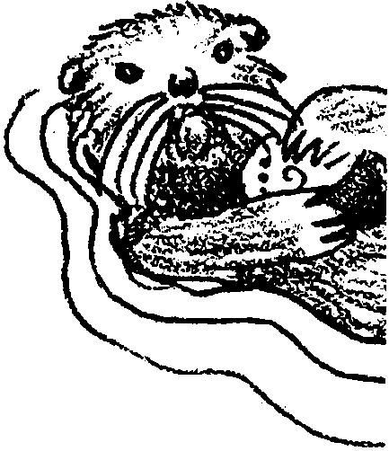
Key Concepts
1. Mammals are warm-blooded animals that usually have hair and that give birth to live babies who are fed with mother’s milk.
2. Marine mammals have special adaptations that allow them to live in the ocean.

Background

In many ways, the often harsh and changeable marine environment seems like an inhospitable place for warm-blooded mammals. Yet we see over 100 different species of marine mammals distributed throughout the oceans. Many marine mammals must cope with cold water temperatures. All must cope with finding food (and each other!) in the vast watery reaches. Each group of marine mammals has its own unique set of physical and behavioral adaptations which allows it to survive in the dynamic marine environment.

The range of adaptations seen in marine mammals is more fully discussed in the Background sections for the preceding activities, “Sea Otter Style”, “Who Are Those Pinnipeds?”, “Whales Are Mammals”, “Whale Adaptations”, and “Oceans as Whale Habitat”.

Materials

For the class:

• pictures of marine mammals for reference and discussion

• large, uncarpeted area to complete the art project

For each pair of students:

• construction paper

• pencils, markers and crayons

• masking tape, scotch tape and glue

• scissors

• selection of other construction materials including tissue paper, fake fur, etc.

For each student:

• 5 foot length of butcher paper
Teaching Hints

In “If Humans Lived in the Sea”, students use drawings and their imaginations to determine the physical adaptations they would need to survive in the sea. Then, they make self-portraits of themselves as ocean animals.

Procedure

1. Ask students to list what adaptations humans would need to live in the sea. Show them pictures of other animals that live in the sea, particularly marine mammals. The list might start like this:

• flippers or fins

• fur

• tail

• a special way to breathe - blowholes of whales, gills of fish, snorkels of human divers

2. Have students work with a partner. Give each person a large piece of butcher paper. The team will also need a pencil.

3. Take students to the site where the project will be done, or assign them a place on the floor in the classroom. Tape one of the pieces of paper from each team onto the floor.

4. Have one member of each pair take his or her shoes off and lay down on the paper while the other draws around his/her body with a pencil, being careful not to poke through the paper.

5. Change the paper and the student, and repeat steps 3 and 4.

6. Each student will use the outline of his or her body to “turn themselves into marine mammals”. Have students use crayons, construction paper and other materials to add fur, flippers, a tail or anything else they feel they might need to live in the ocean. You may choose to label these transformed humans, merpeople.

7.Have students discuss what it would be like to live in the sea as merpeople. Ask questions like:
What dangers would you face?
Where would you live?
What would be your favorite place to visit?
8. Compare the merpeople to marine mammals. Ask questions like:
What do they have in common?
What is different?

Key Word

marine mammals - mammals that have adapted to life in the ocean

Extensions

l. Read the book, The Mer-Child: A Legend for Children and Other Adults (see bibliography).

2. Ask students to write stories about what it would be like to live in the sea as a merchild.

3. Create a wall mural ocean environment in which to display your “merpeople” ocean portraits.

