The Oceans as Whale Habitat
Lesson by Pat Williams, Eugene, OR
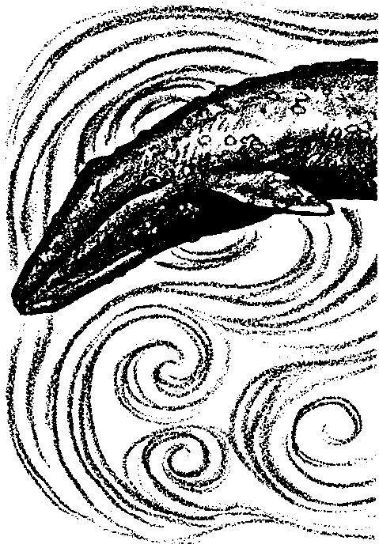
and Laurie Dumdie, Poulsbo, WA

Key Concepts
1. Most of the largest whales are baleen whales.
2. Baleen whales feed on fish and tiny crustaceans in the plankton of the world’s oceans.
3. Most species of whales migrate in the ocean to feed and calve.

Background

Whales have always caught the fancy of humans because of their size, beauty, and playfulness. They have been valuable to humans for centuries as a source of food and oil. Scientists classify whales along with dolphins in the group or “order” Cetacea, a word derived from the early Greek and Latin word for whale. Whales have poor senses of smell and of taste, but a good sense of vision and an excellent sense of hearing. Whales are apparently very intelligent mammals that make a variety of sounds, both for “talking” with one another and, in some cases, for use as a sort of sonar to locate food and avoid underwater objects.

Cetaceans are divided into two groups: toothed whales and baleen whales.

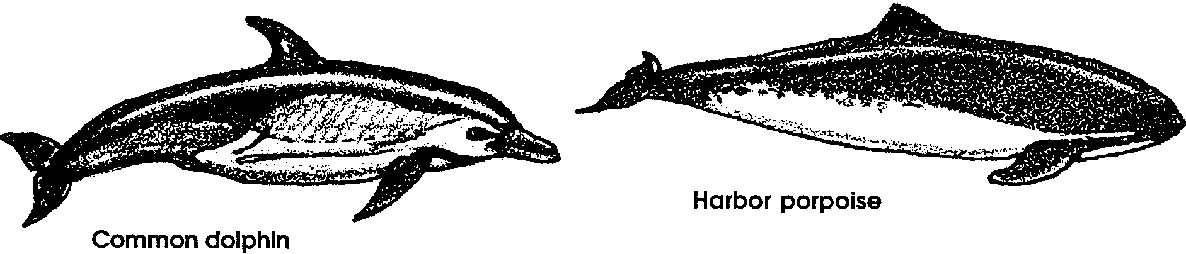
Toothed whales include dolphins, porpoises, beaked whales, sperm whales and pygmy sperm whales. Toothed whales feed mostly on fishes, squids, octopuses, and occasionally on large mammals.

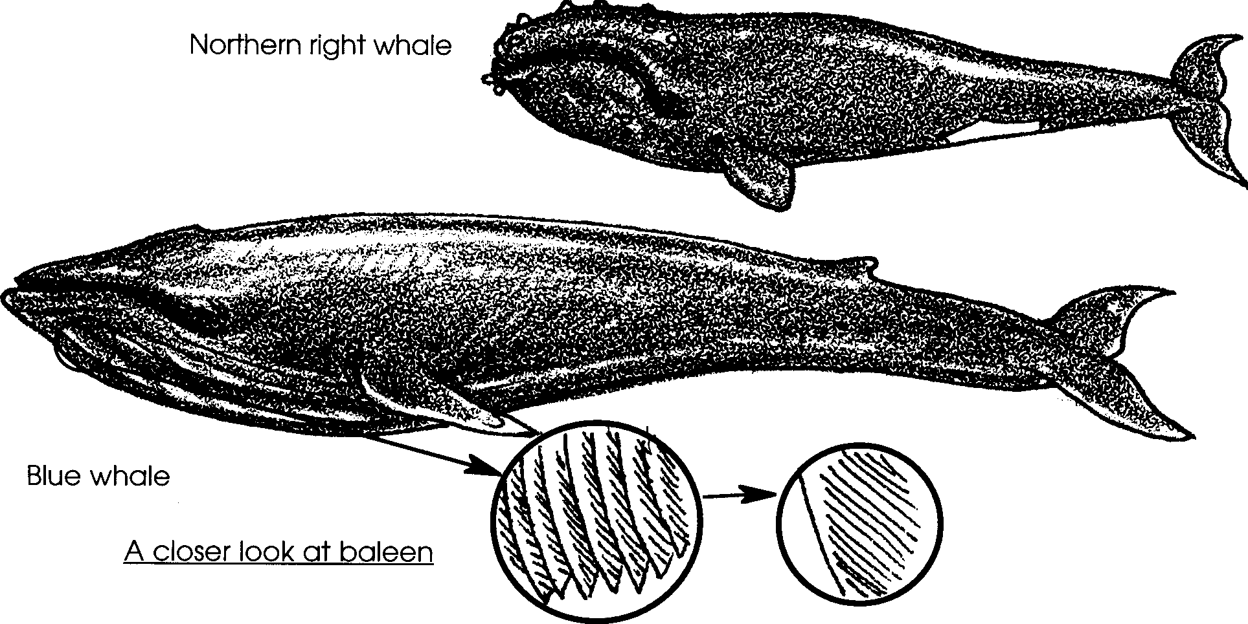
Baleen whales include blue whales, right whales, fin whales, and California gray whales. Baleen whales have no teeth; instead, sheets of a fringed, fingernail-like material, called whalebone or baleen, hang from their upper jaws.
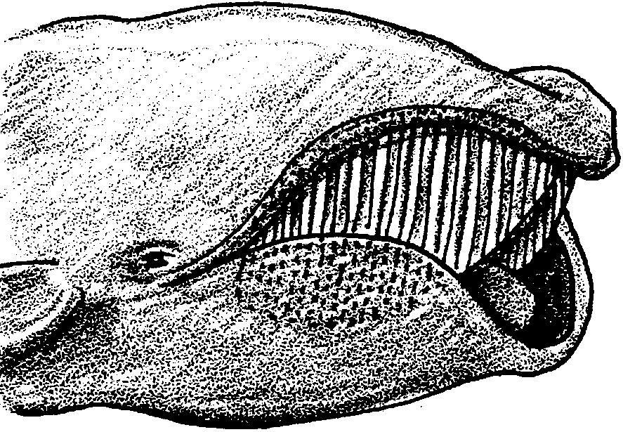

Scientists place baleen whales in a group they call Mysticeti (MISS-tuh-SEE-tee), which means “whales with mustaches”. And rightly so! When one opens its mouth, the hundreds of thin baleen plates that hang from the roof of its mouth resemble a giant mustache.

The baleen plates strain the whale’s food from the water. Millions of tons of a large form of plankton, a shrimp-like creature called krill, are eaten by the baleen whales.
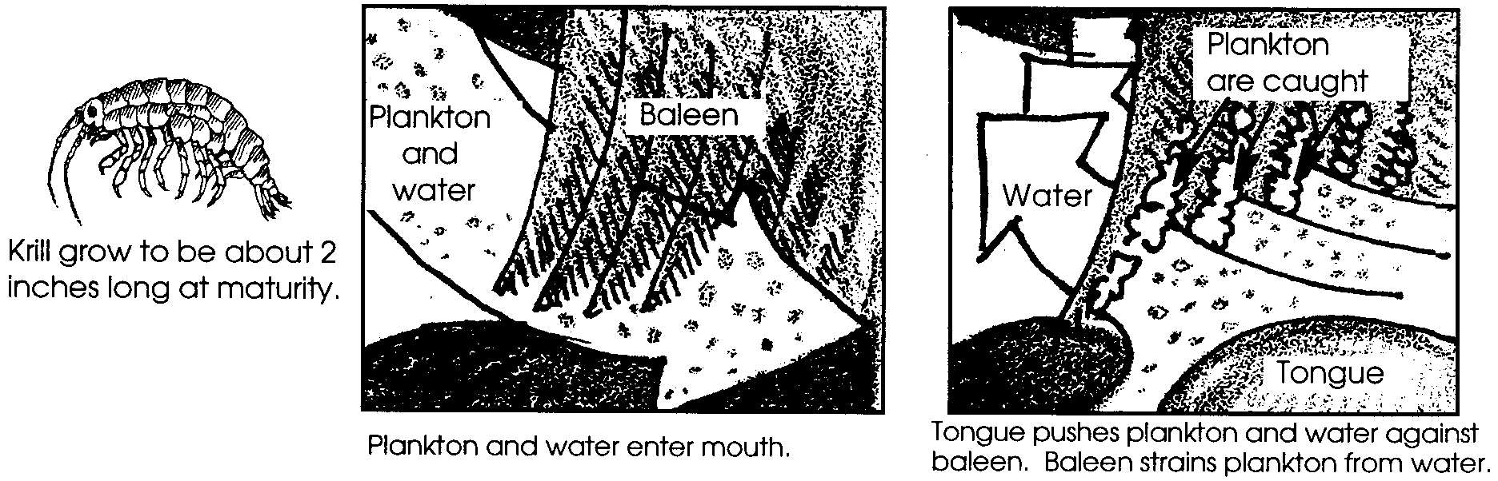

Baleen whales have developed several different feeding techniques:

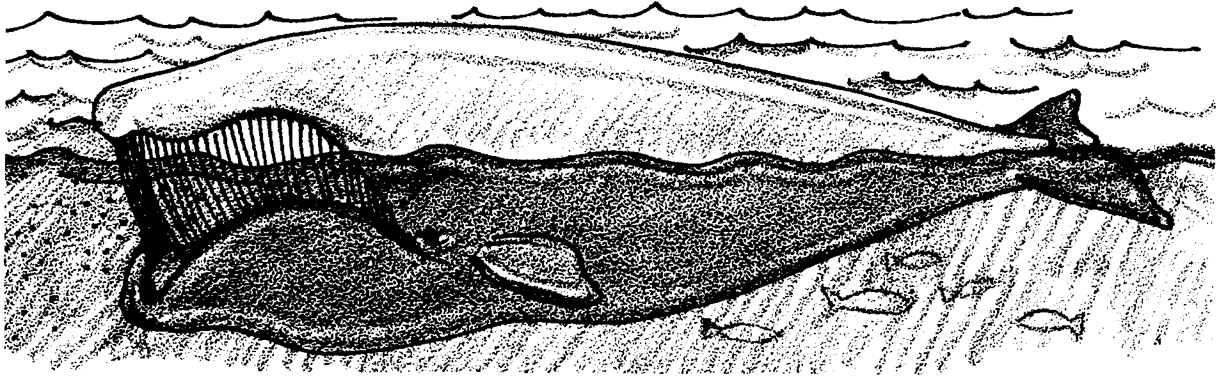
• open ocean “skimmers”- swim slowly at the surface with their mouths open, straining a long column of water through their baleen as they move forward. “Skimmers” include: right whales and bowhead whales.

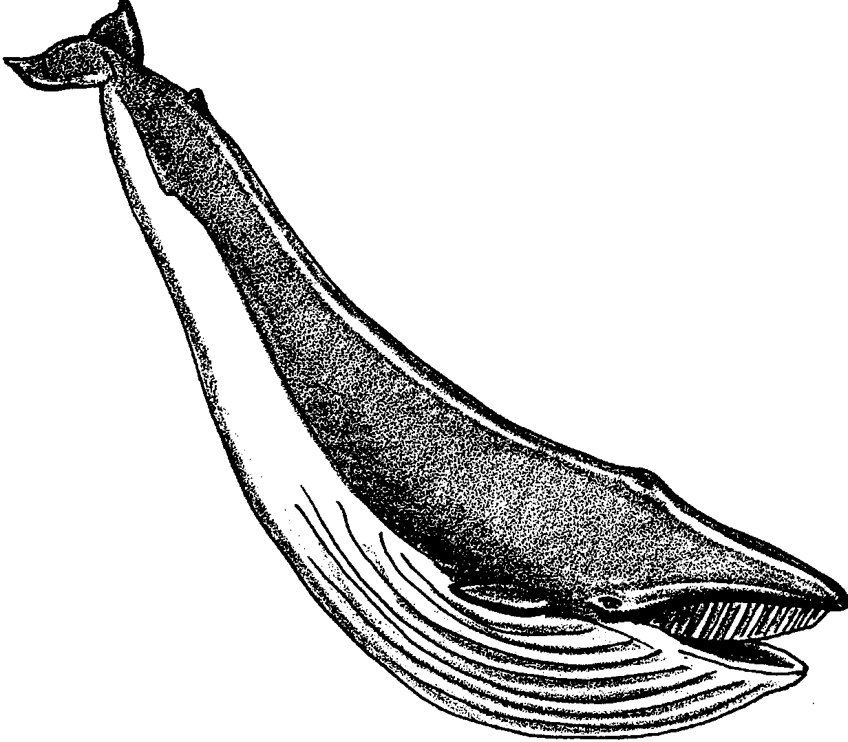
• open ocean “gulpers”- feed by first taking in huge amounts of water, then using their enormous tongue they push the water out through the large baleen plates. A “gulper” has throat grooves (expanding pleats) running on the underside of its jaw and belly. These allow the throat to balloon out to hold a tremendous amount of water. The inside of a “gulper’s” baleen plates have brush-like fibers which filter krill and other food from the water. “Gulpers” include: fin whales, Bryde’s whales, and blue whales.

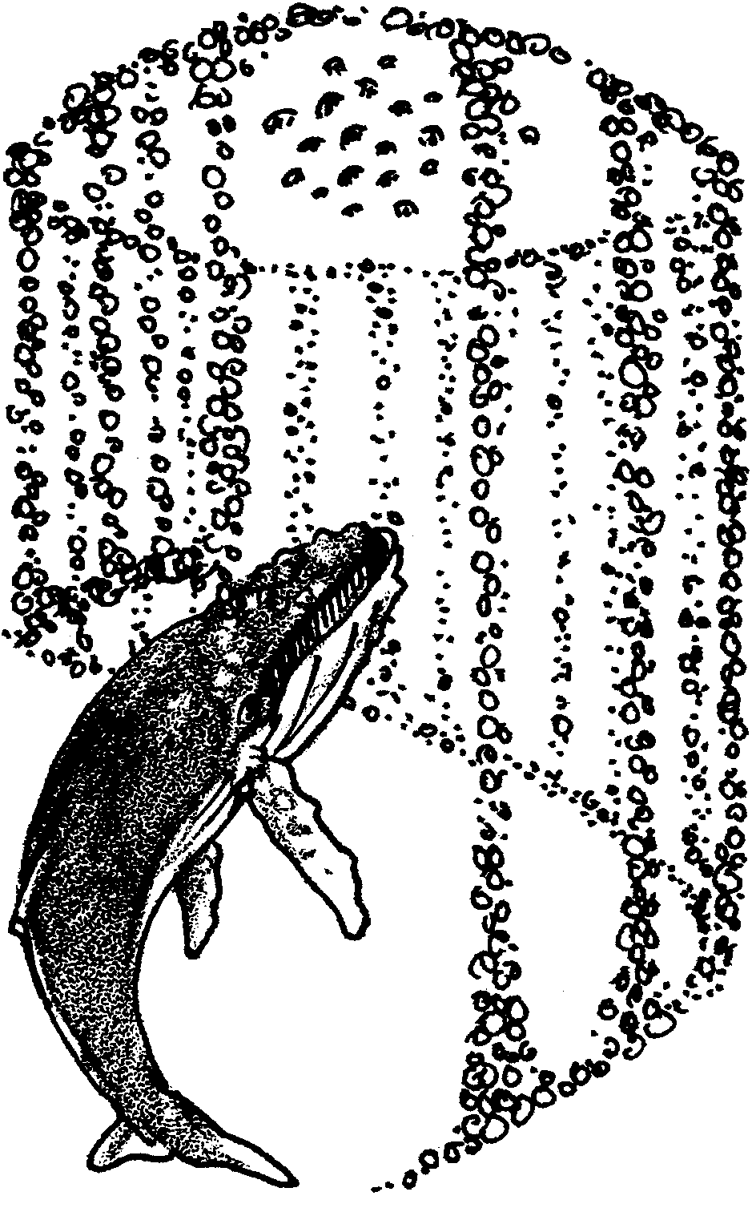
• “bubble netters” - catch krill (or small fish) in a “bubble net”. To do this, one or two whales swim in a circle around a group of swarming krill. As they swim they blow bubbles. The bubbles herd the krill into a tight group. Then the whales swim up the middle of the bubble net to engulf the catch. “Bubble net” hunters include: humpback whales, which sometimes also “skim” or “gulp”.

• “bottom feeders” - dive to the bottom, turn on their sides and open up their mouths to suck up chunks of the bottom. They use their coarse, short baleen to filter out the small crustaceans that burrow in the mud on the sea floor. “Bottom feeders” include: gray whales.
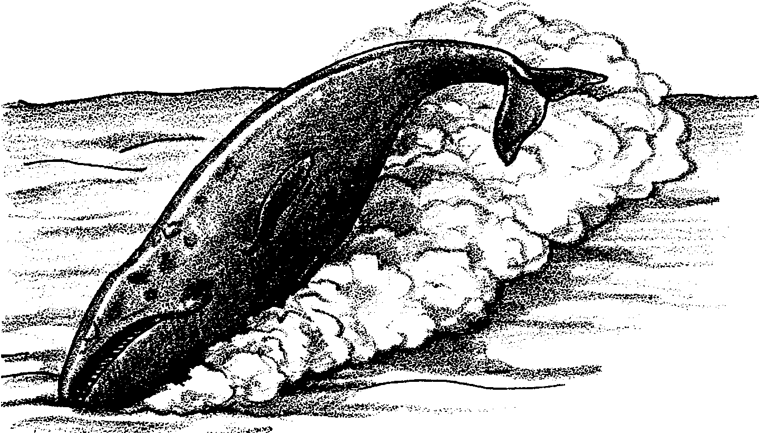

Almost all of the big whales are baleen whales. The biggest whale of all, and the biggest animal that has ever lived on the earth (even bigger than any dinosaur) is the blue whale. This giant weighs more than 32 elephants (392,000 pounds) and can be about 100 feet long (as long as three railway cars). The other nine species of baleen whales, in order of their length, are:

fin 82 ft.
bowhead 65 ft.
humpback 62 ft.
right 60 ft.
sei (SAY) 58 ft.
Bryde’s (BREE-duhs) 50 ft.
gray 50 ft.
minke (MINK-ee) 33 ft.

Migration

Many baleen whale species migrate, or regularly travel, from one part of the world to another as they move between optimal feeding and breeding grounds. During the summer months, some of these whales travel thousands of miles to the higher latitudes, often as far as the polar regions. Odd as it may seem, they are in search of the rich, seasonal feeding grounds to be found there as winter turns to spring. During the lengthening days of spring, miles of waters are exposed to long periods of sunlight, creating the perfect conditions for an explosive growth of plankton.

As the season grows colder and food becomes scarce, these whales make their long journey back to warmer waters and climates. Hawaii and Mexico are among these safe havens. It is here that the whales breed and raise their calves until the next spring. At that time, they begin the long journey back to higher latitudes, keeping their calves close by their sides.

Materials

Part 1: Feeding Habits of Baleen Whales

For the class:

• videos or films showing feeding baleen whales or make transparencies of the feeding habits for discussion

• optional: sample of dried krill (available in most Asian food stores) or make a transparency showing krill next to the baleen whale’s mouth

• “deck” of feeding technique cards using 3" X 5" cards (see preparation below)

Part 2: Baleen Whale Feeding Simulation

For each group of 4 students:

• one plastic container (a plastic shoebox is about right)

• one plastic ziplock bag (sandwich size) per student

• scissors

• aquarium gravel (enough for about an inch on the bottom of each container)

• a standard measure (a 35 mm film canister works well)

Part 3: A Baleen Whale Play

For each student:

• “A Whale of a Tale” script

Part 4: Migration Routes

For the class:

• transparency of the gray whale migration route

For each pair or group of students:

• globe

• clay (two colors)

Teaching Hints

In “Oceans as Whale Habitat”, students are introduced to the feeding habits of baleen whales. This information is reinforced with dramatization of each of the techniques. Next, a baleen whale feeding simulation activity is followed by the performance of a play. Finally, gray whale migration routes are tracked on a globe.

Part 1: Feeding Habits of Baleen Whales

In Part 1, students dramatize the four feeding techniques of baleen whales.

Materials

For the class:

• videos or films showing feeding baleen whales or make transparencies of the feeding habits for discussion
• optional: sample of dried krill (available in most Asian food stores) or make a transparency showing the krill next to the baleen whale’s mouth

• “deck” of feeding technique cards using 3" X 5" cards

Preparation

1. Use 3" x 5" cards to make a class set of “feeding technique cards”. Each card will list one of the four baleen whale feeding techniques. Make enough cards to provide one feeding technique card to each group of 3-4 students. Note: a duplication master for the “feeding technique cards” is included should you wish to copy, cut, paste, and laminate a permanent set of cards.

2. Review the four types of feeding behavior by reading their descriptions in the above Background section.

Procedure

1. Show a video, film, or use the transparencies to introduce the four feeding habits of baleen whales.

2. If available, distribute some of the dried krill to students. Otherwise, use the krill transparency to show students one of the foods baleen whales catch with these feeding techniques.

3. Divide class into groups of 3-4 students.

4. Show students the “deck” of feeding technique cards. Explain that each group will pick one card, but that they should not share the feeding technique on their chosen card with other groups. Instead, they will practice, as a group, dramatizing the technique on their card so that they can give a “performance” which will help the rest of the class guess which feeding technique they are demonstrating.

5. Have each group pick one of the feeding technique cards. (Again, remind groups to keep their techniques secret.)

6. Allow time for groups to practice their technique. If possible, provide some semi-private practice spots.

7. Have each group “perform” their feeding technique. After the performance, have the rest of the class (“the audience”) guess which feeding technique was being demonstrated.

Part 2: Baleen Whale Feeding Simulation

In Part 2, students conduct a baleen whale feeding simulation activity using a plastic bag, cut to resemble baleen, and aquarium gravel, which serves as “whale food”.

Materials

For each group of 4 students:

• one plastic container (a plastic shoebox is about the right size)

• tap water

• scissors

• aquarium gravel (enough for about an inch on the bottom of each container)

• a standard measure (a 35 mm film canister works well)

• data chart

For each student:

• one plastic ziplock bag (sandwich size)

Preparation

1. The spacing of the cuts to be made on the plastic bag is determined by the size of the aquarium gravel used. Although a 1/2 inch long cut about every 1/8 or 1/4 inch works for many aquarium gravels, in order to determine the exact spacing of the cuts on the bag, try this activity yourself, beforehand.

Note: The length of the cut, as well as the space between cuts, plays an important role in the efficiency of the “baleen bag”. You may wish to modify this activity by having different groups use different length cuts, or by allowing groups free choice with regard to length and spacing of cuts.

2. Pour about an inch of gravel on the bottom of the containers. Fill each container about 3/4 full of water.

Note: While aquarium gravel is durable, inexpensive, and works well, other materials, such as dry beans, rice, marbles, etc., may be used instead. Alternatively, once students have completed the activity using aquarium gravel, you may wish to consider duplicating the activity using one or more of these other materials to compare and contrast results.

Procedure

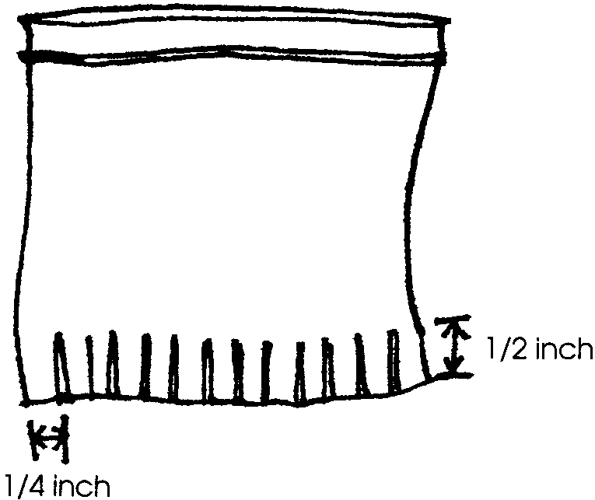
1. Review the bottom feeding technique of the gray whale.

2. Show students one of the plastic containers with gravel. Explain that the gravel will represent the food the whales eat in the bottom of the ocean. Show a ziplock bag and explain that the bag will represent the mouth and baleen of a gray whale. Demonstrate the cutting of one of the ziplock bags. Have students cut similar slits in the bottoms of their bags.

3. Choose a student to demonstrate the activity. As she holds the mouth of the bag open, have the student take one sweep across the floor of the mini-ocean floor in the plastic container. Explain that this sweep represents a gray whale feeding on the bottom. Measure the collected gravel using a standard measure (e.g., a film canister full). Record the result on the board in a chart like the following:

Name Measures Collected

4. Within each group, have students take turns at “feeding”. As they do, have them record each amount of gravel collected on their data chart.

5. Have students clean up their stations, then looking at the chart of collected data, discuss the results. Ask questions like:

Which “whale” in your group caught the most?

Why did different whales catch different amounts?

6. Using the results from step 3 above, demonstrate how to make a bar graph.


number of
measures

student name

7. On their data sheets, have each group create a bar graph using the collected data.

8. Discuss the bar graph using questions such as:

Which “whale” in your group caught the most?

Is it easier to tell which “whale” caught the most from the bar graph or from your data chart?

Why do you think scientists often use graphs to show their results?

Part 3: A Baleen Whale Play

In Part 3, students perform a play as a follow-up to the preceding baleen whale feeding simulation.

Materials

For each student:

• “A Whale of a Tale” script

Procedure

1. Explain that the class will be taking an imaginary trip through the oceans to try and meet some whales. Note that most of the class will be warm and cozy during the trip but that six students will be “in the water”. Select six students to play the roles of individual whales.

2. Provide the accompanying script for “A Whale of a Tale” to each student.

3. Rehearse the chorus lines and whale parts. Consider making and decorating whale puppets for use as props for the skit.

4. Perform the play, first for your class; then, if you wish, for other classes.

5. Have students write about a fictitious trip out to sea in a big yellow school bus. Where would they go? What would they see?

Part 4: Migration Routes

In Part 4, students track gray whale migration routes on a world globe.

Materials

For the class:

• transparency of the gray whale migration route

For each pair or group of students:

• globe

• clay (two colors)

Procedure

1. Show students the transparency of the migration route of the gray whale.

2. Discuss how swimming these incredible distances helps the gray whale survive in its ocean habitat (see Background section above).

3. On the globe, have each group of students mark the migration routes with small clay balls. Use one color for southern migration and another for northern migration. Discuss the whales’ approximate location during each season. Ask:

Do the whales migrate off the shore of the state in which we live?

4. Have students complete a creative writing project describing the adventures of one gray whale’s migration. You may choose to create a “book” highlighting the migration. Here’s how: Have each student write about one “stretch” of the journey. Next, place the pages in order, create a cover, and bind the “book”.

Key Words

baleen - tough, flexible bristles in the mouths of baleen whales used to filter food (small fish and krill) out of the water or mud

crustacean - any member of a group of animals that includes crabs, shrimp, etc., characterized by a segmented body, a hard exterior skeleton, and jointed appendages

krill - shrimp-like crustaceans (mostly of the genus Euphausia) which grow to about 2 inches long; large populations live in certain oceans and are the main food of some fish and baleen whales

migration - a seasonal journey from one region to another; for example, the gray whale migrates annually between feeding and breeding/calving areas

Mysticeti - the group into which scientists classify the baleen whales

Extensions

1. To impress upon students the size of the largest whale, the blue whale, try this activity:

a. Beforehand, mark on the playground or in the parking lot, the length (100 feet) and height (18 feet) of a blue whale.

b. Show students a picture of the adult blue whale and take them outside to see the marks indicating its length and height.

c. Have students estimate how many students it will take lying “head to toe” to make the length and height of the whale. Record their estimates.

d. Return to the marks outside, and have students lie down, head to toe, one at a time, until they reach 100 feet. If necessary, students from the start of the line can get up to continue the line until 100 feet is reached.

e. Use the same procedure for the height of the blue whale.

f. Try drawing the shape of the whale on the playground with chalk. Have children stand on key reference points.

2. a. Read a story about whale migration and/or watching whales. See the bibliography, or choose one of the following:
• “I Watch Whales” from Ranger Rick, May 1981
• I Wonder If I’ll See A Whale by Frances Ward Weller
• Winter Whale by Joanne Ryder.

Have students write a story about a whale watching trip they have taken or why they would like to go whale watching. You may wish to have some write about whale watching from the perspective of a whale during its migration.

3. Read poems about whales such as “The Whale” by Buson.
Part 2: Baleen Whale Feeding Simulation

Name Measures Collected

Student name
Part 3: A Baleen Whale Play

A Whale of a Tale;
A Skit About Whales

by Leslie Tryon

In the skit “A Whale of a Tale”, students dramatize different whales. Because the enormity of some whales is hard to conceptualize, the great whales are often compared to the size of a school bus. A school bus provides a familiar, concrete item upon which to base the following skit.

Set: Arrange chairs in “school bus” rows. While most school busses are between 30 and 40 feet in length, make yours the size of the space available. Children on the bus are the chorus. In addition to the chorus, there are parts for six individual whales: the blue whale, the fin whale, the sperm whale, the gray whale, the killer whale, and the pygmy whale. Direct the individual whales to recite their lines, then “swim” on. All parts are in easy-to-learn couplet form.

Character Dialogue

Chorus The big yellow school bus,
Full of curious kids like us,

Drove right out to sea to see
Just how big a whale can be.

A giant of a whale swam right up to us and said . . .

The Blue I’m the biggest whale. I’m the giant blue.
The earth’s biggest creature. It’s absolutely true.

From my fluke to my nose, a whale of a whale.
The length of three busses, placed nose to tail.

Chorus WOW!
The big yellow school bus,
Full of curious kids like us,

Drove right out to sea to see
Just how big a whale can be.

Another big whale came speeding up to us and said . . .

The Fin I’m the Fin, I’m fast ’cause I’m thin.
Two and a half busses long from end to end.

I have a bony moustache in place of teeth.
Only in the top jaw, there’s nothing underneath.

Chorus Bigger than two school busses. WOW!

The big yellow school bus,
Full of curious kids like us,

Drove right out to sea to see
Just how big a whale can be.

HEY! This one really LOOKS like a whale.

The Sperm I’m the square-nosed sperm whale.
Two busses long, from my nose to my tail.

I feed in the deep where there’s lots to eat.
But the giant squid is my favorite treat.

Chorus Giant squid - Yuck!

The big yellow school bus,
Full of curious kids like us,

Drove right out to sea to see
Just how big a whale can be.

LOOK! Here comes another one.

Gray Whale I’m one school bus long. I’m the gray,
I’m bumpy all over, from barnacles they say.

I love to breach, to jump out of the sea,
And you may see the whale lice, all over me.

Chorus Whale lice - that’s nice.

The big yellow school bus,
Full of curious kids like us,

Drove right out to sea to see
Just how big a whale can be.

Hey! Here comes a two-toned whale.

Killer Whale I’m called the killer whale you know.
I’m dark on the top and light below.

I’m one of the very best hunters in the sea.
Your school bus is just a bit bigger than me.

Chorus The big yellow school bus,
Full of curious kids like us,

Drove right out to sea to see
Just how big a whale can be.

Can that little guy be a whale?

Pygmy Sperm Whale I’m only thirteen feet* long,
that’s all,
For a whale, I guess I’m pretty small.

I would fit in your bus. We could go for a ride.
I could show you where the giant squid hide.

Chorus Thanks very much, but we’ve got to get home.

The big yellow school bus,
Full of very smart kids like us,

Met some whales and now we know,
Just how big a whale can grow.

* (about 4 meters)

