Whale Adaptations
Lesson by Laurie Dumdie, Poulsbo, WA

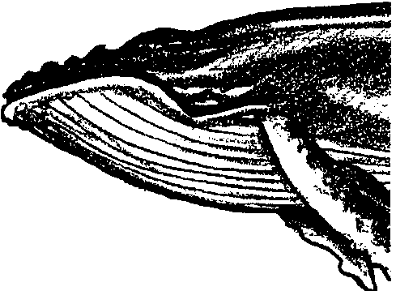
Key Concepts
1. Whales are marine mammals with special adaptations that allow them to live in the ocean.
2. Whales breathe air through a blowhole on top of their heads.
3. Whales are warm blooded. They have thick layers of blubber beneath their skin to keep them warm, even in the icy polar seas.

Background

Next to sharks, marine mammals hold the greatest fascination for students. The sheer magnitude of great whales is overwhelming. The streamlining of seals is impressive. Their big eyes are “sympathetic”. All of these attributes and more tend to give marine mammals a special place with your students.

Marine mammals, including whales, dolphins, porpoises, seals, sea lions, walruses, and sea otters, are air-breathing, warm-blooded animals that live in the sea. They share features in common with other mammals, giving live birth and nourishing their young with milk from mammary glands, and possessing hair at some point in their development. The bodies of marine mammals are well-adapted for life in the sea, featuring special adaptations for maintaining a constant internal body temperature in cool water, for sensing their environment, and for diving.

Most marine mammals are streamlined, making it easier for them to move through the water. Seals’ limbs are modified to form flippers, while sea otters have flipper-like hind feet. Instead of vertical tails like fishes, whales have horizontal tails - an adaptation that enables them to dive and surface easily. Marine mammals, especially whales, also show an amazing ability to dive deep and stay down a long time. Although, proportionally, their lungs are not much larger in size than those of land mammals, sperm whales can dive to depths of 3,000 feet and stay down for as long as 90 minutes.

Whales and dolphins, collectively called “cetaceans” by scientists, have always caught the fancy of humans because of their size, beauty, and playfulness. They have been valuable to humans for centuries as a source of food and oil. The scientific name of the order, Cetacea, comes from “cetus”, the early Greek and Latin word for whale. Cetaceans have poor senses of smell and of taste, but a good sense of vision and an excellent sense of hearing. Whales and dolphins are apparently very intelligent mammals that make a variety of sounds, both for “talking” with one another and, in some cases, for use as a sort of sonar to locate food and avoid underwater objects. Cetaceans breathe through nostrils (blowholes) on top of the head.

Cetaceans usually give birth to only one offspring each year. The young are large at birth, usually one-fourth to one-third or more the length of the mother. For example, an 80-foot blue whale may give birth to a baby that is 25 feet long and weighs 2 tons or more. The young grow quickly, doubling their length within the first year. Cetaceans are divided into two groups:

a. toothed whales - dolphins, porpoises, beaked whales, sperm whales and pygmy sperm whales;
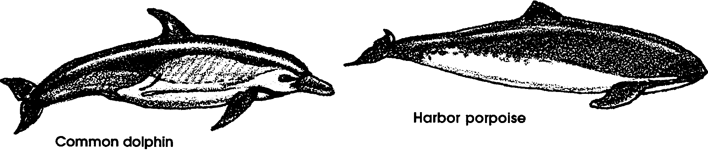

b. baleen whales - blue whales, right whales, fin whales, and California gray whales.

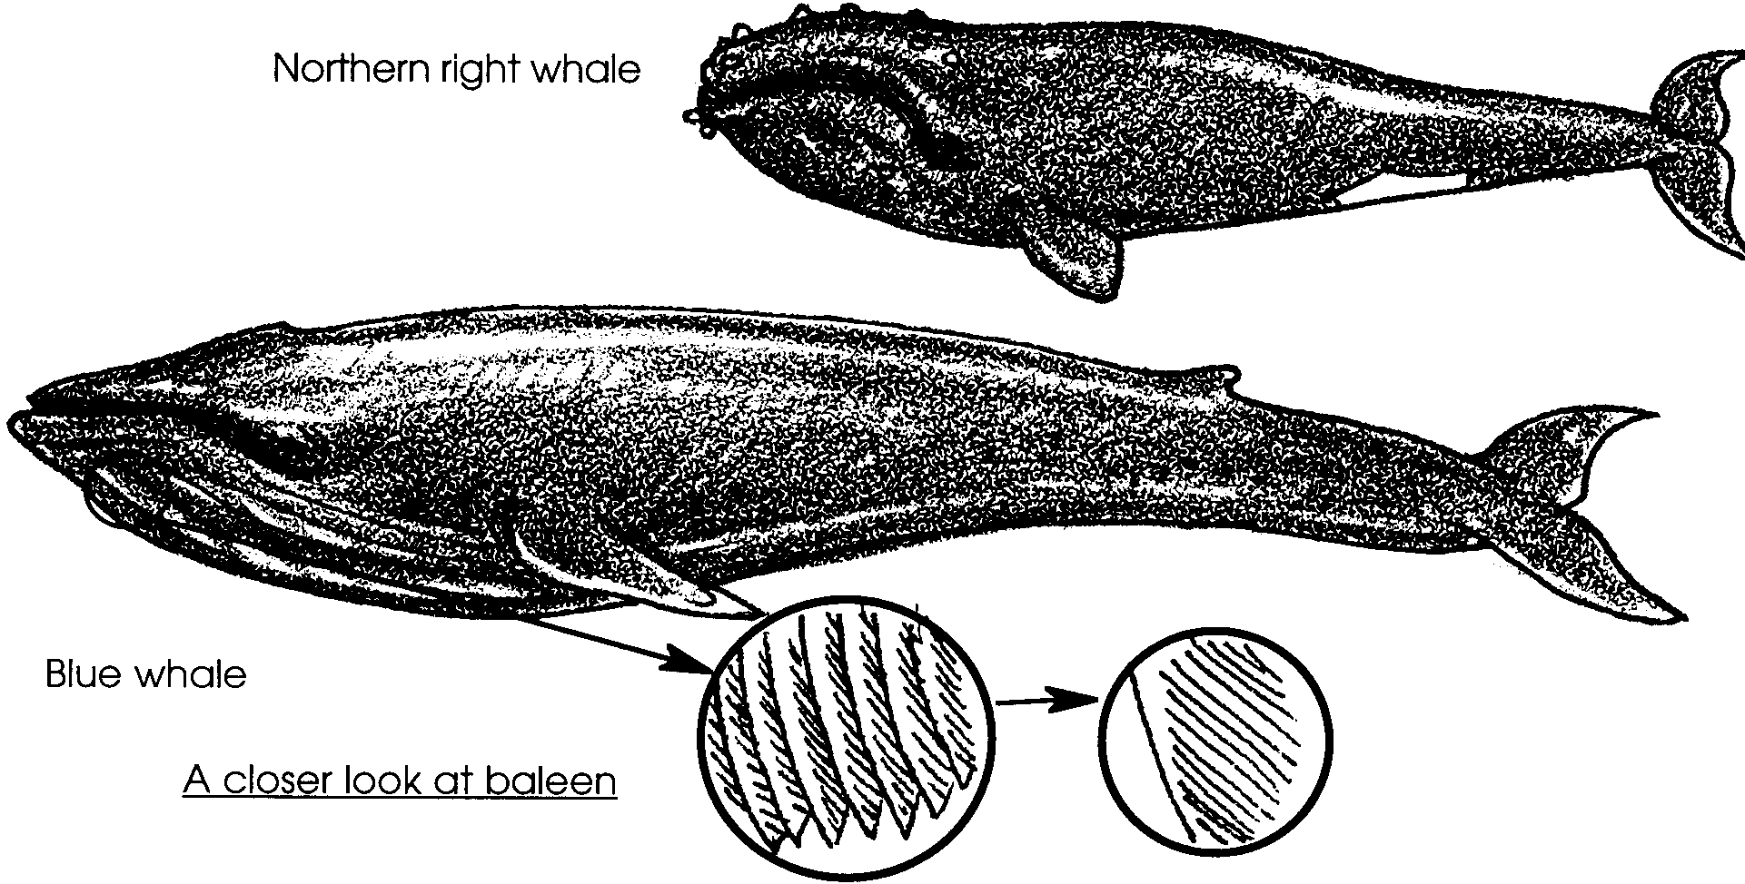

Toothed whales feed mostly on fishes, squids, octopuses, and occasionally on large mammals. Baleen whales have no teeth; instead, sheets of a fringed, fingernail-like material, called whalebone or baleen, hang from their upper jaws. Baleen whales feed on plankton, strained through the baleen, and also on small fishes and shrimp.

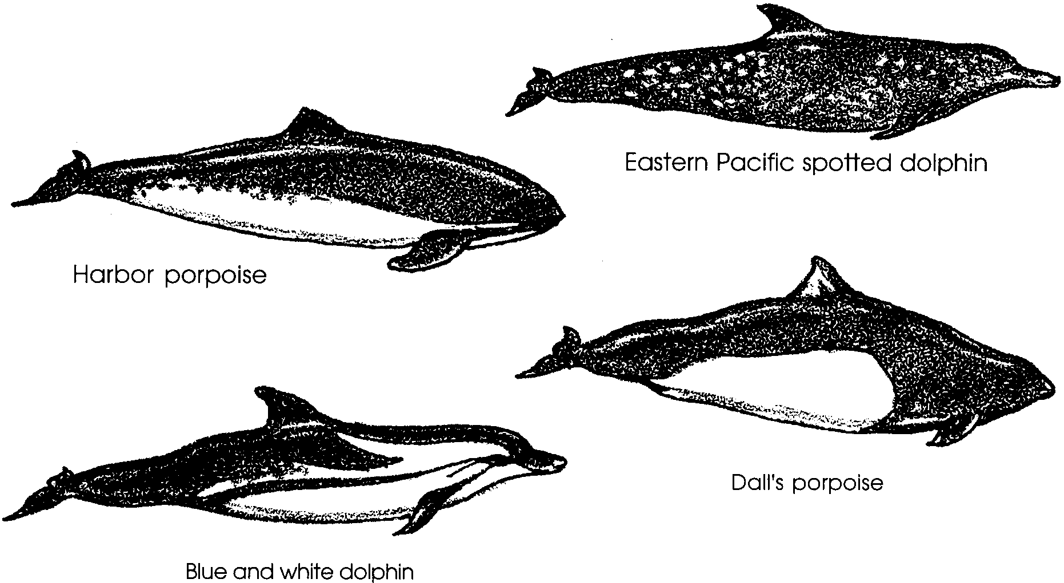
Dolphin and porpoise are terms that often cause confusion. Strictly speaking, the long-beaked forms are called dolphins and the small, snubby-nosed forms are called porpoises. However, these words are commonly used interchangeably. The dolphin fish, also called mahi-mahi, is not a mammal.

Dolphins are perhaps the most popular cetacean with mariners. One reason is the human-like interest they take in play. They can be seen running at the bow of a boat or riding waves in the surf. Dolphins also show concern for one another - when one member of a group is injured, the others will come to its aid.

Whales are the largest animals known. In fact, the blue whale, reaching a length of 100 feet and a weight of more than 100 tons, is the largest animal that has ever lived. Larger than the largest dinosaur, whales can grow so large because their body weight is supported by the water and, in the case of baleen whales, because of the abundance of the planktonic organisms upon which they feed. Not all whales are large, however. Some, like the pygmy sperm whale, reach a length of only 13 feet.
Whales combat cold ocean waters in a variety of ways. As with almost all marine mammals, whales utilize the insulating properties of blubber to stay warm. Beluga whales, which live in frigid northern waters, have the thickest blubber with up to a foot of fat. Blubber is firmer and far thicker than the fatty tissue of land mammals and is laced with connective tissue.

Blubber is such an effective insulator that marine mammals must guard against overheating. Whales and seals have blood vessels close to the skin surface in their appendages and they can regulate blood flow to these extremities to dissipate or conserve heat. In this counter-current circulation system, warmed blood moving to the extremities passes near vessels carrying cooled blood back to the heart. The warm blood loses its heat to the returning blood instead of losing it to the cool water that surrounds the extremities. The returning blood is now slightly warmer and, therefore, will require less reheating when it returns to the body core.
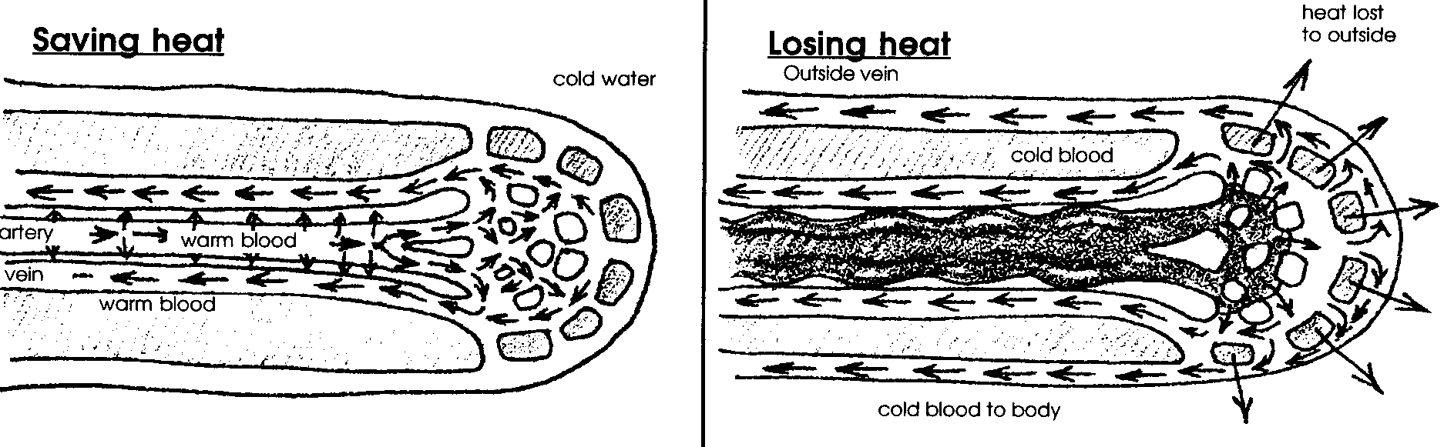

Whales, and in fact all of the marine mammals, also stay warm by consuming large quantities of food. While cold-blooded animals (those animals whose body temperatures vary with the temperature of their environment) generally are less active and eat less as temperatures fall, homeothermic (warm-blooded) animals must eat more as the external temperature falls so that they can maintain a constant internal temperature.

Materials

Part 1: Breathe Like A Whale

For the class:

• pictures of whales showing the blowholes and spouts when exhaling

Part 2: Blubber Mitt

For the class:

• four large or jumbo plastic ziplock bags

• 2 rubber bands

• large container of ice water

• can of shortening or solid lard

• thermometer

Teaching Hints

In “Whale Adaptations”, students simulate whale breathing and experiment with a “blubber mitt” in order to experience two of the special physical features of whales.

Part 1: Breathe Like A Whale
adapted from Whale Workshops by Tamar Griggs

Materials

For the class:

• pictures of whales showing the blowholes and spouts when exhaling

Procedure

1. Introduce the concept that whales and dolphins breathe air just like us. Reinforce that because they live in the water, they have their nostrils, called blowholes, on top of their head. They shut their blowholes when they go under the water and open them on the surface to breathe. Locate the blowholes of whales in several pictures.

2. Have students make “blowholes” by cupping both hands together over their mouth and nose. Then have them simulate breathing like a whale:

• To simulate a whale just coming up to the surface, open the hands and exhale a loud breath, blowing all the air out, very fast.

• To dive, inhale with a deep breath and close the hand “blowholes.” Hold it as long as you can. When you can’t hold it any longer, open the hands and exhale.

Remind students that if they were whales, their “blowholes” would be at the back of their necks.

3. Show students pictures of a whale spouting when it exhales. Explain that the spout is not water coming out of the whale’s lungs. Rather, it is water from two sources: that left on the cover of the blowhole that is pushed upward by the exhaled air rushing out as the cover opens; and, that from fine droplets of water which form when the warm air coming out of the whale’s lungs hits the cooler atmospheric air.

Challenge students to simulate a large pod of whales breathing in unison as they travel. To make a spout, use the movements described above in step 2. When the breath is exhaled, have them shoot their arms into the air and return their hands to their noses on inhalation. This makes a joyful spout when done in unison.

Part 2: Blubber Mitt

Materials

For the class:

• four large or jumbo plastic ziplock bags

• 2 rubber bands

• large container of ice water

• can of shortening or solid lard

• thermometer

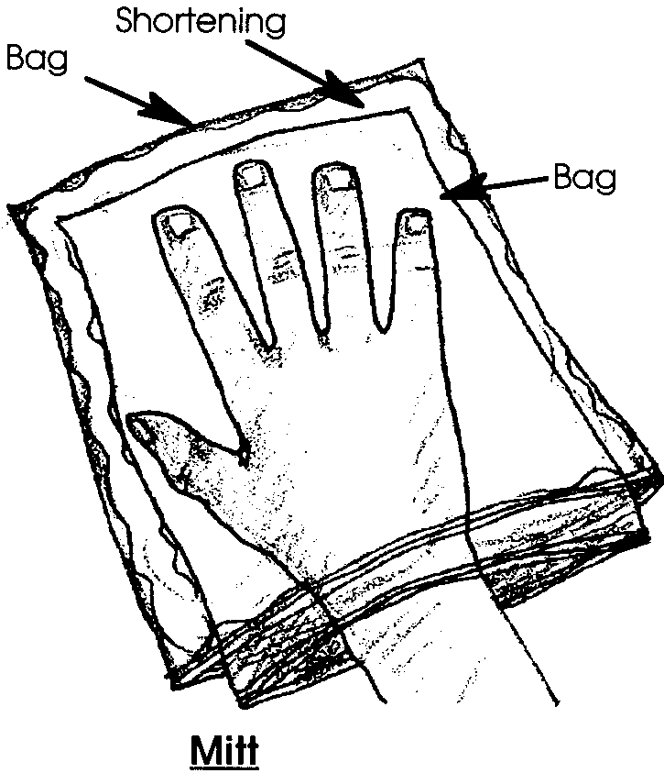
Preparation

1. Prepare a “blubber mitt” for the “whale”:

To construct a blubber mitt, scoop the shortening into one plastic bag. There should be enough shortening in the bag to form a cover around a student’s hand when the mitt is complete. Turn another bag inside out and place it inside the shortening- filled bag.

Start at one side seam and flatten the bag out and zip the two plastic bags together. If you keep the edges free of shortening, the seals will grip more securely. Use duct tape to seal any places where the bags do not self-seal.

2. Prepare a “plain mitt” for the “human”:
Simply turn a ziplock bag inside out and place it inside another bag. Then, zip the two bags together.

Procedure

1. Introduce the concept of whale blubber, emphasizing that it keeps a whale warm even in cold, icy ocean waters. Show students the constructed “blubber mitt”.

2. Ask for 2 volunteers. One student will represent a “whale”, the other will be the “human.”

3. Take the temperature of the ice water. Record the temperature.

4. Have the student who is the “human” hold the thermometer in his closed hand. Record the temperature.

5. Have this student place the hand holding the thermometer into the “plain mitt” (the one without the fat layer). Secure at the wrist with a rubber band. Have the student place this hand in the icy water. When the student can stand the cold no longer, have him remove his hand and again record the temperature of the closed hand.

6. Next, have the “whale” student hold a thermometer in her closed hand. Record the temperature.

7. Have the “whale” student place the hand holding the thermometer in the blubber mitt. Use a rubber band to secure the mitt at the wrist. Have the student submerge the hand with the mitt in the icy water. After several minutes, or until the student can no longer stand the cold, have her remove her hand and record the temperature.

8. Discuss the results. Students should see that the hand with the “blubber” protection stays warmer for a longer period of time than the uninsulated hand.

9. It is likely that each of your students will want to try putting a hand into the “blubber mitt” and sticking it in the icy water to see “first hand” how the fat protects from the cold.

Key Words

blowhole - a nostril for breathing on top of a whale’s head

blubber - the thick, insulating layer of fat beneath the skin of most marine mammals, including all whales and dolphins
Extensions

1. Sing a whale song to the tune of “The Farmer in the Dell.” Use appropriate motions, as you sing.

My flukes move up and down,
My flukes move up and down,
Heigh-ho the whale-oh,
My flukes move up and down.

My blowhole helps me breathe, etc.

My blubber keeps me warm, etc.

Song used with permission from Naturescope - Amazing Mammals

2. Sing along to the tune of “If You’re Happy and You Know It”. Make up your own verses!

If you’re a whale and you know it,
Blow your spout.
REPEAT
If you’re a whale and you know it,
Then your spout will surely show it.
If you’re a whale and you know it,
Blow your spout.

If you’re a sea lion and you know it,
Flap your flippers.
REPEAT
If you’re a sea lion and you know it,
Then your flippers will surely show it.
If you’re a sea lion and you know it,
Flap your flippers.

If you’re a seal and you know it,
Scoot on your belly.
REPEAT
If you’re a seal and you know it,
Then your belly will surely show it.
If you’re a seal and you know it,
Scoot on your belly.

If you’re a walrus and you know it,
Show off your tusks.
REPEAT
If you’re a walrus and you know it,
Then your tusks will surely show it.
If you’re a walrus and you know it,
Show off your tusks.

