Whales are Mammals
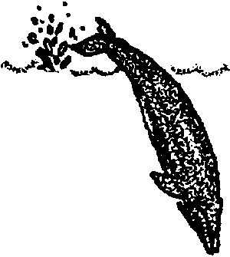
Lesson by Pat Rutowski, Monterey, CA

Key Concepts
l. People classify animals into different groups based on similar characteristics.
2. Mammals are warm-blooded animals that give birth to live babies who are fed with mother’s milk and they are usually furry.
3. Whales are marine mammals.

Background

The animal kingdom is classified into many different groups. Not surprisingly, we humans often focus on the animals with backbones. Scientists call this large grouping, which includes reptiles, fishes, birds, amphibians and mammals, a “class” and give it the name Vertebrata. Animals within this class are called “vertebrates”.

Mammals are a sub-group of vertebrates which includes humans, seals, whales and many other animals. Mammals are usually furry and warm-blooded, and give birth to live young which are fed with mother’s milk for the first part of their lives.

Some of these mammals have adapted to life in the ocean and these are called “marine mammals”. There are 112 species of marine mammals divided into 7 groups:
• sea otters - l species
• polar bears - 1 species
• eared seals - 15 species
• true seals - 17 species
• sirenians/manatees - 4 species
• toothed whales - 64 species
• baleen whales - 10 species

Each group of marine mammals has its own unique set of physical and behavioral adaptations which allows it to survive in the oft times harsh marine environment.

Materials

For each pair of students:

• set of assorted sea animal pictures

For the class:

• optional: overhead transparencies of the set of assorted sea animal pictures

Teaching Hints

In “Whales are Mammals”, students sort and group a set of sea animal picture cards to better understand the differences and similarities among various groups of animals. The previous activities, “Who Are Those Pinnipeds?” and “Marine Mammals in the Garbage”, which introduced pinnipeds (the group of marine mammals which includes seals, sea lions, and walruses), help set the stage for this activity.

Preparation

1. Assemble a master set of 14 assorted sea animal pictures. Each set of pictures should include assorted invertebrates and vertebrates including birds and marine mammals. You may wish to use magazine pictures, or alternatively, you may wish to use the set of black and white drawings included at the end of this Teacher Background section.

2. Duplicate the sea animal pictures and make them into packets, containing one of each card, for distribution to students.

Procedure

l. To introduce the concept of classification, ask for six student volunteers to stand at the front of the room. Sort them into two groups based on gender and ask the students to guess how you sorted them. Choose other characteristics to sort them several different ways and times. Make certain the characteristics chosen are observable characteristics like: glasses/no glasses, belts/no belts, etc. Ask one student to come up and sort the six, and have the rest of the class guess what rule the student used to sort them.

Introduce the fact that people sort animals and plants into groups based on similar characteristics. (Note: sometimes these characteristics are not necessarily observable throughout life. For example, while crabs and barnacles look quite different as adults, the larval form of a barnacle and that of a crab are very similar as plankton and so are grouped together.)

2. Divide all the students into pairs and distribute the sea animal picture sets. Direct students to sort the animal pictures into groups of animals that are the same in some way. There is no single “right” answer since it is people who define and identify classification systems. As long as their groups are logical and consistent, they are valid.

3. When students have finished sorting the pictures, discuss characteristics chosen for sorting by students. Transparencies of the sea animal pictures allow manipulation on the overhead as each pair of students discusses their groupings. Recording the characteristics used for sorting may be helpful.

4. Expand on the concept of classification with students. Explain how animals are classified by scientists as invertebrates or vertebrates. You may want to focus primarily on the vertebrates and just lump the invertebrates together for now. This would be a perfect time for students to observe vertebrae (the actual bones), if you have any in a bone collection.

5. Ask students where they think humans fit in the classification systems discussed. Reinforce that humans are mammals. What makes a mammal a mammal? Lead the students in creating a chart similar to this:

Birds Human Mammals

covering feathers fur/hair fur

blood warm warm warm

birth eggs live babies live babies

baby food like parent milk milk

movement fly walk, swim walk, swim, fly

6. Challenge the students to isolate the pictures of marine mammals in their picture set. Do they have any ideas on grouping these pictures?

Scientists group marine mammals as:
• sea otters
• seals
• sirenians (manatees and dugongs)
• cetaceans (toothed whales, baleen whales)
• polar bears

The fact that whales are classified as mammals may confuse students. While this concept is elaborated in susequent activities, remind students that whales breathe air through a blowhole on top of their head and give birth to live babies that feed on mother’s milk. In addition, although they are usually hairless as adults, they are born with hairs on their chin. They lose these hairs as they mature.

7. Work with the class to cluster words about mammals. Start with mammal characteristics. As you proceed with the activities that follow, add new circles to include the types of marine mammals.

Key Words

birds - warm-blooded vertebrates, usually covered with feathers, that lay eggs and have two wings and two legs

blowhole - a nostril for breathing on top of a whale’s head

fish - cold-blooded vertebrates that live in water, breathe with gills and have a body covered with scales and equipped with fins

fluke - one of the two horizontally flattened divisions of a whale’s tail

invertebrates - animals lacking a backbone or vertebrae; includes sponges, worms, clams, crabs, etc.

mammals - warm-blooded vertebrates that feed their young with mother’s milk and have skin usually covered with fur or hair

reptiles - cold-blooded vertebrates that breathe with lungs and are usually covered with scales; includes alligators, crocodiles, lizards, snakes and turtles

vertebrates - animals with a segmented spinal column

Extensions

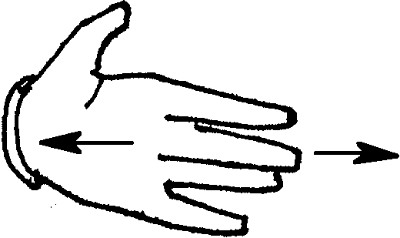
1. Whose Tail?
a. A fish is a vertebrate, like a whale, however it is NOT a mammal. To reinforce another difference between a fish and a whale, have students close their eyes. Ask them to pretend that their hands are fish tails. Ask them to move them in the same way a fish moves its tail when swimming through the water. (Students should move their hands side-to-side, not up and down.)
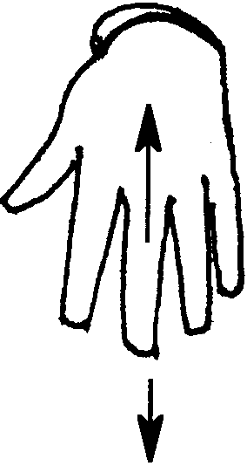
b. Next, have students imagine their hands are whale tails (called flukes). Again have students move their hands in the same way a whale moves its flukes when swimming through the water. (Students should move their hands up and down.)

c. Help students construct a “Swimming Whale Flip Book”. Here’s how:

1. Distribute copies of the “Swimming Whale Flip Book” pattern.

2. Cut out each of the pictures.

3. Glue the first picture to the lower right-hand corner of a 3 X 5 index card. Glue the second picture to another card and so on, until each picture is glued to a separate card.

4. When all pictures are glued down, stack the pages in ascending order. Begin with #1, then lay #2 on top of #1, etc.

5. Lay two empty cards on top of the whole stack.

6. Staple the cards on the left-hand edge twice.

7. Flip the pages of the booklet, from the back, to the front, to observe the whale “swimming.”

2. A Mammal Book (Original idea from Pat Gotch and Janet Simmons)

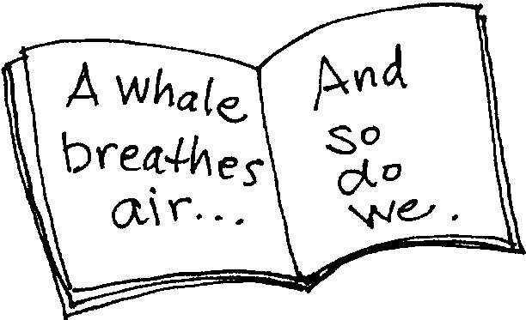
Have students create a book laid out in this fashion:

On the left-hand page, students write a characteristic of a whale and on the right-hand page, they write, “And so do we.”

Example:

A whale breathes air... And so do we.

A whale has warm blood... And so do we.

A whale has live babies... And so do we.

A whale mother cares for and feeds her baby milk... And so do we.

A whale is a mammal... And so are we!

3. A Marine Mammal Report
Have students complete a simple report on a marine mammal of interest to them. A suggested format:

a. Distribute an 8 1/2" X 11" piece of paper to each student.

b. Have each student fold his or her paper widthwise into four equal boxes.

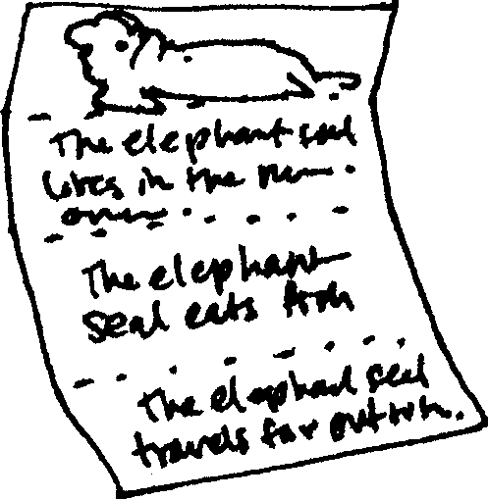
c. In these four boxes have each student do the following:

• In the top box, draw a picture of the marine mammal.

• In the next box, write where the marine mammal lives (which oceans).

• In the next box, write what the marine mammal eats.

• In the last box, write one interesting fact about the marine mammal.

d. Have each student take another sheet of paper (8 1/2" X 11") and again fold it into four equal boxes. This time, have the students cut along each of the fold lines, creating 4 individual boxes.

e. Have each student write the following on his or her individual boxes:

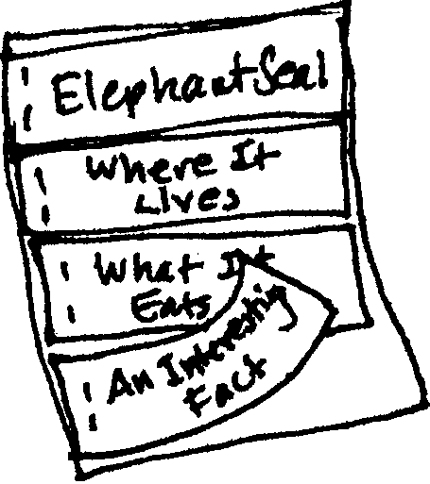
• On one of the boxes, write the name of the marine mammal highlighted in the report.

• On another, write “Where It Lives”.

• On another, write “What It Eats”.

• On the last box, write “An Interesting Fact”.

f. Finally, have students create a flap for each part of the report by stapling the individual boxes on the appropriate boxes on top of the first paper.

4. Construct a Whale Electric Board
Directions for constructing a circuit board can be found in the “Extensions” section of the previous activity, “Shark!”.

Marine Animal Cards
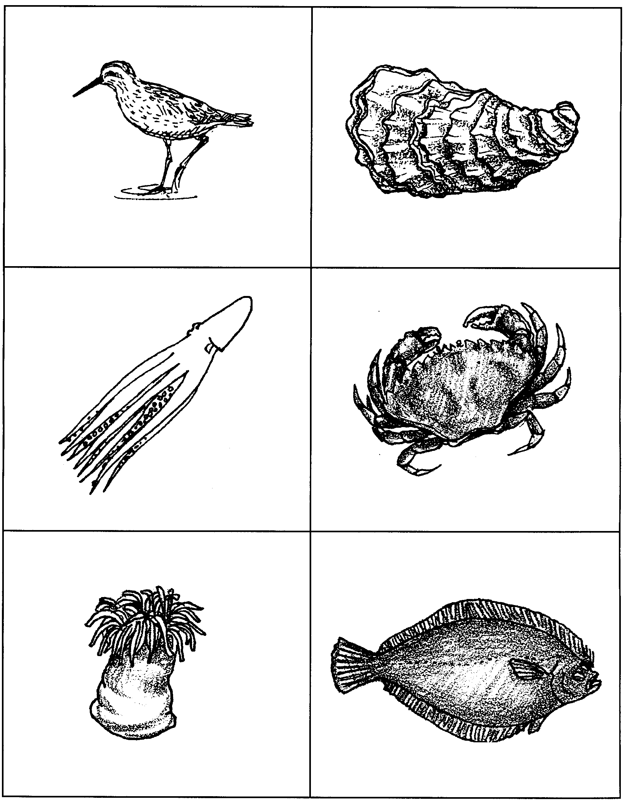
Marine Animal Cards
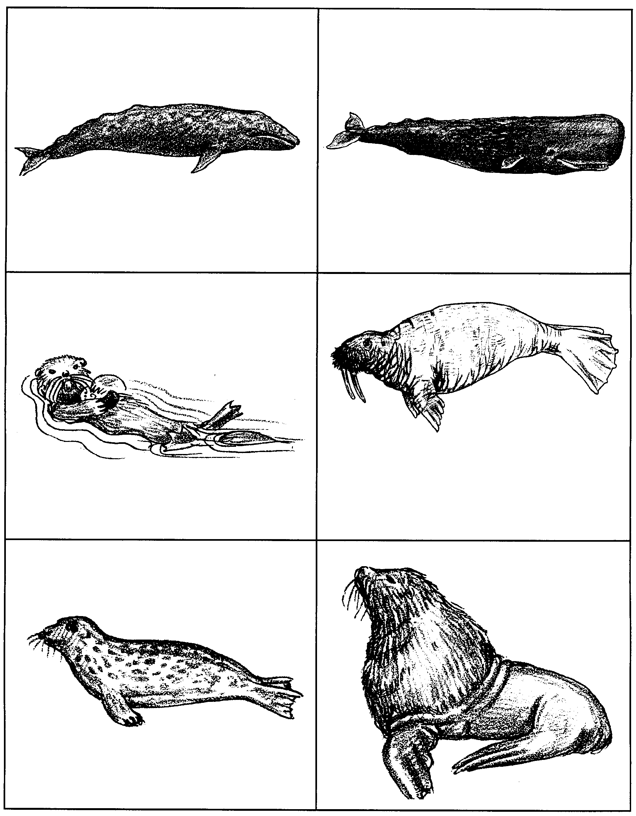
Marine Animal Cards
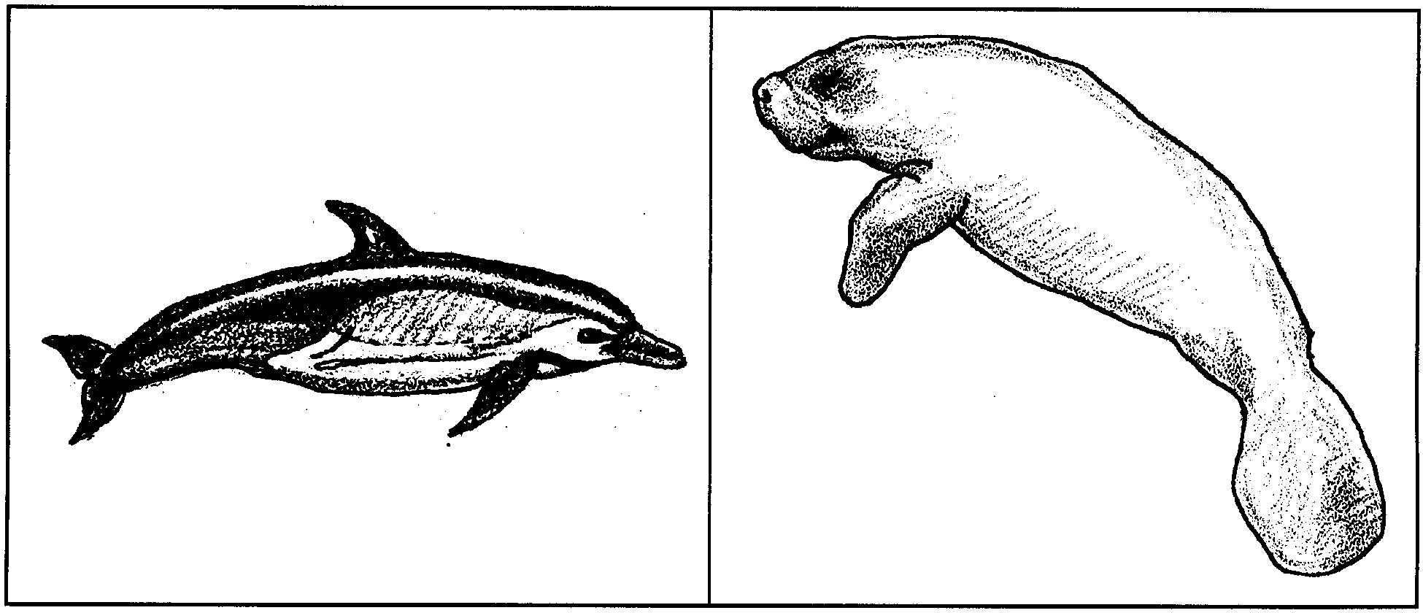

Whale Flip Cards - (two pages)
