Marine Mammals in the Garbage
Adapted with permission by Pat Rutowski, Monterey, CA
from “A New Kind of Homework” Project Wild’s Get the Drift

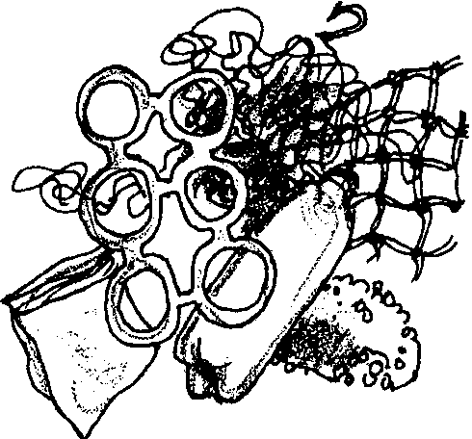
Key Concepts
1. The plastic trash that gets into the ocean is generated by people.
2. Animals, especially sea otters and curious pinnipeds, may get entangled in trash in the ocean.
3. People can help solve the problem of marine debris in the oceans.

Background

Too many of our beaches are covered with trash. Much of this trash is plastic, which takes a long time to degrade. Marine mammals, especially seal pups and sea otters, are naturally curious animals and will investigate and play with this plastic debris in the water and on the beach. Nets, strapping bands and six-pack rings may become lodged around an animal’s neck. This debris may make it difficult for them to swim and eat, or it may cause choking or open wounds and the possibility of infection as the animal grows.

Marine mammals are also drawn to fish caught in nets and may become tangled in the nets themselves while trying to eat the trapped fish. These animals may also mistake plastic bags or plastic sheeting for their natural foods: small fish or squid. Suffocation, choking, or intestinal blockage from the swallowed plastic can cause illness or death.

Populations of pinnipeds, sea turtles, and dolphins throughout the world have been negatively affected by marine debris. Studies have shown that tens of thousands of fur seals die annually in Alaska alone due to entanglement. In recent years, studies have shown a decrease in the number of these deaths. While some think the decline may be due to a decrease in the number of animals, others believe that it may reflect a decrease in the amount of some of the more dangerous types of debris.

It is important to note that marine mammals are not the only animals that become entangled in or eat plastic debris. Sea turtles, for example, seem to confuse plastic bags for jelly-fish, a favorite food item. The widespread nature of the problem (and a relatively simple solution which lies in proper disposal) makes this an important issue.
Materials

Part 1: What’s the Problem with Plastic Trash?

For the class:

• video, “Trashing the Oceans” or “Marine Debris and Entanglement” slide show (found on FOR SEA CD-ROM)

• VCR and monitor

• assorted pieces of plastic trash, including netting, six-pack ring, or strapping bands

Part 2: A Take Home Assignment

For the class:

• plastic trash collected from students’ homes

• a plastic six-pack holder and a pair of scissors

For each student:

• “Plastic Trash Can Hurt Sea Animals” activity sheet

Teaching Hints

In “Marine Mammals in the Garbage”, students examine human litter to understand the negative impacts we are having on marine mammal populations and to learn how to minimize that impact. A take-home assignment follows which summarizes the collection of all plastic trash for a day. The trash is counted and graphed at school and additional solutions to the problem of marine debris are explored. A play, “Dangerous Doings in the Open Ocean” concludes this lesson.

Part 1: What’s the Problem with Plastic Trash?

Materials

For the class:

• video, “Trashing the Oceans” or “Marine Debris and Entanglement” slide show (found on FOR SEA CD-ROM)

• VCR and monitor

• assorted pieces of plastic trash, including a net, six-pack ring, or strapping bands

Preparation

1. Order or borrow the video, “Trashing The Oceans” (see bibliography) and review it for appropriateness for your students. Alternatively, you may wish to use the “Marine Debris and Entanglement” slide show which is found on the FOR SEA “Marine Explorations” CD-ROM. The pictures are very graphic and students will understand the problem of marine debris after viewing. You may choose to only show part of it.

Gather lots of plastic trash and bring it to school.

2. Spread the collected plastic trash around the classroom before students arrive. Place a large quantity of this trash in the front of the classroom.

Procedure

1. As you move around the room, trip on the debris or get caught in it, but don’t get into a discussion immediately. Give the students time to notice and comment on the trash. When you are ready to teach the lesson ask the students about the classroom. Lead a discussion about how the trash in the classroom makes the students feel, why it might be unsafe and how it could have gotten there.

2. Relate the classroom mess to the beach. Ask questions like:

Have you ever seen trash at the beach?

What kinds of trash have you seen?

How do you think it gets there?

How might this trash affect the animals that live there?

How could it be dangerous to marine animals?

How would you feel if someone came to your house and left trash behind?

3. Show the video, “Trashing the Oceans”, or the “Marine Debris and Entanglement” slide show. Review with the class how seals might eat or become entangled in plastic trash. You may want to have a net, six-pack ring, strapping bands or other plastic items available to demonstrate with students how seals can get caught in these objects. Choose a student to become a seal or sea lion and drape the objects around them to show how they would be affected.

Part 2: A Take Home Assignment

Materials

For the class:
• plastic trash collected from students’ homes

• a plastic six-pack holder and a pair of scissors

For each student:
• “Plastic Trash Can Hurt Sea Animals” activity sheet

Procedure

1. Challenge students to collect and save every piece of plastic trash produced in their homes during a one-day period. It would be very appropriate to write a take-home letter explaining the assignment. A sample letter is included at the end of this Teacher Background section.

2. When the plastic trash arrives at school, have students count and graph the number of pieces of plastic trash generated in their homes. Have students save the plastic trash from one school hot lunch or in their own lunch bags. Examine and graph this data. Ask students to think about and discuss:

How could plastic trash, like that collected, get into the ocean?

How could the plastic trash, if it got into the ocean, be dangerous to seals?

Could a seal, especially a pup, get caught in the plastic? How?

Why would an animal like a seal eat plastic trash?

3. Discuss with students how they can be part of the solution to the problem of plastic trash in the ocean. Examples might be: getting involved in beach or waterway clean-ups, not littering, watching what their family buys to take to the beach.

Demonstrate the cutting or tearing of the rings on a six-pack holder before throwing it in the garbage, explaining that this decreases the chances animals will get caught in the holder.

4. Reinforce concepts taught in this lesson by distributing copies of the student worksheet, “Plastic Trash can Hurt Sea Animals”. Have students write a story about how the plastic trash got into the ocean, what happened to the sea lion, and what could happen to the sea lion. Suggest they include ways to keep plastic trash out of the ocean and other bodies of water.

5. “Do Your Part” provides an optional short student reading relating marine debris at sea to beach litter.

6. Use the script that follows and perform the skit, “Dangerous Doings in the Open Ocean.”

Key Words

entanglement - being trapped or entwined in something from which it is difficult to escape

marine debris - any manufactured material discarded accidentally or purposefully in the marine environment

Extensions

1. Create a mural of the beach to which each student adds the seal or seal lion they made in the preceding activity, “Who Are Those Marine Mammals?”. Fasten representative pieces of the collected plastic trash on the seals and sea lions to dramatize the potential hazards to animals.

Create a second mural that shows a beach without plastic trash, illustrating responsible actions that can be taken by people to minimize the potential negative consequences to wildlife and other animals from plastic trash.

2. Make a poster that warns about the dangers of plastic trash to animals in the ocean. Display the posters or murals for others to see: at a library, zoo, nature center or local bank.

3. Participate, as a class, in a beach or stream clean-up.

4. Trace the trail of a piece of trash dropped in the schoolyard to the nearest waterway or storm drain, then to a stream, and on to an ocean or lake. Stage a schoolyard clean-up.

5. Sing along with the following tunes.

Litter’s Not Pretty (tune: the ABC song)

Keep the beaches clean and white.
Litter’s not a pretty sight.
Don’t leave litter on the sand.
Put it in a garbage can!
Keep the beaches clean and white.
Litter’s not a pretty sight.

Clean the Beach (tune: London Bridge)

If you’re playing in the sand,
And there’s trash close at hand.
Put it in a garbage can-
Clean the beach up!

(insert a name) will be proud of you
When you’re through - - I will too!
Let’s do what we all should do
Clean the beach up!

Pick It Up (tune: Row, Row, Row Your Boat)

We don’t like to see
Litter on the beach.
Pick it up, pick it up
Throw it in the can!

Answer Key

1. Litter belongs in the garbage can, not on the beach.

2. Boaters should carry litter bags and take the litter ashore. This might be a good time to discuss the philosophy we seem to have about garbage, namely, “Out of Sight, Out of Mind”. We need to recycle as much as we can both to save resources and to reduce our garbage output.

Dangerous Doings in the Open Ocean
A Play in One Act by Patricia Gotch
Monte Vista School,
Monterey Peninsula Unified School District
March, 1989

Cast: narrator
3 crew members
sea turtle
sea lion
sea gull
a boy
a girl

There is background music playing (e.g., sea chanteys) and an ocean soundtrack.

Narrator: The U.S.S. Monte Vista (insert your school name ) is sailing on the open seas. The crew is pondering over the problem of accumulated trash on board.

1st Crew Member: We’ve got to do something about this trash. It’s getting hard to move around on board!

2nd Crew Member: Yea! Hey! We’re in the middle of the ocean. It’s a big place. Let’s just throw our trash overboard!

3rd Crew Member: Good idea! Nobody will ever know the difference.

Narrator: The crew gets busy throwing all their trash overboard. They don’t notice a sea turtle playing in the area.

(The sea turtle enters.)

Sea Turtle: Wow! Look at all those jellyfish! Yum, yum! My favorite food.

Narrator: She gobbles up one of the small plastic bags and groans.

Sea Turtle: Ohh, that sure didn’t taste like a jellyfish! I feel sick to my stomach!

(The sea turtle exits. The sea lion enters.)

Narrator: A sea lion is taking a leisurely swim. He/she is very interested in a net bobbing up and down in the waves.

Sea Lion: (He/she is eyeing the fishing net.) How curious! I wonder what that is? I’ll just go over and take a look.

Narrator: He swims over and gets his neck entangled in the net! He tries to shake it off without success.

Sea Lion: Oh, no! I’m caught! It will be hard for me to eat and breathe. I hope I can get it off soon!

(The sea lion exits. The sea gull enters.)

Narrator: A sea gull swoops down and eats bits of plastic thinking they are food.

Sea Gull: Yum! Here are some tasty tidbits for my babies back in the nest.

(The sea gull flies off stage.)

Narrator: Meanwhile back on land, a boy and a girl have walked a long distance to a so-called deserted beach.

(Boy and girl enter with shovels and sand pails.)

Boy: Hey! I thought your mom said hardly anyone ever comes to this beach. Look at all the trash!

Girl: I wonder where it all came from? It looks like it might have been washed up on shore by the ocean’s waves.

Marine Mammals in the Garbage
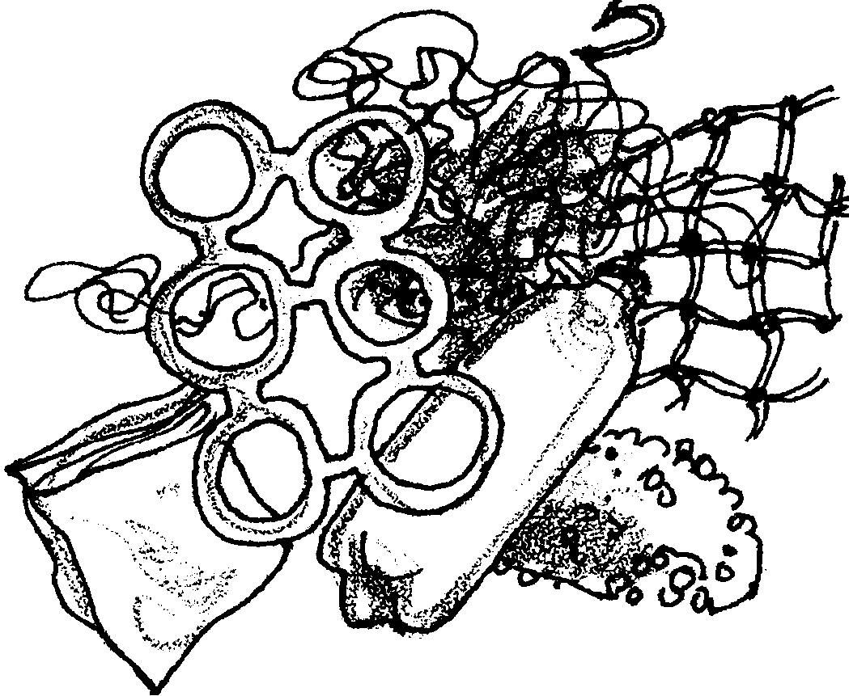
Plastic Trash Can
Hurt Sea Animals

Write a story about plastic trash in the ocean. How did it get there? What happened to the sea lion? What could happen to the sea lion? What can be done?

Marine Mammals in the Garbage
Do Your Part
Think what fun it is to go to the beach! There are so many things to do and see.
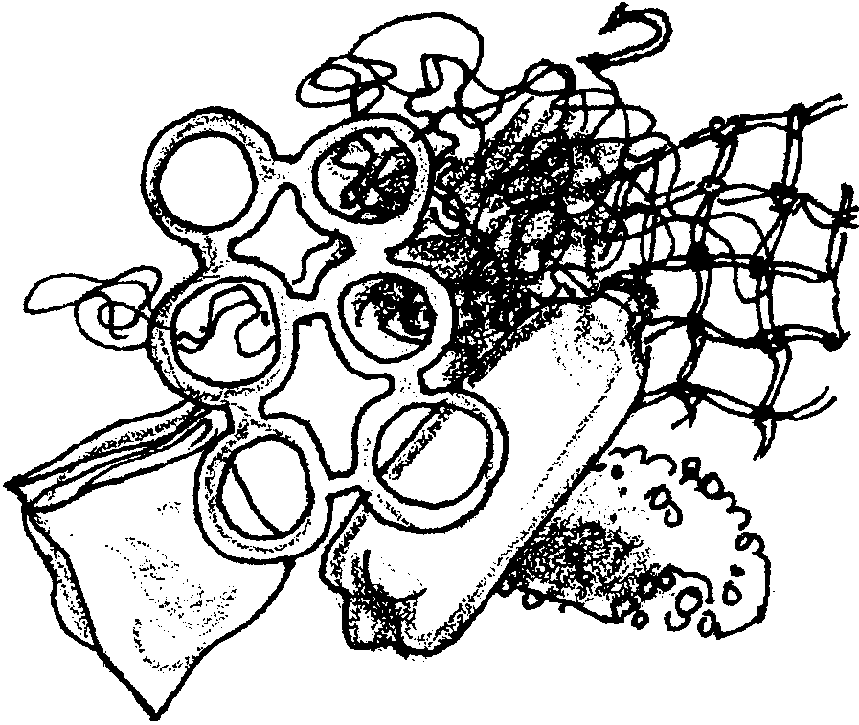
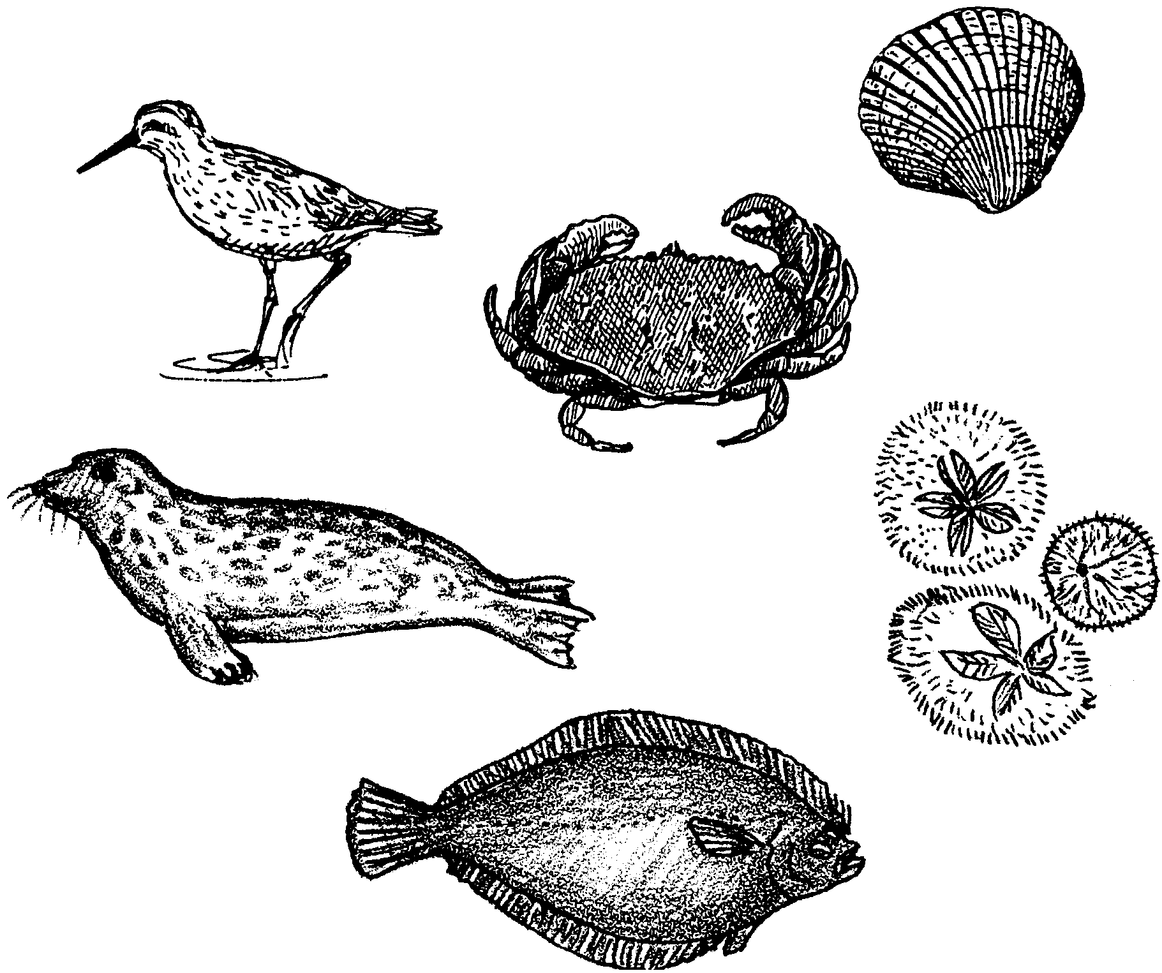
During your trip to the beach you will sometimes find litter. People leave pop cans, plastic bags, bottles and other things. Some of this litter can be harmful to the sea animals.
1. Where does litter belong?
.

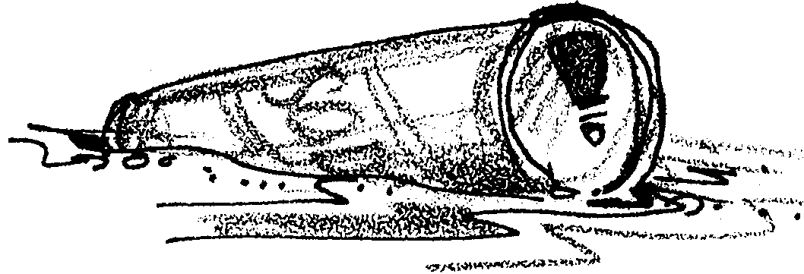
Litter spoils the way the beach looks. Some litter is tossed overboard by boaters. It washes ashore.

2. What should boaters do with litter?
.

Litter can be dangerous for people. People leave glass on the beach. How would you feel if you cut your foot?

After a fun day, you will go home from the beach. Remember that the crabs, sea stars, clams and oysters have homes too. Put them back close to their homes. Their homes are where you found them. Then the next time you come to the beach you will be able to find your friends again.

Boy: Come on! Let’s go home. It’s no fun playing in trash.

Girl: I agree! Next time we come, let’s bring some bags to pick up some of this stuff.

Boy: Good idea!

(Boy and girl exit.)

Cast: (The cast all come on stage carrying a sign and reading in unison the following message.) The moral of this story is:

PLEASE DON’T THROW TRASH INTO THE OCEAN.
IT’S HARMFUL TO ANIMALS AND PEOPLE,
AND IT DOESN’T GO AWAY.

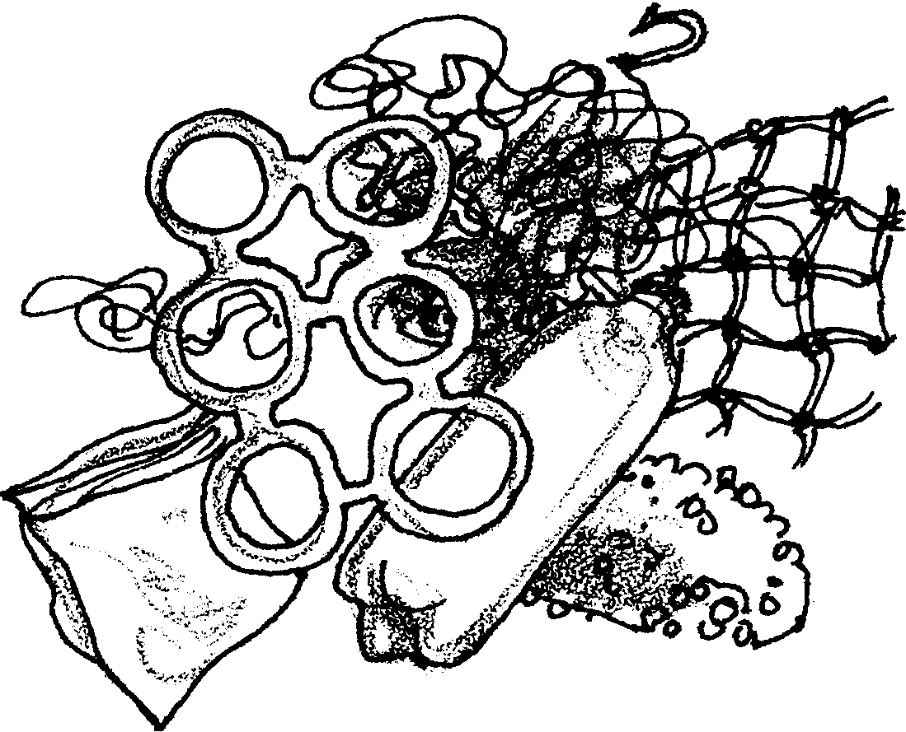

Plastic Trash Can Hurt Sea Animals

Dear Parents,

We are studying plastic trash. Please help us with this lesson by saving your family’s plastic trash (every piece) for one day. Please help your child clean the plastic containers and pack the collected plastic trash in sturdy bags for the trip to school.

CAUTION! Children should NOT handle plastic containers that have contained toxic chemicals. If these containers are part of the day’s plastic waste in your home, have your child count these and record the number for inclusion in his or her total, instead of bringing the actual containers.

