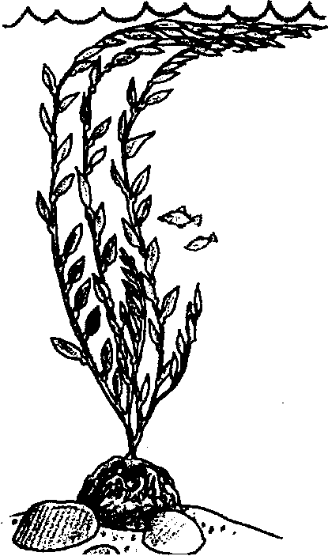
Urchins, Kelp, and Otters

Key Concepts
1. Sea otters, sea urchins and kelp form a dynamic, interdependent community.
2. As the numbers of otters decreased during the years of hunting, the number of sea urchins increased, causing a large reduction in the size of the kelp forest.

Background

Sea otters are especially fond of eating the large red sea urchins (Strongylocentrotus franciscanus) often found in kelp forests. They usually eat all they can find in one area and then move on to find more.

The sea urchins, in turn, like to dine on the kelp. They usually attack the holdfast and eat the lower parts of the plant, causing it to become detached and eventually die. So, if the otters eat most of the urchins, the kelp is free to grow to great heights and density. In a sense, it can be said that the otters help to produce and maintain a healthy kelp forest.

When the otters were almost exterminated in the 19th century, this balance was destroyed. In the absence of otters, the urchins reproduced and multiplied, and, in the process, consumed and destroyed many large beds of kelp. Since kelp is harvested for algin and also provides protected habitat for young fish, this destruction was viewed as a disaster.

Because of its importance to inshore kelp communities, the otter has come to be called a “keystone” species. As the otter population slowly increases, we hope to see a return to “normal” conditions in the kelp forest.

Materials

For each pair of students:

• 30 3"x5" cards, all the same color, or “Urchins, Kelp and Otters” card set

• markers
Teaching Hints

In “Urchins, Kelp and Otters”, students make game cards and then play a matching game to learn about the interactions among these three organisms. Before starting the activity, give students a summary of the information above.

Procedure

1. Each student will start with 15 blank 3"x5" cards. Have them write “Urchin” (or make a simple drawing of an urchin) on 5 of them, “Kelp” on 5 and “Otter” on 5. (Optional: copy, cut, and laminate ten “Urchin, Kelp and Otters” card master sheets for each pair of students.)

2. One student of each pair will shuffle all 30 prepared cards thoroughly and then deal 5 cards to each player, who does not look at the cards. The remaining cards in the deck will stay face down on the table.

3. The first student turns over one of his/her cards without looking at it first. The second student then does likewise. Depending on the combination found, the following possible actions occur:

otter and kelp leave both cards on table and play again

otter and urchin otter “eats” urchin (takes both cards as well as
any cards on table)

urchin and kelp urchin “eats” kelp (takes both cards as well as
any cards on table)

otter and otter put both cards face down on deck

urchin and urchin put both cards face down on deck

kelp and kelp put both cards face down on deck

When one player runs out of cards, he/she shuffles the face down deck and deals 5 cards to each player. The game continues as above until there are no longer any cards in the deck and one player has lost all his/her cards.

4. The students may notice that sometimes it seems as if the otters are “winning”; at other times it may be the urchins. In real life, there are seldom clear winners or losers either. And, just as in a game, each action in the kelp forest affects every other action. Often a long period of time is necessary before the “result” can be observed, much less understood.
“Urchins, Kelp, and Otters” Game
Card Masters - To make a complete card set, copy, cut, and laminate ten sheets which will yield 30 cards, ten each urchin, kelp, and otter. One set is needed per pair of students.
