Sea Otter Style
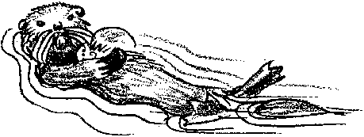
Lesson by Libby Palmer, Port Townsend, WA

Key Concepts
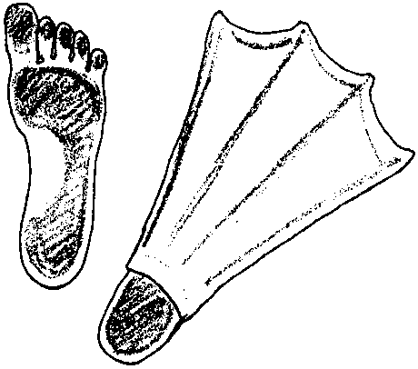
1. Sea otters are marine mammals, like whales, seals and dolphins, but are more closely related to weasels.
2. Sea otters are important residents of the kelp forest, contributing to a complex web of inter-relationships among kelp, sea urchins, abalone, fish and humans.

Background

For hundreds of years, sea otters have fascinated humans. Sometimes confused with seals if seen from a distance, sea otters are physically very different from seals. Scientists group sea otters (Enhydra lutris) in the family Mustelidae, along with weasels and minks, but they are the only member of that family to spend their entire lives in salt water.

Sea otters can grow to be 5 feet long and weigh up to 100 pounds. Their front feet have retractable, cat-like claws which leave telltale marks as part of any sand tracks they might leave. Their back feet are flipper-like, to enable them to move through the water faster, and their tail is slightly flattened as well. This enables them to use their tail as an oar or as a steering device, moving it in a back-and-forth sculling motion.

Unlike seals or whales, sea otters do not have a layer of blubber beneath their skin. However, their fine, thick fur (the thickest of any mammal) traps air bubbles and provides a layer of insulation if kept clean. An otter spends many hours grooming itself to maintain that insulating layer. Thick fur (a physical adaptation) coupled with grooming (a behavioral adaptation) mean that oil spills present a dual threat to otters. If an otter runs into an oil spill, the oil will mat its fur, making it impossible for air bubbles to be trapped. No air bubbles means greatly reduced insulation and the chances that the otter will die of hypothermia increase dramatically. Making matters worse, as the otter grooms to remove the oil from its coat, it ingests the toxic oil.

To maintain their body temperature, otters also have to eat a great deal; much of their day is therefore devoted to food gathering and eating. Fortunately, a healthy kelp forest and the relatively shallow ocean floor nearby provide many of the otter’s favorite foods: sea urchins, abalone, clams, mussels and occasional bottom fish.
The otter uses its paws to loosen an urchin or other shellfish from the rock or crevice in which the shellfish lives and then uses its teeth to crack open the shells. But the sea otter has also become famous for another way of cracking shells. It actually uses a “tool”, and is one of the few animals to do so. Otters have been observed returning to the surface from a dive with a clam or mussel and a large rock. Lying on its back, the otter places the rock on its stomach and then cracks the clam or mussel shell against it. It then uses its sharply pointed teeth to extract the meat, after which it discards the shells.

Another fascinating feature of sea otters is how they hold food during their dives. As they gather food in the deep, they store it in a pouch of their armpit until they can return to the surface to eat. They rarely eat or rest on shore or even on a rocky promontory, partly as a result of almost two centuries of being hunted for their fur. They prefer to eat, play, give birth and raise their young in the water, amidst the protective fronds of kelp. They even sleep in the kelp forest, sometimes wrapping fronds around their bodies to hold them in place.

Sea otters can survive in deeper water as well. The kelp beds they inhabit are usually 10-30 meters deep but otters can dive down to 40 meters and can stay down for up to 4-5 minutes. When not gathering food, otters seem to prefer floating, grooming, chattering and playing with other otters at the surface.

Otters have long been hunted for their fur but in 1742, large-scale hunting began along the entire West Coast of North America. By the end of the 19th century, they were almost extinct. In 1911, Canada, Russia, Japan and the United States signed a treaty agreeing to cease the hunt. Since then the population of sea otters has slowly increased but has still not reached its earlier levels.

Often, sea otters are confused with river otters. The latter are common in both fresh and saltwater environments but are not considered a marine mammal. They are usually smaller, never float on their backs, have small non-finlike feet and a long thin tail. They are frequently seen on docks and sandy beaches, and sometimes playfully sliding down plant-covered banks.

Materials

Part 1: Big Foot

For each pair of students:

• 4-6 sheets of centimeter graph paper

• pencil

• tape

For class to share:

• pair of swim fins, preferably child size

• tub or vat filled with water, deep enough for students to try using the fins on their hands

Part 2: The Original Hard Rock Cafe

• large stable rock or concrete surface (playground or sidewalk)

• 4-6 empty shells from clams, mussels or abalone

• safety glasses or goggles

Teaching Hints

In “Sea Otter Style”, students use their own bodies to gain an understanding of the importance of greater surface area in swimming; they also try getting food “sea otter style”. Part 1 focuses on the flipperlike hind feet of the otter. Students determine the area of their own feet and then the area of a typical sports fin. They also examine the difference in ease of movement in each case. Part 2 gives the students a chance to try breaking different types of shells on a rock, to simulate the action of the sea otter as it feeds.

Part 1: Big Foot

Procedure

1. One student in each pair removes his or her shoes and stands on the centimeter graph paper. His or her partner then uses the pencil to trace the outline of one foot on the paper.

2. Have each pair count the number of square centimeters contained within its outline. The pencil line will go through some squares; let the students figure out how best to count those parts of squares. Be sure they record the total number of squares counted (i.e., the area in square centimeters) on the Student Worksheet.

3. Have partners switch places and repeat steps 1 and 2.
4. Now, have one student of each pair put on one swim fin and repeat the outline and counting process. (If necessary, tape two pieces of graph paper together to accommodate the swim fin.) Have them record the total area on the Student Worksheet and compare the results.

5. Ask the students to gather around the tub in groups of 6-8. Have each run one hand (easier than using a foot, but stress the similarity) back and forth through the water, feeling the water resistance and pressure. Now have them do the same thing wearing the fin on their hand. Discuss the differences experienced.

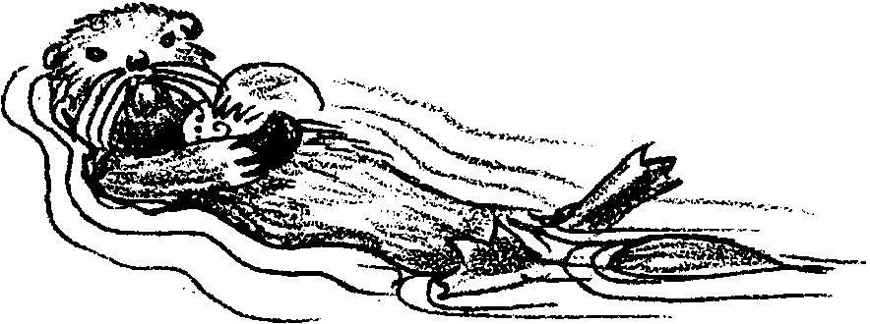
Note: Be sure to tell students that otters’ hind feet are flipper-like but are not as large as the swim fins used in this experiment.

Part 2: The Original Hard Rock Cafe

Part 2 gives your students a chance to try breaking different types of shells on a rock as they simulate the action of the sea otter as it feeds. Caution students regarding the possibilities of flying shell bits and be sure that they wear safety glasses or goggles.

1. Ask students to try breaking one of their shells by pounding it on the concrete or rock surface. (Remember that the sea otter holds the rock on its stomach and breaks the shell while it floats on its back, so dropping the shell from a height isn’t acceptable!). After they have made a trial or two, ask them to observe the shell carefully. As they do, you may wish to prompt them with questions such as:

Is one part thinner or weaker than another?

How can you use that knowledge to break the shell more easily?

2. Have them break the remaining shells, trying to do so in the fewest number of moves possible. So that you can compare the effectiveness of the different “otter” strategies, have one partner count and record the number of moves of the other. Have enough shells so that partners can switch roles.
Key Words

hypothermia - dangerously low body temperature

retractable - capable of being pulled completely in or being extended

webbed - in this case, having flaps of soft skin between the toes

Extensions

1. Invite a SCUBA diver to class, asking her/him to bring all of the equipment necessary for diving. Have the diver explain how it is all used, stressing that humans have had to invent these aids to diving since we are not adapted to life in a marine environment. If possible, allow time for the students to try on several pieces of the equipment. Discuss how a “wet suit” or “dry suit” insulates the diver from cold water just as the fur does for sea otters.

2. Have several live mussels, clams, abalone and sea urchins in an aquarium. Examine them closely and discuss the feasibility of cracking their shells as above. Do not actually do it.

Answer Key

1., 2. Answers will vary depending upon experimental results.


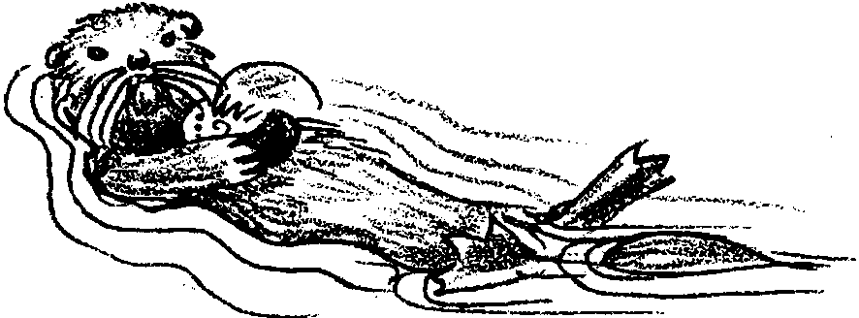
Sea Otter Style

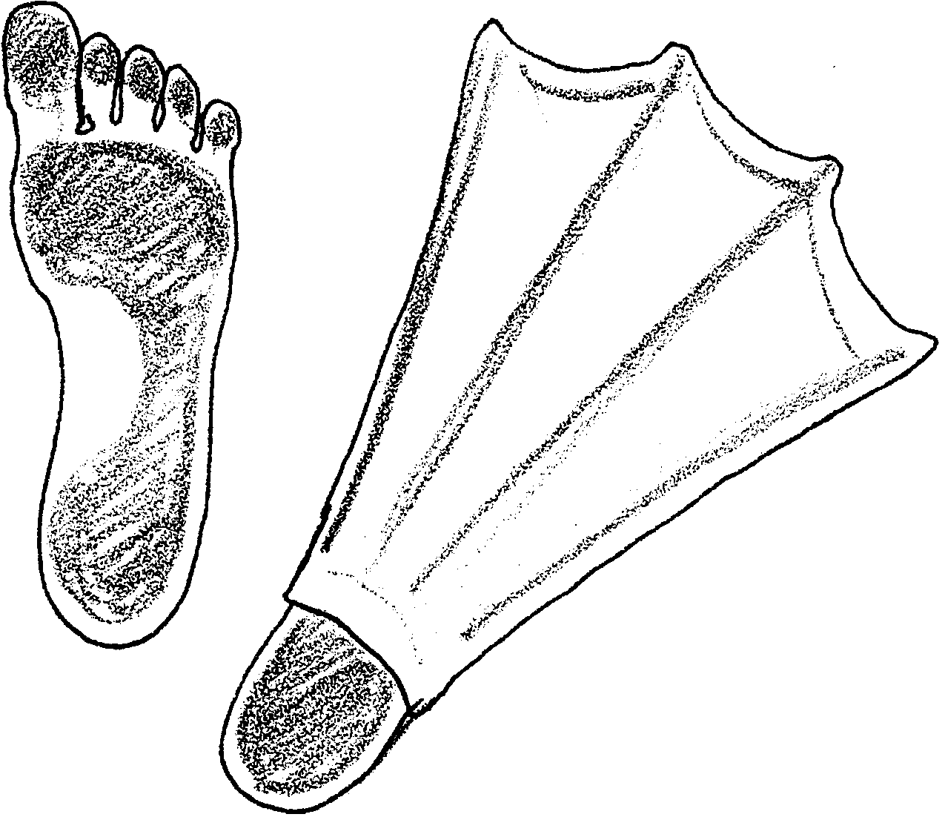

1. The area of my foot was sqaure centimeters.

2. The area of the swim fin on my foot was
square centimeters.

