Fishing Boats

Key Concepts
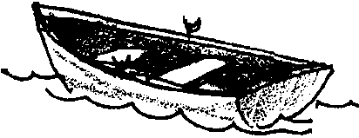
1. Fish are collected by people for use as food.
2. People use the aquatic environment.
3. Waterways are used for the transport of goods and people.

Background

For thousands of years, people have collected fish for food. As it is today, during much of that time people made and used boats for transportation and food gathering. Proximity to aquatic environments and the availability of aquatic resources have influenced the values, religion, lifestyles, politics, science and technology, arts and humanities of cultures. Waterways have served as routes for the dispersal and concentration of human populations and cultures and for military and commercial transport.

Materials

For each pair of students:

• two milk cartons

• drinking straw

• paper

• scissors

• glue or staples

• rubber band

• two hairpins

• “Fishing Boats” activity pages

Teaching Hints

In “Fishing Boats”, students make simple boats and experiment with their ability to carry loads. This fun activity can easily be expanded to include buoyancy, floatation, and other related concepts.

Duplicate the activity pages. One set is recommended per student. Caution your students on the use of scissors and supervise the cutting of the cartons.
Allow ample time to help those students who need it. You can provide completed boats to serve as models. Have your students decorate their creations. Discuss the basic concepts covered and provide time for a discussion of the results and to answer the questions.

Key Words

hull - the hollow, lowermost portion of a ship, floating partially submerged and supporting the remainder of the ship

lengthwise - in the direction of the length

load - anything put in or on something for conveyance or transportation; freight; cargo

mast - a pole rising above the hull and upper portions of a boat to hold sails, etc.

paddle wheel - a wheel for propelling a ship, having a number of paddles entering the water more or less perpendicularly

Answer Key

Sail Boats

6.a. Predictions will vary.

c. The amount carried depends upon the individual boat but can be surprisingly high. They carry flat, low loads best.

Power Boats

6.a. Predictions will vary for the powerboat also.

b. Again, the amount depends upon the individual boat.

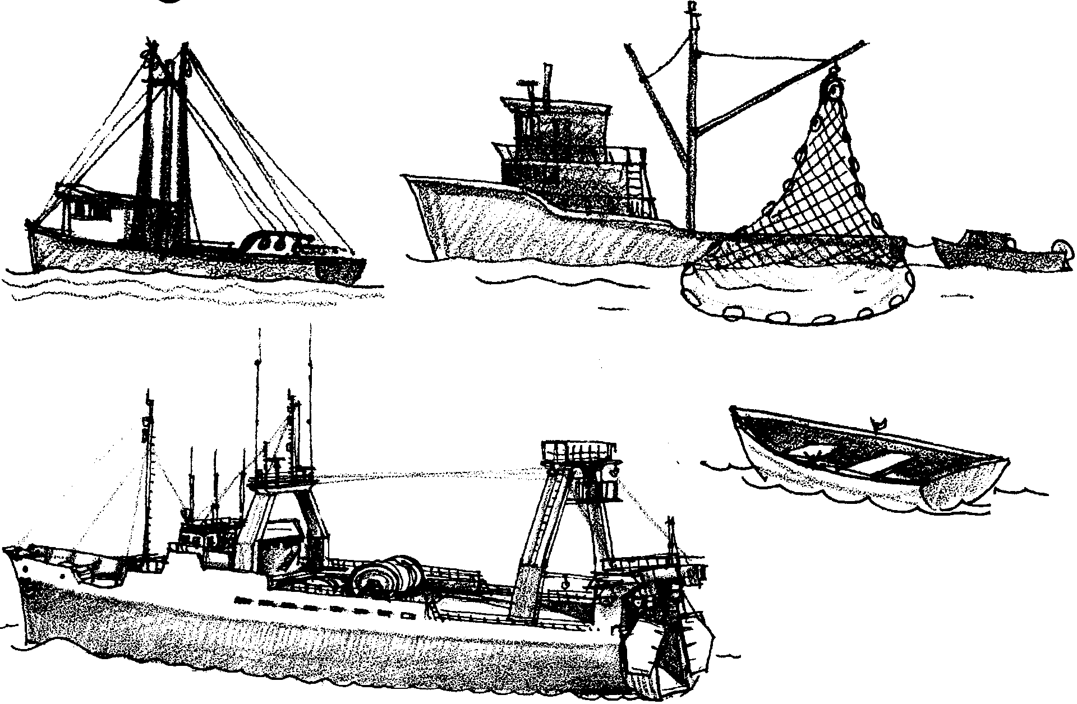
Fishing Boats

Fishing boats come in all shapes. You can make your own fishing boats. Here is what you’ll need:

Materials
two milk cartons
drinking straw
paper
scissors
glue or staples
rubber band
two hairpins
Here is how to make your first boat:

Procedure
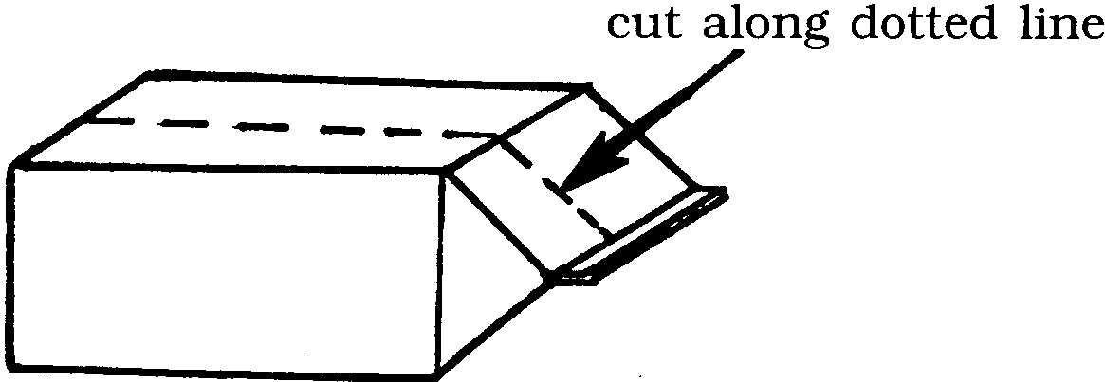
1. Cut your carton in half lengthwise.

These will be the hulls.

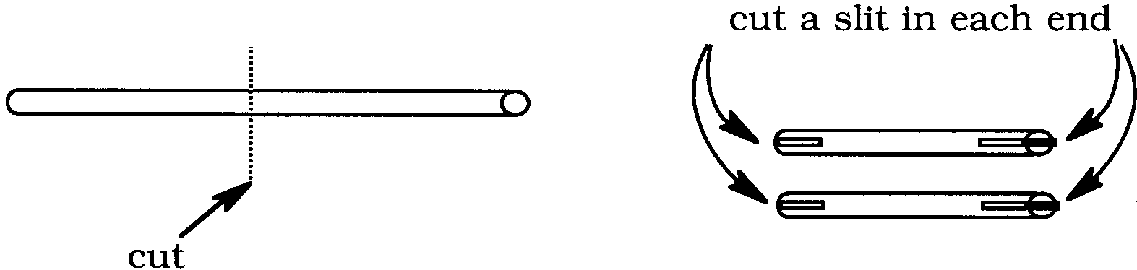
2. Cut a straw in half. Cut a slit in each end of the straw pieces.

These will be the masts.

3. Cut a piece of paper for the sail.
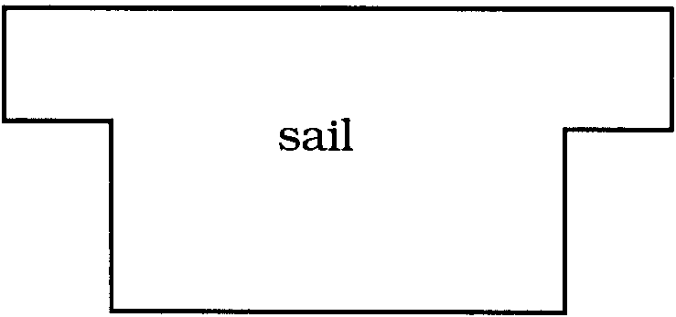
4. Slip one straw onto each side of the hull. Glue or staple them in place.
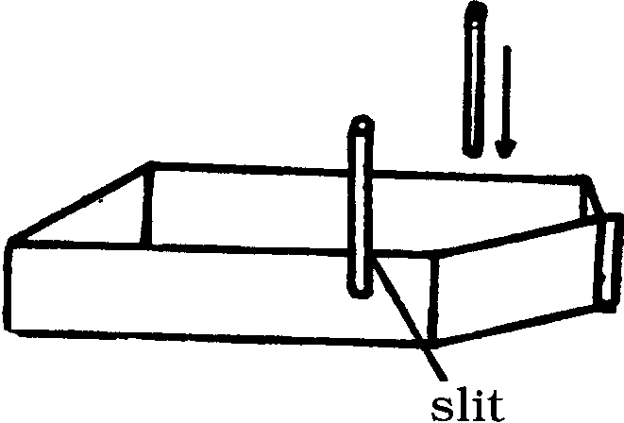

5. Slip your sail into the top slits of the masts.
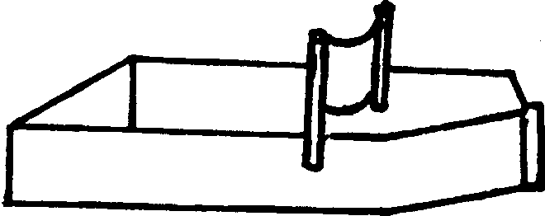

6. You are now ready to sail.

a. How many fish do you think your sail boat can carry?
.

b. Try it and see.

c. How much can it carry?

.
Most modern fishing boats have motors. Use the second hull to make a motor boat. Here is how to do it:


1. Make a paddle to fit your boat. Use parts of another milk carton. Cut two rectangles. Cut each rectangle halfway up the middle.

Slide the two rectangles together to make the paddle wheel.
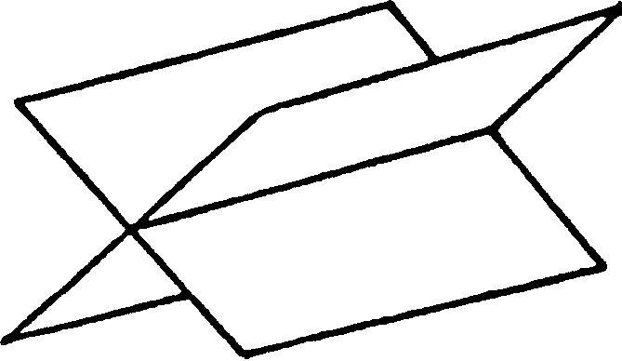

2. Put your rubber band on your paddle wheel.
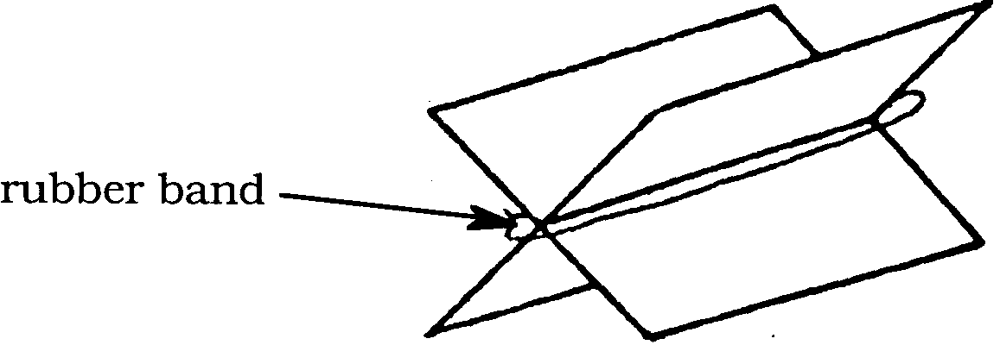

3. Slip one hairpin through each end of the rubber band.
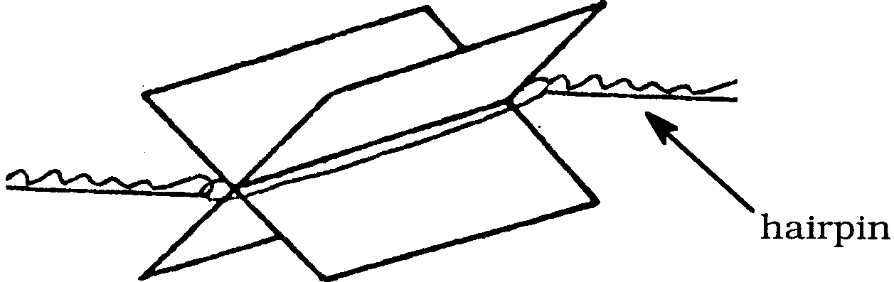

4. Cut two squares from the extra carton paper. Glue or staple these pieces on the sides of your hull next to the back. The hairpins will attach to these squares.

5. Attach the paddle. Do not let the paddle touch the hull.
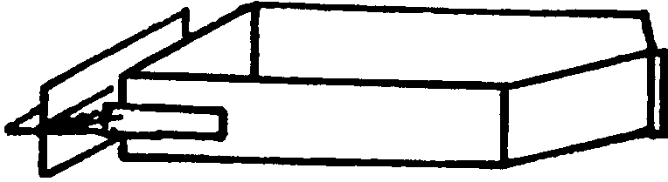

6. Wind the paddle. Put the paddle below the water level. Let’er go!

a. How many fish do you think your power boat can carry?
.

b. Try it and see.

c. How much can it carry?

.

d. Can it carry more or less than your sailboat?

.

