
Shark!
Lesson by Pat Rutowski, Monterey, CA

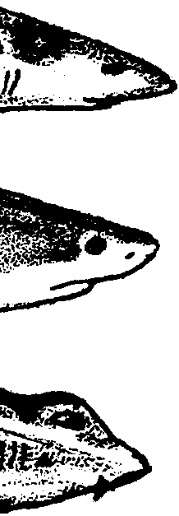
Key Concepts
l. There are many kinds of sharks and not all are large “man-eaters”.
2. Sharks live in all the oceans of the world and eat a variety of food.
3. Many types of sharks may soon become endangered from overfishing.
4. People have many ideas about sharks that are not true.

Background

Sharks are the most misunderstood of fish and perhaps of all animals. Although only a few types of sharks make relatively infrequent attacks on humans, the whole group is thought of as blood thirsty man-eaters. On the coast of California, only 95 people have been attacked by sharks since 1926 and only six of these people died. Worldwide only 50 to 75 people each year are attacked by sharks with only 5 to 10 of those attacks being fatal. More people die every year from elephant stompings than from shark attacks.

In contrast, people kill sharks for food and other products, and also in “sport”. For every person killed by a shark, humans kill more than ten million sharks. If this number of sharks continues to be harvested, recent reports predict that 22 large, coastal species of sharks, including the Great White, Hammerhead and Tiger, may be extinct in the next 10 years.

Sharks live all over the world and frequent a great variety of habitats. While few sharks live exclusively in kelp forests, kelp forests do provide habitat, shelter and food for numerous animals upon which sharks feed.

Materials

For the class:

• large gameboard

• 7 “Trouble” cards

• 22 “Shark!” cards

• 6 shark identification tags with strings attached to hang around students’ necks

• l die

For each student or pair of students:

• “Sharks! - Sizing Up Sharks” activity pages

Teaching Hints

In “Shark!”, students play a game which provides new information about sharks and, hopefully, a new appreciation of this much maligned animal.

Preparation

l. Replicate the gameboard as large squares which can be placed together on the floor. NOTE: The “Trouble” and “Shark!” squares should be colored to match the cards.

2. Write or duplicate “Trouble” and “Shark!” cards. Use a different color for each card set.

3. Make shark identification tags with strings long enough to hang around the students’ necks.

Procedure

l. Begin by giving each team a different shark identification tag. Read aloud, or have a student read aloud, the information on each card.

2. Examine the gameboard with students. Explain that a person from each team (wearing the identification tag) will serve as a “game marker” to indicate the team’s position on the board. As the game progresses, students can rotate through this role.

3. Play the game using the following rules:

a. Place the two sets of cards (“Trouble” and “Sharks!”) face down in piles for you or a student to read.

b. Players move according to the throw of the die.

c. When a “game marker” lands on a “Shark!” or “Trouble” square, the appropriate card is turned over and read aloud.

In the cases of a “Shark!” card, the “game marker’s” team decides whether the statement on the card is true or false. If the team’s answer is correct, the “game marker” moves ahead. If the answer is incorrect, the “game marker” remains in the same place.

In the cases of a “Trouble” card, the “game marker” follows the directions on the card.

If a “game marker” lands on a habitat square where his or her shark lives, they are “home” and go immediately to the end.

d. The first team to go around the board is the least endangered, most successful, shark species.

4. Use the “Sizing Up Sharks” student worksheet as a review. If students are unfamiliar with graphs, you may need to explain their role in presenting information.

The idea for this lesson came from an activity by The Seattle Aquarium’s “Puget Sound on Wheels” program.

Key Words

crustaceans - the group of arthropods (animals characterized by a hard outer skeleton and jointed appendages) that includes shrimp, lobster, and crabs

dorsal - on the back

endangered - animals or plants threatened with extinction

extinct - no longer in existence

overfishing - fishing which results in more fish being removed from the population than are added by reproduction resulting in a depletion of the fish stock

Extensions

1. Have students research and write their own “Trouble” and “Shark!” cards for the game.

2. Have students draw an ocean without sharks. What effect would the elimination of sharks have?

3. Discuss fears that students have about different animals, plants and other things. Why do they have these fears? Do they have reasons for all of these fears? Discuss the role of television and movies.

4. For practice in reading and interpreting graphs, have students complete the student worksheet, “Sizing Up Sharks”.

5. Have students follow these directions to construct a “Shark Electric Board”:
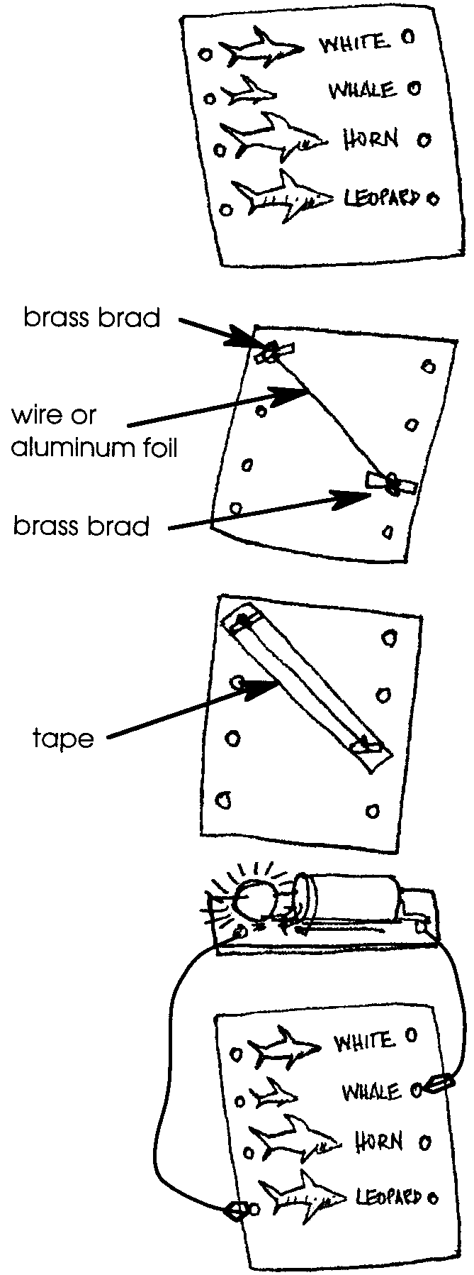
a. Provide of different sharks. Cut out the shark pictures and glue them, in a column, onto the front of a file folder. In another column, list the names of the sharks, but in a order different from the order of their pictures.

b. Put a brass brad through the cover of the folder, next to the picture of a particular shark (i.e., a basking shark). Also, place a brad in front of the shark’s name in the other column.

c. On the other side of the paper, run a piece of very fine wire or a strip of aluminum foil to connect the two brads.

d. Make certain the wire or foil firmly connects with the brads. Cover the entire wire or foil with masking tape so that it cannot touch any other wires.

e. Repeat steps b. to d. for each of the remaining sharks. To avoid confusion, do sharks one at a time, until they are all hooked up.

f. Connect a flashlight battery/light bulb circuit or use a purchased circuit tester (available at Radio Shack and most hardware stores) which will light up when one wire touches the brad next to a shark picture and the other wire touches the brad in front of that shark’s name.
Shark Identification Tags

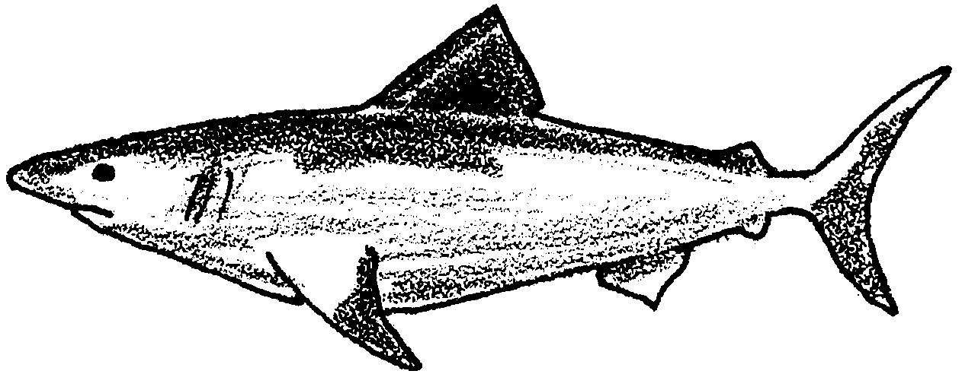

Great White Shark

• I have a heavy, gray body.
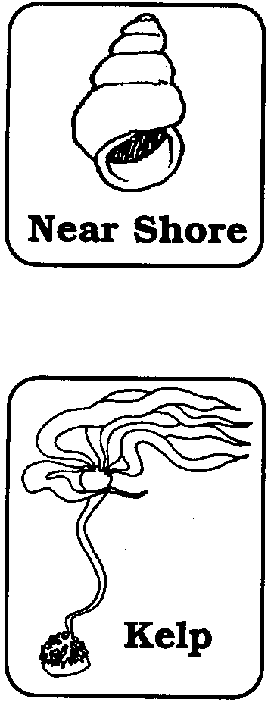
• My tail is half-moon shaped.

• I live in cool ocean waters near the shore.

• I often swim near where seals live.

• Seals, dolphins, large fish and other sharks are my food.

• I hunt around the edge of the kelp forest.

• I can be 23 feet long.

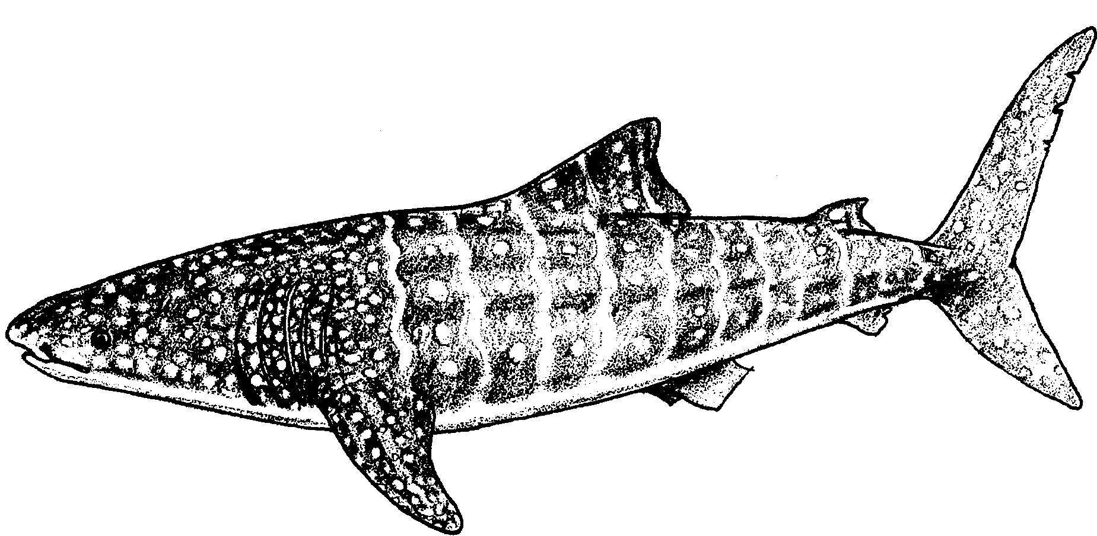

Whale Shark

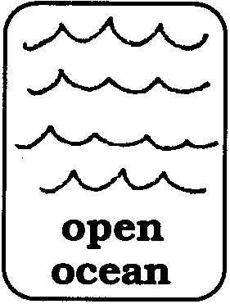
• I am huge.

• My skin has spots and bars.

• I live in the warm, open ocean.

• I eat plankton.

• I can be 60 feet long!

• I am the largest fish.

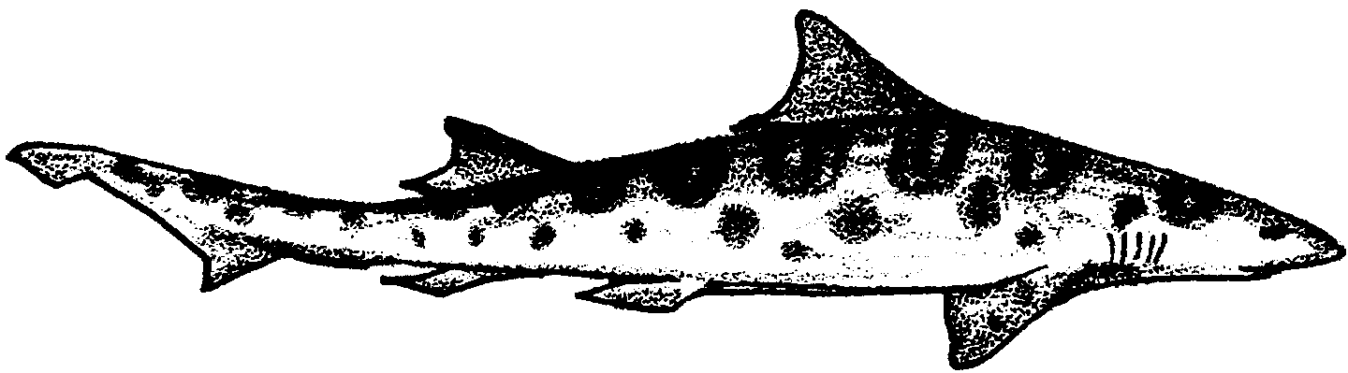

Leopard Shark

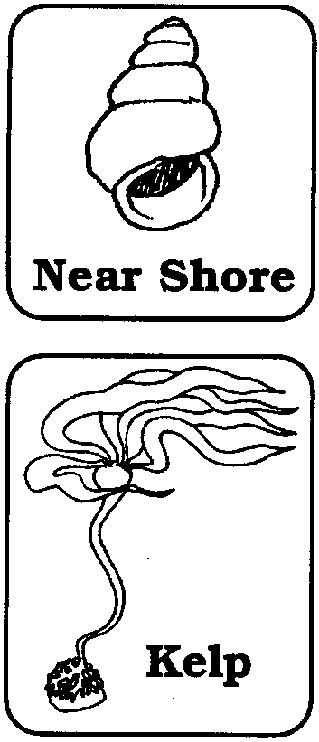
• I am gray with black spots.

• I swim in schools.

• I live in cool, near shore ocean waters.

• I am found in the kelp forest.

• Small fish are my food.

• I can be 7 feet long.

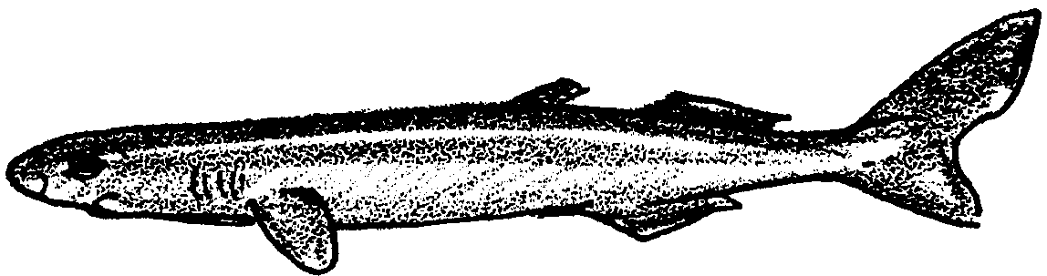

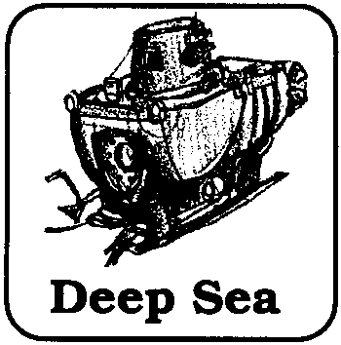
Pygmy Shark

• I am tiny and black.

• I live in the deep sea.

• Small fish and squid are my food.

• I only grow to be 10 inches long.

• I am the smallest shark.

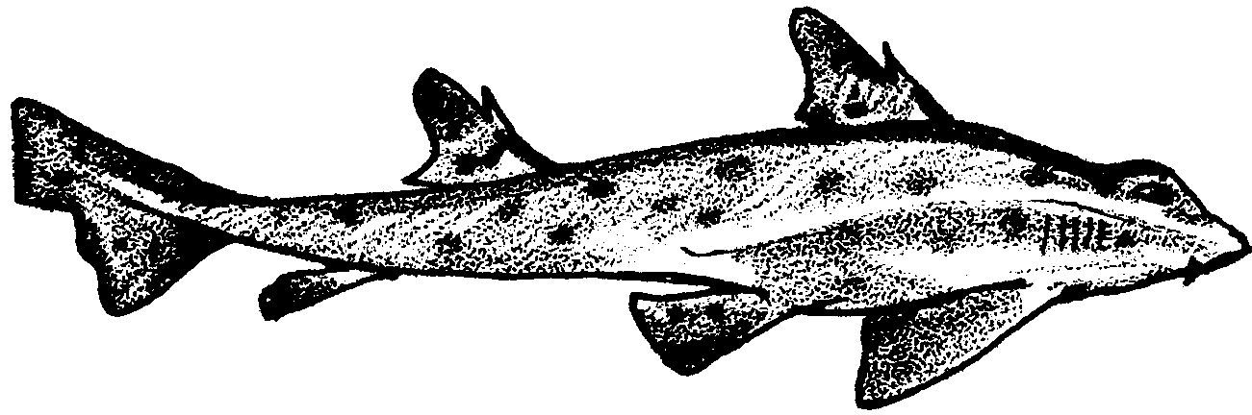

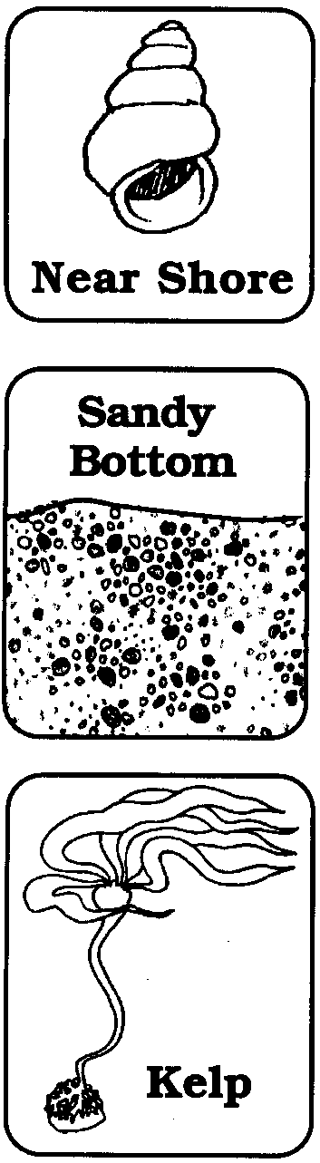
Horn Shark

• My gray skin is spotted.

• My back fins have a spine.

• I live in near shore ocean waters.

• I live on sandy bottoms.

• I also visit the kelp forest.

• Crabs and small fish are my food.

• I can be 4 feet long.

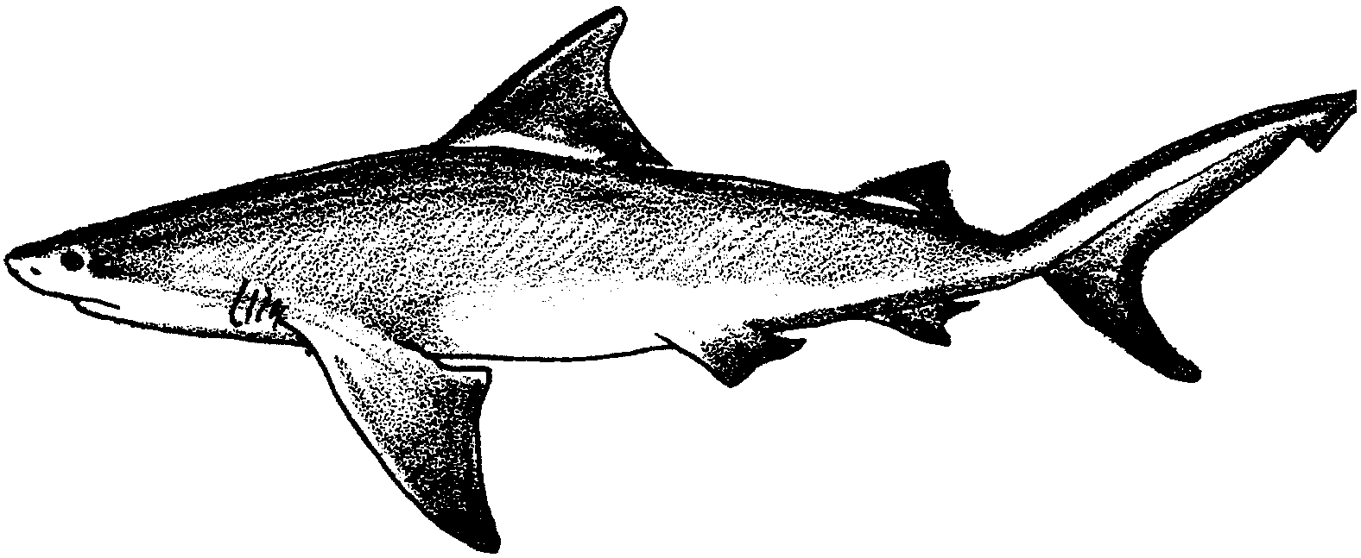

Bull shark

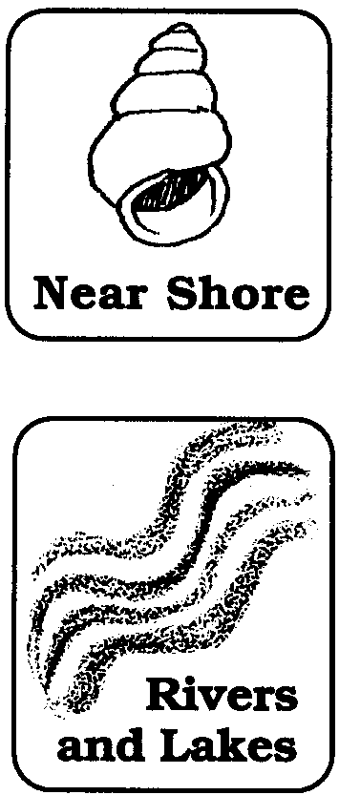
• I have a round body and flat nose.

• I live in warm, near shore ocean water.

• I also live in rivers and lakes.

• Fish are my food.

• I can be 11 feet long.

Trouble Card
1. A fisherman cuts of your fins. Your fins are used to make soup. He throws you back in the water to die. A new shark must start at the beginning.
Trouble Card
2. You get eaten by a great white shark. A new shark must start at the beginning. If you are a great white shark, go to the closest "shark" square.

Trouble Card
3. You are hit by the propeller of a boat. You have bad cuts. Lose the next turn while resting.
Trouble Card
4. You are caught in a shark fishing derby. You are left to die on the bank. Peoplae want to see how big you are. A new shark must start at the beginning.
Trouble Card
5. You are killed by a fisherman. You are one of the over 100 million sharks killed each year. A new shark must start at the beginning.
Trouble Card
6. You get caught in a net. It slows you down. Lose a turn.
Trouble Card
7. You swallow a plastic bottle. It fills up your stomach so you can't eat. Lose a turn.

Fold here; glue or laminate
sides together
Back of card
Front of card
Shark!
Sharks are hard to kill.

False. Sharks die easily from stress. They often die in the nets of fishermen or on hooks.

False. Some sharks can pump water over their gills to keep breathing even when laying on the bottom.

Shark!
All sharks have to swim constantly.

Shark!
Sharks are found only in saltwater.

False. Bull sharks live in freshwater rivers and lakes.

Shark!
Sharks lay eggs.

True. Some sharks lay egg cases while others give birth to live young.

Fold here; glue or laminate
sides together
Back of card
Front of card
Shark!
All sharks are harmful to people.

False. There are about 350 kinds of sharks. Aalmost 300 of those are not able to hurt people.

False. Sharks can be found in all oceans of the world.

Shark!
Sharks live only in warm parts of the ocean.

Shark!
Sharks have no enemies.

False. People catch over 100 million sharks every year. They are eaten or used for fish oil, fertilizer, glue and leather goods. Sharks are eaten by other sharks. They are also eaten by killer whales, birds and even sea turtles.

Shark!
All sharks are man-eaters.

False. Each year only about 100 people are attacked by sharks. A person is more likely to die from a bee sting.

Fold here; glue or laminate
sides together
Back of card
Front of card
Shark!
Sharks are able to smell blood in the water.

True. Sharks can smell tiny amounts of blood in the water. They can smell it from up to 1/2 mile away.

False. Sometimes sharks are found with rubber tires, bottles and tin cans in their stomachs. The only way they can get rid of these things is to throw them up.

Shark!
Sharks can eat and digest anything.

Shark!
Sharks are fish.

True. But unlike most fish they do not have hard bones. They have cartilage instead.

Shark!
Sharks are part of the whale and dolphin family.

False. Sharks are fish not mammals. They do not feed their babies with milk.

Fold here; glue or laminate
sides together
Back of card
Front of card
Shark!
Sharks are covered with little teeth.

True. Shark scales are like little teeth.

True. They have rows of smaller teeth behind the ones in front.

Shark!
Sharks can replace theur teeth.

Shark!
The largest shark eats plankton.

True. The whale shark is the largest shark and the largest fish. It filters small fish and crustaceans out of the water for its food.

Shark!
All sharks have one large dorsal fin.

False. Some sharks have two small dorsal fins near their tail.

Fold here; glue or laminate
sides together
Back of card
Front of card
Shark!
Biologists think that 22 large shark species may go extinct in the next 20 years because of overfishing.

True.
False. Someone thought a shark jaw they found was from a 36 foot long shark. But the largest specimens ever caught and measured were between 19 and 21 feet.

Shark!
Great white sharks can grow to up to 36 feet in length.

Shark!
In California, only 96 peolple have been attacked by sharks since 1926 and only six of these people died.

True. More people die from elephant stompings than from shark attacks.

Shark!
For every human life a shark takes, humans kill more than ten million sharks.

True. People kill over 100 million sharks each year.

Fold here; glue or laminate
sides together
Back of card
Front of card
Shark!
More people die from elephant stompings each year than from shark attacks.

True.
False. People catch 7,000 tons of shark every year to eat. In some places, the fins sell for $100 each.

Shark!
People never eat sharks because they taste bad.

SHARK! Gameboard Pattern
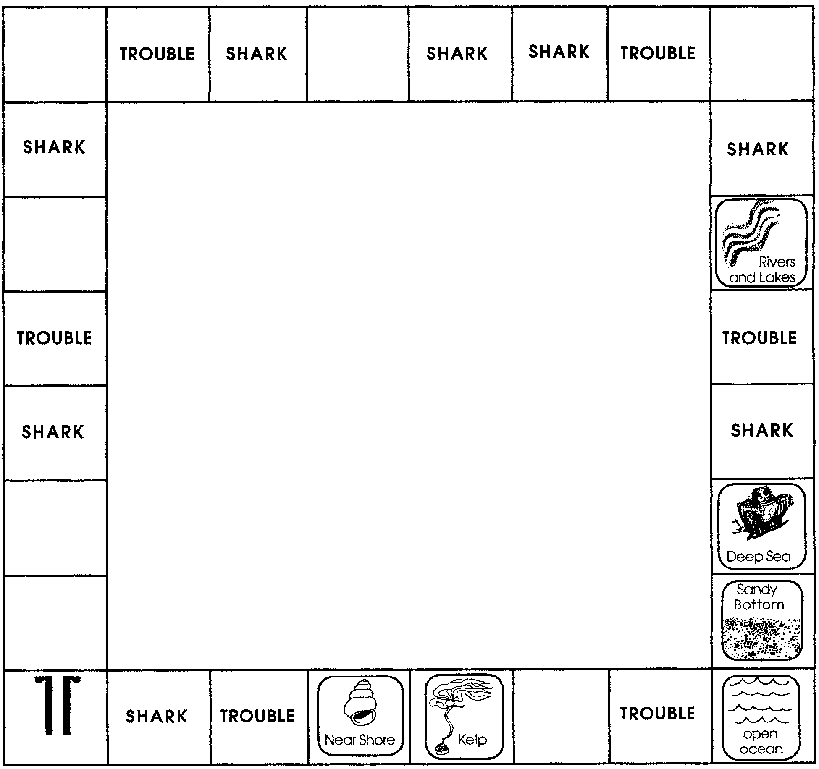

Shark!

Sizing Up Sharks

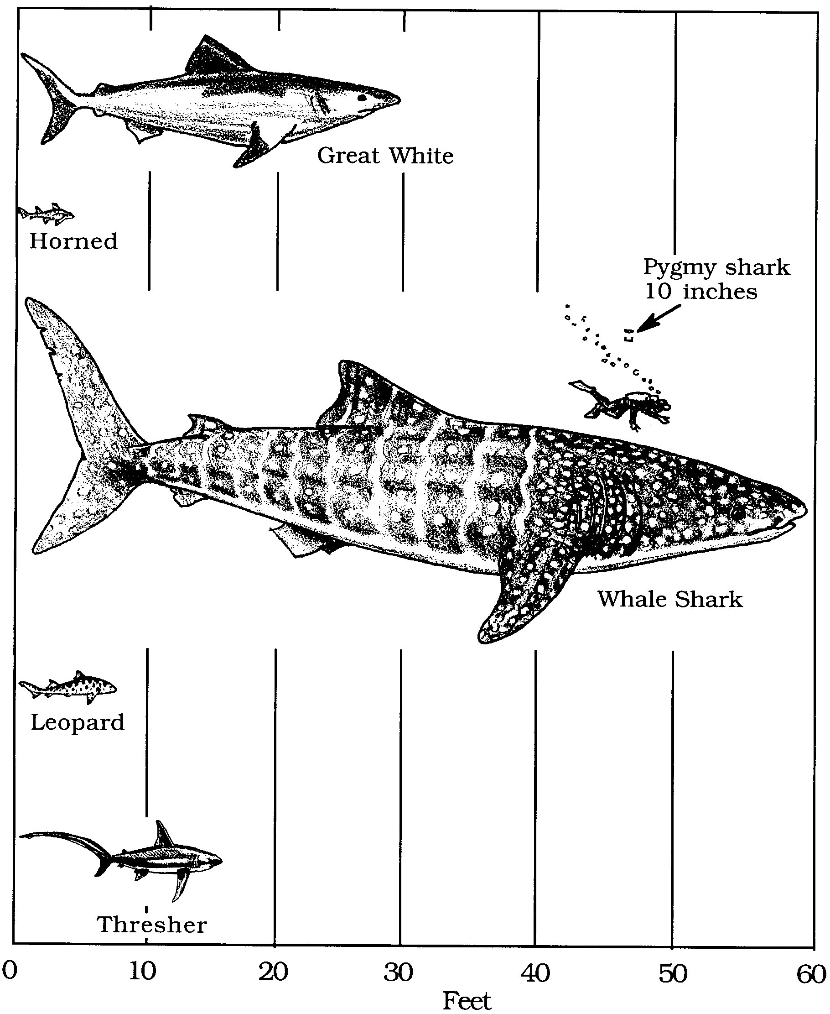
Look at the graph below. It shows six different sharks. Use the graph to answer the questions.
1. The largest shark is the
.

2. Leopard sharks are longer than
.

3. The whale shark is feet long.

4. The shark is the smallest shark.

5. How many sharks are longer than the leopard shark?
.

6. The horn shark is feet long.

7. The shark is 16 feet long.

8. List the sharks in ABC order. Use the back of this paper.

