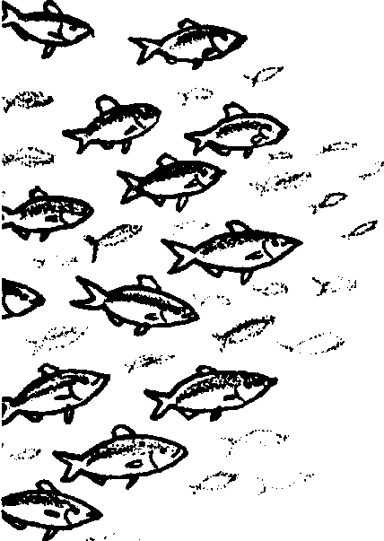
Schooling for Survival
Lesson edited by Pat Rutowski, Monterey, CA and Laurie Dumdie, Poulsbo, WA

Key Concepts
1. Fish have body parts and behaviors or adaptations that help them survive in their habitat.
2. Schooling, a behavior found in some species of fish, offers protection from predators and increases opportunities for finding food.

Background

Many fish behaviors protect them from predators. One form of protection fish use is schooling or swimming together in groups. Schools containing millions of nearly identical fish can confuse predators: it may be difficult for a predator to pick one fish from the crowd.

Schooling also makes it easier for fishes to find food. When one fish in a school goes after a meal, all the rest join in.

In schooling fish, as well as in all animals, form follows function. Each fish in a school keeps a rigid distance from its neighbors. Their eyes and lateral line (form) are especially adapted to help schooling fish hold their position in the school (function).

The relationship between form and function is more fully explored in the background for the preceding activities, “Observing Living Fish”, “Heads, Tails, and Scales”, “Read a Fish”, “Fish in the News”, and “Hide and Go Fish”.

Materials

For the class:

• 30 perch

• sturdy paper (for mounting perch)

• scissors

• glue

• ruler or dowel

• shark nose (optional, but exciting)

Teaching Hints

In “Schooling for Survival”, students simulate schooling behavior as they investigate schooling as an adaptation that helps some species of fish survive in their habitat.

Preparation

1. Locate a large, open space for the students to “school”.

2. Identify an adult or student to be the “predator” that will chase the “school” of students. A shark nose, worn by the “predator”, makes for a very dramatic entrance.

Procedure

1. Ask students if they have ever seen fish swim together in groups.

Note: If you still have goldfish in an aquarium from “Observing Living Fish”, you may be able to observe schooling behavior first-hand. With inch long goldfish, a ratio of one to one and a half goldfish per gallon should provide enough goldfish in an aquarium to display schooling. (Note further: If you are buying fish just for this activity, neon tetras (a tropical fish readily available from pet stores) show more obvious schooling behavior than goldfish.)

Ask the students to come up with ideas about why fish might school.

2. Explain why biologists think fish school.

When threatened by a predator, fish will often group together. It is thought that the school might look like a larger fish to the predator or that each individual fish is less likely to be picked out and eaten in the large group. Sometimes a predator will rush into a school. Then the fish “scatter” all over, probably confusing the predator.

3. Use the perch drawing to create a “perch puppet”. Have students cut out the perch drawing and glue it to the stiff paper but leaving an unglued “pocket” in the belly portion of the perch. The pocket provides a point of insertion for a finger, dowel, or ruler, thereby turning the perch drawing into a finger or stick puppet for use in the schooling activity.

4. Take students to a large, open space. Conduct the simulation:

a. Provide each student with one of the perch pictures. Demonstrate that the fish should be held so that it is in front of the student, but not above head height.

b. Tell students that they will “school” together as a group of perch. At this point, you may choose to tell students a “predator” will arrive, or you may wish to add the element of surprise by not telling students about the predator.

c. Pick a student to be the leader. This person holds her perch high enough up into the air so all the other perch can identify and follow the leader.

d. Have the leader begin the “schooling” behavior by rapidly walking in what ever path she chooses.

e. After a period of schooling, choose a new leader by calling out another student’s name. All the other students should then follow the new lead “fish.” This may change the direction of the “schooling” perch.

f. Alternate leaders, observing changes in schooling.

g. Signal for the “predator” to join the group. When he or she arrives, the “predator” moves swiftly toward the group of “schooling” perch. Have the “predator” count the number of “prey” caught. (A perch is caught when it is lightly tapped by the predator). Observe what the “schooling” perch do to protect themselves.

5. Collect the perch and ask students how they responded as a “school” when the predator arrived. Discuss how students felt as “fish” in a school or how they felt being threatened in a “school”. Ask questions such as:
Does a school need a leader?
How are decisions made as to which way the school will move?

Key Words

adaptation - an alteration or adjustment (body part, behavior, etc.), often hereditary, by which a species or individual improves its condition in relationship to its environment thereby improving its chances for survival

lateral line - a line of pits on the side of a fish that allow it to sense water movement

predator - an animal that hunts and eats other animals

prey - an animal taken by a predator for food

schooling - swimming or feeding in a large group

Extensions

1. Swimmy , by Leo Lionni is an excellent literature book for reinforcement of the concept presented in this activity.

2. Draw pictures of fish schools in which the smaller fish bodies look like one big fish.

3. Visit an aquarium or a pet store and watch the groups of fish in the individual tanks. Do they school?
