Going Fishing

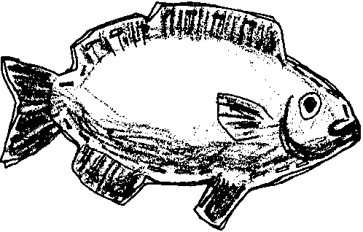
Key Concepts
1. Fish have special structures and behaviors that help them survive in aquatic environments.
2. Aquatic organisms adapt to their environment in different ways.

Background

Background information for “Going Fishing” is found in the preceding activities, “Observing Living Fish”, “Heads, Tails, and Scales”, “Read a Fish”, “Fish in the News”, and “Hide and Go Fish”.

Materials

For each student or pair of students:

• paper - butcher, or construction, about 4'

• paper - waste or newspaper

• crayons or paint

• glue

• construction paper - scrap

• stapler

• string

• scissors

Teaching Hints

In “Going Fishing”, students make three dimensional fish as a way to reinforce their learnings regarding the relationships between form and function in fish. As the children make their fish, utilize the opportunities that arise to relate structure (e.g., streamlining) to function (swimming fast, etc.)

Duplicate the activity pages. One set per student is recommended. This activity can be demonstrated, but there is something to be gained by having the students follow the steps of the procedure on their own. Provide lots of pictures of fish for motivation and ideas. Be sure to add a little color to your room by displaying student fish creations.
Key Words

lengthwise - along the direction of length (i.e., the longest dimension on a sheet of paper)

widthwise - from side to side, in terms of width (i.e., the shorter dimension on a sheet of paper)

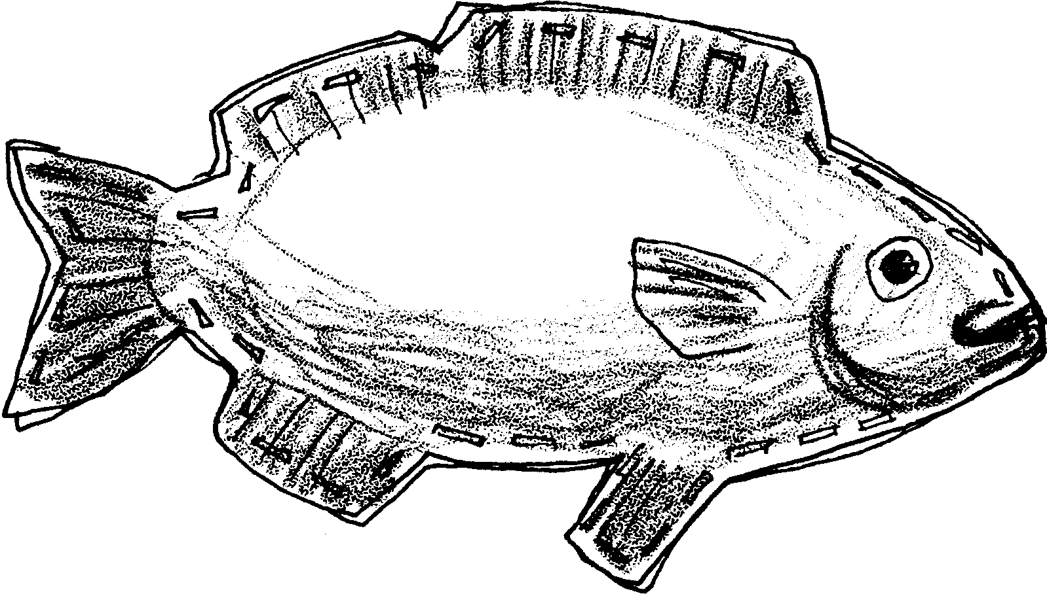
Going Fishing

Now that you know about fish, let’s make one! Here are the things you will need.

Materials
paper - butcher, or construction
paper - waste or newspaper
crayons or paint
glue
construction paper - scrap
stapler
string
scissors
Here is what to do.

Procedure
1. Fold your piece of paper in half (either lengthwise or widthwise).

2. On one side of the folded paper, make a drawing of your favorite fish.

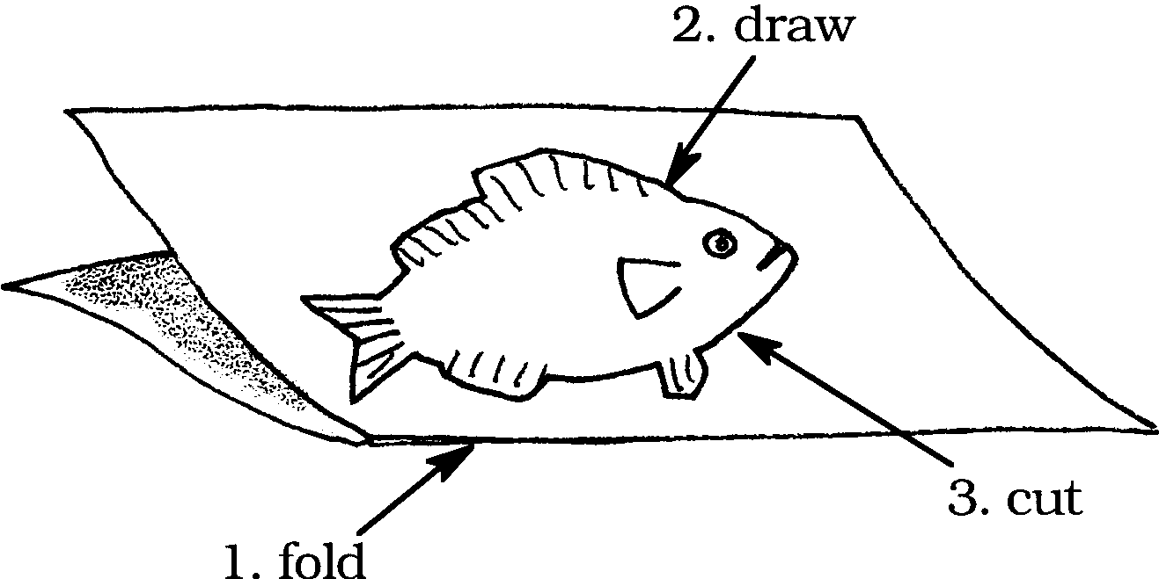
3. Start at fold and cut out the fish. Cut both sides of the folded paper at once. You will have two fish when you have finished.

4. Give your fish some color. Use crayons, paint or colored paper. Add fins, tails etc. Do both fish.

5. Staple the two pieces together around edge of fish leaving an opening.

6. Stuff fish with waste paper or newspaper.

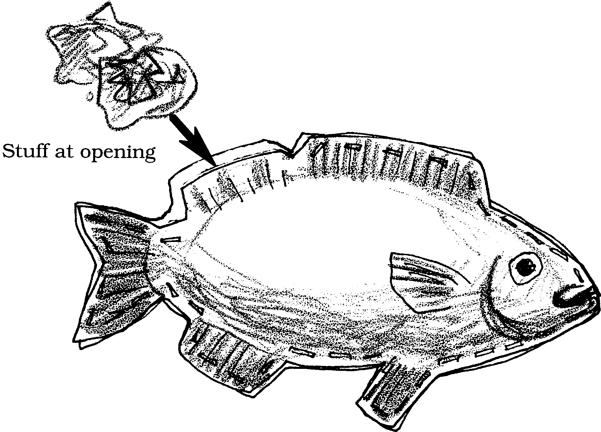

7. Staple opening,

8. Hang by string,

9. Enjoy your creation.

