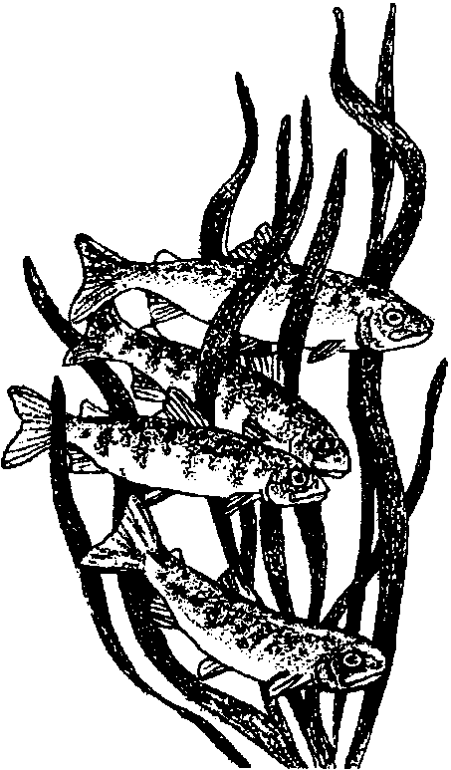
Hide and Go Fish
Lesson edited by Pat Rutowski, Monterey, CA

Key Concepts
1. Fish have body parts that serve specific functions.
2. Fish have body parts and behaviors that help them survive in their habitat.
3. The body parts and behaviors of a fish provide clues to the habitat of the fish.

Background

In fish, as well as in all animals, form follows function. As a result, a great deal can be learned about how a fish functions by looking at its form: the shape and number of fins, body shape, coloration, etc. This topic is more fully explored in the background for the preceding activities, “Observing Living Fish”, “Heads, Tails, and Scales”, “Read a Fish”, and “Fish in the News”.

Materials

For the class:

• pictures of camouflaged fish (e.g., cabezons) in the kelp forest or fish camouflaged in other habitats

• brightly colored wrapping paper or cloth to represent the sea floor

• frosting to “camouflage” the cookies (NOTE: Frosting colors must match the cloth or wrapping paper. Don’t forget you can use white frosting and food coloring to mix the colors you need.)

• stir sticks or other frosting spreaders

• assorted colored sugars or other cookie sprinkles

For each student:

• one fish cookie per student (sugar cookies work well)

Teaching Hints

In this fifth activity on form and function in fish, students use frosting and other edible decorations to “camouflage” their fish-shaped cookies on a sea floor of brightly colored wrapping paper or cloth.

Preparation

l. Make or buy unfrosted cookies. In case you don’t have a favorite one of your own, here’s a spicy sugar cookie recipe that is easy enough for even young bakers to manage.

Spicy Sugar Cookies

makes about 2 dozen, 2" cookies

Ingredients:
1 1/2 cups flour
1 teaspoon baking powder
1 tablespoon cinnamon (or cloves, nutmeg, or allspice - alone or in combination)
1/2 cup sugar
6 tablespoons butter
1 small egg
1/4 cup corn syrup

a. Preheat oven to 325 °F.

b. Sift the flour, baking powder, and cinnamon into a mixing bowl.

c. Add the sugar and stir mixture together.

d. Add butter and cut it up, blending everything together until the mixture looks like bread crumbs.

e. Break the egg into a cup and beat it with a fork. Add the corn syrup and mix until smooth.

f. Make a hollow in the flour and pour in the egg mixture. Mix together well to make a ball of dough.

g. Put the dough into a plastic bag and place in the refrigerator for 30 minutes.

h. Roll out the dough on flat surface, sprinkled with flour, until the dough is about 1/4 inch thick.

i. Use cookie cutters or cut the dough into fish shapes.

j. Place the cookies on a baking pan and bake on a high rack in the oven for 15 to 20 minutes, or until golden brown.

k. Remove from the oven and use a spatula to place them on a wire rack to cool. The cookies will harden as they cool.
2. Decorate a few to show the students examples of camouflaging.

Procedure

1. Use pictures or photographs of fish camouflaged in the kelp forest (or a different habitat). Focus the discussion on observations of body characteristics that make the fish camouflaged.

2. Explain to the students that the wrapping paper or cloth will represent different (and imaginary) habitats in the sea. Challenge each student to decorate his or her fish cookie so that it is camouflaged.

3. When students have completed their camouflaging, have them put their fish on the wrapping paper or cloth habitats. Ask questions like:

Which fish are most difficult to see? Why?

Which fish would be easier prey than others? Why?

You could play the predator and eat the cookie fish that’s easiest to see, but be sure to have extras on hand for the prey student!

4. Students will no doubt enjoy consuming their fish.

Key Words

camouflage - body coloration or parts that allow an animal to conceal itself in its habitat

fin - a membranous appendage of a fish used for movement, steering, or balance

gills - the breathing organs of many water animals

lateral line - a line of pits on the side of a fish that allow it to sense water movement

predator - an animal that hunts and eats other animals

scales - small plates that cover a fish’s body

schooling - swimming or feeding in a large group

Extensions

1. Have your students think about what would happen to the fish in their wrapping paper habitat of the sea as time goes by. Ask questions like:

Which fish do you think will live the longest?

Which fish do you think would have the most new fish?

Look at the fish in our habitat now. Over time, what do you think the fish in our habitat will look like?
(In time, the fish will resemble the fish that live the longest and have the most new fish. The other fish will have been eaten before they could reproduce.)

