
Fish in the News
Lesson by Sandy Stewart and Pat Rutowski, Monterey, CA

Key Concepts
1. Fish have body parts that serve specific functions.
2. Fish have body parts and behaviors that help them survive in their habitat.
3. The body parts and behaviors of a fish provide clues to the habitat of the fish.

Background

In fish, as well as in all animals, form follows function. As a result, a great deal can be learned about how a fish functions by looking at its form: the shape and number of fins, body shape, coloration, etc. Fish have a variety and brilliance of color unequaled by any other group in the animal world. Often these colors are used to help fish hide from predators. Many fish also have the ability to change color. To accomplish these color changes, fish have specialized skin cells called chromatophores (Greek, chromato (color) + phore (bearer) = color bearer). Chromatophores are little sac-like cells, shaped like many armed stars, which are scattered through the skin in great numbers. Each contains colored pigments. Fish can make the pigment practically invisible by withdrawing the coloring into the center of the cell, or it can expose its color in varying degrees by spreading the color into the arms of the star.

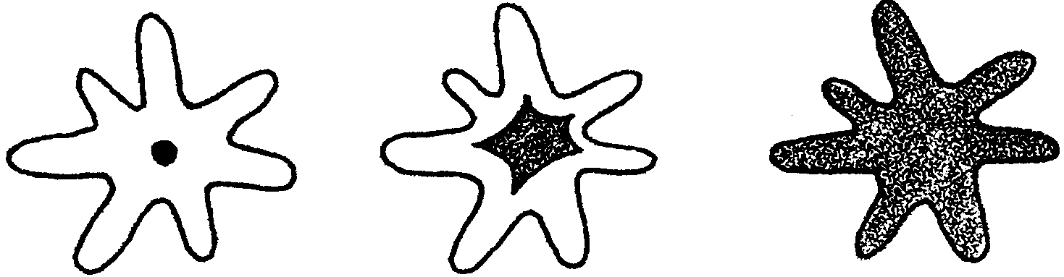

Many fish are countershaded. Countershading is a pattern of coloration in which the dorsal or back side of the fish is darker in color than the ventral or underside. It appears that the shading is a good example of protective coloration. The dark back is almost invisible to an enemy like a fish-hunting bird looking down from above into the dark water. To an enemy looking up from below, the light ventral or underside would be inconspicuous against the light coming from the surface.
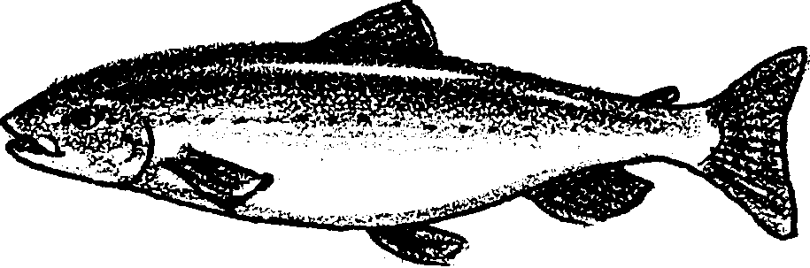

Materials

For the class:

• 6-8 double sheets of the classified section of a newspaper

• masking tape

For each student:

• half sheet of any newspaper page

• black crayon

Teaching Hints

In “Fish In The News”, students “go fishing” for newspaper fish living in a newspaper “fish pond”.

Preparation

1. Spread out the classified section of the paper to simulate a large “pond.” Tape it to the floor.

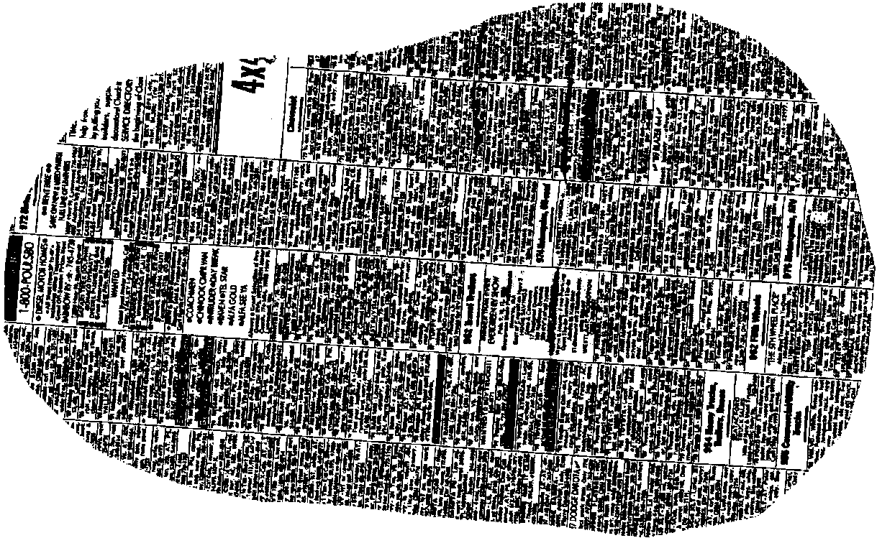

Procedure

1. Discuss the difference between a fish hiding and one that is camouflaged. If possible, read Creatures of the Sea , How to Hide an Octopus and Other Sea Creatures, or another book with examples of camouflage. As you read, call students’ attention to body characteristics or behaviors which help camouflage the animal. Explain that in this activity, students will be creating camouflaged fish from newspaper.

2. Have each student draw and cut out 6 fish from a half sheet of newspaper (any section). Using a black crayon, instruct students to modify 3 of their 6 newspaper fish by:
• coloring in the eye/s on one of their fish,
• outlining the edge of another fish and
• drawing stripes or polka dots on a third fish.

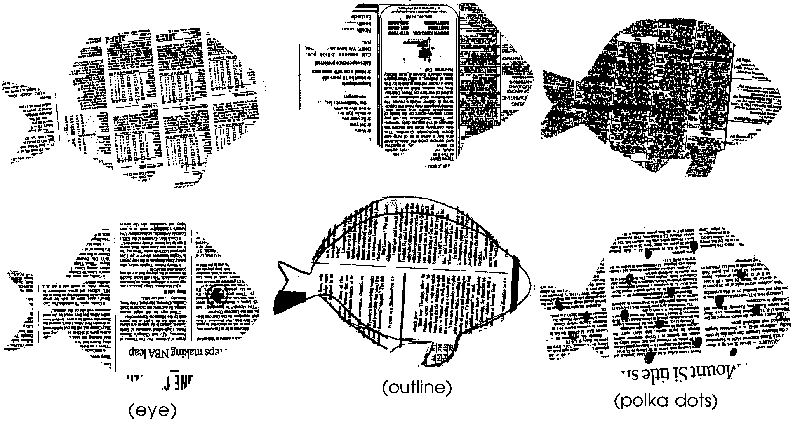
3. Gather the students around the “pond” to scatter their fish (be sure the modified sides are facing up). Instruct everyone to take 5 steps to the right and close their eyes. On a signal given by you, they will open their eyes and “go fishing” by picking up the first fish they see. Repeat this 4-5 times. Graph the results after each session of “fishing”. Discuss the results using questions such as:

How many people picked up a striped fish first?

How many picked up an outlined fish first?

How many picked up a fish with just a colored eye first?

Which kind of fish were caught most frequently?

Which fish were not caught?

Which fish were best camouflaged? Why?

Key Words

camouflage - body coloration or parts that allow an animal to conceal itself in its habitat

predator - an animal that hunts and eats other animals

schooling - swimming or feeding in a large group

