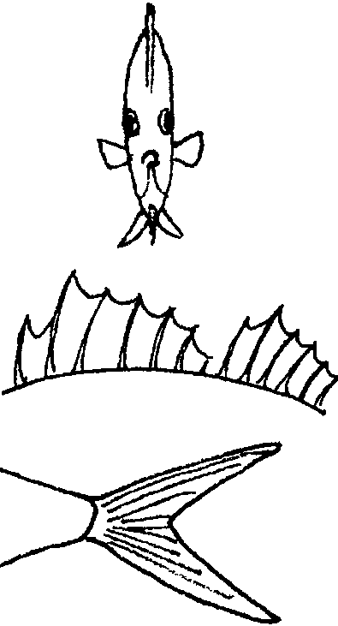
Read a Fish

Key Concepts
1. Fish have body parts that serve specific functions.
2. Fish have body parts and behaviors that help them survive in their habitat.
3. Fish behaviors help them survive in their habitat.

Background

The world’s oceans and coastlines provide a myriad of diverse habitats utilized by a great variety of fish. Approximately 20,000 different kinds of fish have been observed by scientists. From the 50-foot long, ocean-dwelling whale shark to the tiny freshwater gobies that are only a half inch long as adults, fish show an amazing variety of adaptations for enduring the many challenges of the water world. Often a fish’s body provides clues to its habitat and habits. Fish clues to “read” include: body shape, the shape and size of fins, color, and behaviors or habits.

An adaptation is an alteration or adjustment, often hereditary, by which a species or individual improves its condition in relationship to its environment. In other words, adaptations are those structures or behaviors which help plants or animals survive to reproduce. Physical adaptations are body structures or parts that help an organism survive; large eyes, protective coloration, sharp claws are examples of physical adaptations. Behavioral adaptations are those specific behaviors that organisms carry out that help them survive; birds building nests, wolves marking their territory are examples of behavioral adaptations. Fish show an abundance of behavioral and physical adaptations. In the oceans, these adaptations let fish live successfully in a wide variety of habitats from the surface to depths of over six miles!

Additional background material is found in the preceding activities, “Observing Living Fish” and “Heads, Tails, and Scales”.

Body Shape

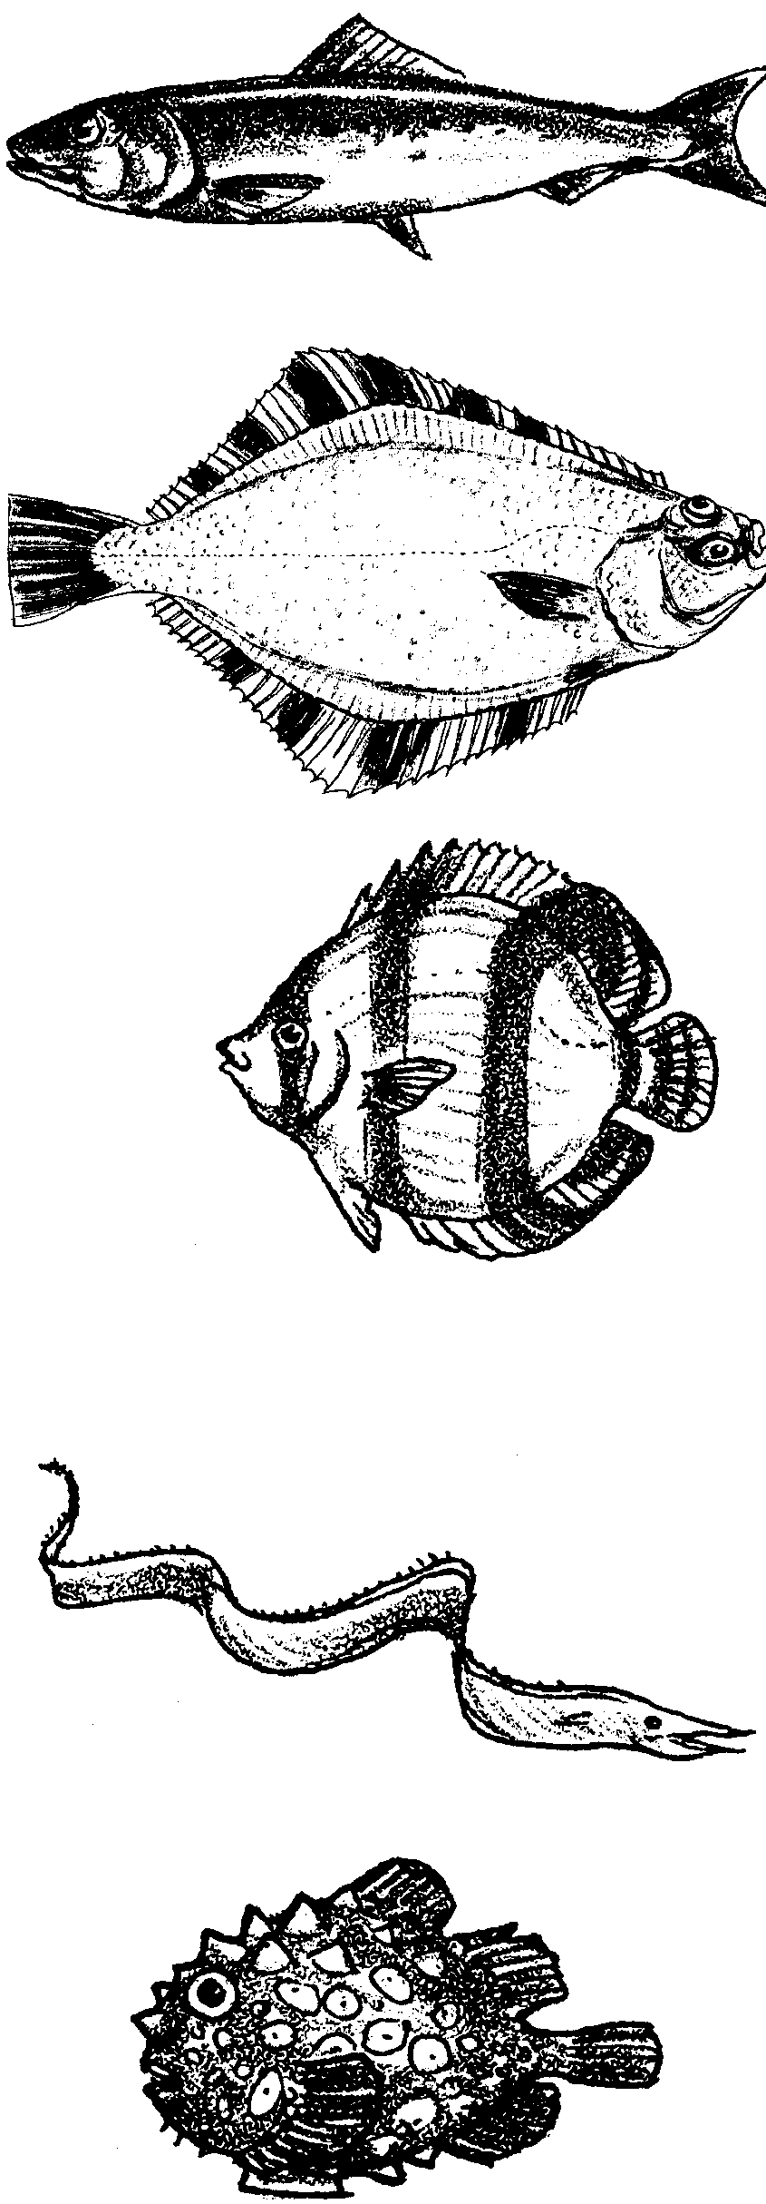
Torpedo shape (fast moving)

Many of these fish live in the open ocean and swim continuously, traveling thousands of miles in their lifetimes. Powerful tails help them chase prey and avoid predators.

Horizontal disk (bottom dweller)

These fish use camouflage instead of speed for survival. Many change the color of their skin to match their surroundings. Some escape predators by burrowing into the sand or mud.

Vertical disk (flattened from side to side)

When viewed head-on these thin fishes almost always seem to disappear. They are common on coral reefs. Their compressed bodies allow them to make quick sharp turns and dart in and out of hiding places.

Ribbon shape (snake-like fish)

These fish are relatively slow swimmers but move easily through cracks and crevices and under rocks. They are secretive, hiding from predators and ambushing prey that come too near their hiding places.

Sphere (puffers and balloon fishes)

When threatened these fish fill their bodies with water or air, becoming too big to swallow. Some have spines all over their bodies for added protection.

Mouth

Some fish have sharp teeth to catch and hold their prey, others have brush-like teeth to scrap algae off rocks, while others lack teeth and swallow their food whole. The shape and orientation of a fish’s mouth also provides clues as to what it eats. Sometimes it can also tell us how it eats. For example:

MOUTH WHAT OR HOW IT EATS
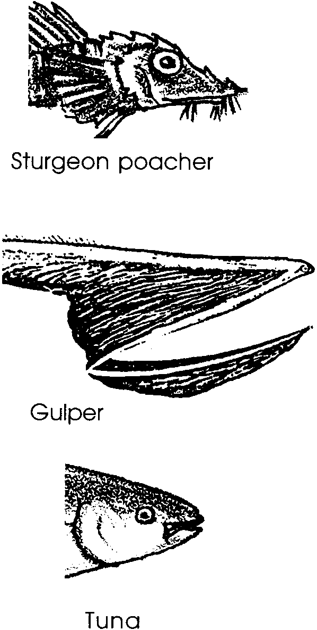

feeds on bottom (sucker)

surrounds prey

feeds on prey above and below it

Protection

Fish are often the same color as the place they live. This is a type of camouflage. Many fish behaviors also protect them from predators. When a camouflaged fish lies on the bottom of the ocean or floats near kelp, another animal might not be able to find and eat it.

Fins

Fins help a fish to move and steer. Muscles move the fins up and down or back and forth. The shape and size of the fins can tell us about how the fish moves. While most fish have the following types of fins, the number of each kind of fin varies according to the fish species.

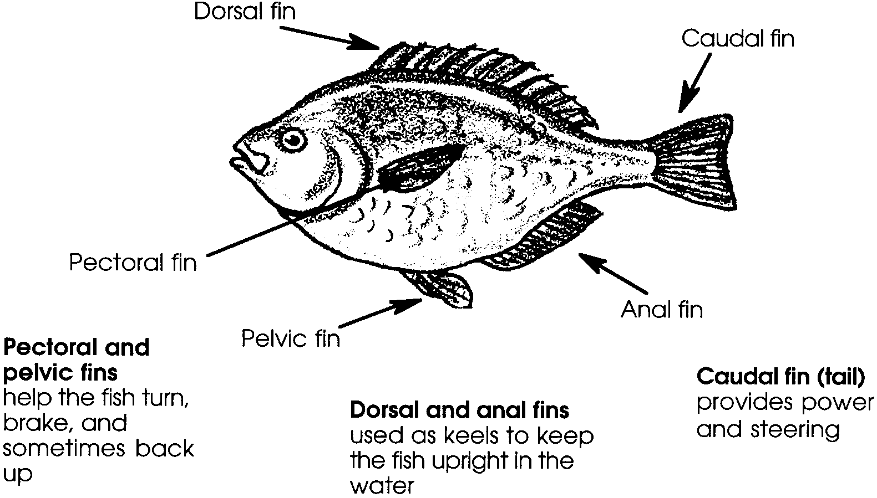

Once again, note that not all fish have the same number of each kind of fin. For instance, a fish might have one, two, or no dorsal fins.

The shape of the pectoral, dorsal, and caudal fins are an indication of a fish’s swimming ability.
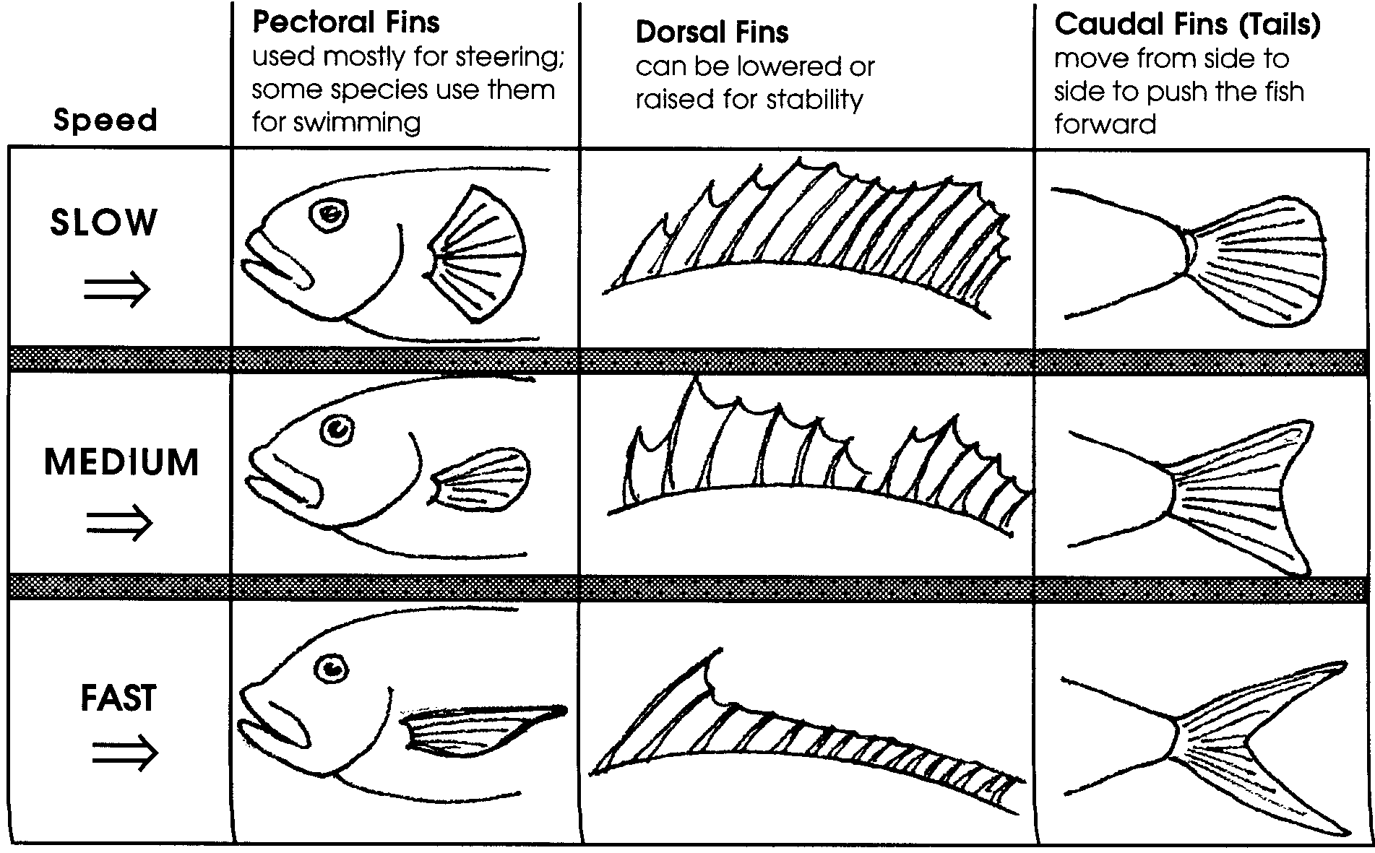

Materials

For the class:

• set of “Read a Fish” fish cards* duplicated as a transparency, then cut apart
* “Read a Fish” master is found in the Resouce File for this lesson.

• large pictures showing fish in their habitats [color copies or transparencies made from books/slides/pictures]

• “Read a Fish” overhead transparency

• overhead projector

For each pair of students:

• set of “Read a Fish” fish cards

Teaching Hints

In “Read A Fish”, students identify fish adaptations as body structures and behaviors that help fish survive in their habitat. Using observations of a fish’s body shape and the shape of its tail, they then infer how fast a swimmer the fish is, as well as where the fish lives and how it behaves.

Preparation

1. Use the fish cards set master to duplicate card sets for your class. Make one set for each pair of students. Cut each set apart and clip the eight different fish of the set together.

2. Also duplicate the fish cards set master as a transparency, then cut the eight individual fish apart.

3. Locate two or three large pictures showing fish in their habitats (magazines such as National Geographic or Natural History are a good source).

Procedure

1. Using the fish cards set, display several of the fish on the overhead. Explain to students they will receive a set of these cards and they will be used to learn how to “read a fish.” Using the background information provided, demonstrate for students how to “read” the swimming ability of a fish.

Ask: “Which fish do you think swims fast?”
(Have students predict by pointing to one or more of the fish displayed on the overhead. The smelt, perch, and salmon are the best swimmers:
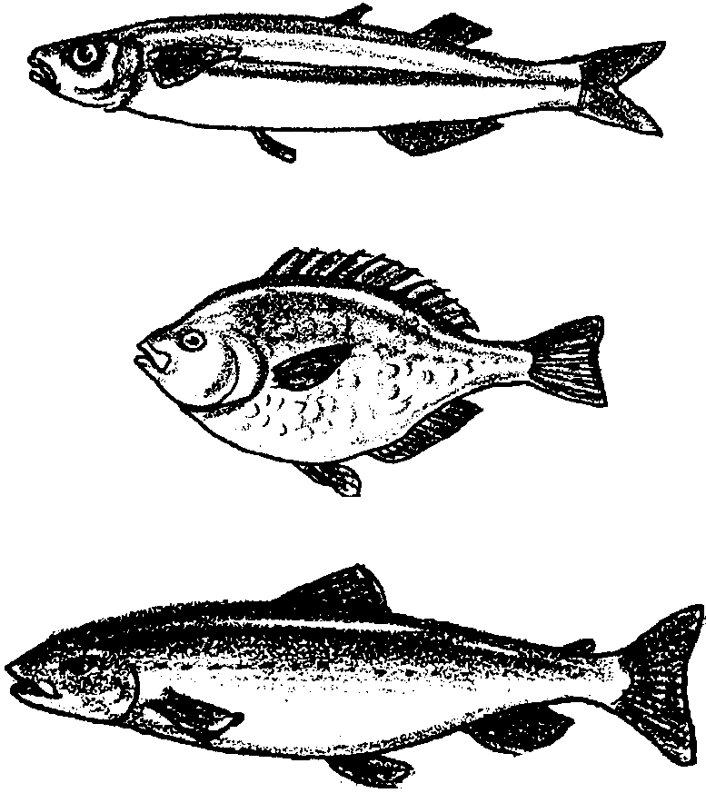
Smelt: an open-water fish that normally forms large schools and spawns on sandy beaches.

Perch: basically a shallow-water fish that inhabits areas with rocks or pilings; swims with a rowing motion of the pectoral fins

Salmon: an open-water fish, except to spawn.)

Ask: “Why do you think this fish is a good swimmer?”
(Discuss their responses which may include: smelt and salmon are torpedo shaped or streamlined and the perch is a vertical disk. All three have powerful forked tails and single, reduced dorsal fins.)

Ask: “Which fish do you think is a slow swimmer?”
(Again, have students predict by pointing to one or more of the fish displayed on the overhead. The sculpins, sanddab, wolf-eel and rockfish are slow swimmers:

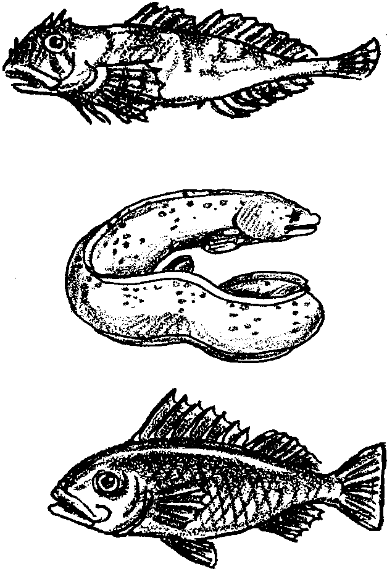
Sculpin: Primarily bottom-dwelling fish, usually preferring areas with rocks and pilings, and in some species, sand. Well-camouflaged; move only when provoked; sit and wait predators.

Wolf-eel: Inhabits shallow rocky areas, typically seen with only heads protruding from caves.

Rockfish: Preferred habitat is around rocks in deep water; mostly a sit and wait predator

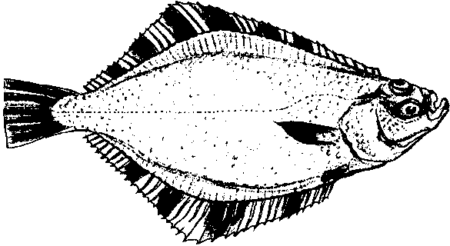
Flounder: A bottom-dwelling fish found on the floor of kelp forests; experts at camouflage; don’t rely on swimming to catch their food.)

Ask: “Why do you think this fish is a slow swimmer?”
(Have students explain the reasons for their choice which may include: these fish are not torpedo shaped or streamlined. They have large pectoral and dorsal fins and plain tails.)

2. Display and discuss the “Read a Fish” transparency. Use the information in the teacher background to help guide discussion.

3. Distribute a packet of the fish cards to each pair of students. Have students divide the fish into groups of fish that they think are fast and slow swimmers, using the transparency for reference.

4. Using the overhead set of fish cards, discuss students’ groupings. Focus on discussion of the body shape and shape of the tail and dorsal fins of the fish.

5. Display one of the large pictures of a fish in its habitat. Discuss the shape of the fish’s body and fins. Have students identify the fish from their fish card set that have similar adaptations to the fish shown. Have students draw inferences about the fish’s behavior. Discuss other obvious or unique adaptations.

Key Word

adaptation - an alteration or adjustment (body part, behavior, etc.), often hereditary, by which a species or individual improves its condition in relationship to its environment thereby improving its chances for survival

Extensions

1. As a class, read Fishes by Brian Wildsmith. This book is aesthetically very pleasing and provides students with a chance to apply what they have learned about reading a fish, since several different kinds of fish are pictured.

2. Have students create a mural of one or more ocean habitats. You might choose to make the habitat mural (or solicit some talented parent help) and have students add stuffed fish that are adapted for specific niches in the habitat.
“Read a Fish” Transparency
1. Body Shape

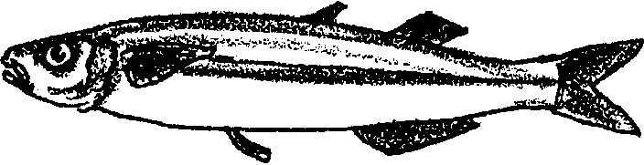
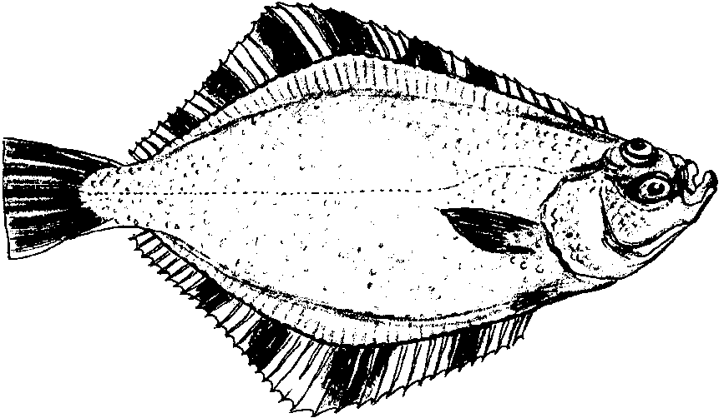

Torpedo shape
(fast moving)

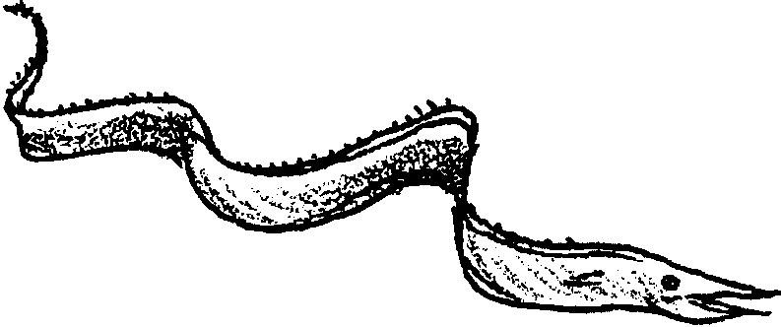
Horizontal disk
(bottom dweller)

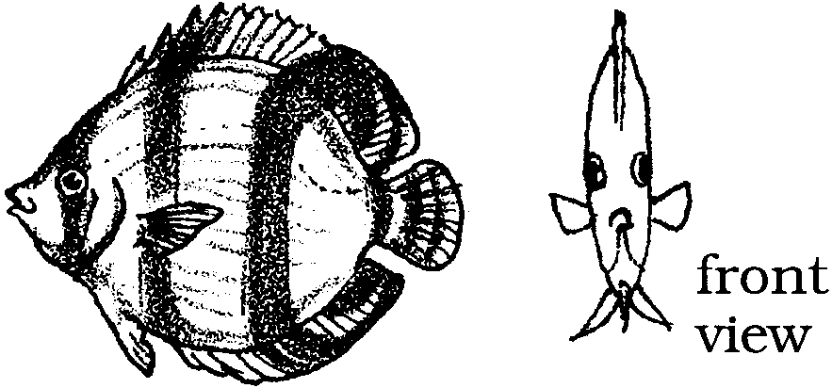
Ribbon Shape
(snake-like fish)

Vertical disk
(flattened from side to side)

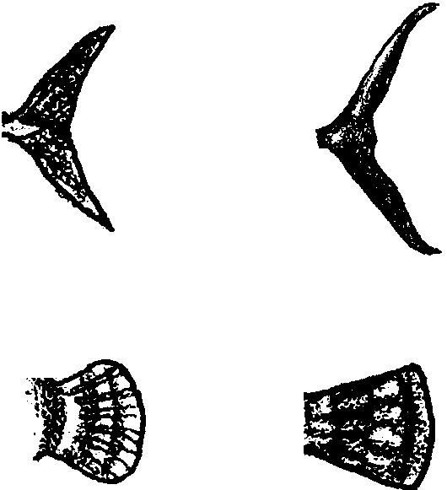
2. Tail Shape

Fast swimmer

Slow swimmer

