Heads, Tails, and Scales
Lesson edited by Pat Rutowski, Monterey, CA

Key Concepts
1. Fish have body parts that serve specific functions.
2. Fish have body parts and behaviors that help them survive in their habitat.
3. The body parts and behaviors of a fish provide clues to the habitat of the fish.

Background

In fish, as well as in all animals, form follows function. As a result, a great deal can be learned about how a fish functions by looking at its form: the shape and number of fins, body shape, coloration, etc. This topic is more fully explored in the background for the preceding activity, “Observing Living Fish”.
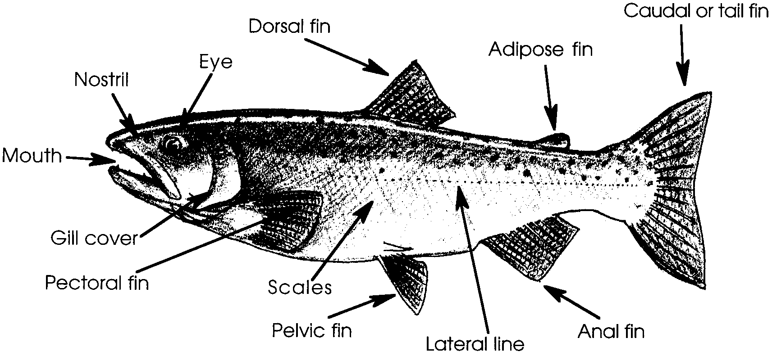

Some helpful highlights of fish anatomy to supplement the illustration above, include:

TEETH

Not all fish have teeth. Some fish swallow their food whole. Those that do have teeth exhibit a wide variety . . . some have big, sharp teeth to catch and hold prey, others have bristly teeth to scrape off algae, or flat and heavy teeth for crushing hard-shelled animals.

MOUTH

There are big mouths, tubular mouths, flexible mouths, mouths that point up and mouths that point down . . . all with special functions for that fish, dependent on its environment, the food it eats and how it protects itself.

NOSTRILS

Yes, fish do have nostrils, but they are used to smell chemicals in the water, not for breathing. Some fish have one nostril (a blind sac) on each side of their face. Others have two nostrils on each side, forming a tube through which the water circulates. Some fish are able to smell things located miles away.

EYES

Eye size and color vary from fish to fish. Most fish lack eyelids since their eyes are constantly bathed in water. (Some sharks are the exception). Fish lack sharp vision . . . they are nearsighted, and some cave fish lack eyes completely.

GILL COVER OR OPERCULUM

The operculum is a flap that covers and protects the delicate red gills found underneath. Fish get their oxygen from air dissolved in the water and gills are the specialized structures they use for gas exchange (absorption of oxygen from the water and expulsion of carbon dioxide). This ability can be compared with mammals such as seals and dolphins which must surface periodically to breathe.

DORSAL FINS

Some fish have one, some have two, some have no dorsal fin at all. There is a great variety of fins and their uses in fish. Mammals that live in water, do not have fins, but have modified legs referred to as flukes or flippers.

CAUDAL FIN

The caudal fin is the fish’s tail. Some fish move their bodies by thrusting the tail back and forth. For some fish, the tail serves as a rudder or a stabilizer, with propulsion coming from body movements or other fin movements.

ANAL FIN

The anal fin is sometimes armed with sharp projections. When these supporting rods in the fins are soft, they are called rays. When they are hard and stiff, they are called spines.

PELVIC FINS

The pelvic fins are analogous to our legs. They are primarily used for fine adjustments of the fish’s movements but may be modified for special functions, such as crawling along the bottom, holding or grasping.
PECTORAL FINS

The pectoral fins are analogous to our arms and are also used for fine movements. They may be modified for special functions or, in some fishes, absent.

SCALES

Although most fish have scales, a few (such as the flounders and sharks) do not have any scales, while others (such as the catfishes or moray eels) have such small scales that they are not noticeable. Scales are modified skin cells and, in combination with a slime layer coating, help protect the fish from abrasion and skin diseases.

LATERAL LINE

The water fishes live in is sometimes turbid, usually in motion and often dark. Therefore, some fish do not depend on sight. Instead, they use a special sense organ, the lateral line. This is a series of pits in the skin that looks like a dotted line. The nerve cells in these pits are sensitive to changes in pressure and tell the fish how deep it is, how wavy it is and what sounds are present. The lateral line is also sensitive to chemicals dissolved in the water. In some fish, it is even sensitive to electrical fields, and works as a sort of radar.

Materials

For each student:

• “Heads, Tails, and Scales” fish puzzle pieces set

• scissors

• crayons or markers

• glue or glue stick

• large sheet of construction paper

• optional: “Fish” and “Fishwich Crossword Puzzle” activity pages

Teaching Hints

In this second activity on form and function in fish, students construct a fish from puzzle pieces to review the names and functions of the body parts. A student reading and crossword puzzle also review the information presented in the activity.

Procedure

1. Distribute copies of the puzzle pieces to students. Have students color the pieces before cutting them out.

2. Have students put the fish puzzle pieces together on their desk.

3. Ask students to isolate the piece(s) that:

•helps the fish move quickly through the water (the tail)

•takes oxygen from the water (the gills)

• helps the fish sense changes in pressure or how close it is to another fish or object (lateral line)

4. Have students glue the assembled fish to a large sheet of construction paper.

5. You may choose to have students cut out and hang their fish as a “school” from the ceiling.

6. “Fish”, a student reading, and “Fishwich Crossword Puzzle” may be utilized to reinforce the concepts presented during completion of the fish puzzle. If your students are not familiar with this type of puzzle, provide as much help as is necessary to get them started. The puzzle is not complex and the clue words are listed next to the puzzle. For curious students, the fish is a C-O sole which lives on the bottom and is flattened to the point of having both eyes on one side!

Key Words

camouflage - body coloration or parts that allow an animal to conceal itself in its habitat

fin - a membranous body part of a fish used for movement or steering

gills - the breathing organs of many water animals

lateral line - a line of pits on the side of a fish that allow it to sense water movement

predator - an animal that hunts and eats other animals

scales - small plates that cover a fish’s body

schooling - swimming or feeding in a large group
Extensions

1. A Fishy Game
Play “Pin the Fin” on the fish. This requires no blindfold. Hang an outline of the fish puzzle. Each student simply chooses a piece of the fish puzzle out of a pile, says what it is and then sticks it on the outline in the proper position.

2. A Fishy Sock
To make an attractive fish windsock, provide a basic fish body pattern (about 18" long) for students to trace on tissue paper. Have them cut two and glue them together, except for the mouth, which should be left open. The scales and other body parts can be added to the tissue paper fish body using a Q-tip dipped in bleach. The bleach will remove the color of the tissue paper (and also of clothing, if not carefully used!). Reinforce the edge of the open mouth with stiff paper so that strings can be attached for hanging the windsocks.

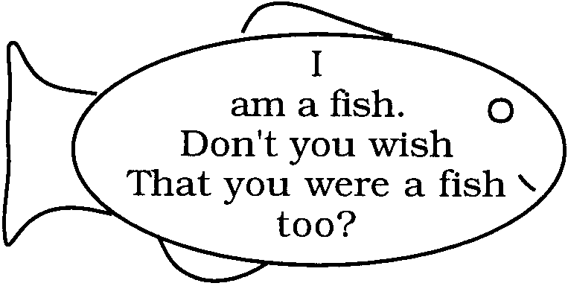
3. Fish Poems
Ask students to write simple poems that follow the shape of a fish.

Answer Key

Fish Puzzle

1. Below is a properly constructed fish puzzle.
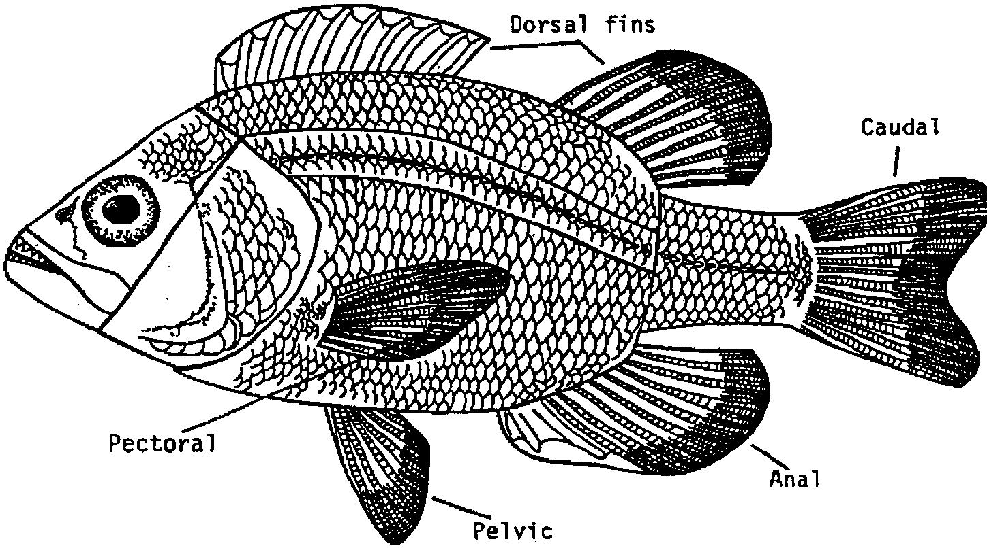

Original puzzle developed at the Helen Shedd Keith Aquatic Science Center of the John G. Shedd Aquarium,
1200 S. Lake Shore Drive, Chicago, Illinois 60605.
“Fish” student reading
1. This fish has eight fins (only six show, the seventh and eighth are a pectoral fin and a pelvic fin on the opposite side). The answer to this question depends, in part, on the concept of bilateral symmetry - the fish is made in two mirror image halves.

2. The dorsal fin is used to prevent rolling. The anal and adipose also have a role in preventing rolling.

3. The caudal and tail fin supply the power necessary for fast swimming.

4. Schools seem to offer protection by having many eyes that can see possible danger as it approaches. Fish may also sense vibrations (“hear”) more effectively in a school. In spite of all indications that schooling is an effective adaptation, no one has really been able to show why it is so effective. Other explanations include that the school may look like a much larger fish and offer protection in this manner; the school shape may be a more efficient way to move through the water, or perhaps schooling facilitates reproduction. This is an area of current study. Speculation can lead to hypothesizing and experimentation which may finally give us some answers.

5. Gills are like lungs in that they take oxygen out of the surrounding environment.

6. Gills do not function out of water, lungs do. Gills take oxygen from the water. Lungs take oxygen from the air.

7. If we overfish, we may not leave enough fish to reproduce and replenish the fish population. This is a serious problem as nets and fishing gear become more efficient and costly.

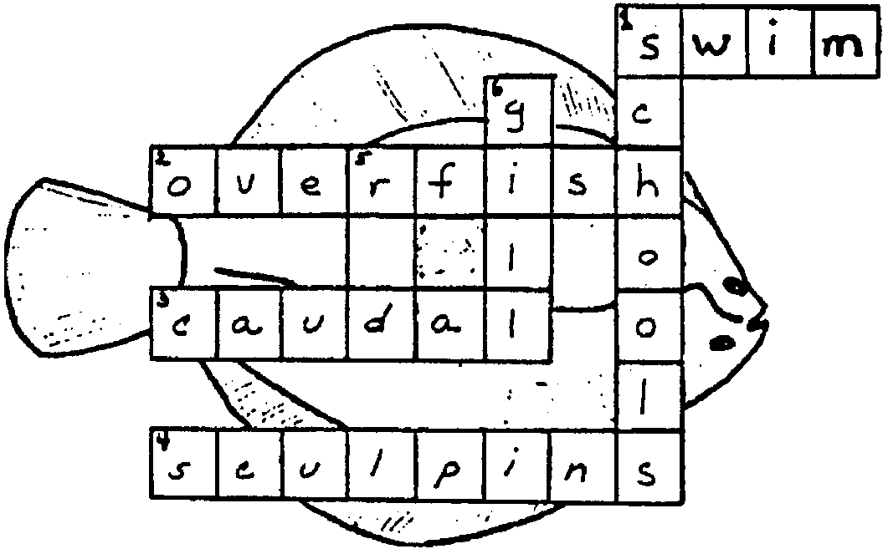
Fishwich Crossword Puzzle - Key
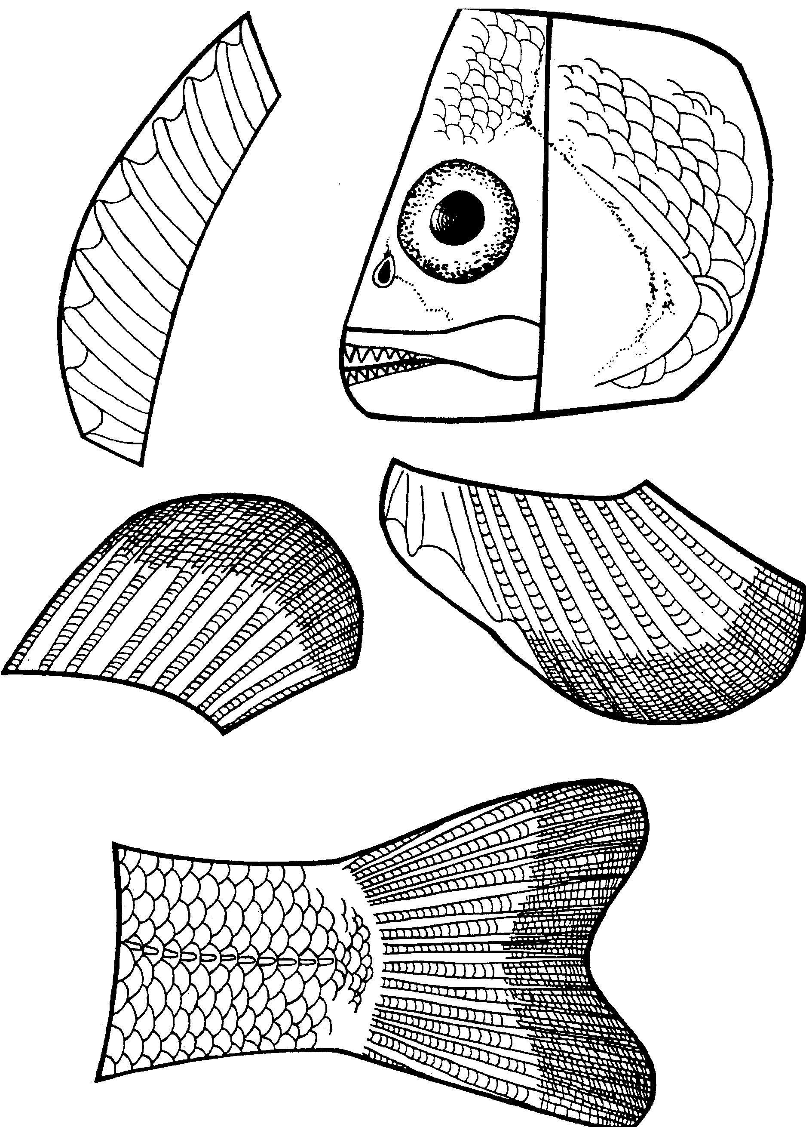

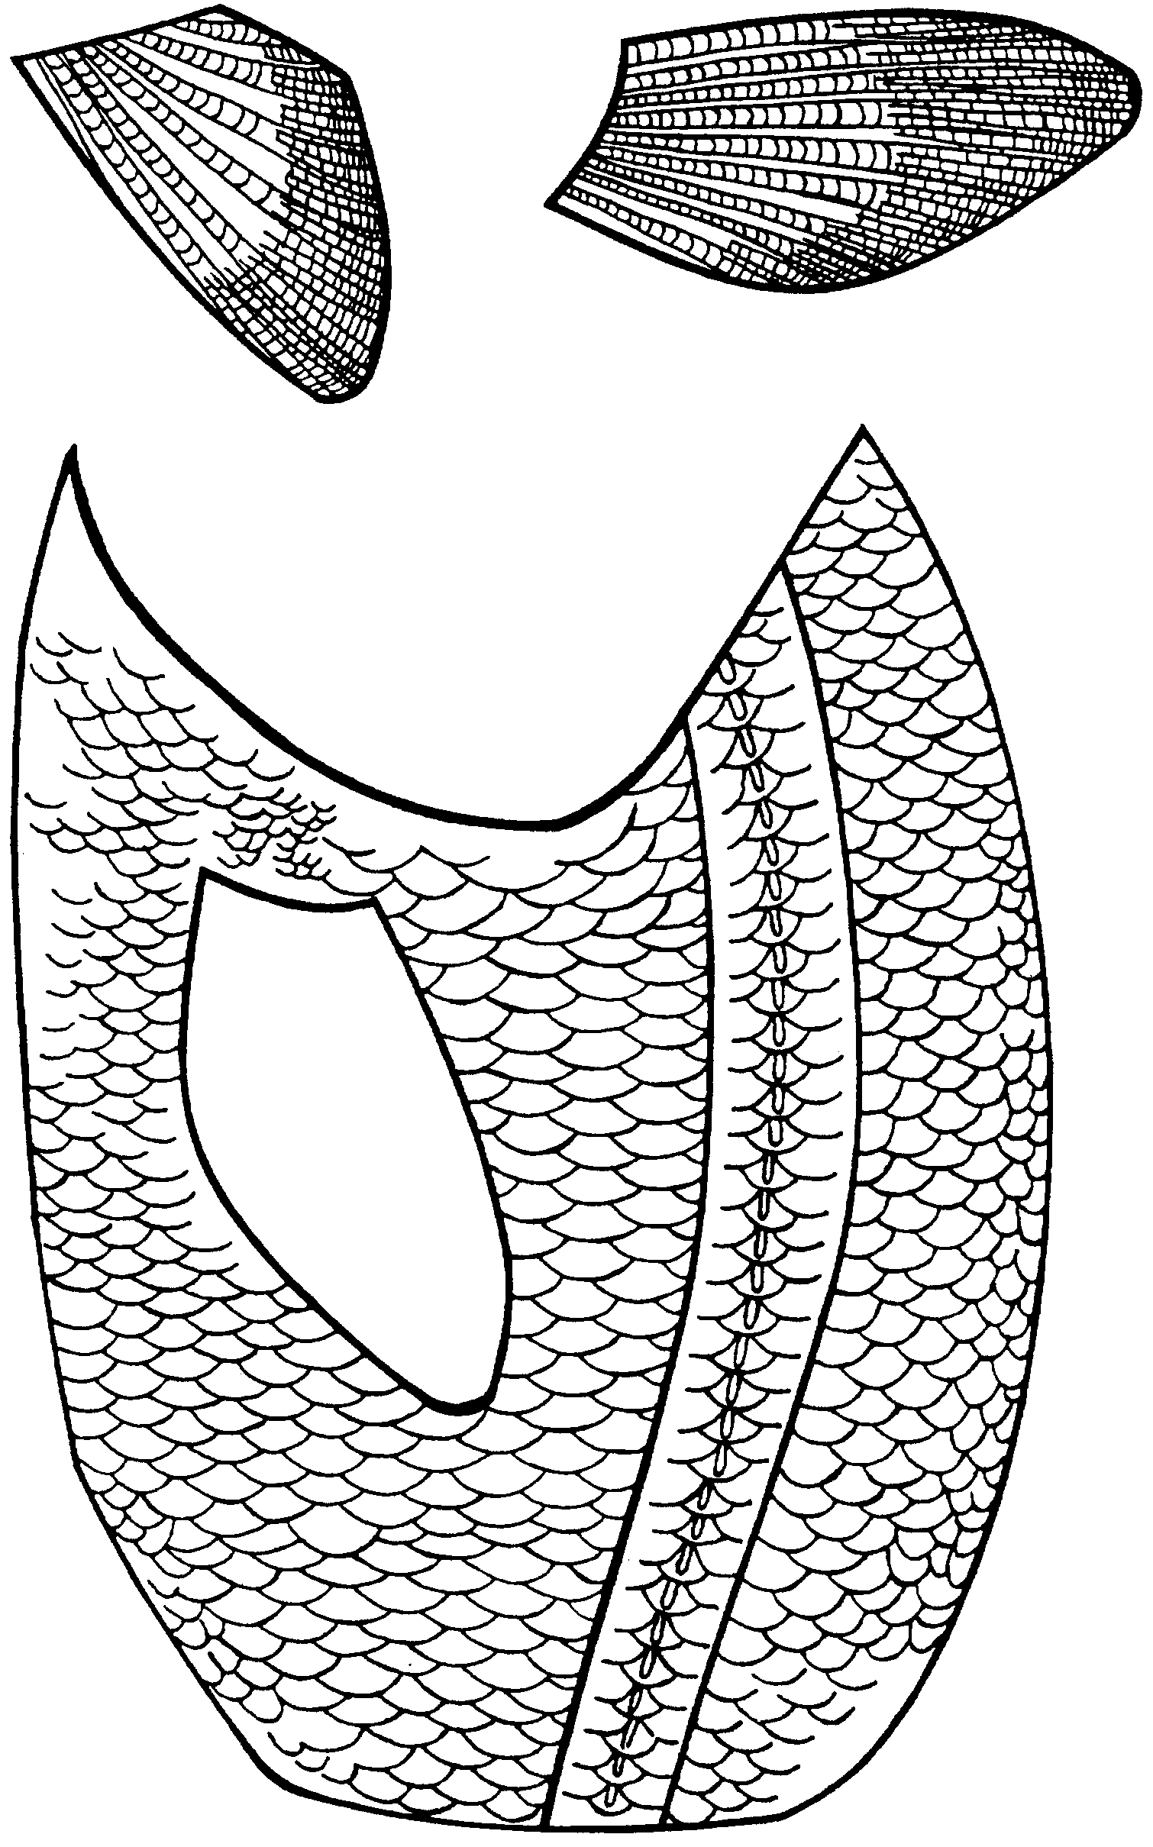

Heads, Tails, and Scales
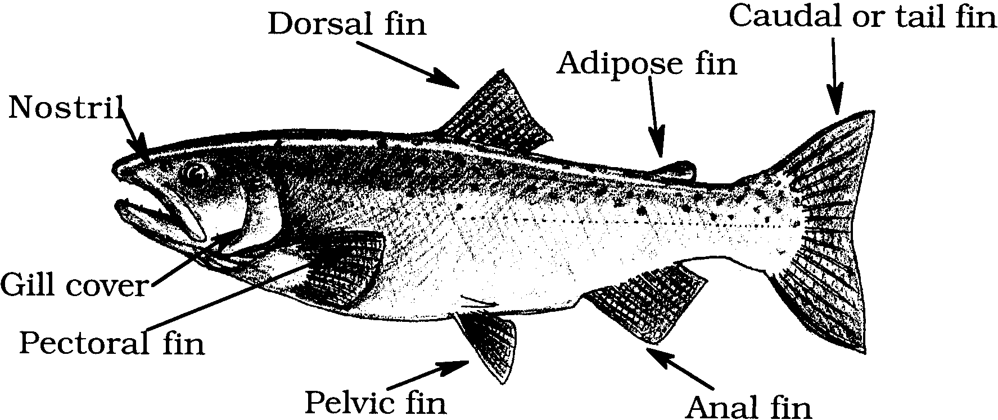

Fish
How many fins do you think a fish has? Why don’t you count them?

1. This fish has fins.

Each fin has a job to do. A fish uses its tail fin for steering and power. Its pectoral fins work like an airplane’s wings. They control its ups and downs.

2. Which fin do you think it uses to keep from rolling over?

.
Many fish are very fast. Swimming fast helps them catch their food. They also swim to avoid danger.

3. Which fin supplies the power for fast swimming?
.

Some fish swim in large groups for protection. The groups are called schools.

4. How can being in a school give a fish protection?

.
All animals need oxygen to live. Our lungs take oxygen out of the air. A fish’s gills take oxygen out of the water.

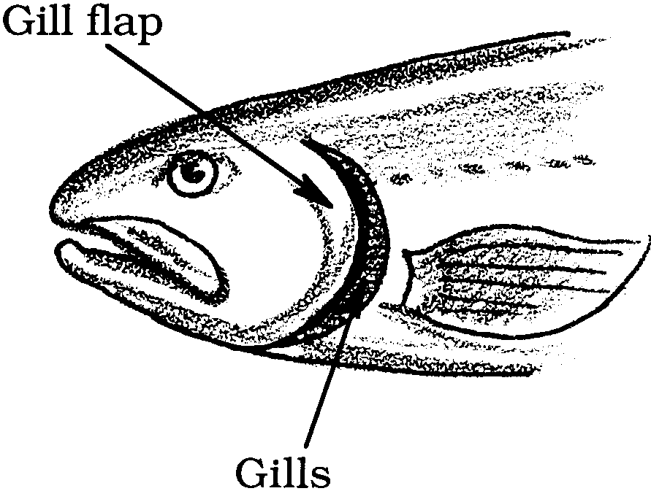

5. How are gills like lungs?

.

6. How are gills different from lungs?

.
Many fish are good to eat. People like to catch these fish. What if people catch too many? There may not be enough to lay eggs to make more fish.

7. What can happen if people overfish?

.

Each kind of fish has its own life story. Herring lay their eggs on seaweeds. Sculpins lay their eggs on the bottom side of rocks. Smelt bury their eggs on sandy beaches. Salmon swim from the ocean to lay eggs in rivers. For these fish to survive, some of the eggs must grow to adults.
Look at these fish. People can disturb their way of life. Write two ways that might happen:
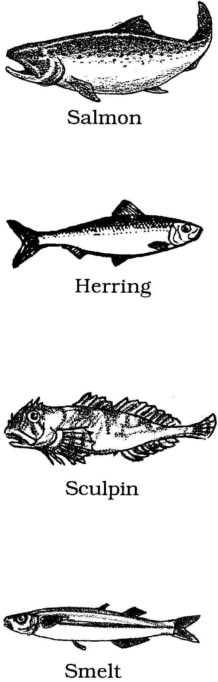

1.
2.

1.
2.

1.
2.

1.
2.

Head, Tails, and Scales
Fishwich Crossword Puzzle
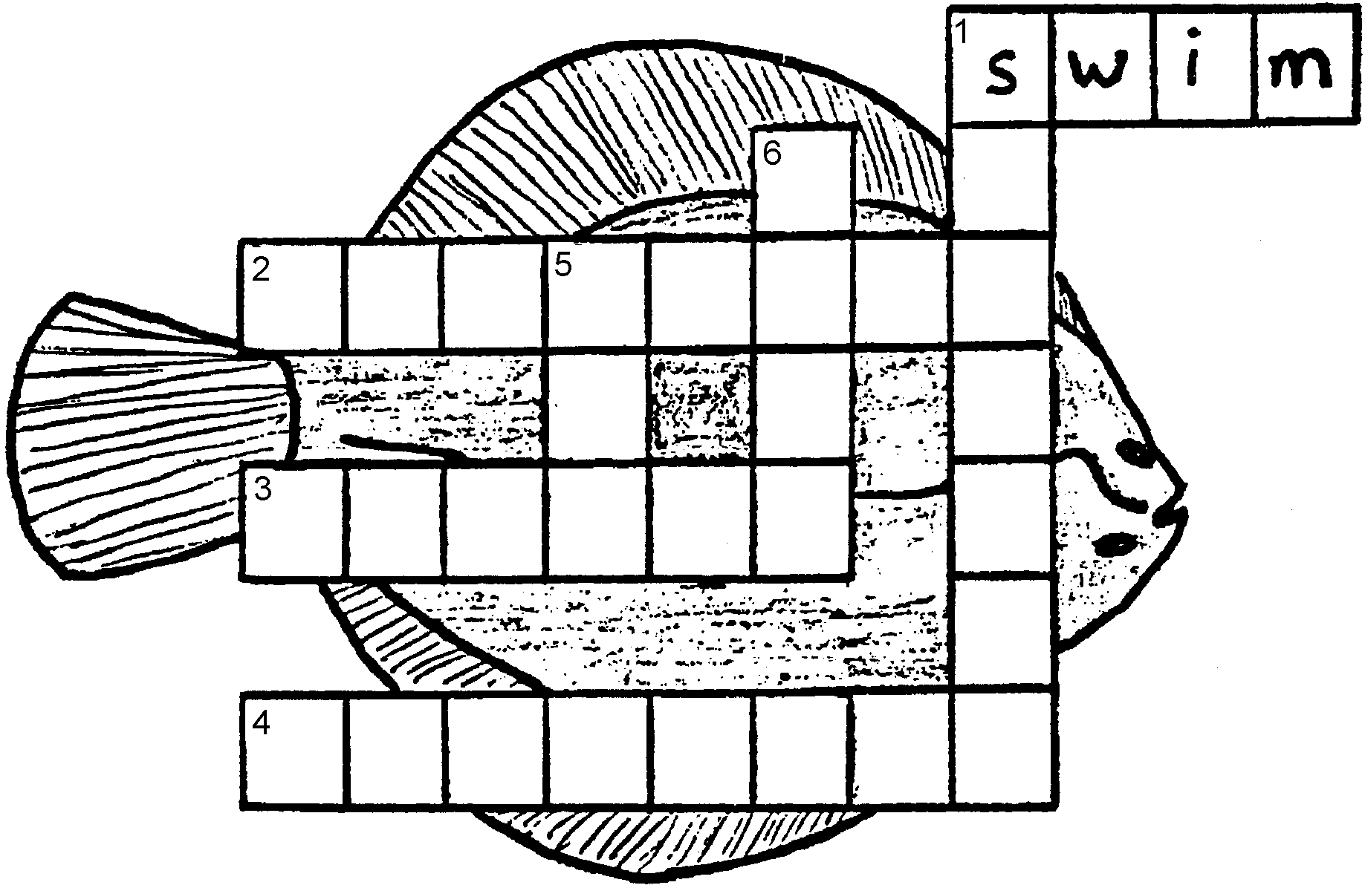
Each clue describes a word you have learned about fish. Figure out each clue word. Write it in the row of boxes that begins with the same number as the clue. Clue number 1 across is done for you.

Words:
dorsal lungs
caudal sculpins
swim smelt
gill overfish
schools pole
ocean rod

CLUES
Across:

1. Fins help a fish to .

2. If we today, there will be no fish tomorrow.

3. This fin is used for power.

4. These fish lay their eggs on the bottom side of rocks.

Down:

1. Some fish swim in .

5. You can catch fish with a fishing .

6. This is a fish’s lung.

