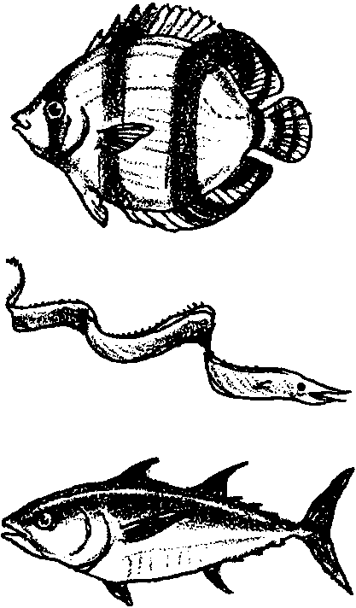
Observing Living Fish
Lesson edited by Pat Rutowski, Monterey, CA

Key Concepts
1. Fish have body parts that serve specific functions.
2. Fish have body parts and behaviors that help them survive in their habitat.
3. The body parts and behaviors of a fish provide clues to the habitat of the fish.

Background

The world ocean is home to a wide variety of fish. Each of the many varied habitats of the ocean support an assemblage of intriguing fish. While few fish dwell exclusively in kelp forests, a variety of habitats within the kelp forest offers options for different kinds of fishes.

It is possible to tell where a fish fits in its habitat (for example, the kelp forest) by clues such as: body shape, color, and behaviors or habits. The schools of sardines, which are sleek and streamlined swimmers, appear as silvery flashes in the midwater habitat. Forked tails give them speed and power and their evenly distributed fins provide stability and maneuverability. They are constantly on the move, feeding on plankton. The lie-in-wait predators, like the cabezon and other sculpins, have body colors patterned to match their seaweed hiding places. With its large, upward pointed mouth, a lie-in-wait predatory fish launches surprise attacks to snap up crabs and fishes.

Body Shape
A fish’s body shape provides clues about its habits and habitat.

Shape Habit/Habitat Example
torpedo fast moving sardine

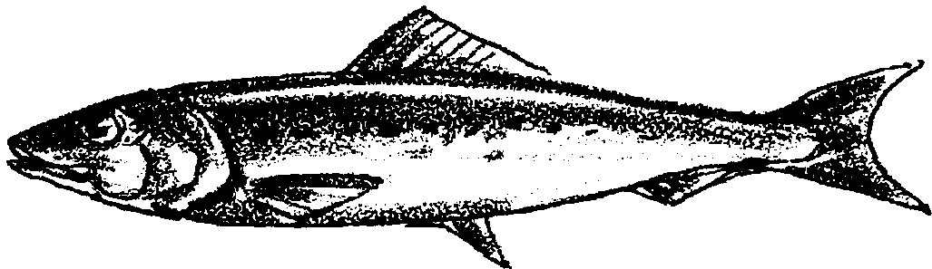

Shape Habit/Habitat Example
flat-bellied bottom feeder sturgeon poacher

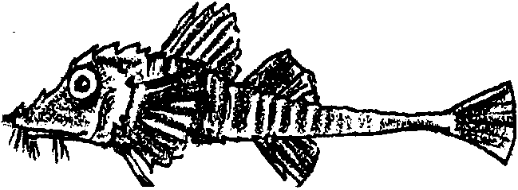

Shape Habit/Habitat Example
vertical disk feeds above or below butterfly fish
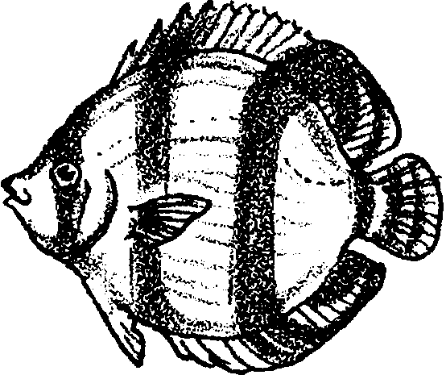

Shape Habit/Habitat Example
horizontal disk bottom dweller sand sole
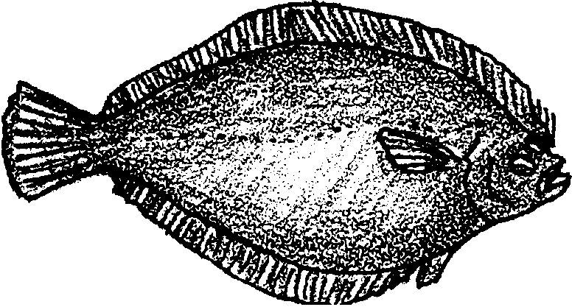

Shape Habit/Habitat Example
hump-backed stable in fast moving water salmon
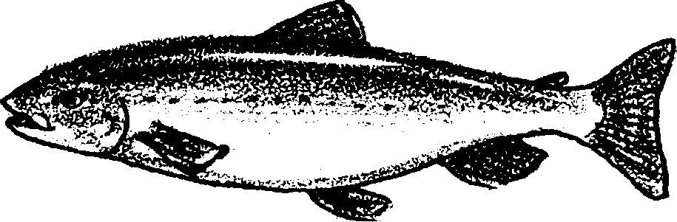

Fins
A fish’s fins help it to move and maneuver in the water. While the fins help a fish move, a fish’s main power comes from contractions of the muscles along the sides of its body. Most fish have the following types of fins:
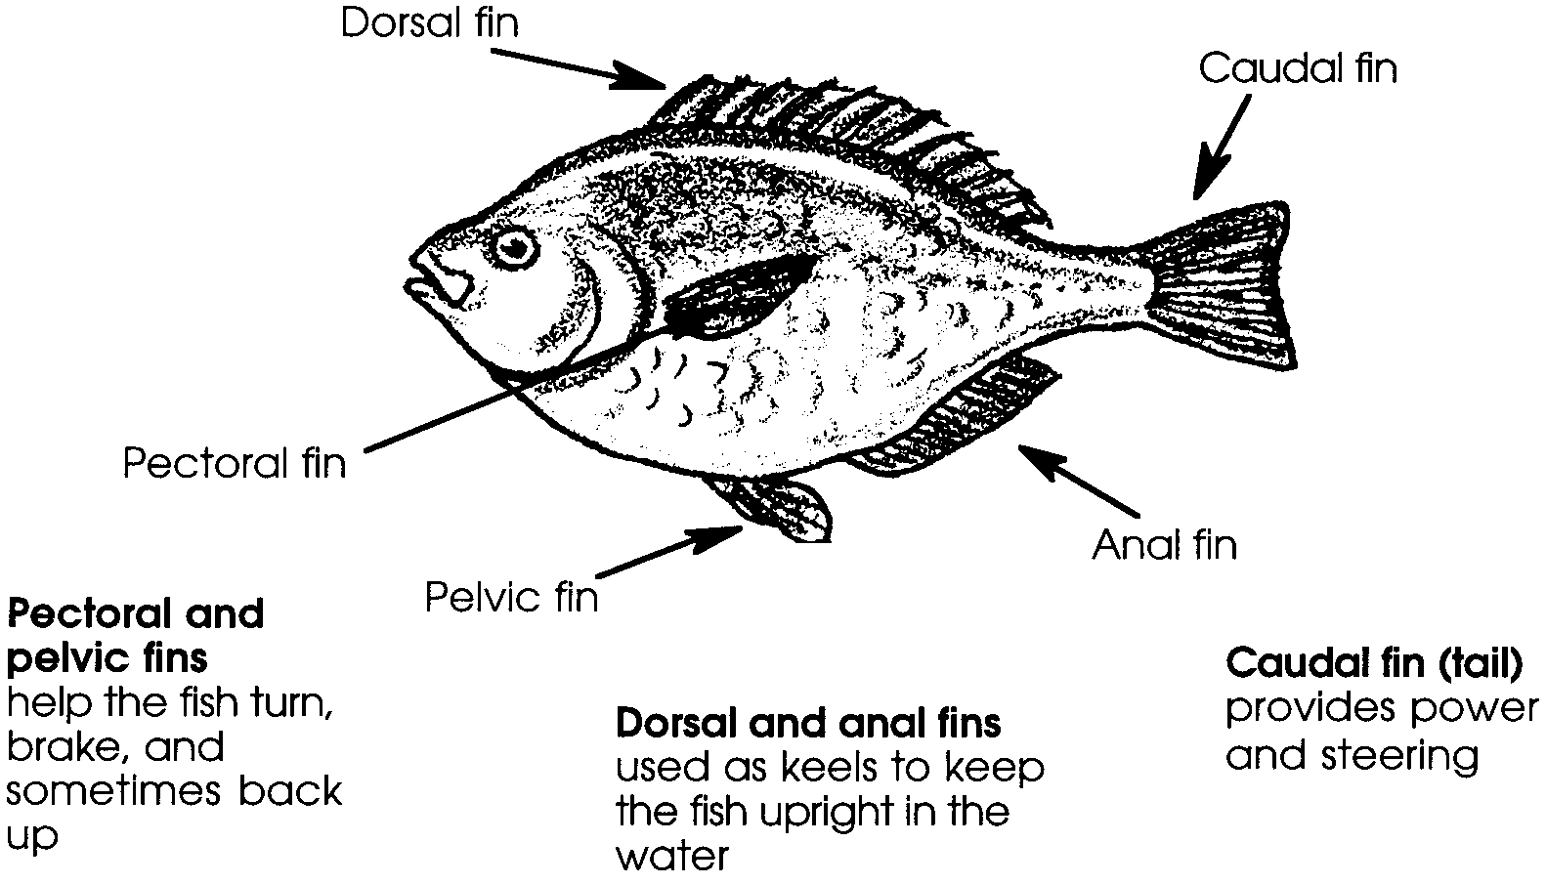

The number of each kind of fin varies according to the fish species. For instance, a fish might have one, two, or no dorsal fins.

Gills and gill flaps
Fish use gills to take oxygen from the water. Gill flaps or covers protect the delicate gills.

Mouth
The shape and orientation of a fish’s mouth provides clues to what and/or how it eats.

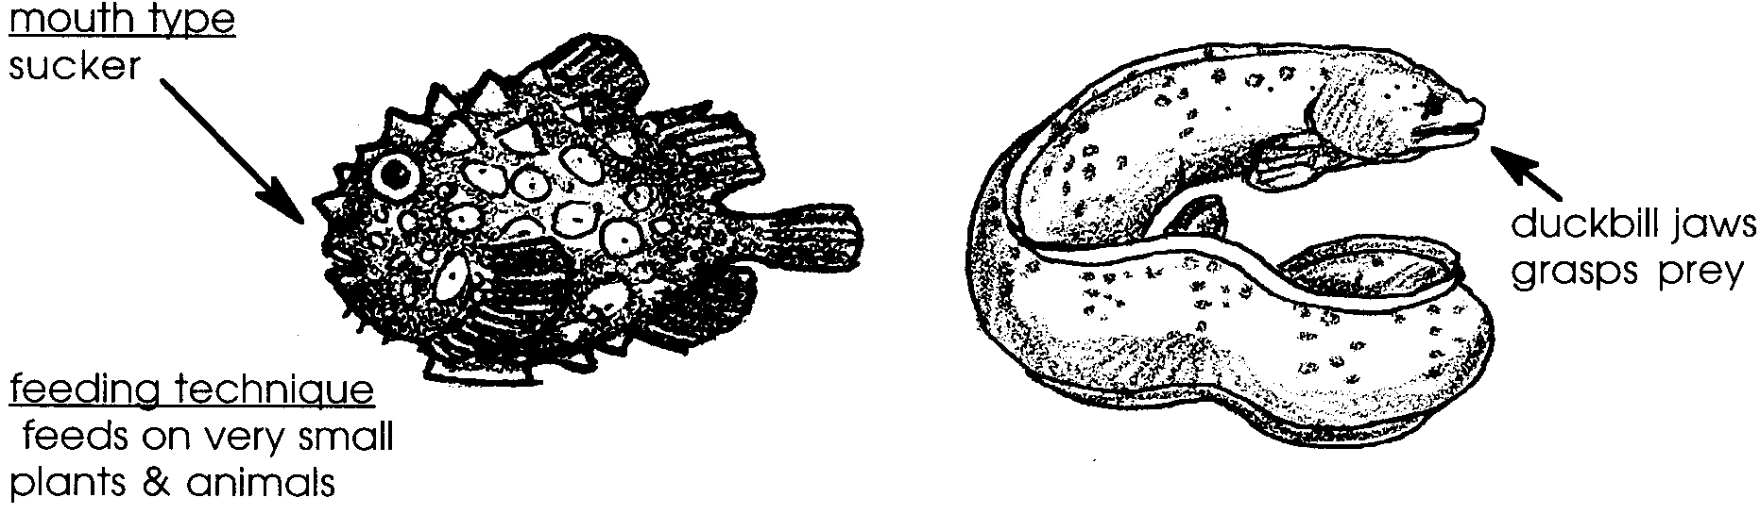

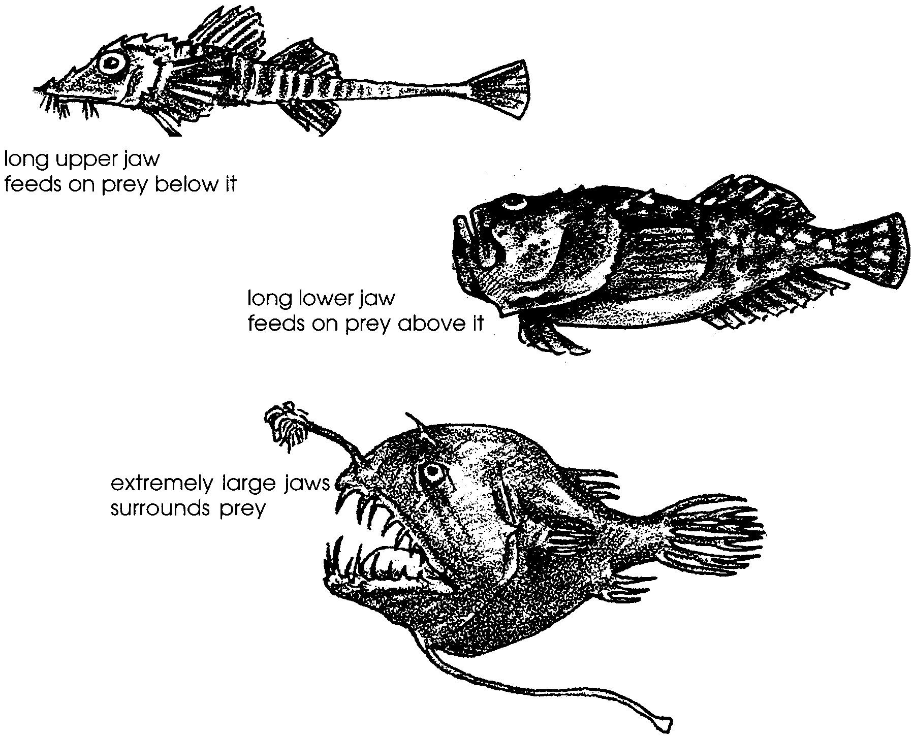

Some fish have sharp teeth to catch and hold their prey, some have brush-like teeth to scrap algae off rocks, while others lack teeth and swallow their food whole.

Scales
Most fish have scales to protect their skin from cuts and disease. Scales are made from a material much like human finger nails and can be very small, or large and platelike. Sharks and rays are a noticeable exception. Instead of scales, these fish have tiny tooth-like structures which cover their skin. (Sharks and rays also differ from other fish in that their skeletons are made of cartilage rather than bone.)

Sensory organs
Fish have nostrils, or nares, used to smell chemicals in the water. Fish eyes vary greatly in size and color. For example, while deep sea cat sharks have large eyes that face upward to use any available light coming down from surface waters, some cave fish lack eyes altogether. Although fish have no external ear, they do have ear bones which pick up sounds and serve as a balance organ. Fish also have a lateral line. This is a line of small pits in the skin on the side of the fish’s body. Nerve cells in these pits are sensitive to the movement of the water and tell the fish whether there are other fish nearby.

Protection
Many fish behaviors protect them from predators. When a fish is swimming together with other fish (schooling), it might be harder for a predator to catch it or the predator might think the school is a larger fish. Fish are also often the same color as the place where they live. Such coloration is a type of camouflage. When a camouflaged fish lays on the bottom of the ocean or floats near kelp, a predator might not be able to find it to eat it.

Materials

For the class:

• aquarium or large bowl to hold all the fish for the class

For each group of 4 students:

• goldfish (1-2 fish)

• clean, clear containers large enough to allow fish to swim

• “Observing Living Fish—Fish Observations” activity sheets, optional

Teaching Hints

In “Observing Living Fish”, students observe goldfish (or other living fish) and try to mime the different fish body parts and behaviors. This activity is the first of four dealing with form and function in fish.

Preparation

1. If you do not have an aquarium in your classroom, buy goldfish and an aquarium or bowl from a pet store or borrow the fish from another teacher. Be sure the bowl or aquarium has an air pump and air stone so the fish have the air they need.

2. If the water supply at your school is chlorinated, dechlorinate the water or let it sit out for at least 24 hours before placing the fish in the water.

3. For student observation, place one or two fish in individual containers.

Procedure

1. Assign four students to each container of fish. Have students sit quietly for a few minutes and just watch the fish. Then have each student tell the class something they observed about the fish while you record their observations and discuss the fish body parts and behaviors.

2. Have students imitate the fish behaviors. First ask them to mime putting on each of the fish’s body parts. Ask questions like:
What covers a fish’s body?
How does the fish swim?
How many fins do we need to put on?

Have students move their imaginary fins and discuss the function of each. When they move their caudal fin or tail back and forth, they can swim forward. Their pectoral fins and pelvic fins help them turn, brake and back up. Their dorsal and anal fins keep them straight up in the water. (Note that the number of fins “put on” depends upon the type of fish observed.)

How do fish breathe?

First, review how humans breathe. Then have them watch the fish carefully to see if they can describe how a fish breathes. Tell them that water animals that have gills take oxygen right out of the water so that holding a water animal in the air would be like someone holding another person's head under the water.

Have students breathe like a fish. Ask them to put their hands at their necks to make gill covers and then give them the following directions: open your mouths, open your gill covers, let the water flow in your mouth, over the gills and out your gill slits, close your mouth and start again.

Key Words

camouflage - body coloration or parts that allow an animal to conceal itself in its habitat

fin - a membranous appendage of a fish used to moves its body forward or steers it

gills - the breathing organs of many water animals

lateral line - a line of pits on the side of a fish that allow it to sense water movement

predator - an animal that hunts and eats other animals

scales - small plates that cover a fish’s body

schooling - swimming or feeding in a large group

Extensions

l. Have students draw the fish while they are observing it and label the body parts.

2. Create a haiku fish poem which includes some of the fish body parts. Remember, a haiku is three lines that don’t have to rhyme. An example:
The fish swimming here; (5 syllables)
fins flutter in the water(7 syllables)
let it move and steer.(5 syllables)

Answer Key

“Fish Observations”

2-3. Answers depend upon observations.

4. The caudal fin should have an X on it, as it is generally the fin used for power to swim fast.

5. Pectoral and pelvic fins should be circled, as they are generally the fins used to help a fish stay in one place in the water.

6. Answers will vary, but goldfish commonly use speed, coloration, and good vision to keep from being eaten. Other kinds of fish add spines, teeth, and poison to keep from being eaten.

Observing Living Fish

Fish Observations

1. Observe the fish.

2. How many fins does the fish have?
.

3. Draw the missing fins on the fish below. Remember to draw its eye and gill covering.

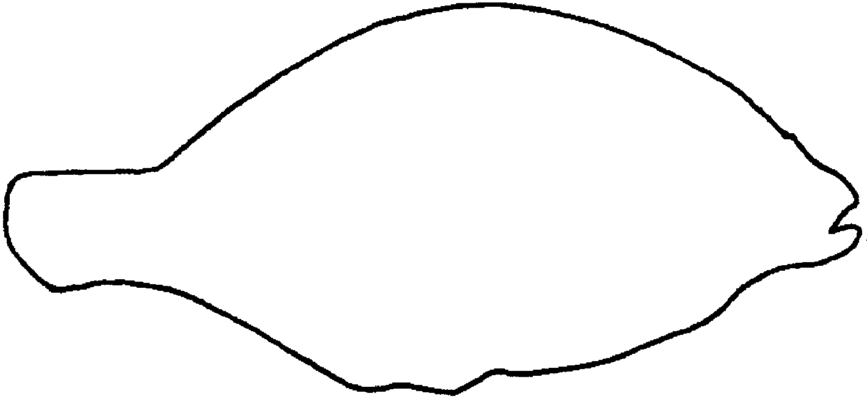

4. Put an X on the fin or fins the fish uses for power to swim fast.

5. Circle the fins the fish uses to stay in one place in the water.

6. What does this fish do to keep from being eaten?

.

7. Color the fish.

