Creating Kelp Creatures

Lesson by Pat Rutowski, Monterey, CA

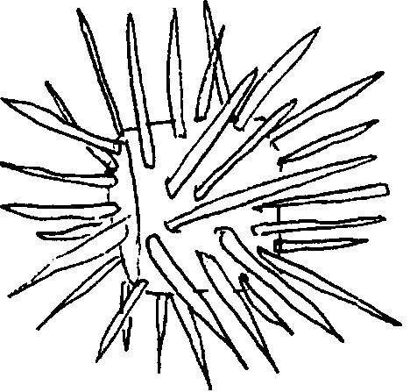
Key Concepts
1. The kelp forest habitat is home to many animals.
2. Animals of the kelp forest have structural and behavioral adaptations for survival in their habitat.
3. Animals have different roles, or “niches”, in the kelp forest habitat.

Background

The varied kelp forest residents live in different parts of the kelp forest. The green and pink lingcod lives on the rocky reef to which the kelp plants are anchored. Brittle stars, purple sea urchins and worms make their homes among the kelp holdfasts, while turban snails and kelp crabs hang tightly to the kelp stipes and fronds.

Long and thin, the giant kelpfish is colored to look exactly like a kelp blade and spends its time entwined with the kelp fronds. Kelp bass, senorita fish and rockfish float next to the plants, hiding among the blades and in the kelp canopy. Large purple sea hares climb through the kelp canopy, while the pineapple-scented Melibe, a translucent sea slug with a large hood, drifts among the fronds.

Larger animals also feed upon the rich abundance of life in the kelp forest. Sea otters search out almost all of the animals found in the kelp forest as food, while harbor seals and sea lions dart among the fronds catching and eating fish.

Animals that live in the kelp are specially adapted to this environment. Kelp fish and kelp crabs are the same color as the kelp enabling them to hide among its blades. Gray-bodied fish bob face down next to the kelp, hiding in the shadows close to the kelp blades. Kelp crabs and snails hold on tightly to the moving kelp, while colonies of bryozoans cement their tiny box-like homes to the blades. These and countless other physical and behavioral adaptations help kelp forest animals survive, and thrive, in their rich, changing environment.

Materials

For the class:

• sets of the 10 “Creating Kelp Creatures” cards (each student, or pair of students, needs one card, so plan accordingly)

• reference materials for students to research kelp creatures

• assortment of the following, depending upon construction method selected:

• scissors

• construction, scrap and tissue paper

• foil

• cotton balls

• pipe cleaners

• yarn and wire

• toothpicks

• paint

• markers and crayons

• tape

• papier-mâché materials

Teaching Hints

In “Creating Kelp Creatures”, students investigate some of the physical and behavioral adaptations of kelp forest animals as they make models of various kelp creatures to add to the kelp forest created in the previous activity, “A Kelp Forest in the Classroom”.

A wide variety of construction methods can be used to create kelp forest animals with your class. In deciding upon the approach to use, give some thought to the amount of time available, the abilities of your students, and the ease with which the necessary materials can be collected. Since different animals lend themselves well to different construction techniques, there is merit in providing a wide variety of materials and letting children choose their own solution to the problem.

Solutions may range from simple, two-dimensional paper cut-outs, to paper models, to wire framed papier-mâché 3-D models. The drawings on the cards may be enlarged xerographically to serve as a starting point for the student projects. The activity “Going Fishing”, found in Unit 4 of this guide, provides instructions you may wish to use to make “stuffed” kelp creatures. Although more time consuming, papier-mâché has merits. Instructions for basic papier-mâché creatures may be found in Pagoo - FOR SEA Investigating Marine Science Grade 5, in the activity “Papier-mâché Tide Pool Creatures”. Directions for other modeling methods are also included in the Grade 5 guide.

Procedure
1. Begin by discussing with students how creatures in the kelp forest are adapted for survival in this unique habitat. Introduce the word “adaptation”. Discuss ways that the animals hold on to the kelp, hide or are camouflaged in the kelp, move through the kelp, and find food in the kelp.

2. Explain to students that each of them will be making an animal that lives in the kelp forest. Show students the “Creating Kelp Creatures” cards. Explain that each card describes how an animal is specifically adapted for life in the kelp forest and describes the role, or “niche”, of that animal in the kelp forest.

3. Distribute the “Creating Kelp Creatures” cards.

4. Provide the materials necessary for the construction approach you have chosen, and have the students work independently, or in pairs, to create the animal described on the card.

5. Have each student add her or his completed animal to the correct “habitat” (e.g., surface, holdfast, edge) of your “classroom kelp forest ecosystem”. Be sure to have the student briefly describe the animal’s adaptations for “making a living” (i.e., how it finds food, holds on, etc.) in the kelp forest.

Key Words

adaptation - any alteration in the structure or function of an organism or any of its parts by which the organism becomes better fitted to survive and multiply in its environment

camouflage - concealment by some means that alters or obscures the appearance

niche - the role of an animal or plant in its habitat or community

Extensions

1. Work with students to create a dance or creative movement piece that uses the animals and plants of the kelp forest as subject matter.

2. Have students make and mount kelp animals in a diorama box representing the kelp forest. Here’s how: Make the kelp with stipes of brown string and blades cut out of brown paper bags or brown and yellow cellophane. Use modeling clay holdfasts to attach the stipes to pebbles. Cover the opening of the box with blue cellophane to make it look like an underwater scene.
3. Use the example below to have students write a “Creature Riddle” about one of the creatures of the kelp forest. On the top of a piece of paper, have them write the riddle; on the bottom, have them draw a large rectangle.

Laminate the Completed riddles, and put them in a binder at a center. Students then read the riddles and use an erasable marker to sketch the answer to the riddle in the rectangle. Number each riddle and include a similarly numbered answer key at the back of the notebook.

The riddle below comes from a second grade class of the originator of this idea, Georgia Urlacher, who teaches in Silverdale, Washington.
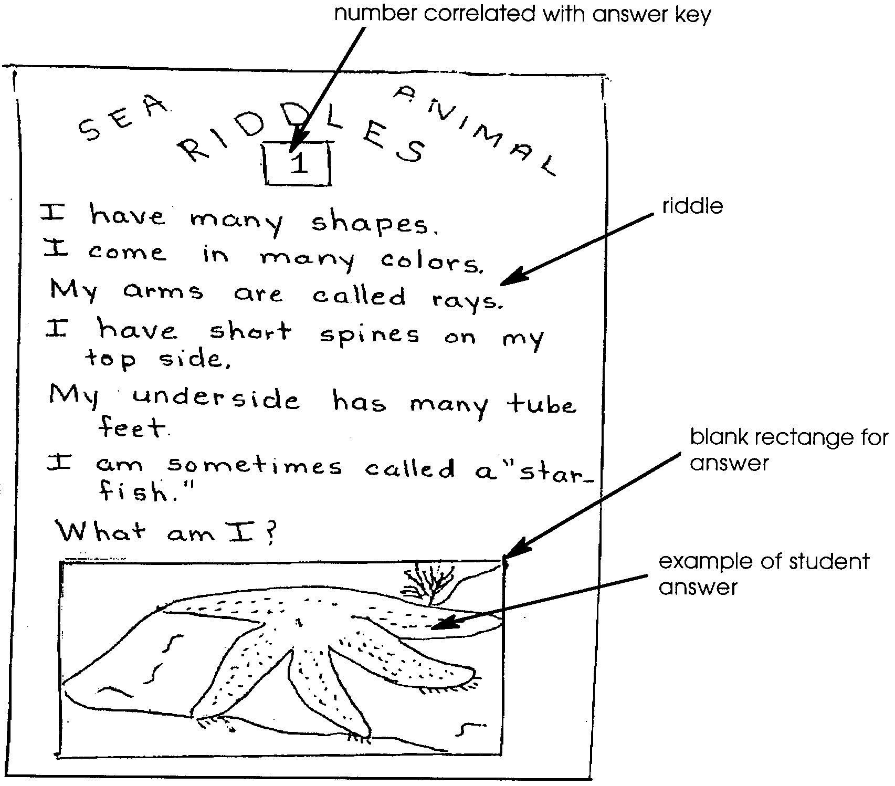

“Creating Kelp Creatures” Cards Fold. Glue, tape or laminate sides together
Create a kelp creature that....
lives on a kelp stipe.
Ringed Top Snail
My pointed, hard shell is pink.
I eat kelp.
I hold on with a strong foot.
I live on a kelp stipe.

Create a kelp creature that....
lives in caves under the kelp forest.
Red Octopus
I eat crabs.
I have very good eyes.
I can swim and crawl.
I live in caves under the kelp forest.

Create a kelp creature that....
lives on rocks in the kelp forest.
Sunflower Sea Star
My arms are purple and pink.
I move very fast.
My many tube-feet make me strong.
I eat snails.
I live on rocks in the kelp forest.

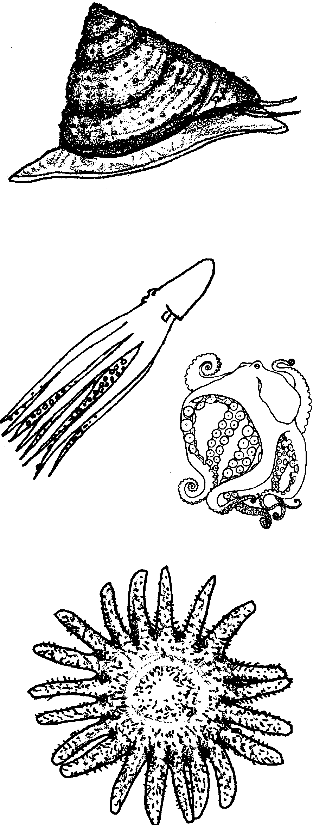

“Creating Kelp Creatures” Cards Fold. Glue, tape or laminate sides together
Create a kelp creature that....
swims easily through the kelp.
Pacific Sardine
My sides are silver.
I eat tiny plankton.
I am a fast swimmer.
I swim in schools.
I live near the stipes.

Create a kelp creature that....
hunts at the edge of the kelp forest.
White Shark
I have a gray back. My belly is white.
I eat fish and seals.
I hunt at the edge of the kelp forest.
I am a fast swimmer.

Create a kelp creature that....
lives on the kelp stipe.
Kelp Crab
I am the color of kelp.
I eat kelp.
My pncers are strong.
I live on a kelp stipe.

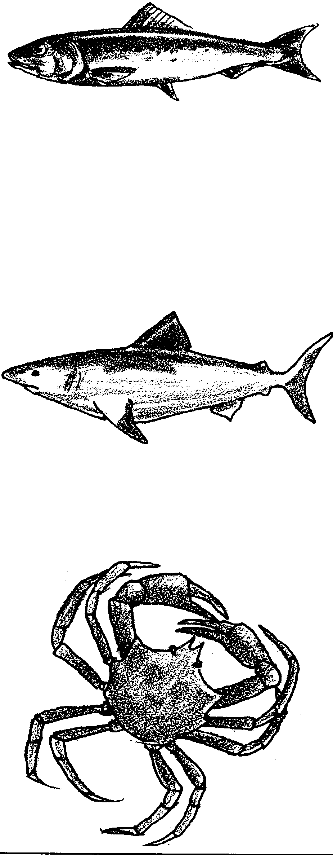

“Creating Kelp Creatures” Cards Fold. Glue, tape or laminate sides together
Create a kelp creature that....
looks like a frond.
Giant Kelpfish
I change color to hide.
I eat small fish and crabs.
I am shaped like a frond.
I live among kelp fronds.

Create a kelp creature that....
eats the kelp.
Sea Urchin
I am red or purple.
I am covered with spines.
I eat kelp.
I live at the base of the kelp.

Create a kelp creature that....
lives in the holdfast.
Brittle Star
I am brown or green.
I have long, spiny arms.
I eat tiny bits of food from the water.
I live in the kelp holdfast.

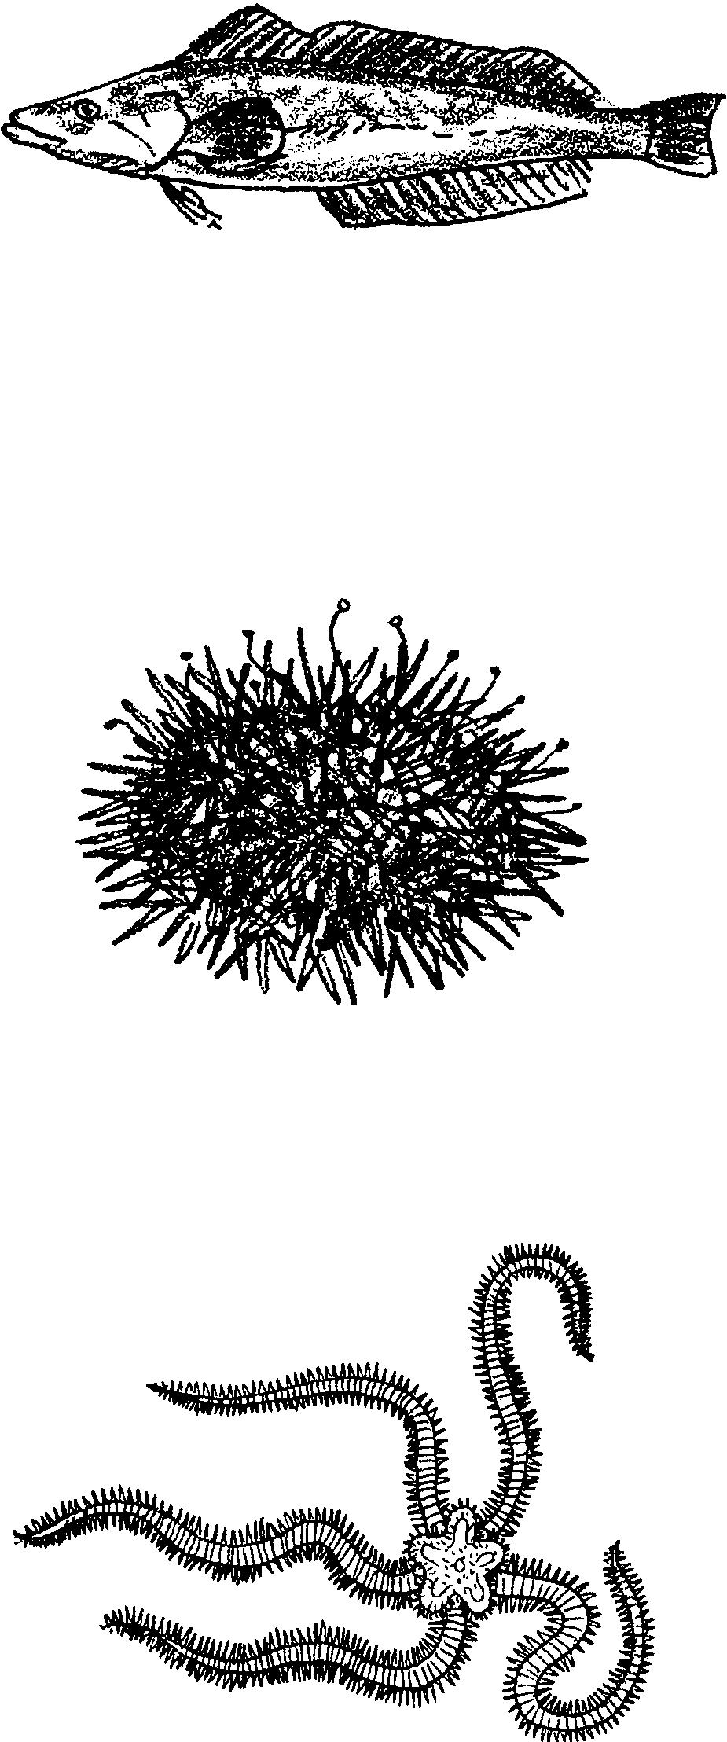

“Creating Kelp Creatures” Cards Fold. Glue, tape or laminate sides together
Create a kelp creature that....
eats sea urchins.
Sea Otter
I am brown.
I have thick fur.
My hind feet are webbed.
I eat sea urchins.
I float on my back at the surface.

