A Kelp Forest in the Classroom

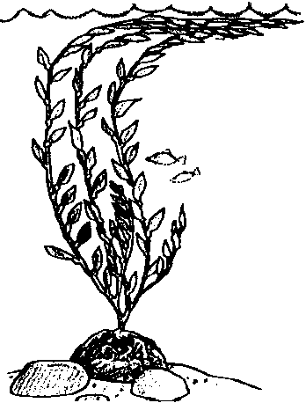
Lesson by Pat Rutowski,Monterey, CA. Adapted with permission from NatureScope - Diving Into Oceans, National Wildlife Foundation, 1988

Key Concept
1. A kelp forest consists of many individual kelp plants.

Background

Kelp plants grow in dense forests off the West Coast of the United States and in cold, nutrient-rich waters elsewhere in the world. Underwater, the kelp plants look like giant trees towering a hundred feet or more. Kelp rivals bamboo as one of the fastest growing plants in the world. Fronds that have reached the surface, where there is lots of sunlight, may grow as much as two feet per day!

Like a forest on land, a kelp forest may be divided into layers. These forests provide homes or habitats for over 800 different kinds of animals at different levels among the kelp plants. The top layer of a kelp forest, like that of a forest on land, is called the canopy. Marine mammals, young fish, and seabirds are among the animals that spend time in this area. In the middle of the forest, snails and other animals crawl around on the blades and stipes. Many kinds of fish swim among the fronds. At the bottom of the kelp forest, brittle stars, sea urchins, and many other creatures live among the holdfasts. The holdfast anchors the plant for five years or more. Fronds are shed as often as twice a year.

Materials

For the class:

• a video or slides of the kelp forest habitat (see bibliography for the Monterey Bay Aquarium videos)

• brown butcher paper and/or streamers

• tape

• a ladder or chair

• large sheets of blue cellophane or tissue paper

• real or imitation rocks

• string to hang kelp and animals (directions for the animals are in following activities)

Teaching Hints

In “A Kelp Forest in the Classroom”, students construct an almost life-size kelp forest, featuring many of the animals to be found there.

Preparation

l. Cut long strips of butcher paper or streamers for kelp stipes. The stipes should be longer than the height of the ceiling so that you can make a “canopy” of kelp draped across the ceiling. Cut rectangles (6" x l0") for students to cut out blades and thin strips of paper (3/4" x 18") to braid for holdfasts.

2. Locate a video or slides of the kelp forest habitat.

3. Collect rocks or make plans for production of imitation rocks by students.

Procedure

l. Review the different kinds of algae. Remind students that the large brown algae or seaweeds are called kelp and that these grow in large forests in the ocean. You may even want to put on a tape of crashing waves and have the students pantomime the kelp forest again, reviewing the kelp plant parts and swaying back and forth with the waves. If you have access to an underwater videotape, slides, or pictures of the kelp forest, show them to the students.

2. Read the following guided imagery to students or another story about the kelp forest.

Guided Imagery

“You dive into the cold ocean water and feel the sting of the salt in your eyes. As you move your arms and legs through the water, you feel its weight pushing back. The kelp blades surround you, the slick surfaces against your skin.

You kick to dive down among the kelp fronds and pull yourself along holding on to the slippery stipe of one kelp plant. The stipe feels like rubber, bending towards your pull and yet firmly anchored in place by both its holdfast and the thick canopy of blades above. A school of sardines darts away in a massive silver cloud as you descend. Gray-blue fish shapes hang without movement next to the kelp plants surrounding you.

The dim light coming through the blades above makes everything look spotted and blurry. The golden forest rises around you as you come to the bottom and you see swaying kelp fronds, moving with the surges of water. The reddish-gold holdfasts line the bottom like the feet of the kelp, their toes bent around the rocks that anchor the giant plants. Brittle stars, relatives of the sea star, wave their snaky arms from their homes in the holdfasts. Crabs scuttle for rocky cover and hide behind the kelp blades as they sense your movement. A large fish lurks in the dimly lit holes of the rocky reef at your feet.

You push upwards, back to the light, feeling the blades lick your skin as the kelp canopy surrounds you. As you break the surface of the water, you can breathe again.”

3.Discuss with students plans for creation of a kelp forest in the classroom. List the elements needed. Show them the materials you have prepared to make the forest and give them the kelp plant construction directions below. You may want to assign a couple of students to work on building each kelp plant.

Kelp Plant Construction Directions

a. Have students cut out kelp blades with floats at the base of each blade and attach these to the long strips of paper you cut for the stipe.
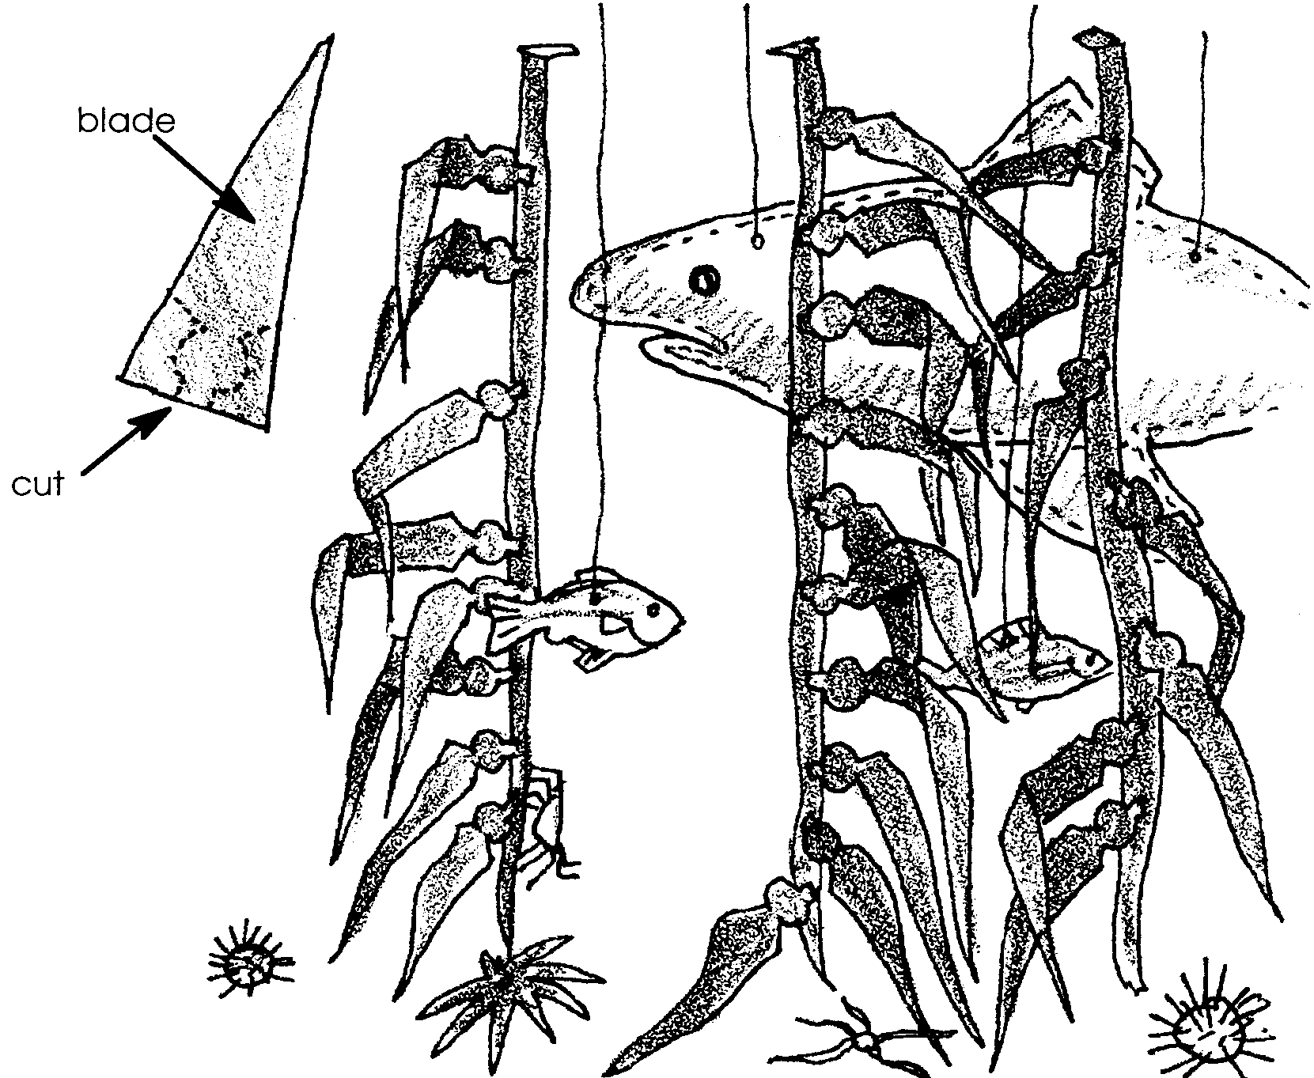

b. Make holdfasts by braiding together thin strips of paper, attaching one end to the kelp stipe and one end to a rock or the classroom floor.

c. Have students help you hang the kelp plants from the ceiling, draping the stipe across the ceiling and allowing the blades to hang down.

4. Have students work with you to measure and cut out blue cellophane squares to cover the windows to give your whole classroom an underwater feeling.

5. Add animals to the kelp forest (see the next activity, “Creating Kelp Critters” for suggestions). Hang the swimming animals from the ceiling using string or fishing line and tape snails and other clinging animals to the kelp plants.

Key Word

canopy - the top layer of a kelp forest

Extensions

l. Have students imagine what it would be like to dive into the kelp forest and write stories about their adventures there.

2. Have students estimate how many blades there are in your kelp forest and then count them to check their estimating skills.

3. Using ideas adapted by Lynne Ball of Boise, Idaho, and Laurie Dumdie of Poulsbo, Washington, help your students “create some painless poetry”.

a. Show students video footage from a kelp forest. “The World’s Below” (see Bibliography) is excellent for motivating students to write about the kelp forest.

b. As students view the video, they should be thinking about words that describe the kelp forest.

c. After the video, list the individual words students suggest.

d. Have each student choose 15 of their favorite words from the list and record them on a sheet of paper.

e. Explain that they will place their 15 words in 4 different word patterns. The order of the 15 words should remain the same as that recorded in step d. Distribute copies of the word patterns for students to fill in, using their selected 15 words. (The four blank word patterns are included in this lesson, ready for duplication.)

f. After reading each of the four word patterns aloud to a partner, each individual should select the pattern that is most pleasing.

g. Have students illustrate their favorite “poem.”

A.

B.

C.

D.

