Kelp in the Kitchen

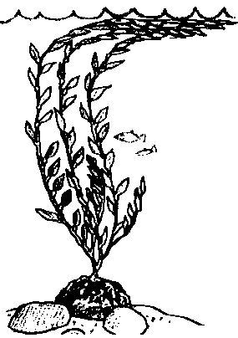
Lesson by Pat Rutowski, Monterey, CA

Key Concept
1. People use algae in foods and other products.

Background

Humans use substances from seaweeds in many different food and household products. Kelp contains iodine, minerals, vitamins and carbohydrates and is used in many countries as a food supplement for people and animals.

While kelp may be eaten directly, a large variety of widely eaten food extracts are derived from these algae. For example, kelp contains a substance called algin which acts as an emulsifying, stabilizing and gelling agent. Algin prevents liquids from separating and makes liquid foods thicker and smoother. One unique property of algin is its ability to absorb large quantities of water - a singletablespoon of algin added to a gallon of ice cream prevents the water from forming ice crystals.

Algin is also used to suspend drugs in antibiotics and to suspend the abrasive in auto polish and the pigments in paint. It is used as a creaming, thickening, and stabilizing agent in rubber and textile manufacturing and prevents the dyes in printing fabrics from running.

Kelp is harvested for algin off the southern California coast. Large vessels move over mature kelp forests, trimming off the top three feet of the kelp canopy. These harvesters can gather up to 600 tons of kelp in 8 hours. Because only the tops are trimmed, in a few months the canopy grows back and can again be harvested without harm.

Algin is not the only useful product derived from seaweeds. The following is a list of the most common algal derivatives and their uses:

agar - made from red seaweed and used in canning jellied meats, stabilizing sherbets and making cheeses and candies

algin - made from kelp and used in ice creams, chocolate, puddings, icings, candies, rubber, paints and gum adhesives

carrageenan - made from red seaweed and used in stabilizing ice cream and whipped cream and in puddings, toothpastes, hand lotions

mannitol - made from various seaweeds and used in foods, chewing gum, shoe polish, coatings for paper and leather

Materials

For the class:

• at least one box or wrappers from a product containing algae

• Japanese rice crackers with seaweed

• jar or can of ajitsuke nori (flavored seaweed)

For each student:

• take home letter describing words to look for on product labels

• “Algae, Anyone?” survey page

Teaching Hints

In “Kelp in the Kitchen”, students discover that substances extracted from seaweeds are found in many common household foods and products.

Preparation

1. Compose and copy a letter for students to take home explaining that they are on a scavenger hunt for food or other household products with any of the following algal derivatives listed on the label:
agar
algin
carrageenan
mannitol

You may want to assure parents that anything brought into the class will be returned if they write their child’s name on the package. If they do not want to send the product to school, ask them to send the name of the product and the type of algal derivative with the student.

2. Display a list of the algal derivatives.

Procedure

l. Ask students if they have ever eaten seaweed. Many will say, “No!” Discuss the role of seaweeds in other cultures (sushi in Japan, salads and soups in various Asian countries, bread in Ireland). Then, ask how many brushed their teeth that day, or who had chocolate milk or ice cream that week. Explain that seaweed is in many of the foods we eat and the products we use, including toothpaste, chocolate milk and ice cream! Show students the list of words which indicate that algae was used in making a food or product.

2. Explain the scavenger hunt they will do at home for products containing algae. Demonstrate how to read the ingredients label on a package, looking for any of the words for algae (see the list above). Ask them to bring in the package of any algae containing product. If this is not okay with their family, ask them to write down the name of the product and the algal derivative on a slip of paper and bring that in.

3. When the students bring in the products, ask them to sort their contributions according to which word is on the label. Remind them to write their names on each package. Then read through the list and have each student add their contribution to a table labelled with the name of the algal derivative.

4. Discuss what they found and what each algal derivative adds to the products. Discuss how people use seaweed.

5. Explain that seaweed is also an important food itself. Many people around the world enjoy its flavor and nutritional value. Distribute the Japanese rice crackers and flavored seaweed for taste tests.

6. Ask students if they know any other groups of people who eat seaweed as a basic food (Korean, Vietnamese, Chinese, some Native Americans, and Irish, among others, regularly eat seaweed). To show students how often they eat seaweed, distribute the student worksheet, “Algae, Anyone?” and help students complete it.

Key Words

agar - made from red seaweed and used in canning jellied meats, stabilizing sherbets and making cheeses and candies

algal derivatives - extracts taken from algae and used in food and other products

algin - made from kelp and used in ice creams, chocolate, puddings, icings, candies, rubber, paints and gum adhesives

carrageenan - made from red seaweed and used in stabilizing ice cream and whipped cream and in puddings, toothpastes, hand lotions

mannitol - made from various seaweeds and used in foods, chewing gum, shoe polish, coatings for paper and leather

Extensions

1. Have students try small pieces of nori dipped in soy sauce.

2.Make a food that includes seaweed: sushi, Chinese seaweed soup or try some Kelp Candy from the following recipe:

Kelp Candy

1. Wash and cut the kelp into bite-size pieces (not too small as it will shrink somewhat in the cooking process).

2. In a large pan, cover kelp with distilled vinegar and bring to a boil. Simmer for 45 minutes.

3. Drain and rinse. Let stand in fresh water for 4 hours, changing the water every hour, until the vinegar taste is gone.

4. In a pan over medium heat, place 2 cups of kelp. Cover with 2 cups of sugar in which 2 teaspoons of cinnamon have been mixed. Stir until the sugar has melted. Add flavoring (2 teaspoons of cherry, or similar flavoring). Bring mixture to a boil. Reduce heat and let cook for one hour.

5. Remove kelp pieces from the syrup and drain. Syrup can be re-used (by adding more sugar and flavoring) for the next batch of kelp candy, or it can be poured over ice cream.

6. Place cooked pieces of kelp in a loaf pan with granulated sugar and coat well. Put coated pieces on waxed paper to dry. Pieces of kelp candy should be stored, loosely covered, in the refrigerator.

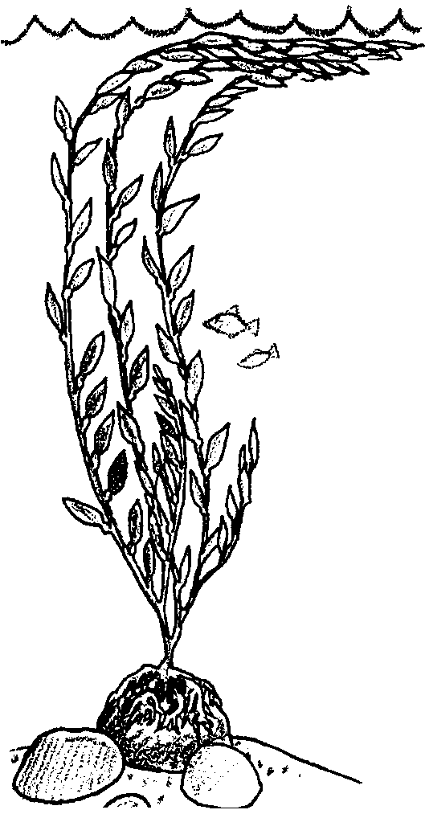
Kelp in the Kitchen

Algae Anyone?
Have you eaten algae this week?
Place a check mark by each item that you have eaten in the past week.
Bakery
Bread doughs
Cake batters
Doughnuts
Pie fillings
Fruit fillings
Doughnut glaze
Meringues
Cookies
Cake fillings/toppings
Frozen pie fillings

Dietetic foods
Starch free desserts
Salad/French dressings
Jellies, jams
Puddings
Sauces
Candies
Vegetables and health foods

Miscellaneous
Jams, preserves
Prepared cereals
Processed baby food
Soups
Frozen foods
Synthetic potato chips
Fountain toppings
Artificial cherries

Dairy
Ice cream
Milk shake
Sherberts
Ice pops
Chocolate milk
Puddings
Cottage cheese
Cream cheese
Yogurt
Packageable milk

Beverages
Soft drinks
Fruit juices

Candy
Candy gels
Caramels
Marshmallows

Dressings, Sauces
French dressing
Mayonnaise
Syrups, toppings
White sauces
Mustard
Catsup

Meat, Fish
Canned fish, meat
Sausage ingredient

1. How many items did you check? .
2. Think about last night’s dinner. How many of the foods in the dinner contained algae? .

