Nature's Protection

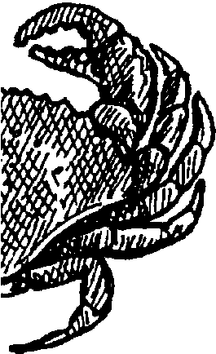
Key Concepts
1. Aquatic organisms interact in complex feeding relationships.
2. The more diverse and complex an aquatic ecosystem, the more it is stable and resistant to change.
3. Aquatic ecosystems depend on a constant flow of energy and the recycling of materials.

Background

Plants and animals interact in many ways. While animals sometimes act in a cooperative fashion, they also interact in predator-prey relationships. The many and diverse relationships which exist maintain the stability of the world of life. As we simplify ecosystems by removing links in the food chains, we increase the chance of dramatic and drastic change within those systems. A classic example of this type of drastic change occurred on the central coast of California when sea otters were hunted to near extinction. With no more otters to eat them, the sea urchins, who eat the kelp, increased in numbers and the kelp forests almost disappeared. Without predators to hold them in check, urchins may achieve a density of 300 animals per square yard. Such a mass of urchins can move through a kelp forest, grinding everything in its path. When people stopped hunting sea otters and the otter numbers grew again, the otters ate the urchins that eat the kelp and the kelp forests grew back. As can be seen, humans play a complicated role, sometimes we are harvesters and sometimes, sadly enough, depleters. Wise harvesting cultivates a crop while unwise use often eliminates it.

To help maintain nature’s balance, each plant and animal has some means of protection to insure the continuance of its species. It may be a protective covering of shell or the ability to dig down into the bottom. It may be that the animal is capable of moving or swimming very fast and is thus able to outdistance its predators. Some animals and plants maintain their species by reproducing in large numbers. Most of the young eventually are eaten or die, but a few survive to keep the cycle going.

In this section “plankton” is again defined. Plankton are those forms of plant and animal life that drift, depending upon the currents for locomotion. They are the free floating microscopic plants and animals that, among other things, are responsible for the colors of the sea. When you see clear blue water it indicates an ocean desert, or the lack of planktonic life. A very simple, yet accurate, definition of plankton is any form of drifting plant or animal life in the sea, regardless of size.

Materials

For each student or pair of students:

• “Nature’s Protection” activity pages

Teaching Hints

“Nature’s Protection” takes the concept of interrelationships stressed in the previous lessons one step further. This student reading and activity pages deals with nature’s way of keeping a balanced system.

Duplicate the pages of the text. One set is recommended per student or pair of students. The basic concepts covered in the reading need to be discussed by the teacher. Continue to be aware of new vocabulary and teach the “Key Words” if they are unfamiliar to your students. The activities included are designed to reinforce the concepts introduced.

Key Words

pincers - in this case, the first two legs of a crab bearing the claws

plankton - free floating plants and animals, usually (but not always) microscopic, that are at the mercy of currents in the ocean

species - a classification of animals

stinger - a sharp-pointed structure used to pierce or wound

Answer Key

1.Ways in which animals protect themselves noted in the reading include:
a. with pincers
b. by changing color
c. with stingers
d. by looking like something they are not
e. with shells
f. by moving fast

2. Some eggs live because mother animals lay many eggs.

3. Plankton move by drifting.

Nature's Protection
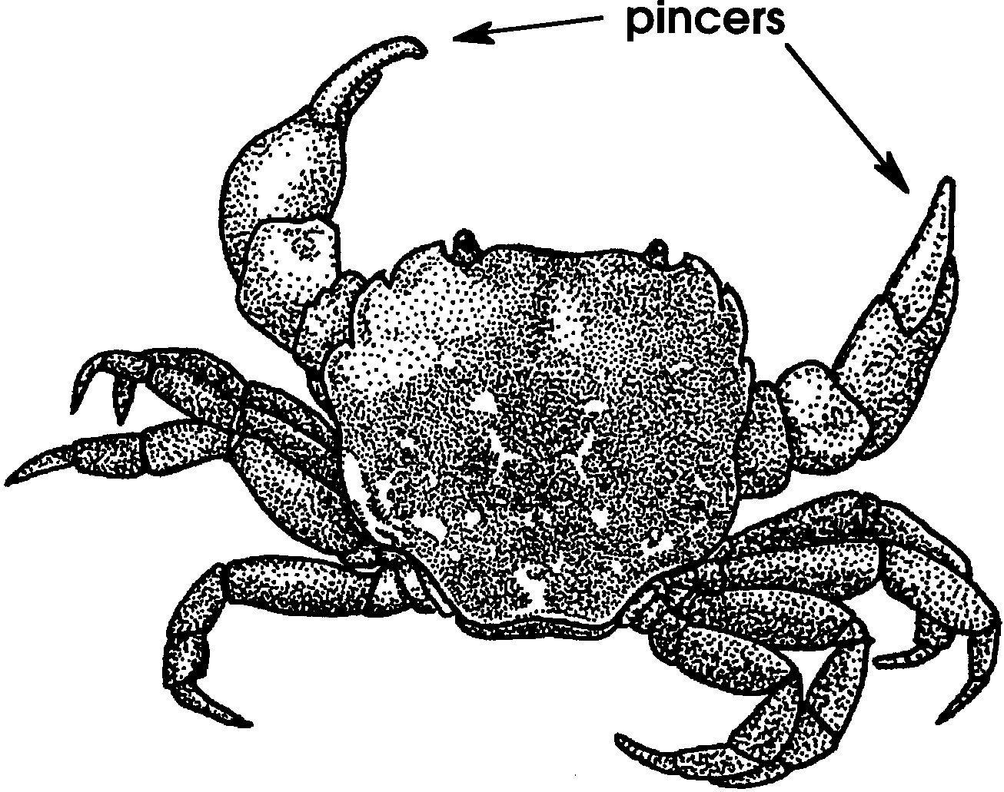

Many plants and animals become food for other animals. All animals have ways to protect themselves. Some animals protect themselves with pincers.

Others change their color. Some use a stinger to keep their enemies away. Other animals look like something they are not. A limpet can look like a pebble. A sea anemone sometimes looks like a stump.

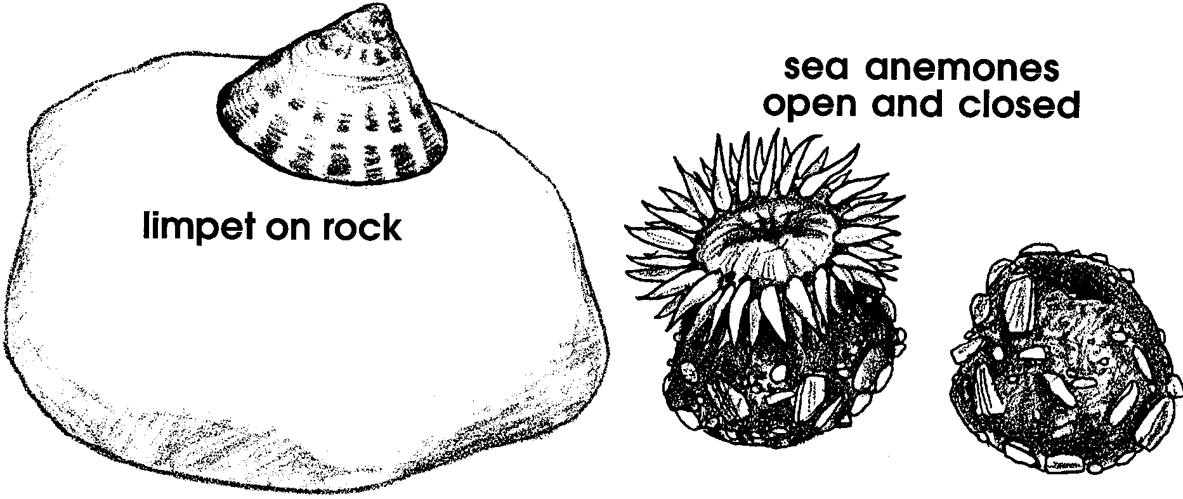
Many animals use shells for protection. Clams, oysters and hermit crabs are just a few.

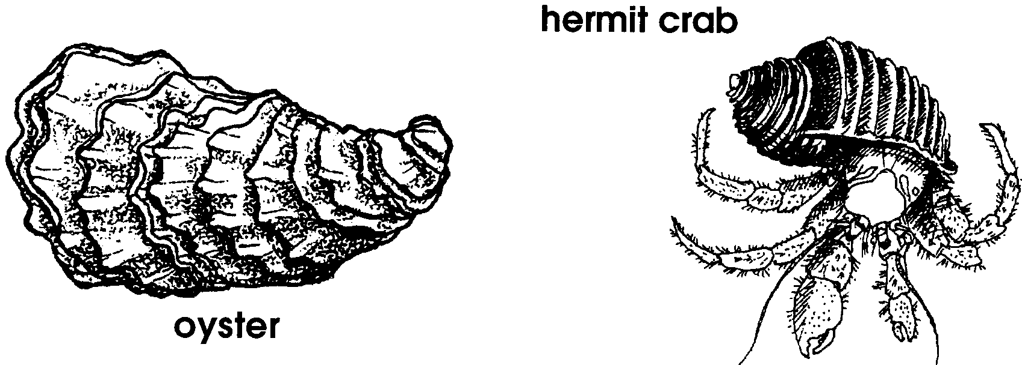
Other animals can move very fast. It is hard for their enemies to catch them.

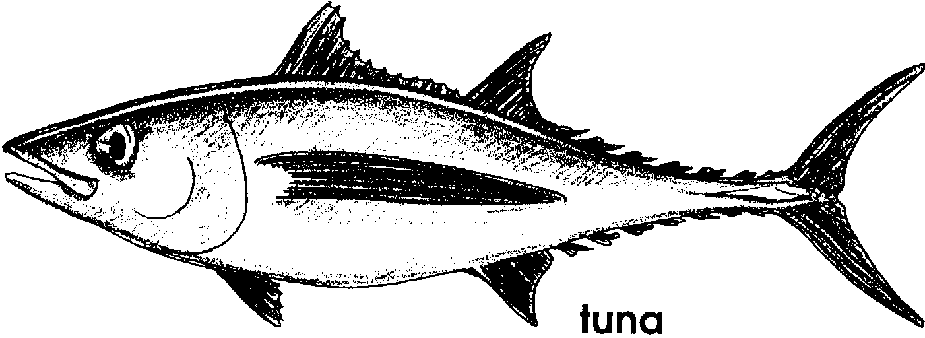

1. List 5 ways animals protect themselves.

a. .
b. .
c. .
d. .
e. .

Nature helps marine life survive in other ways. Mother animals lay many eggs. Sometimes these eggs drift in the water. Many of the eggs are eaten. However, the mother laid many eggs. Some eggs will survive to continue the species.

2. Some eggs live because mother animals lay
eggs.

The drifting eggs are part of the plankton. Plankton are living plants or animals which can only drift in the water. They can not stop themselves. They can not decide where they will go.

3. Plankton move by
.
