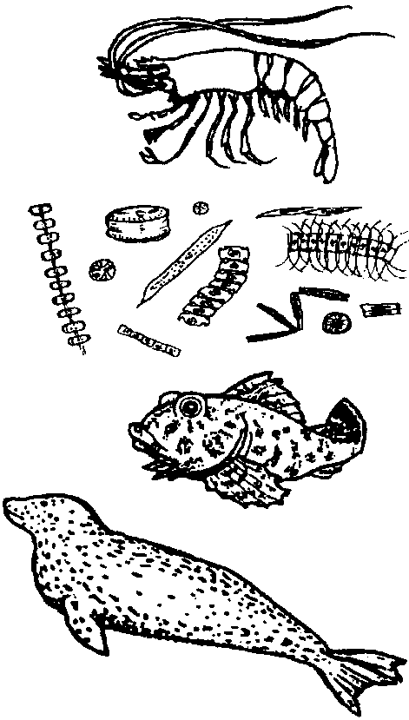
Who's For Dinner?

Key Concepts
1. The more diverse and complex an aquatic ecosystem, the more it is stable and resistant to change.
2. Aquatic ecosystems depend on a constant flow of energy and the recycling of materials.

Background

Plants and animals interact and depend on each other. In a balanced environment, the plants provide food and oxygen for the animals, and the animals provide nutrients and carbon dioxide for the plants. Dead and decayed tissue provide some of the nutrients for the plants. The fate of one group of organisms influences the fate of all.

Additional background information is found in the preceding lesson, “Food Chains in the Kelp Forest”.

Materials

For each student:

• 1 plastic sandwich bag

• 2 colored, 8 1/2" x 11", pieces of paper

• 2 safety pins

For class:

• 4-5 liters of popped corn

• clipboard and paper for results

• marking pen

• kitchen timer with bell

• roll of 1" masking tape

Teaching Hints

“Who’s For Dinner?” is a role playing game designed to help your students understand the food chain concept. Your students will play the roles of shrimp, kelpfish and harbor seals. The first link in the food chain will be plankton (represented by popcorn) spread over the game area. The shrimp eat the plankton, the kelpfish eat the shrimp and are, in turn, eaten by the harbor seals. The object of the game is for each animal to get something to eat without being eaten during the timed course of the game.

“Who’s for Dinner?” is a poor model of nature because of the small population sizes. Natural populations are usually able to withstand the loss of some of their individuals. In our populations, the survival of any of each kind of animal will be considered a success. The community is “balanced” and will survive.

Object

The object for each student is to survive as an animal in a food chain by getting enough to eat while avoiding being eaten.

Preparation

Before you are ready to being the role playing, you will need to prepare the following:

stomachs: The plastic sandwich bags will be animal stomachs. Place a strip of masking tape 4 cm. from the bottom and parallel to the bottom edge.

name tags: The colored paper will serve to identify the animals. You will need three colors: one for the shrimp, one for the kelpfish, and the third for the harbor seals. Have enough of each color to allow, at different times, 3/4 of the group to be shrimp, 1/3 to be kelpfish, and 1/3 to be harbor seals. The fact that you have a surplus of shrimp tags will allow you to change population numbers as the game progresses. A piece of the colored paper will be pinned on the front and on the back of each student.

How to play

1. Briefly review food chains. Outline the boundaries of the game area. An area about 15 meters square is adequate. A grass area is best, but a gymnasium, parking lot, etc., will work. Outdoors missed popcorn plankton will be eaten by birds.

2. Spread about 3/4 of the plankton (popcorn) over the area. Tell your class you are spreading out the plankton that the shrimp will eat.
3. Hand out a plastic bag stomach and two shrimp name tags to 1/3 of your group. Tell your students to put their food (popcorn) into their stomachs when the game begins.

4. Hand out a bag and two kelpfish name tags to a second 1/3 of the group, and bags and two harbor seals name tags to the last 1/3. When the game starts kelpfish will try to capture (tag) shrimp and harbor seals will try to capture (tag) kelpfish. When a kelpfish captures a shrimp, the shrimp’s stomach contents are transferred to the stomach of the kelpfish. When a harbor seal captures a kelpfish, he takes the kelpfish’s whole stomach. Note that harbor seals do not eat shrimp in this game.

5. State the challenge. Set the timer for five minutes and say “Go!” The first game usually lasts only a few seconds with one of two things happening. The shrimp are gobbled up before they have a chance to forage, or the kelpfish are gobbled up and the shrimp continue to eat popcorn and get fat.

6. Analysis. How many animals survive? For a shrimp to survive, popcorn must fill the stomach bag to the bottom of the tape (4 cm.). For a kelpfish or a harbor seal to survive, popcorn must fill the stomach bag to the top of the tape (6 1/2 cm.). If at least one of each kind of animal survives, you have an on going food chain. Return the popcorn to the activity area after each game.

7. Encore: Learning by making rule variations. Ask for suggestions on rule changes that might result in more of a balance after the five minute “day”. Usually one rule is changed for each replay. When you have settled on your new rules, play again. Suggest these changes if your students can’t offer any:

a. change the number of shrimp and/or kelpfish and/or harbor seals.

b. Let each shrimp come back as another shrimp once after being captured and transferring stomach contents.

c. Provide a “safety zone” for shrimp and or kelpfish where they can be safe.

d. Timed releases. Let shrimp go first to forage unmolested. One minute later release the kelpfish, and later the harbor seals.

e. Spread out more popcorn.

To reduce discontent over who will be which organism, draw markers from a hat to assign roles for replays.
Afterward..........

Analyze the results of each game. How many shrimp got a full stomach? How many kelpfish? How many harbor seals? Compare game results after each rule change and comment on how the game “balance” compares with the balance in the real world. In nature, there are more plants than plant eaters and more plant eaters than animal eaters.

Here are some questions to consider back in the classroom:

1. What would happen if there were only half as many popcorn plankton?

2. If there were no kelpfish, what would happen to the plankton population? The shrimp population? The harbor seal population?

3. Do harbor seals need plants to survive? Explain!

4. Can you describe some food chains that you are part of?

5. Are there any plants or animals that are not part of any food chains?

Adapted from “Food Chain Game” by Outdoor Biology Instructional Strategies (OBIS), Lawrence Hall of Science, University of California, Berkeley, California.

