Interdependence
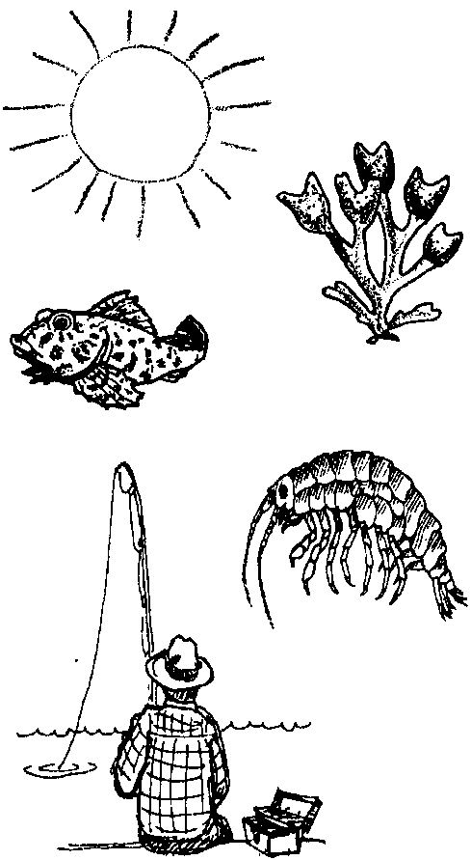
Lesson by Laura Erickson, Poulsbo, WA

Key Concepts
l. Animals and plants depend on each other for the things they need to survive.
2. Plants and animals are sources of food for other plants and animals. These interrelationships are described in diagrams called food chains or food webs.
3. Aquatic plants convert solar energy to food energy.

Background

All life in the sea is interrelated, every organism is dependent upon other organisms. In a balanced environment, plants and animals interact and depend on each other in a stable, predictable fashion. The plants provide food and oxygen for the animals, and the animals provide nutrients and carbon dioxide for the plants. Dead and decayed tissue provide some of the nutrients for the plants. Energy from the sun drives all of these interactions.

In the sea, seaweeds and microscopic plant plankton use the sun’s energy and nutrients in the water to produce their own food. These seaweeds and plant plankton (phytoplankton) form the basis of food for almost all of the animals in the sea. Seaweeds provide food directly to some animals, like turban snails which graze on kelp fronds. Others, like abalones and urchins, feed on fronds that have detached (drift kelp) and have drifted to the bottom. Drift kelp that is not eaten is decomposed by bacteria. The resulting material is eaten by filter-feeders, like sponges, which take the food particles from the water, or by deposit-feeders, like sea cucumbers, which eat the food particles which have settled on the sea floor. Many of these animals are eaten by larger predators like crabs, rock fish, or sea stars. Kelp and other seaweeds that pile up on the beach are eaten by shrimp-like creatures called beach hoppers which, in turn, provide food for shore birds. These relationships may be represented in diagrams called “food chains”.

All food chains follow this general pattern:

Producer → Herbivore → Carnivore → Higher Order Carnivores

In a food chain, plants are called the producers. Producers make, or “produce” food using the sun’s energy. Herbivores, animals that eat the plants, are called first consumers. First consumers are
“first” to eat the producers. Carnivores that eat the first consumers are called second consumers and so on up the chain. An example of a simple food chain is:

kelp → sea urchin → sea otter
(producer) (first consumer) (second consumer)

Other food chains are:

drift kelp → abalone → people

decomposed seaweed → beach hoppers → shore birds

decomposed drift kelp → filter feeders → rock fish → people

Arrows in a food chain show the direction of the movement of the food energy and matter.

Note that although many food chains in the intertidal zone and the near shore areas of the sea are based on seaweeds, most food chains in the ocean are based on plant plankton rather than on the larger seaweeds.

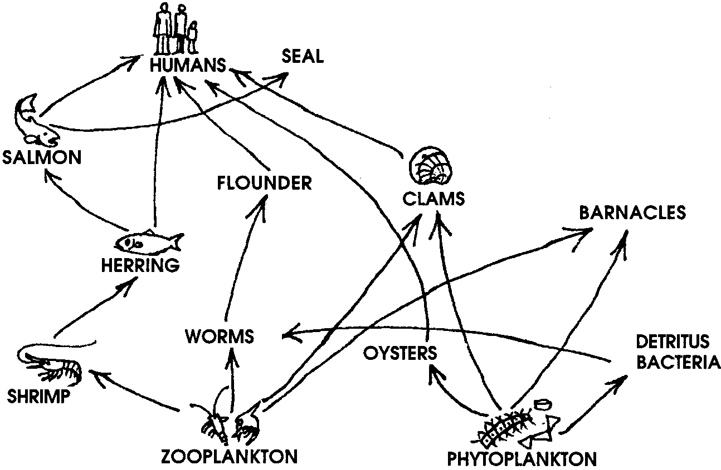
Within a kelp forest or any other defined area of the sea, many food chains may exist. A food web integrates all of these individual chains into one diagram which may have a very intricate and complex pattern. A food web may describe as many as a hundred or more food chains. A simple food web might look like this:

Materials

For the class:

• “Interdependence” card set (30 total cards)

• ball of yarn or string

• 3" x 5" cards for names/sketches

• marking pen

• scissors

Teaching Hints

In “Interdependence”, the class models a kelp forest food web. Note that “Interdependence” builds upon the previous activity “Food Chains in the Kelp Forest”, in which students make a variety of food chains to see how kelp forest creatures transfer energy and matter in the form of food from one organism to another.

Procedure

1. Have students sit in a circle on the floor. Start the food web by using land animals with which the children are familiar.

Example: “I am the sun. What needs the sun to grow? Grass! Good I will roll the ball of yarn to Fred and he will be our grass. Here is the word “Grass” for Fred to hold. (On a 3" x 5" card or slip of paper, write the word “Grass” and make a quick sketch of grass.)

Now, what needs grass to grow? A cow! Great, Susie can be our cow. Fred will roll the ball of yarn to Susie and we will give her a card with the word “Cow” on it.

What else eats grass? Horses! Right, we now need to cut the string that went from our grass to cow, and start the string at the grass again and lead it to Jake, our horse.

Does anything eat a cow or a horse? People eat cows. Let’s give Sally the word “people” and put a string between the cow and our people. Now we are starting to make a web, etc.”

2. Once students understand how to make this food web model, begin all over with kelp forest creatures. Give each student a picture card from the “Interdependence” picture set. Once again, start the food web with the sun. Remind students that the plants in the kelp forest also obtain their energy from the sun. Then go on to animals that need seaweed to grow. Then to what eats those animals. The picture cards help eliminate confusion regarding what has already been said.

You may find several animals that will eat the same thing. Be sure that separate pieces of yarn go to each animal before the yarn goes to the next food source.

You should end up with a spider-like web on the floor. Tell the students that a food web is many food chains that are interconnected. (Show what this means by pulling up on part of the web and having students notice that the other parts of the web move also.)

3. Choose one of the animals in the food web. Say:

“Let’s see what will happen to (name of the animal) if the food web changes.”

Observe the links to the chosen animal and discuss with students the problems that animal would face if one, or all, of its food sources were to die off. Ask questions like:

“What would happen if the animal only ate one type of food and that food was all destroyed?”

“What would happen, then, to the animals that eat this animal?”

4. Move the web to a bulletin board so that students can continue to add links as you study more marine animals and plants. Have students decide on the organisms to include and where the strings will need to go. Students may want to make pictures or 3-D models of the plants and animals to place on the bulletin board.

Key Words

food chain - a diagram showing relationships among plants and animals based on who eats whom

food web - a diagram showing interconnected food chains
"Interdependence" Cards
SUN
Hermit Crab
Eats:
dead plants and animals
Eaten by:
shiner perch
herring
sunflower star
octopus
Sea Otter
Eats:
salmon
herring
shiner perch
Red Rock crab
shrimp
sea urchin
sea cucumber
Eaten by:

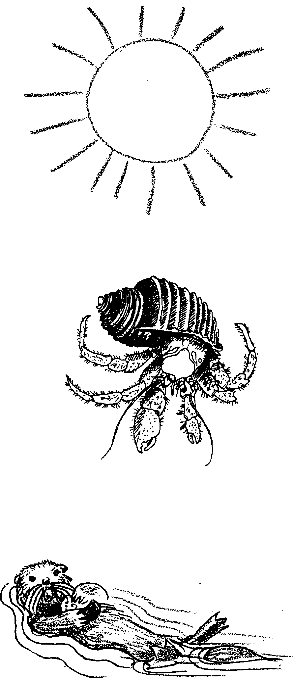

"Interdependence" Cards
Human
Eats:
shiner perch
herring
salmon
oyster
shrimp
cockle clam
Red Rock crab
octopus
Eaten by:
Barnacle
Eats:
zooplankton
phytoplankton
eaten by:
moon snail
sunflower star
shiner perch
herring
Red Rock crab
oyster drill
gull
Salmon
eats:
zooplankton
herring
Eaten by:
harbor seal
Great Blue heron
sesa lion
orca
sea otter
human

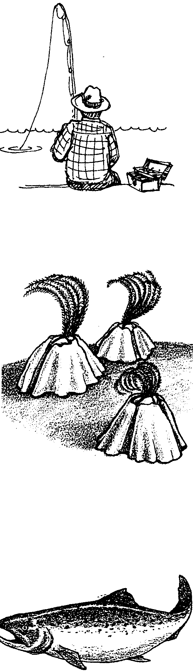

"Interdependence" Cards
Herring
eats:
zooplankton
hermit crab
barnacle
eaten by:
salmon
Great Blue heron
sea otter
human
harbor seal
shrimp
sea anemone

Zooplankton
eats:
phytoplankton
eaten by:
shrimp
salmon
herring
barnacle
sea anemone
oyster
cockle clam
Oyster
eats:
phytoplankton
zooplankton
dead plants and animals
eaten by:
human
oyster drill
Red Rock crab
sunflower star
octopus

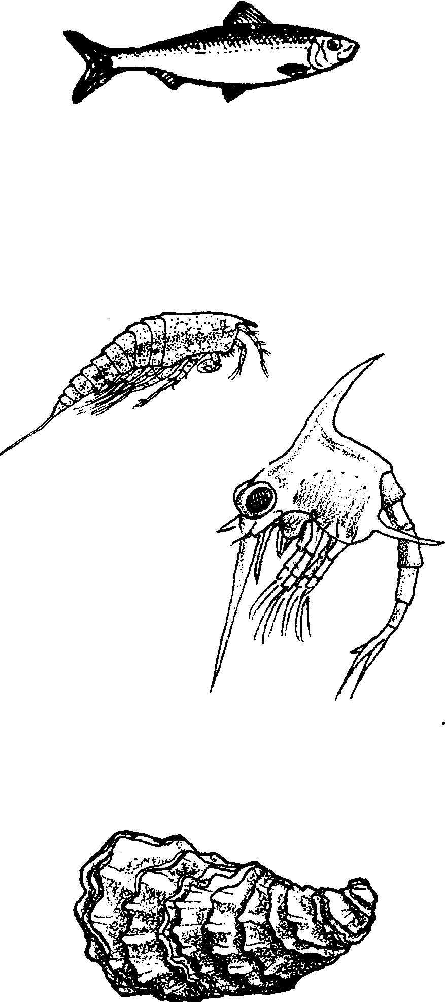
"Interdependence" Cards
Dead Plants and Animals
Eats:
Eaten by:
hermit crab
oyster
cockle clam
shrimp
sea cucumber
gull
Purple Shore crab
Sunflower Star
Eats:
limpet
moon snail
hermit crab
sea urchin
barnacle
oyster
cockle clam
sea cucumber
eaten by:
Shrimp
eats:
zooplankton
herring
dead plants and animals
eaten by:
sea otter
human
Great Blue heron

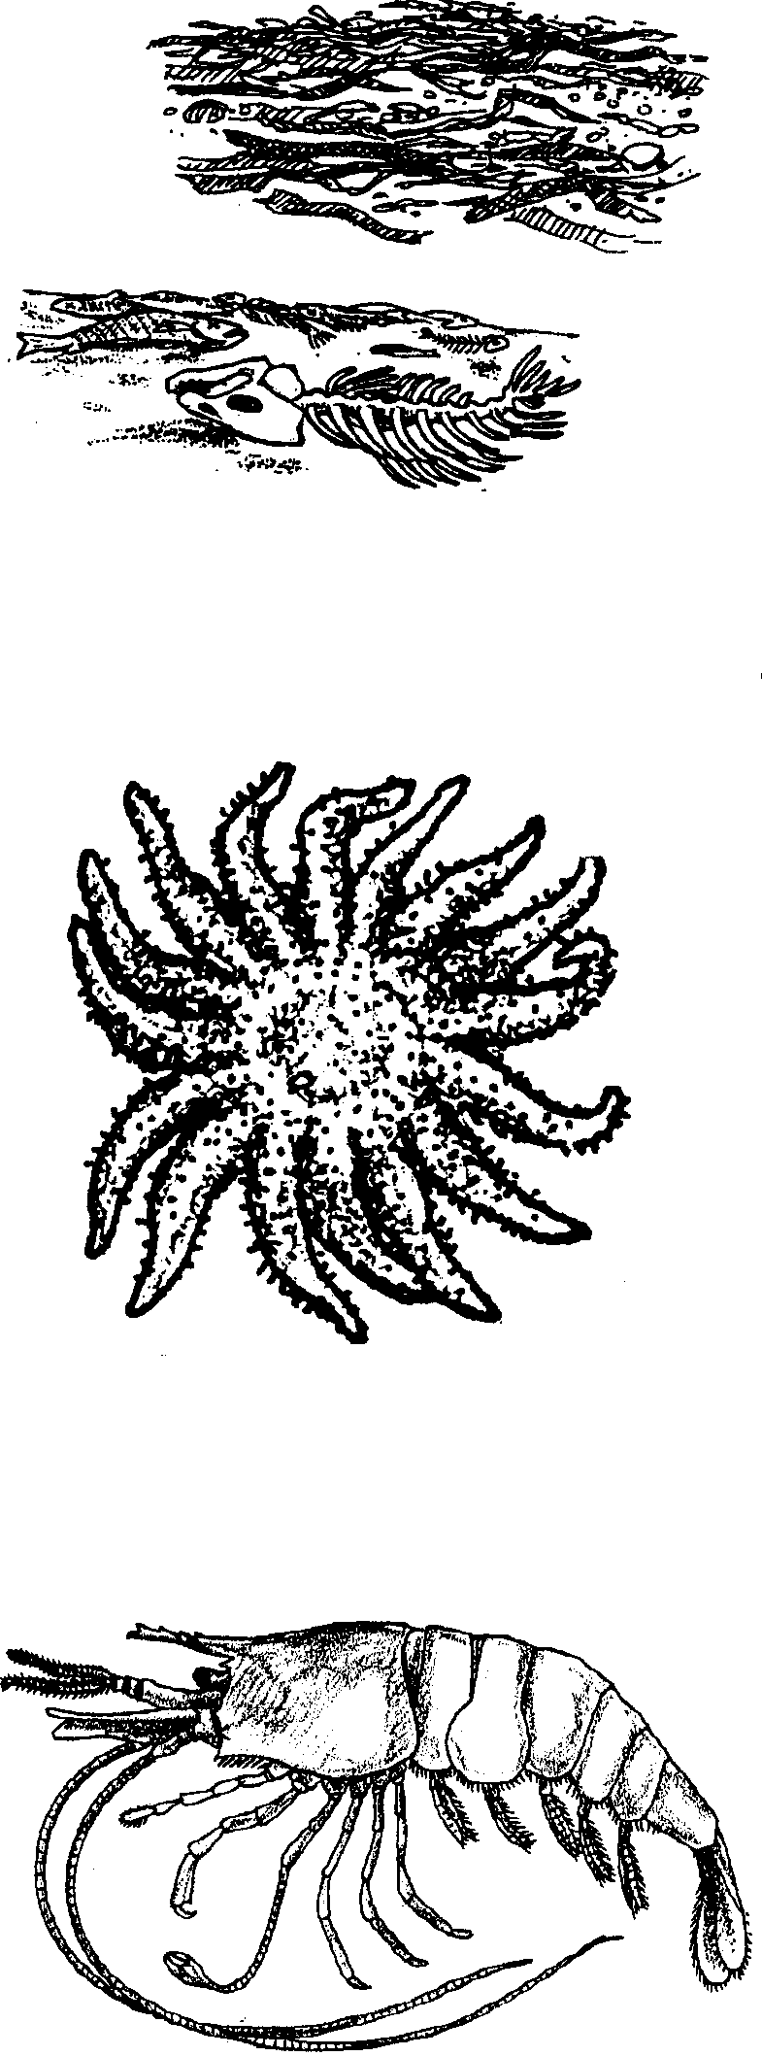

"Interdependence" Cards
Moon Snail
eats:
cockle clam
oyster drill
barnacle
eaten by:
sunflower star
octopus
Limpet
eats:
kelp seaweed
eaten by:
shiner perch
sunflower star
Red Rock crab

Oyster Drill
eats:
cockle clam
oyster
barnacle
eaten by:
Great Blue heron
moon snail
Red Rock crab
octopus

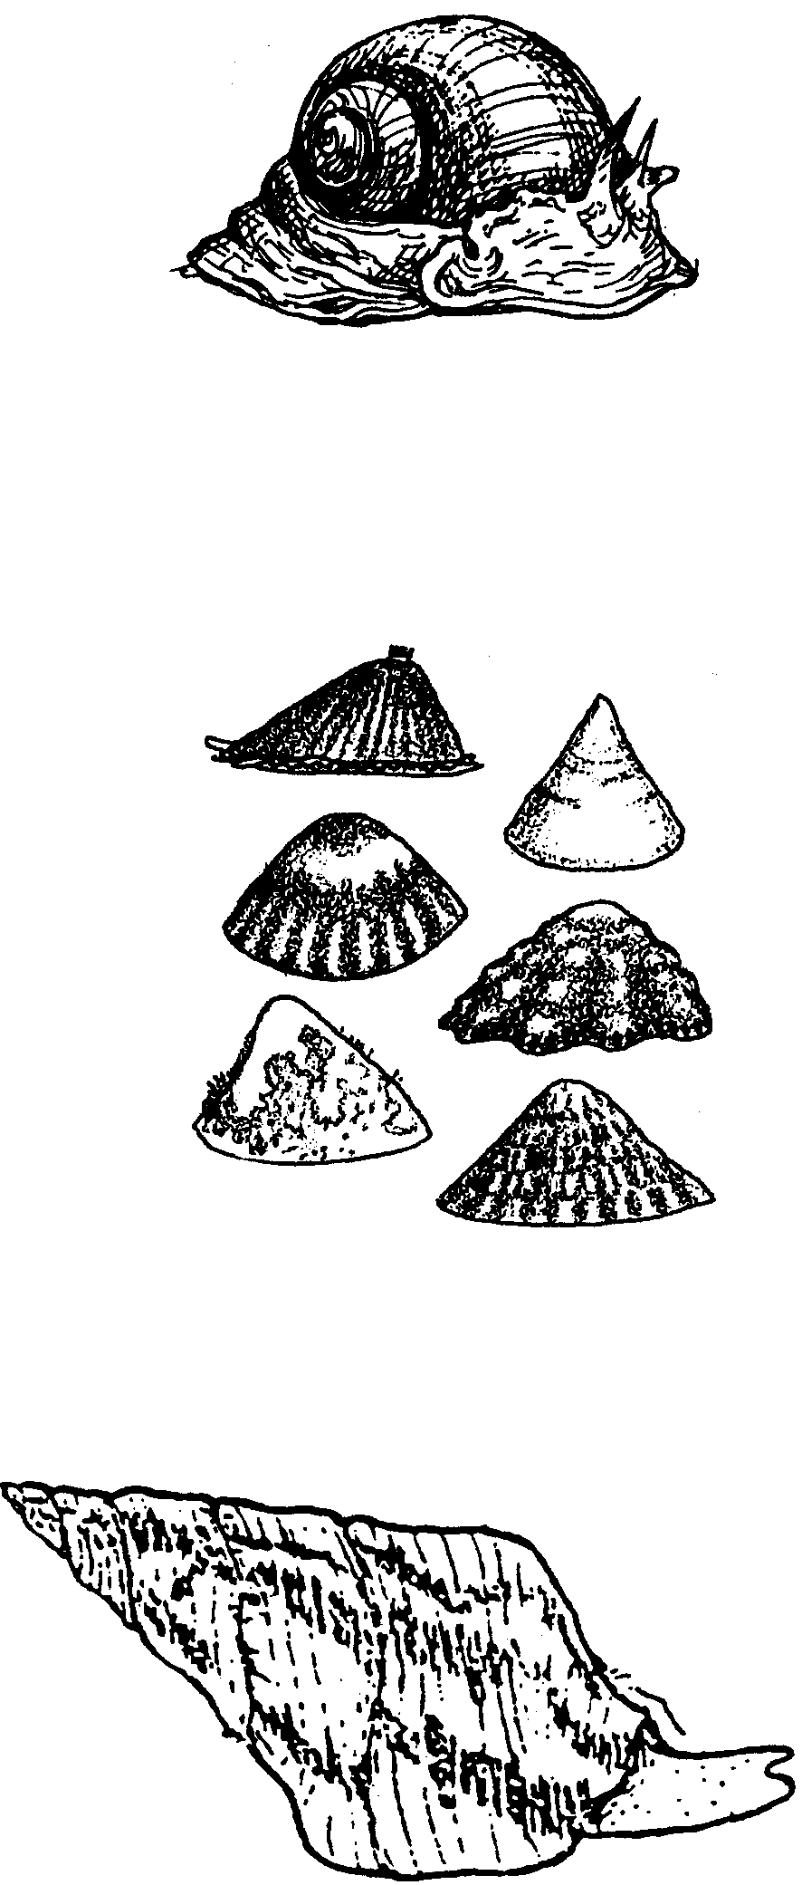

"Interdependence" Cards
Cockle Clam
eats:
phytoplankton
zooplankton
dead plants and animals
eaten by:
moon snail
oyster drill
sunflower star
human

Red Rock Crab
eats:
oyster
barnacle
oyster drill
chiton
limpet
Purple Shore crab
eaten by:
sea otter
Great Blue heron
human
octopus

Sea Cucumber
eats:
phytoplankton
kelp seaweed
dead plants and animals
eaten by:
sunflower star
shiner perch
sea otter

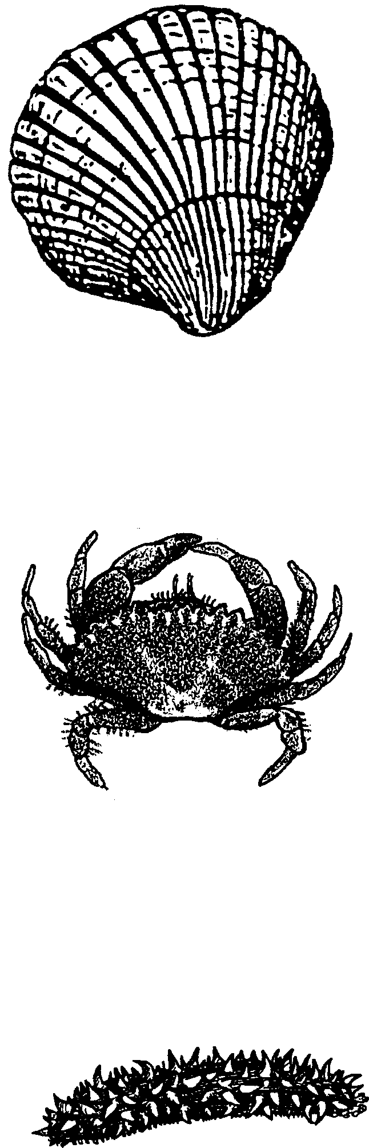

"Interdependence" Cards
Gull
eats:
sea urchin
crab
barnacle
dead plants and animals
Purple shore crab
eaten by:

Purple Shore Crab
eats:
dead plants and animals
kelp seaweed
eaten by:
Great Blue heron
Red Rock crab
gull

Shiner Perch
eats:
hermit crab
barnacle
limpet
sea cucumber
sea anemone
eaten by:
Great Blue heron
sea otter
human
sea lion
harbor seal

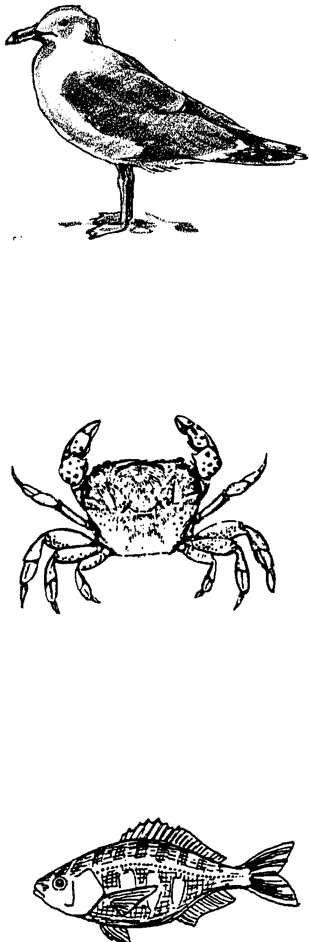
"Interdependence" Cards
Sea Urchin
eats:
kelp seaweed
eaten by:
sunflower star
gull
sea otter

Kelp Seaweed
eats:
makes its own food
eaten by:
sea urchin
limpet
sea cucumber
Purple Shore crab

Phytoplankton
eats:
makes their own food
eaten by:
zooplankton
barnacle
cockle clam
sea anemone
oyster
sea cucumber

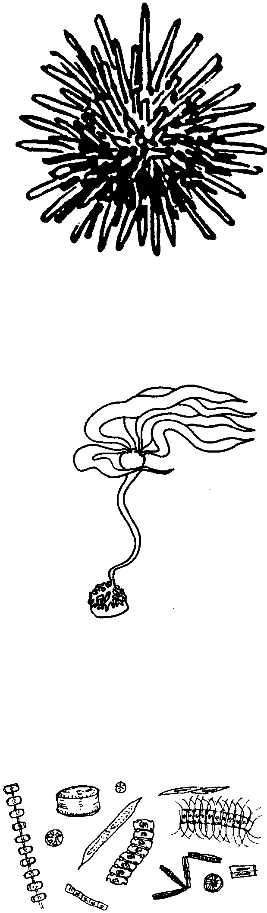

"Interdependence" Cards
Sea Lion
eats:
salmon
octopus
shiner perch
eaten by:
orca

Great Blue Heron
eats:
shrimp
Red Rock crab
herring
shiner perch
oyster drill
Purple Shore crab
salmon
eaten by:

Orca
eats:
salmon
harbor seal
octopus
sea lion
eaten by:

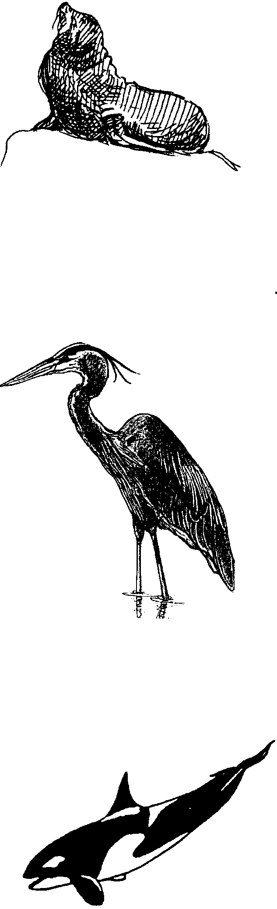
"Interdependence" Cards
Harbor Seal
eats:
salmon
herring
shiner perch
octopus
shrimp
eaten by:
orca

Sea Anemone
eats:
zooplankton
herring
eaten by:
shiner perch

Octopus
eats:
Red Rock crab
oyster drill
moon snail
hermit crab
cockle clam
eaten by:
orca
harbor seal
human
sea lion

