Food Chains in the Kelp Forest

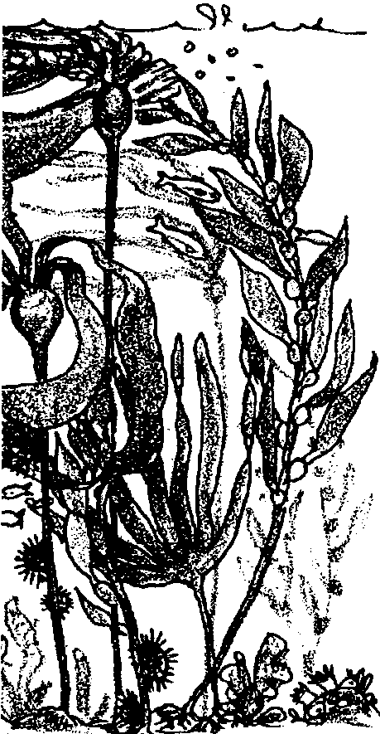
Edited by Laurie Dumdie, Wendy Naruo, and Pat Rutowski

Key Concepts
l. Animals and plants are interdependent.
2. Ecosystems depend on a constant flow of energy and the recycling of materials.
3. Plants and animals interact in feeding relationships called “food chains”.
4. When members at a particular level of a food chain are removed, their loss can affect all the other members of the food chain.

Background

In a balanced environment, plants and animals interact and depend on each other. The plants provide food and oxygen for the animals, and the animals provide carbon dioxide for the plants. Dead and decaying tissue provide some of the nutrients for the plants.

At the beginning of most food chains is the sun. Plants use the energy from the sun, water, and nutrients from the soil to make or “produce” their own food so they are called producers. Animals eat or “consume” the plants or other plant-eating animals so they are called consumers. An example of a simple ocean food chain is:
kelp → sea urchin → sea otter

Arrows in a food chain show the direction of the movement of the food energy and matter.

An example of an ocean food chain that includes humans is:
drift kelp* → abalone → people

* Kelp plants continually produce new fronds that grow toward the surface. Old fronds regularly break off and drift away to make room for new growth. The discarded fronds are called drift kelp.

Sometimes the environment is not in balance and the food chain is disrupted. On the central coast of California, sea otters were hunted to near extinction. With no more otters to eat them, the sea urchins, which eat the kelp, increased in numbers. Without predators to hold them in check, urchins may achieve a density of 300 animals per square yard. Such a mass of urchins can move through a kelp forest, grinding everything in its path. The kelp forests almost disappeared. When people stopped hunting sea otters and the otter numbers grew again, the otters ate the urchins that eat the kelp and the kelp forests grew back.

For more information about kelp forest ecology and human efforts to preserve these vital ecosystems see “Kelp: Keeping a Forest Afloat,” National Wildlife, June/July 1992, pages 5-10.

Materials

For the class:

• transparency of “Living Things in the Kelp Forest” drawings

• transparency of “Who Eats Whom?” sheet

For each student:

• “Living Things in the Kelp Forest” student activity page

• 6 empty strips page

• “Who Eats Whom?” sheet

• scissors

• paste or glue sticks

• marking pens or crayons

• “Food Chains in the Kelp Forest” student reading, optional

Teaching Hints

In “Food Chains in the Kelp Forest”, students examine the inter-relationships among plants and animals through a study of the kelp forest.

Preparation

Make an overhead transparency of the “Living Things in the Kelp Forest” drawings. Cut the drawings so each organism can be manipulated separately on the overhead.

Procedure

1. Lay on the overhead the kelp drawing from the “Living Things in the Kelp Forest” set. Ask for a volunteer to choose an organism that eats kelp and lay it next to the kelp drawing. Introduce the following terms:
producer - a plant which can use energy from the sun and different nutrients to make or produce their own food

consumer - an animal which preys upon or consumes other animals or plants for its food

2. Distribute copies of the pictures of the “Living Things in the Kelp Forest” to students. Have them cut out each picture.

3. Challenge students to sort the pictures into groups such as:

• plants and animals

• herbivores, carnivores and omnivores

• producers and consumers

After each challenge is given, select a student to come to the overhead to sort the pictures. The groups displayed on the overhead provide an opportunity for discussion.

4. Select a drawing of one of the producers and display it on the overhead. Have students select an animal that eats the producer. Have them lay it on their desk next to the producer. Demonstrate on the overhead. Next, have them add an animal that eats the animal that eats kelp. Explain that the students have created a food chain which diagrams the relationship between a plant and several animals and indicates a flow of energy and matter (“food”).

You might encourage students to lay the pictures on a piece of paper and draw arrows between the pictures to show the feeding relationships. Select another producer and challenge students to complete the food chain. Construct and discuss the possible food chains represented in the twelve pictures. Display on the overhead or distribute to students the sheet, “Who Eats Whom?” for reference.

Emphasize the interrelationship between plants and animals. Show how plants are the basis of most food chains on land and in the ocean. One notable exception are the hydrothermal vent communities in the deep sea (discussed in the Grades 6 and 8 FOR SEA curriculum).

5. Challenge students to think about what would happen if:

• all the middle members of a food chain disappeared (due to disease, over harvesting, whatever)

• the last consumers disappeared

• the producers disappeared.

6. Have students construct two “3 member food chains” from the 12 pictures. When they have shown you their completed chains, distribute one sheet with the 6 empty strips to each student. Have them discard the pictures not used in their two food chains. Students may wish to color the 6 organisms comprising their two food chains. Have students cut the strips apart and glue one organism (from their 2 food chains) on each strip. Students should then glue the strips together (interlocking, like a paper chain), showing the 3 member food chains.

7. You may choose to have your students complete the “Food Chains in the Kelp Forest” student reading to reinforce the concepts introduced in the activity.

Key Words

consumer - an animal which preys upon or consumes other animals or plants for its food

extinct - no longer in existence

food chain - a diagram or model indicating the flow of energy and matter; usually showing the relationship between the sun, a plant and several animals

food web - a diagram or model indicating a group of interrelated food chains in a particular community

producer - a organism which produces its own food; usually using energy from the sun, water, and various nutrients

Extensions

1. Connect students’ individual food chains to each other to illustrate a food web (e.g., connect an otter in one chain to a sea urchin in another).

2. Decide, as a class, to take one animal or plant out of the food webs constructed. Cut it out of each chain. Discuss what happens to the food web.

3. Read, The Ocean Alphabet Book by Jerry Pallotta (see bibliography). Have students create an alphabet book for the kelp forest.

4. Read the poem, “In The Kelp Bed” by Helen M. Webster.

5. To reinforce the interconnected nature of food chains, sing A Food Chain of the Sea found in the previous activity “Sea Soup”.

6. Use the “Living Things in the Kelp Forest” cards to play “Conseatration”, a game in which students pair the pictures of kelp forest plants and animals with their names. Here’s how:

a. Make a blank grid with squares the same size as the individual cards on the “Living Things in the Kelp Forest” sheets.

b. Write the name of one kelp forest plant or animal in each square.

c. Duplicate the card sets and the name sheets. One set is needed per team of two to four players.

d. Have students cut along the lines, separating the cards into twenty-four rectangles.

e. The game is played by placing each card face down in a four card by six card pattern.

f. In turn, students select two cards and turn them over.

g. If a matched set occurs between the name and the organism, the student keeps the two cards. If no match occurs the cards are returned face down in their original position. The student with the most cards at the end of the game wins.

h. To introduce or reinforce the mathematical concepts of graphing and coordinates, have the students call out their square choice using the coordinate position of the square.

Answer Key

“Food Chains in the Kelp Forest”

1. Producers: giant kelp seaweed, green seaweeds, and algae.

2. Yes, the sea urchin is a first consumer since it eats the plant (giant kelp) directly.

3. An otter would be a second consumer if it ate the sea urchin.

4.Something that eats a second consumer is called a third consumer.
Living Things in the Kelp Forest
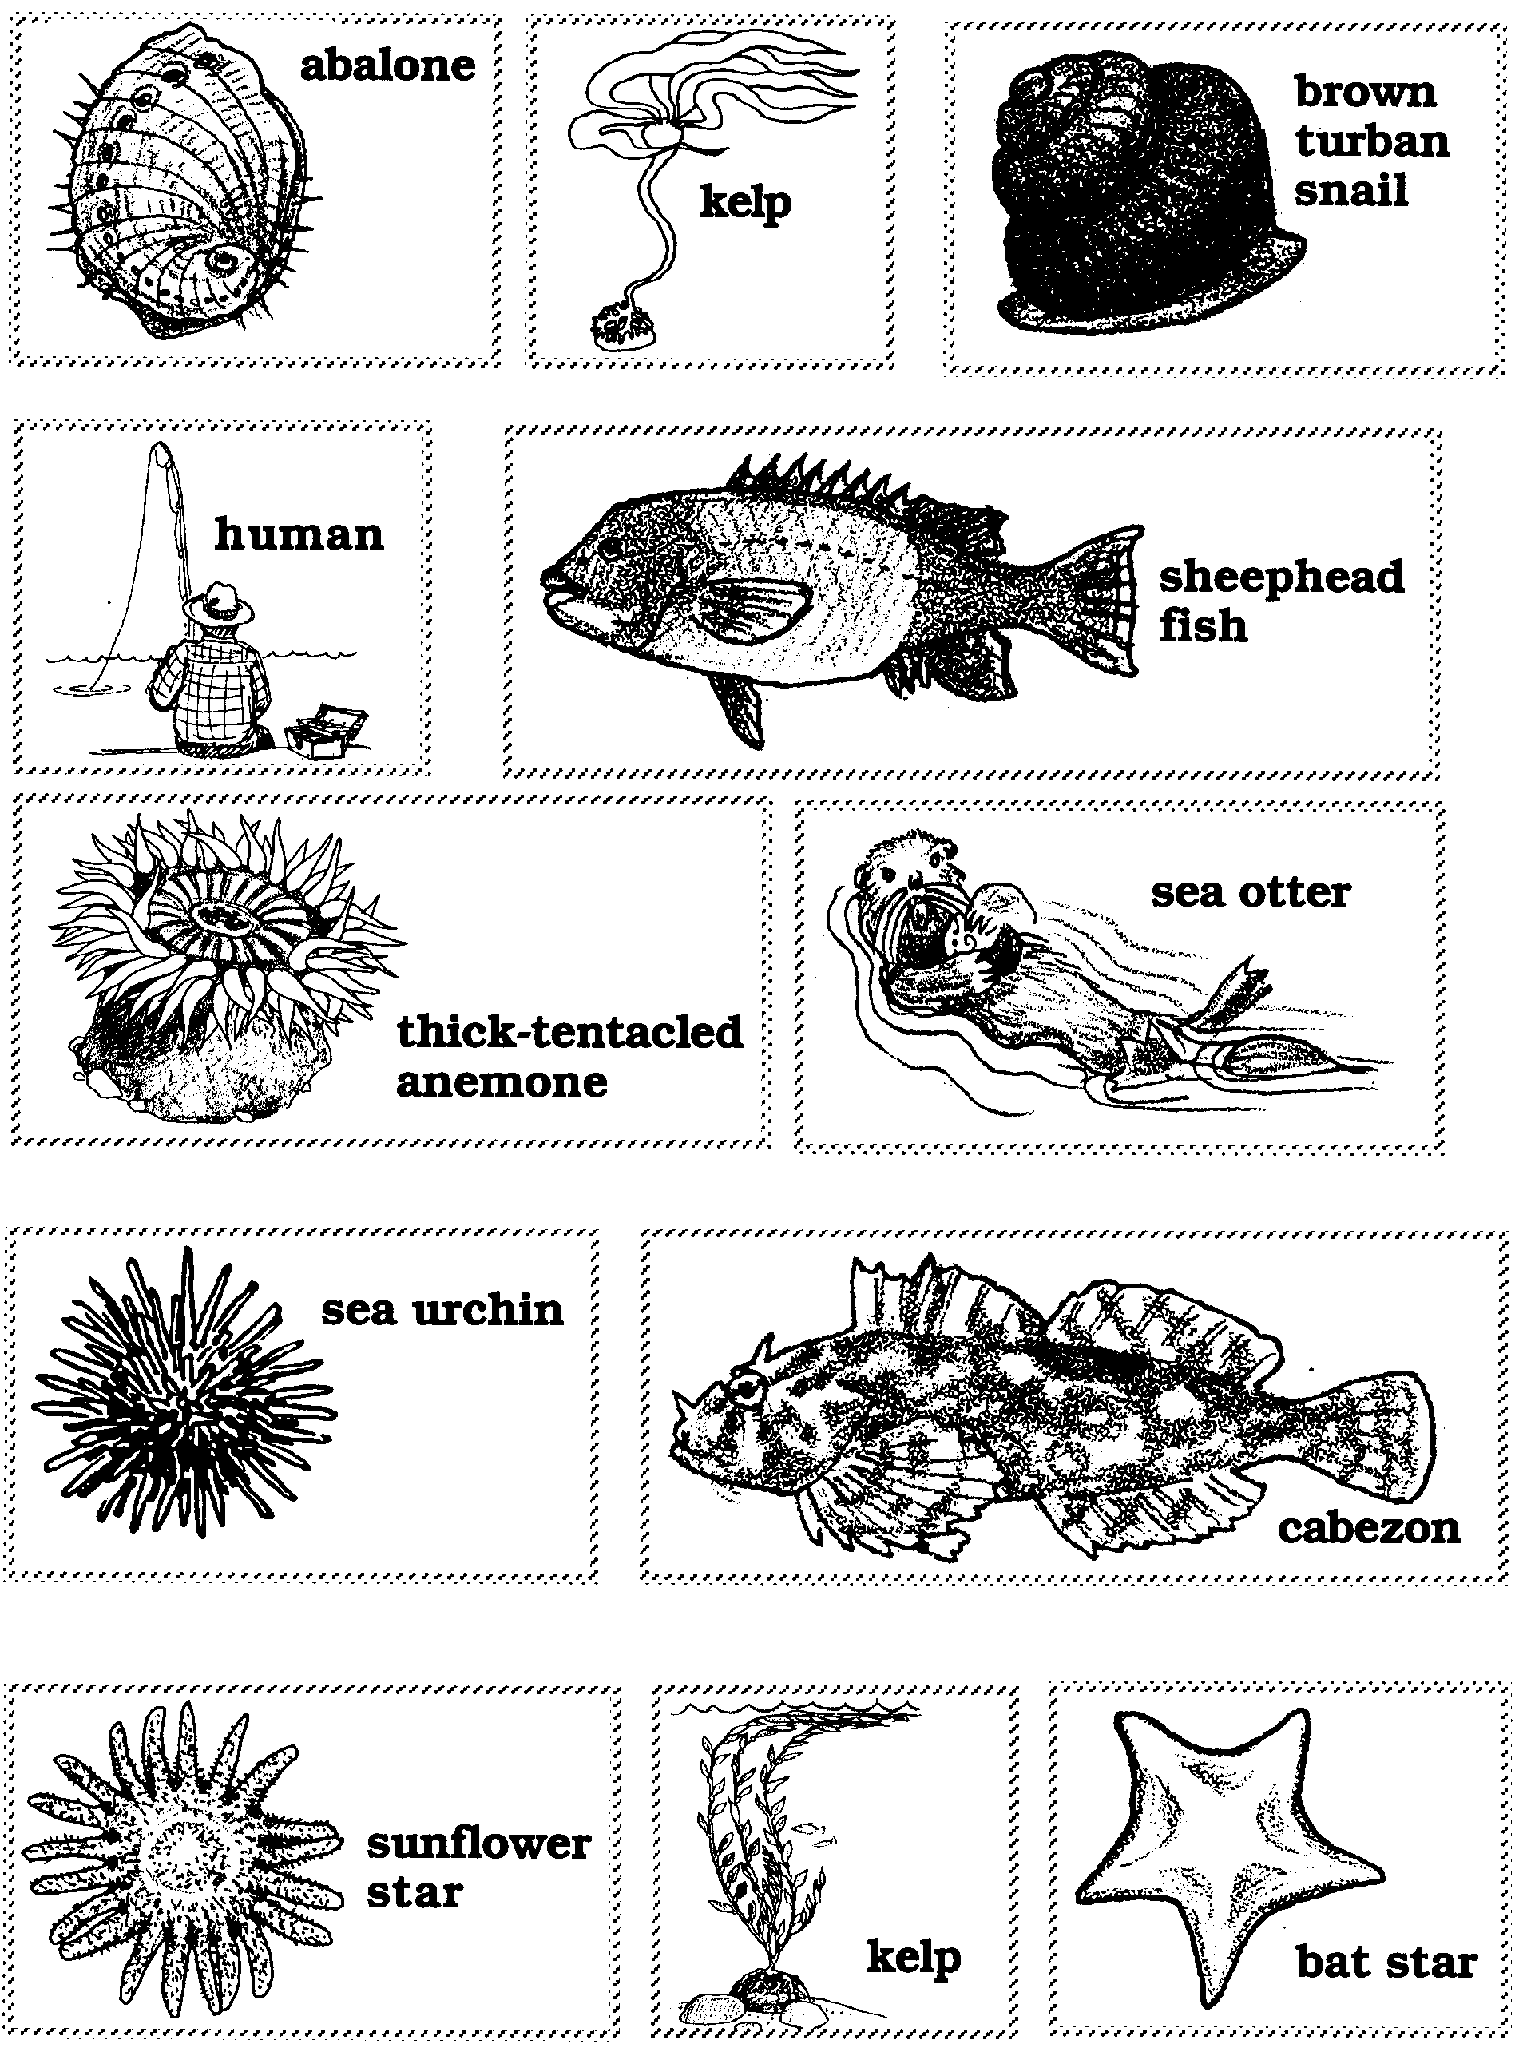

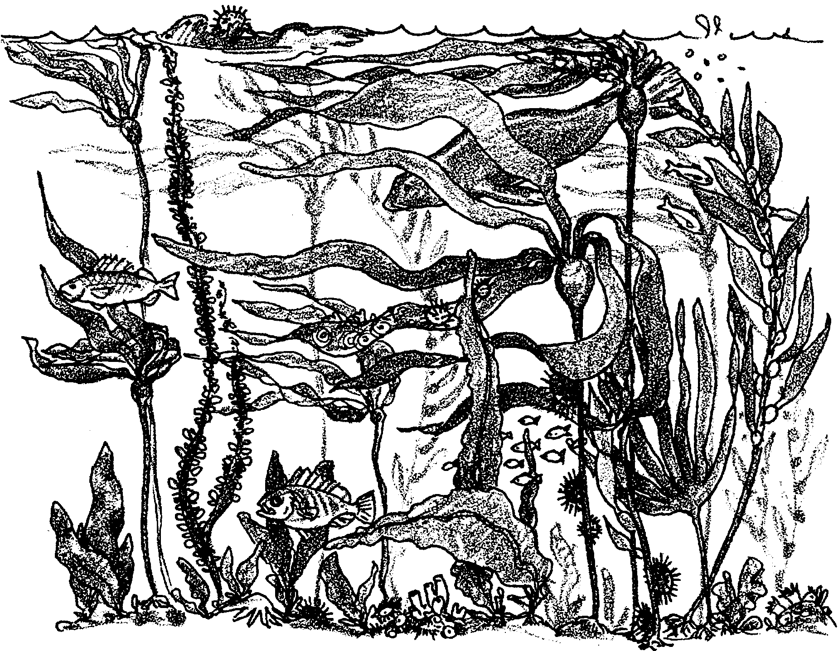
Food Chains in the Kelp Forest

Food Chains

Seaweeds make food. We call plants like seaweeds producers. Animals can’t make food. They need to eat plants or other animals. We call animals consumers.

1. Read the words below. Circle the producers.

giant kelp seaweed sea anemones
moon snails algae
green seaweeds oysters

Animals that eat plants are called first consumers. They are the FIRST to eat the plant. The sea urchin eats kelp seaweed.
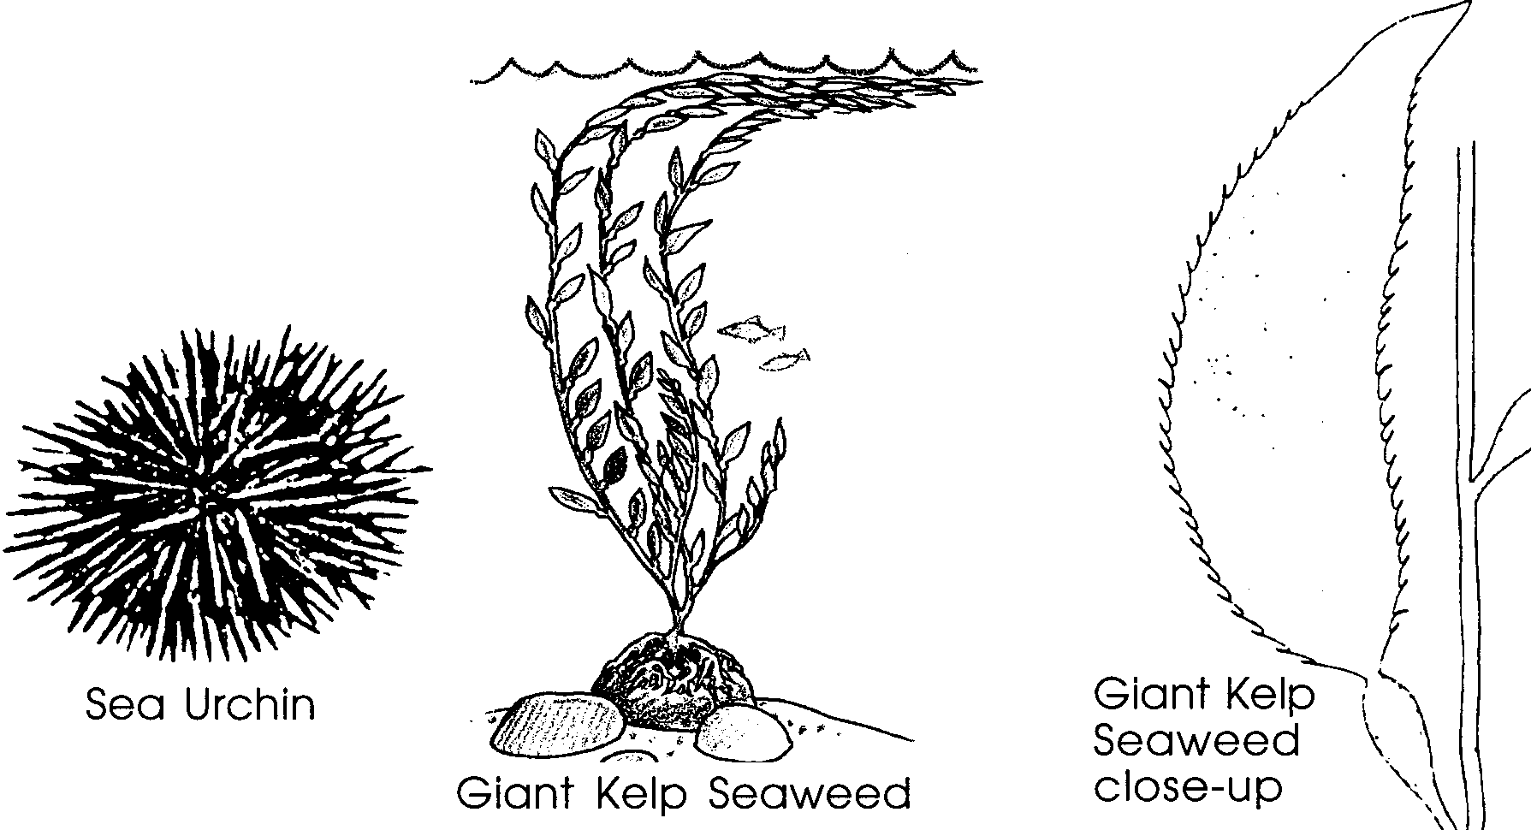
2. Is the sea urchin a first consumer?

.

Animals that eat first consumers are called second consumers. They are the SECOND to eat the plant.

3. An otter would be a consumer if it ate the sea urchin. (Remember, the sea urchin is a first consumer).

4. What do you think something that eats a second consumer is called?

Below is a food chain. It shows who eats whom.
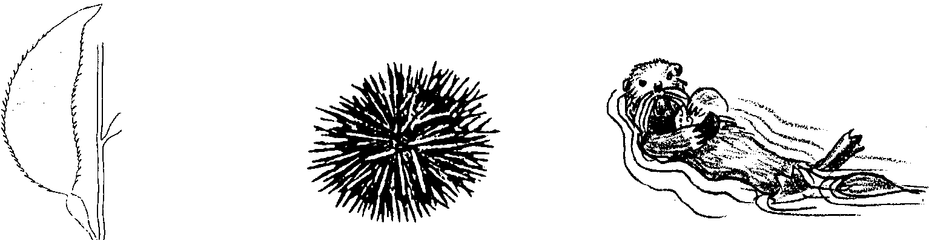
giant kelp → sea urchin → sea otter
(producer) (first consumer) (second consumer)

5. Make a food chain with these: human, grass, cow.

6. Make a food chain with these:

seaweed, sea otter, sea urchin.

Food Chains in the Kelp Forest

Who Eats Whom?

abalone → drift kelp

human → abalone

sea otter → sea urchin and abalone

cabezon → abalone, crabs, and other fishes

sea urchin → kelp and other seaweeds

brown turban snail → kelp (especially the stipe)

anemone → bat star

sheephead fish → sea urchins

bat star → sea urchins

sunflower star → sea urchins and turban snails

