Algae Are Plants, Too

Lesson by Pat Rutowski, Monterey, CA

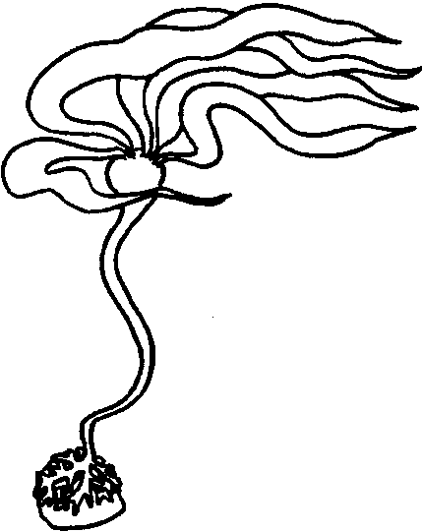
Key Concepts
l. Algae are plants that live mostly in water and differ vastly from land plants.
2. Like other green plants, algae use sunlight to make their own food.
3. Algae can be sorted into groups based on observable characteristics, such as color.

Background

The group of plants called algae, or seaweeds, includes many different kinds of plants from microscopic forms to the large kelp plants that grow in underwater forests in the temperate and colder coastal waters of the world ocean. Algae are found in fresh water and saltwater.

All plants in the sea photosynthesize to create their own food. As land plants do in the terrestrial world, seaweeds and plant plankton form the basis of food for almost all animals in the sea. Because all algae need sunlight for photosynthesis, they are restricted to relatively shallow depths. In many areas, for example, algae rarely exist below a 75-85 foot depth.

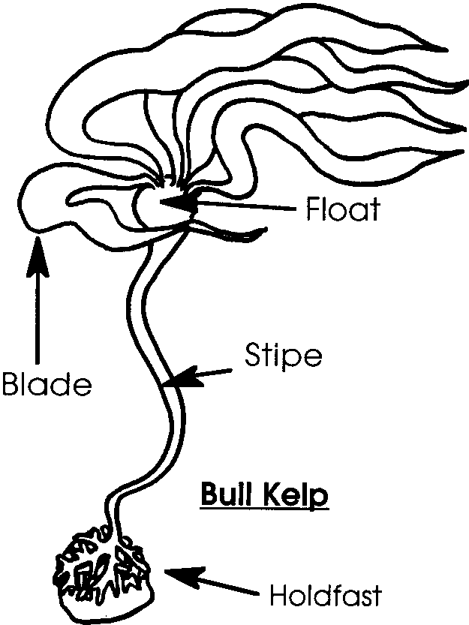
When comparing algae to land plants, there are several similarities and differences. Starting from the bottom of each plant type, land plants require a root as an anchor and to take water and nutrients from the soil. Since algae live in water, what looks like a root serves only as a holdfast, attaching the plant to a solid surface at the bottom. Instead of a stem, algae have a stipe which is flexible and bends with the waves. The “leaves” of algae are called blades. Kelp, and some other seaweeds, have air-filled bladders called floats which buoy the plant up toward the sunlit surface. The stipe and blades of a single kelp plant are called a frond. The floating fronds form the top layer, or canopy, of a kelp forest.

Bathed in a sea of nutrients, algaes often grow quite rapidly. In fact, some juvenile kelp plants, at first visible only through a microscope, will grow as much as 10-15 feet in six months and one species of kelp is the fastest growing plant in the world.

Algae are grouped into phyla or large divisions of the plant kingdom by color. The main groups are the brown, green and red algae. The groups tend to sort themselves by depth in the lighted, surface waters. Green algae are found in shallow water, brown algae in the middle zone, and red algae in deeper waters.

While many algae are obviously the color of their phyla, others may look one color but are classified with a different color group because of the presence of other, masked pigments which only can be determined chemically. For example, Fucus (few-kuss), often called “popweed” because of the swollen tips when the plant is reproducing, is actually a brown seaweed that looks quite green. Red seaweeds can be especially difficult to identify because they may be green, purple-brown or reddish-brown. Interestingly, the green pigment chlorophyll is present in all algae but is masked by other pigments in all but the greens.

Materials

Activity 1: Comparing Plants

For the class:

• transparency of a kelp plant and a land plant

• large labels (3"x 8") for students to hold: stem, stipe, leaves, blades, holdfast, roots, float, flower

Activity 2: Sorting Seaweeds

For the class:

• assorted seaweed

• seaweed pressings or pictures of seaweeds

• flat dishwashing tubs

• seawater

Teaching Hints

In “Algae Are Plants, Too” students compare land plants to marine algae, noting similarities and differences. In the first activity, students “build” land plants and algaes out of people in the class. In the second activity, they group and regroup an assortment of seaweeds. A student reading is provided to reinforce the concepts presented in the activities.
Activity 1: Comparing Plants

Materials

For the class:

• transparency of a kelp plant and a land plant

• large labels (3"x 8") for students to hold: stem, stipe, leaves, blades, holdfast, roots, float, flower

Preparation

Draw a kelp plant and a land plant with parts labelled on the board or on a large piece of paper at the front of room.

Procedure

1. This lesson is best introduced by students’ observations of a real land plant, comparing it to algae. The land plants are relatively easily acquired; have students pull a weed from the school yard for close examination. The algae will probably be much more difficult to acquire. Explain that since we can’t bring a river, pond or ocean into the classroom that the students will have to “be” the algae.

2. Ask students what they know about plants that live in the water. Introduce the idea that certain plants that live in the water like cattails and water lilies are just like land plants but that there is another group called algae which is very different.

3. Ask if anyone has ever been to a beach or pond and gotten plants caught on their legs or seen plants on top of the water or on the shore. Explain that those plants were probably algae.

4. Display the transparency of the land plant and kelp. Discuss the algae called kelp which are large brown algae, characteristic of exposed shores. Most obvious and well known are bull kelp (Nereocystis) and giant kelp (Macrocystis).

5. Review the parts of the land plant and what purpose each serves:

root - absorbs water and nutrients from the soil

stem - holds the plant up toward the light and conducts the water and nutrients

leaves - absorb sunlight to manufacture food

flower - creates seeds of the plants

6. Discuss the parts of the kelp plant.

holdfast - anchors the plant to the bottom

stipe - allows the plant to float in the water and bend with the waves

blades - leaflike structures that absorb sunlight to manufacture food

floats - keep plant near water surface and sun

7. Tell the students that you are going to build each of these kinds of plants out of people in the class. Solicit from students the parts of the land plant and “build” it as the parts are mentioned:

• roots - several people crouch on the floor, reach out their arms and make slurping noises to represent the roots taking water and nutrients from the soil.

• stem - other students stand close together behind the roots. They stand straight and keep the leaves off the ground and facing the sun.

Discuss the “tubes” in the stem that carry water and nutrients up from the roots to the leaves and others that carry food made in the leaves down to the roots. A brief introduction to photosynthesis here would be great. Plants are amazing because they can take the sun and make their own food; we can’t do that. “Photo” means light, “synthesis” means making, so “photosynthesis” is just the scientific name for plants using light to make their own food. Ask if we took (use one of your student’s names) out in the schoolyard, buried her feet in the dirt and gave her water, would she be able to survive without food? No. But a plant can, because it can make its own food. All it needs is sun, water and the nutrients it gets from the soil.

• leaves - a few more students stand behind the stem students. They raise up their arms on either side of the stems to form leaves. You might have them clap their hands together as they “gather” rays of sunlight to make their food.

If you wish, add a flower which will make the seeds to continue the plant’s family. Give the students an appreciative hand clap and ask them to sit down.

8. Next “build” the kelp as the parts are mentioned:

• holdfast - point out that these students do not need to make slurping noises, they just need to hold onto the ground very tight.

• stipe - add several students acting together as the flexible stipe, which can bend and float in the water. These students should make slurping noises (again, to represent taking nutrients from the water).

• blades and floats - several more students stand behind the stipe and put their arms out. These students should also make slurping noises.

Give these students a hand clap of appreciation and ask them to sit down.

9. Explain how the kelp plants grow in the water to form huge forests. Have all the students stand and “put on” the parts of the kelp plant to make a kelp forest. To reinforce the group pantomime information, have the students tell you what they need to become kelp. Play some appropriate music and enjoy swaying in the water as one great kelp forest.

Activity 2: Sorting Seaweeds

Materials

For the class:

• assorted seaweed

• seaweed pressings or pictures of seaweeds

• flat dishwashing tubs

• seawater

• “Algae Are Plants, Too” student reading

Preparation

Collect a variety of seaweeds at the beach, including different colors and forms.

*BEFORE COLLECTING: Call your local state Department of Fish and Game office to determine whether you need a license or permit to collect seaweed.

If you are not near a beach or a place to collect seaweed, you can either collect seaweed on a trip to the coast and press it to show your students, borrow pressings from a museum or individual, or use pictures. You can purchase seaweed, but it is very expensive. Contact: Carolina Biological Supply, 2700 York Road, Burlington, North Carolina 272l5, or call (9l9) 584-038l.

Procedure

l. Divide students into groups of 4 or 5 and give each group an assortment of seaweeds. Challenge them to group the seaweeds in as many ways as they can find (they might use color, size, texture, shape). Tell them to remember their favorite way of grouping them so they can share that with the whole class.
2. Have each group show the rest of the class how they sorted their seaweeds.

3. Discuss the fact that scientists most frequently use color to group or classify the seaweeds: green, red, and brown. Challenge students to sort the seaweed observing color. Be aware that this is a very challenging exercise. Perfection in sorting is not the goal; careful observation is more important.

4. After students have observed the seaweed, return it to the beach from which it was collected, if at all possible.

5. Have students complete the “Algae Are Plants, Too” student reading as a way to reinforce the concepts introduced in the above activities.

Key Words

algae - mainly aquatic, non-vascular plants

blades - the broad leaf-like structures of a kelp plant

classification - arrangement of animals or plants into groups based on certain criteria

holdfast - a part of an algae that attaches the plant to a rock or other surface

nutrient - something that nourishes or promotes growth

photosynthesis - the process by which plants use sunlight to make their own food; (photo = light, synthesis = making)

stipe - the stalk of an algae

vascular plants - those plants that have “tubes” (vessels called xylem and phloem) which carry water and food through the plant

Extensions

1. The video, “The World’s Below”, available from the Monterey Bay Aquarium, contains a wonderful kelp bed segment, with music only or with narration. It is a perfect lead-in to many creative writing projects.

2. Take a trip to a saltwater beach or local waterway and look for different kinds of algae.

3. Make presses, sun prints or seaweed prints (like fish prints) from the algae used in the sorting activity. Here’s how:
Sun Prints

Materials

• dry pieces of seaweed

• flat tray or cookie sheet

• water

• sun print kit (sun sensitive paper and transparent covering found in toy or educational stores)

Sun print paper is also available from:

Solar graphics
P.O. Box 7091 P
Berkeley, CA 94707
(415) 548-5230

Nature Print Paper
P.O. Box 314
Moraga, CA 94556

Procedure

1. Place sun sensitive paper, blue side up, on cookie sheet in the shade.

2. Arrange seaweed specimen on paper.

3. Cover with a transparent cover (to hold the seaweeds on the paper).

4. Place in direct sunlight for 3-7 minutes, until the paper turns almost white.

5. Develop by placing the exposed paper in a tray of water, in the shade, for at least two minutes.

6. Dry prints on a flat, clean surface.

Seaweed Prints

Materials

• newspaper

• ink or paint

• brushes

• plain newsprint or other absorbent paper

• seaweed specimens
Procedure

1. Lay flat pieces of dry seaweed, or freshly collected seaweed washed in water and dried, on newspaper.

2. Paint seaweed with ink or paint.

3. Lay plain paper on seaweed and rub lightly.

4. Lift print off carefully.

Pressed Seaweed

Materials

• shallow pan or tray of water

• newspaper

• waxed paper

• heavy white paper (large index cards work well)

• various specimens of seaweed

Procedure

1. Place seaweed in tray with just enough salt water to cover it.

2. Slip heavy, white paper under the seaweed, leaving just enough water to arrange seaweed easily.

3. Remove the seaweed and paper carefully and place between two sheets of waxed paper.

4. Place the mounted seaweed on top of a stack of newspapers and cover with several more layers of newspaper.

5. Put heavy weight on top and dry in a warm place, replacing newspapers daily for faster drying.

6. When dry (after a few days), the pressed specimen is usually adhered to the white paper. If not, it may be glued to the white paper or to another piece of paper.

Answer Key

“Algae Are Plants, Too” student reading

1. Plankton are small plants that drift in the sea.

2. The holdfast holds the seaweed on the bottom.

3. The blades are like the leaves of a tree.

4. Seaweeds live on rocks and on shellfish.

5. STEM BLADES

LEAVES HOLDFAST

ROOTS STIPE

This question emphasizes the similar structures of seaweeds and land plants. The structures are similar in shape and, to a degree, in function. Internally they are vastly different and some of their physiological functions are also quite different. Even so, the parts look similar and the comparison is valid.

Transparency Master

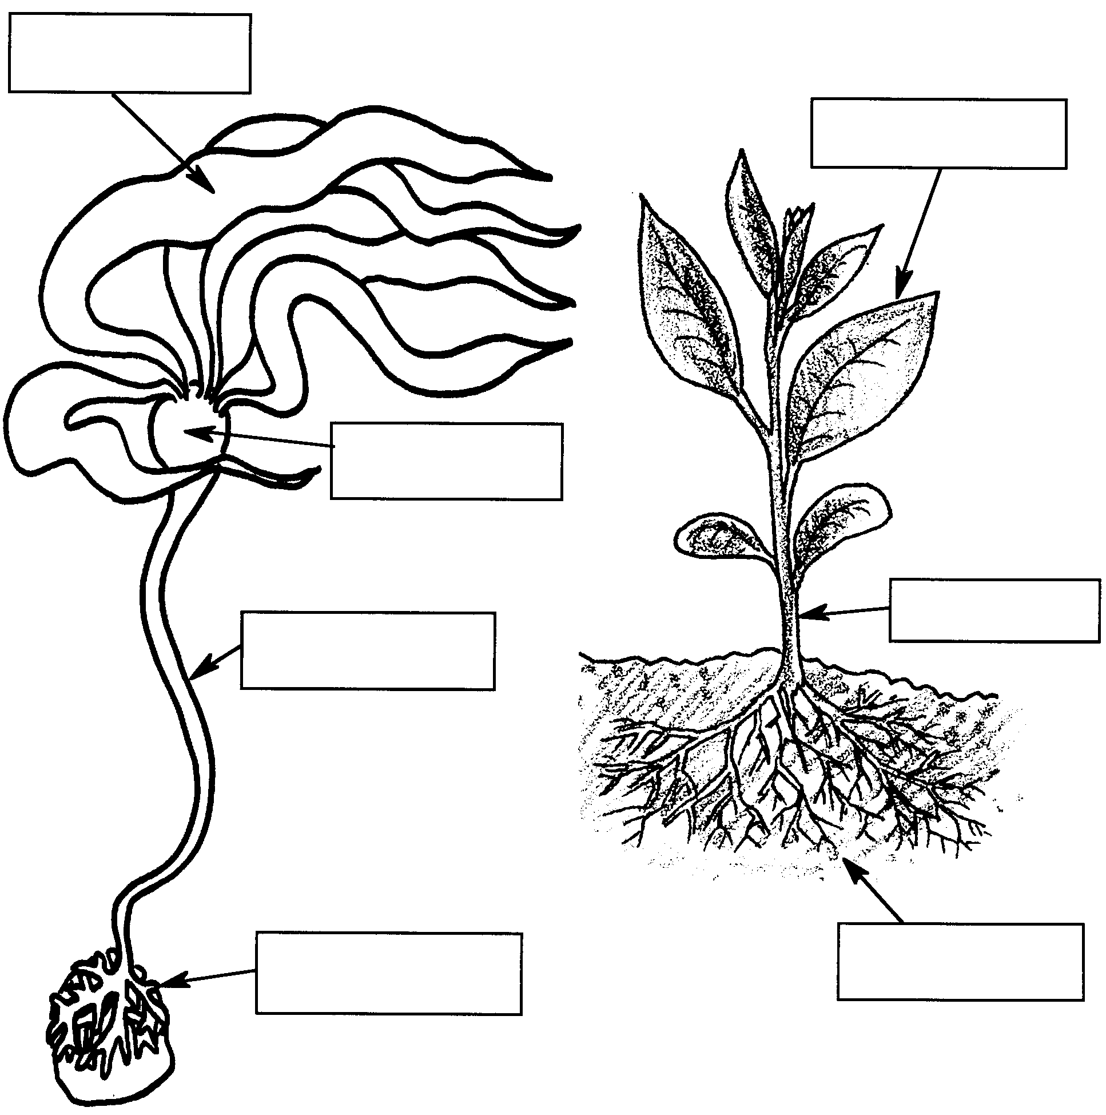

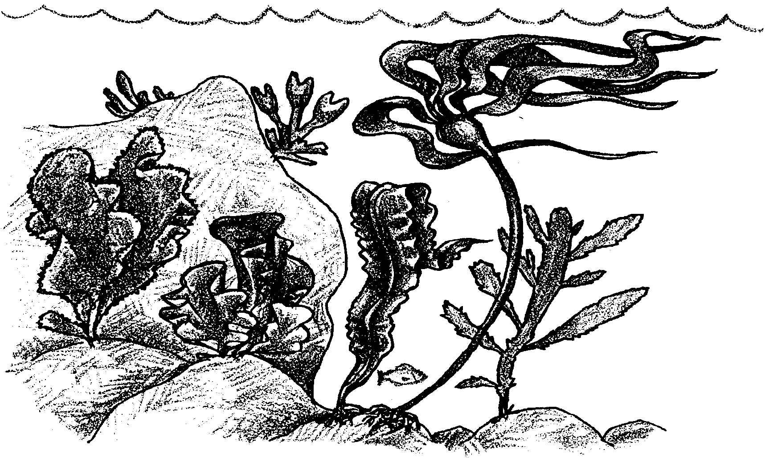
Algae Are Plants, Too
Seaweeds
Some plants in the sea are very small. They drift free. Small plants and animals that drift free are called plankton.

1. are small plants and animals that drift in the sea.

Larger plants are called seaweeds or algae. They have a holdfast. The holdfast anchors the seaweed to the bottom. They also have a stipe and blades.

2. The holds the seaweed on the bottom.
Some kinds of seaweeds have air sacks on their blades. The air sacks help the seaweeds float.

The holdfast, stipe and blades are like the roots, stems and leaves of a tree.

3. The are like the leaves of a tree.

Seaweeds use their holdfast to hold on to rocks. Sometimes they hold on “piggyback” on shellfish.

4. Seaweeds live on and on
.

5. Match the parts of the land plants to the similar parts of the sea plants.

STEM BLADES

LEAVES HOLDFAST

ROOTS STIPE

Seaweeds make a tasty dinner. Many sea animals eat them.

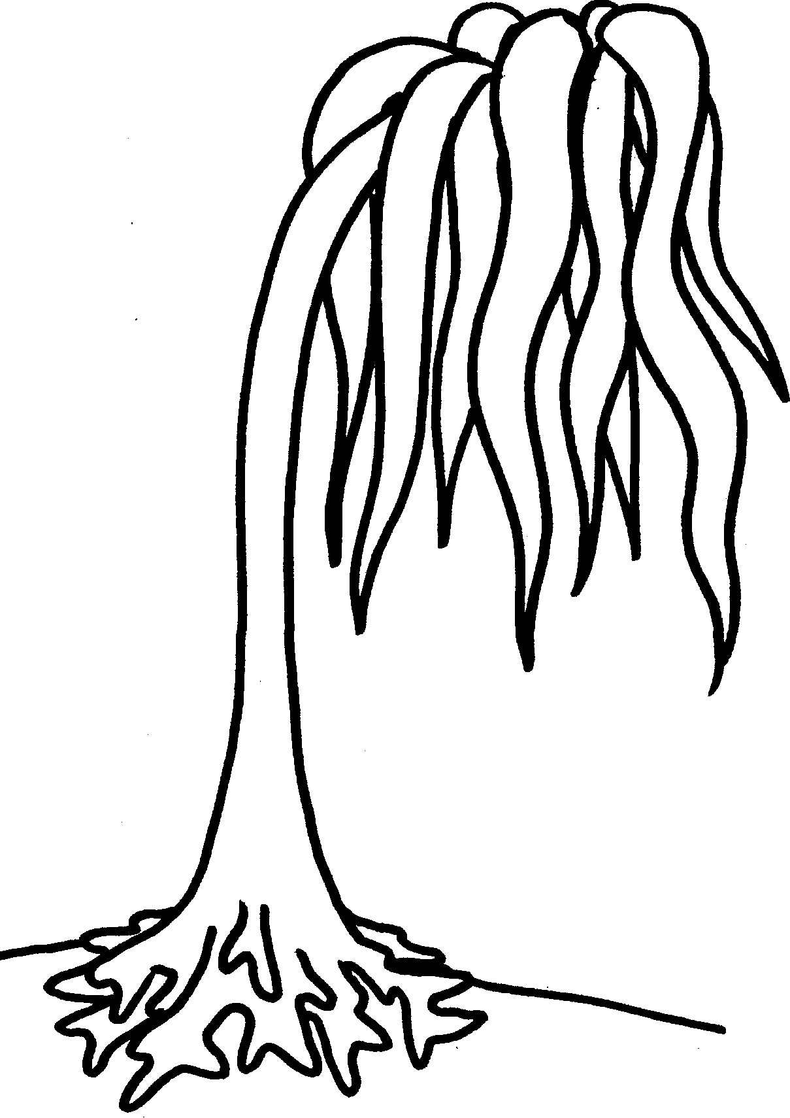

This is a sea palm.

1. Can you find the stipe? Color it brown.
2. Color the holdfast darker brown.
3. Color the blades green.

Some algae are green, like Ulva. It is sometimes called sea lettuce.

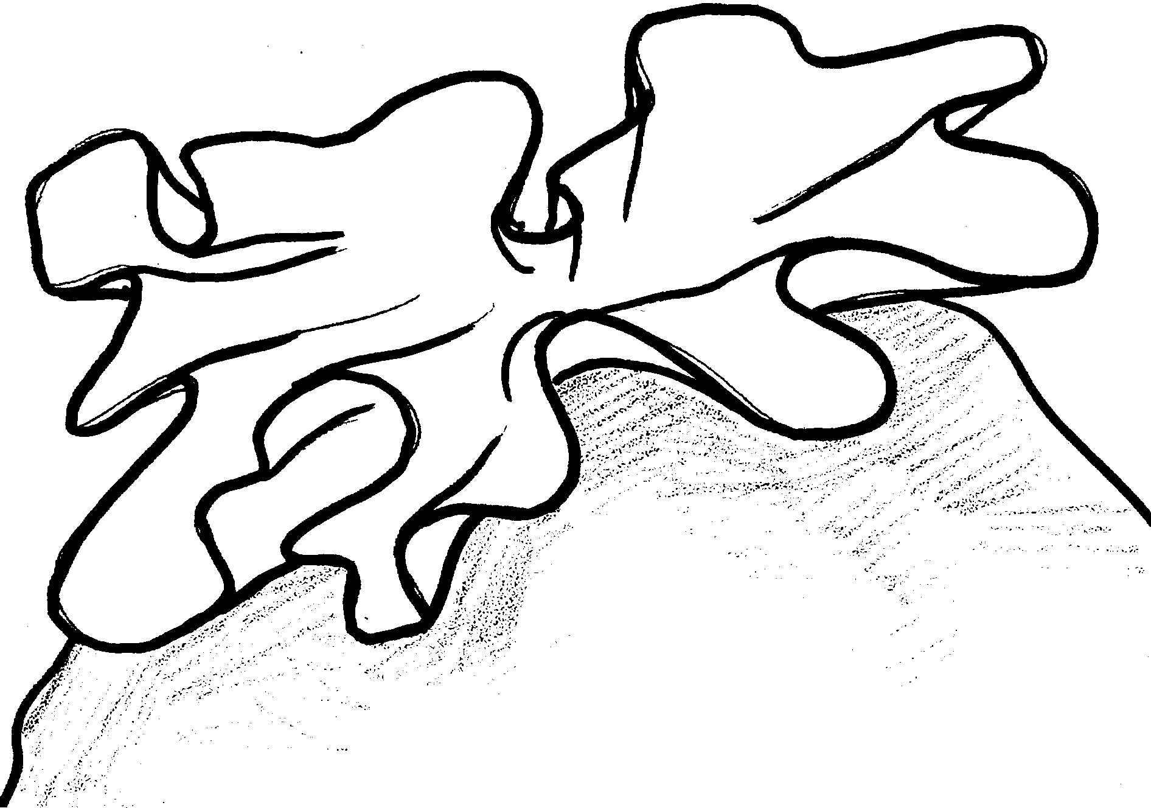

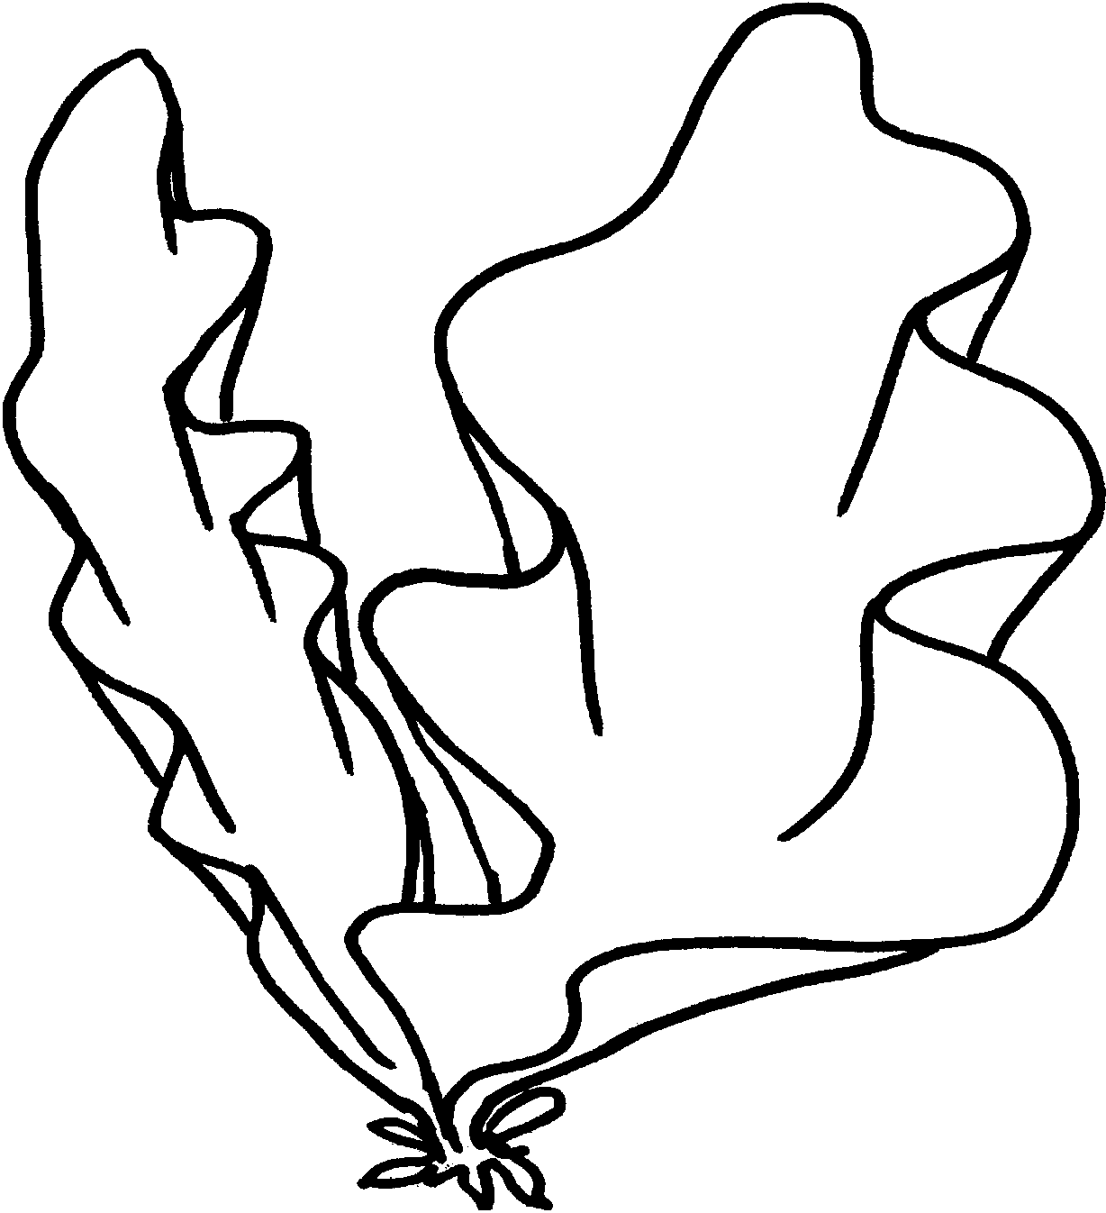
Some algae are red like Iridea.

Some of the red algae have a hard mineral coating. These are small coralline (kor-a-lin) algae.

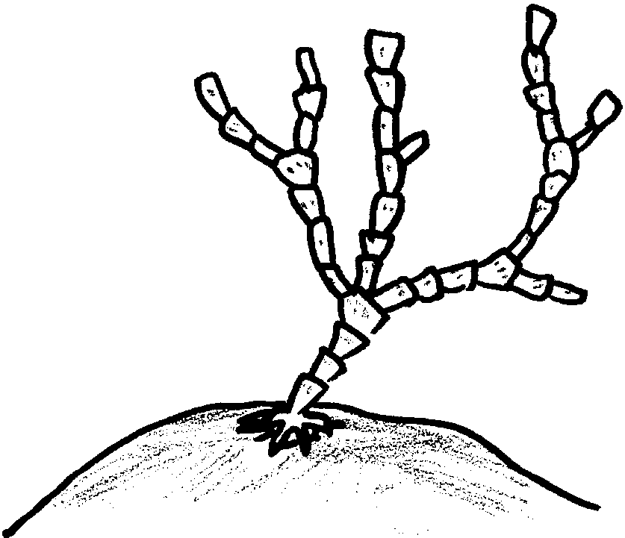
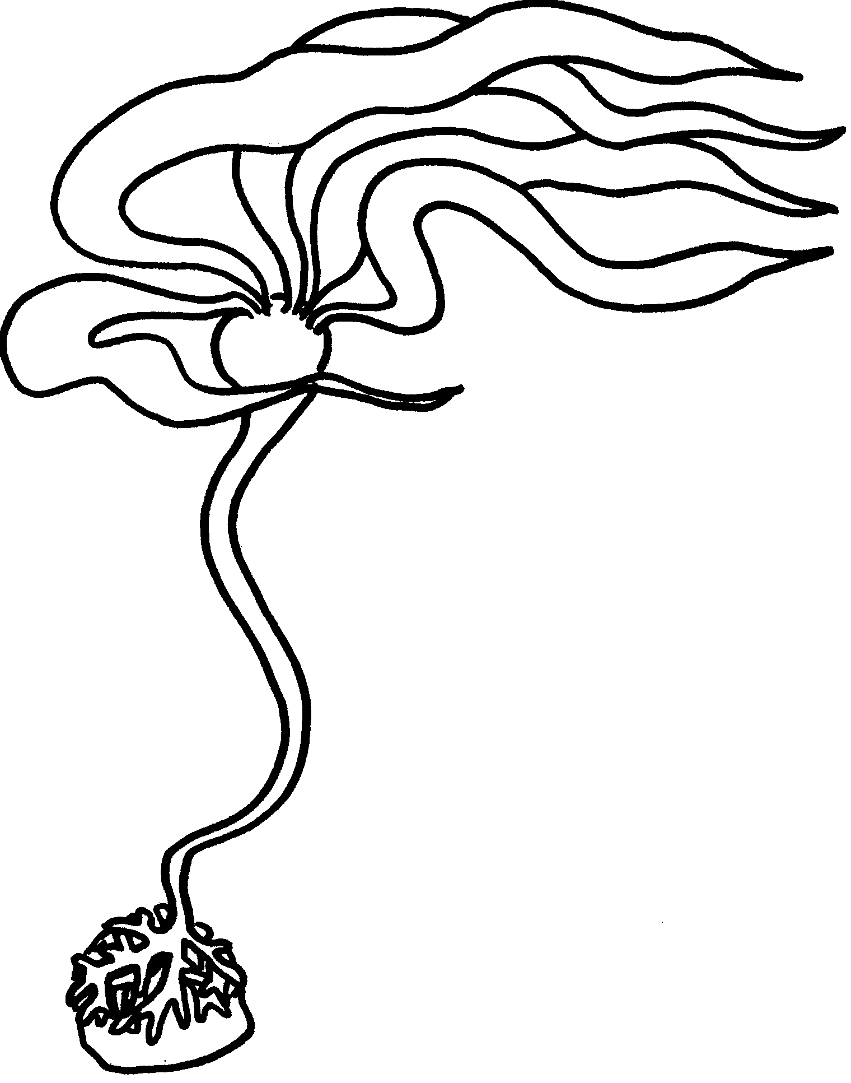
Other algae are brown and very large.

One of these is the bull kelp.

