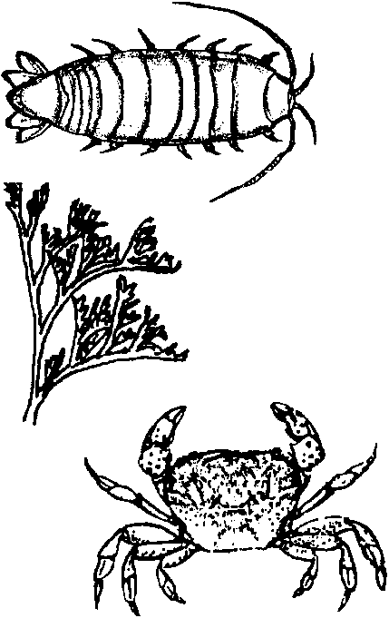
Visual Aid

Key Concepts
1. Scientists use a variety of tools to help them make better observations.
2. Microscopes are devices to increase the apparent size of objects allowing more detail to be observed.

Background

Many of the plants and animals of the ocean and kelp forests are small. Scientists for many years have used a variety of microscopes to help them make better observations of these creatures. Microscopy was introduced to the world in the 1600’s. Antony van Leeuwenhoek, a Dutch lens-maker and naturalist, was an early pioneer in this field. His hand ground lenses and the tubes he constructed to hold them apparently allowed him to be the first person to observe microscopic life in drops of water. Lenses can be made of a variety of materials aside from glass, as in the case of the microscope constructed in the activity “Visual Aid” which uses a water lens.

Materials

For each group of 2 to 4 students:

• cardboard paint bucket (or a large plastic container)

• plastic wrap (enough to loosely cover opening of container)

• string (slightly longer than circumference of opening of container)

• water

• knife or scissors

For each student:

• “Visual Aid” activity pages

Teaching Hints

“Visual Aid” provides your students with the opportunity to create and then use a microscope. These water microscopes can be used to examine some of the principles of optics as well as to examine small items from the beach or kelp forest.
Procedure

1. Before construction begins, tell students that they will be making water microscopes to help them view some of the small items found in the kelp forest or at the beach. You may wish to encourage them to bring such items from home to examine.

2. Secure the needed materials. Cardboard paint containers may be purchased from paint or hardware stores. If you use plastic paint containers (or bleach bottles, etc.), plan to cut the side hole yourself, since these materials are difficult for young children to cut.

3. Duplicate the instruction pages. One set per student is recommended. This activity works well in pairs or small groups.

4. You may wish to demonstrate the construction prior to having your class do the activity. Some students will probably need help in tying the string.

5. Plan to provide some time upon completion for discussion of the activity and of the questions.

Key Words

image - an optical counterpart of an object, in this case produced by refraction of light from the object by a lens

microscope - an optical instrument having a magnifying lens or lenses for inspecting objects too small to be seen or seen distinctly and in detail by the unaided eye

visual - of or pertaining to seeing or sight

water microscope - a microscope in which the lens is composed of water held in position by a transparent membrane

Answer Key

4. Your hand will go in and out of focus as you move it up and down.

5. Answers depend upon what has been provided to view and your students’ imaginations.

6. Newspaper photos are comprised of many tiny black dots.

7. Changing the tightness changes the focus point.

8. Depends upon the particular microscope.

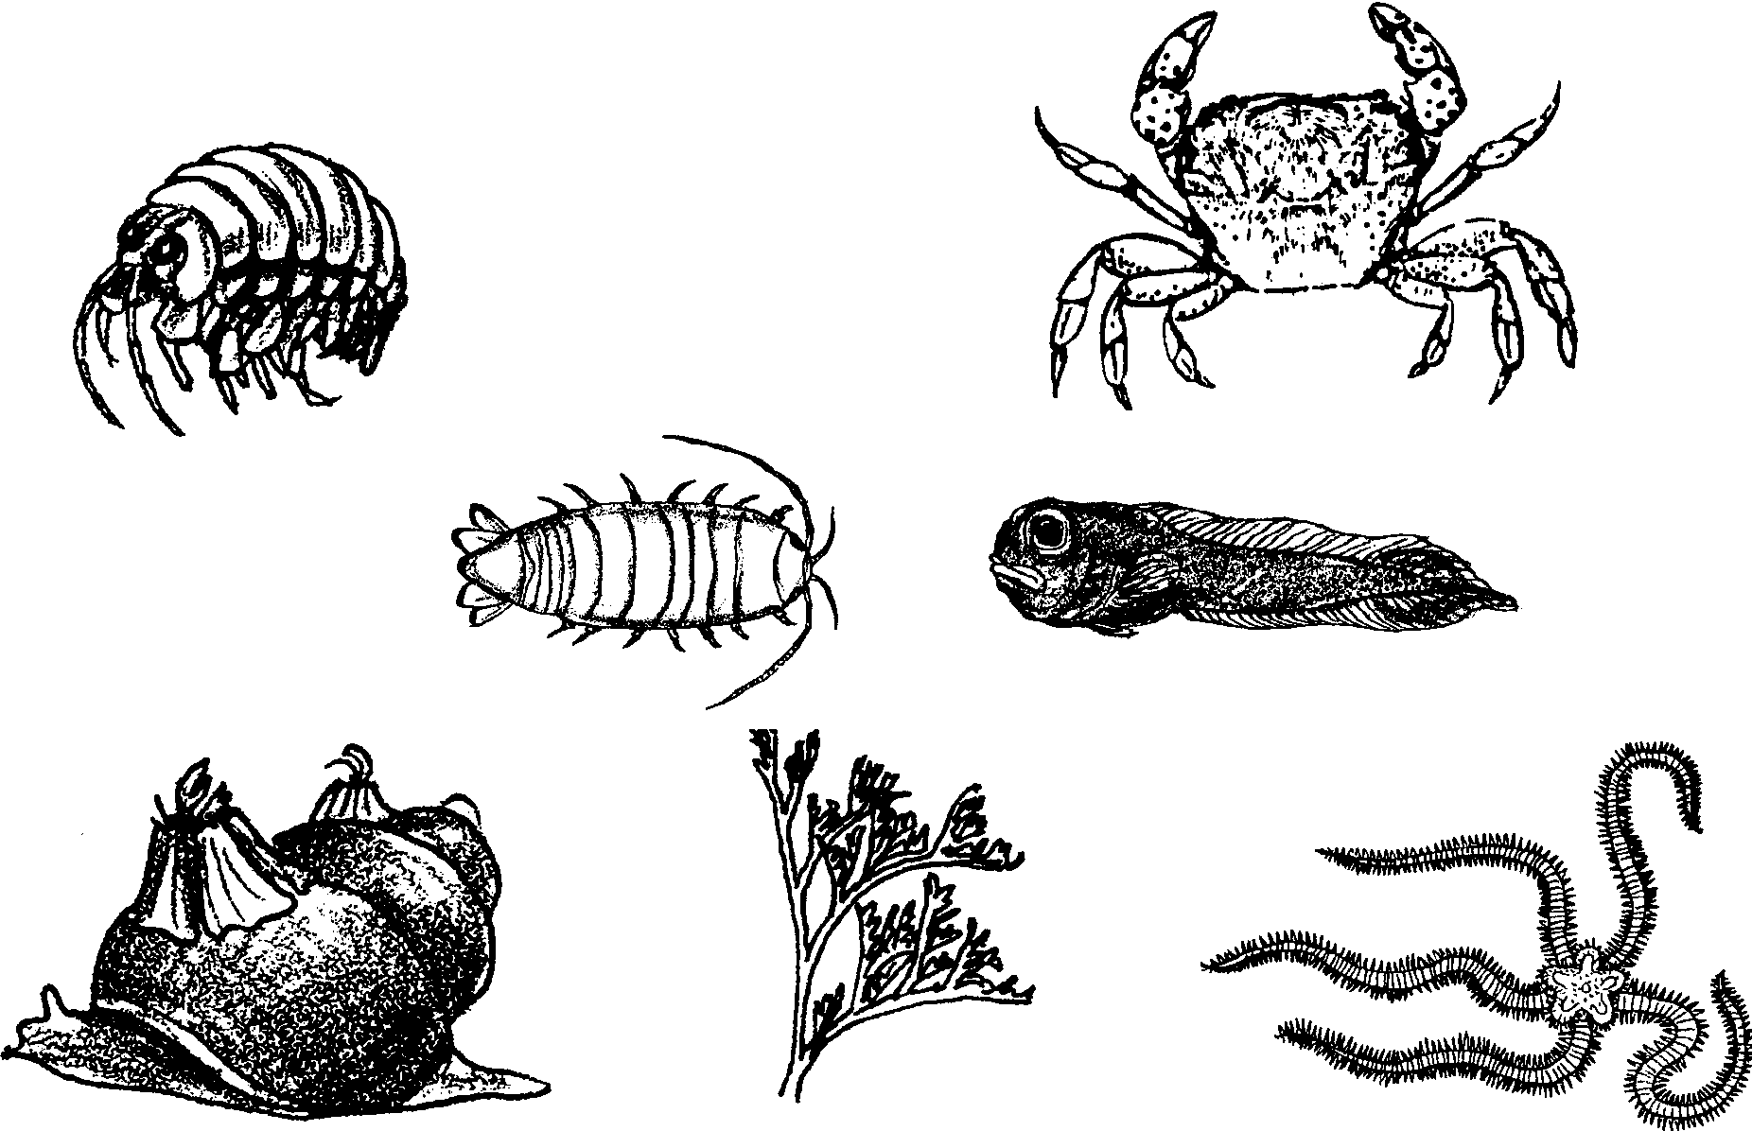
Visual Aid

The plants and animals of the ocean come in all sizes. Some are small. How can you study the small ones? Let’s make a water microscope. Here is what you will need:

Materials:
• a cardboard paint bucket (or a large plastic container)
• plastic wrap
• string
• water
• scissors or knife
Here is what you do:

Procedure:
1. Cut a hole in the side of the bucket. Make it big enough for your hand. Be careful!

2. Stretch the plastic wrap loosely over the top of the bucket. Wrap the string around the top of the bucket. Tie a knot in the string.

3. Fill the loose plastic wrap with water.

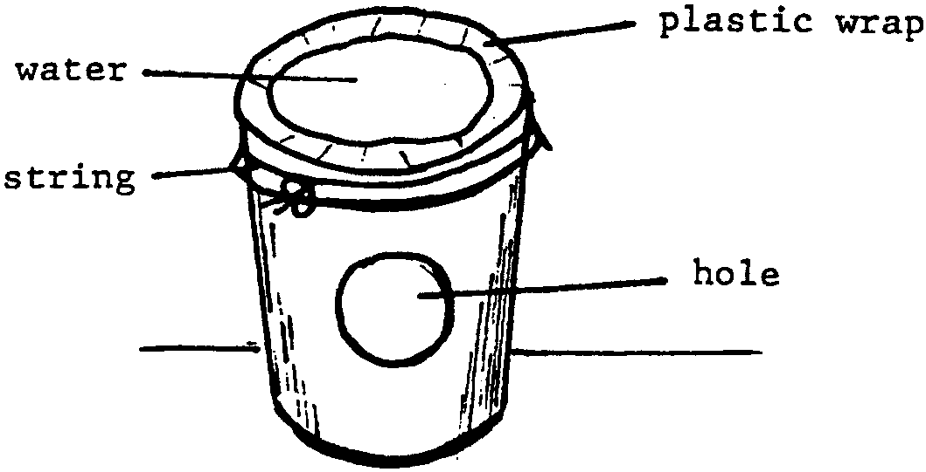
4. Put your hand through the hole. What happens when you move your hand up?

.

What happens when you move your hand down?

.

5. Look at shells and other small objects.
I looked at:
.

6. Look at a newspaper picture. What do you see?

.

7. Change the tightness of the wrap. What happens?

.

8. The image is what you see with your microscope. How many times larger than life is the image? Can you figure it out? Draw a line one inch long on a piece of paper. Put it under your microscope. Measure the length of the line in the image. How many times longer is the line in the image?

.

FOR REAL EAGLE EYES . . . . . . . . . .

Look at the back of a penny. How many steps are there on the Lincoln Memorial?

