Tiny – But Important

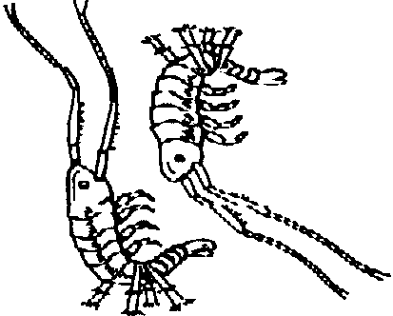
Key Concepts
1. Although plankton are very small - microscopic to about 2 inches in length - they are very important to all forms of life on this planet.
2. Even the largest animals on earth, the blue whales, need plankton to live.

Background

There are large numbers of both phytoplankton (plants) and zooplankton (animals) that can only be seen with a microscope. However, some of the most common are slightly larger. Krill and copepods (pronounced “ko'-po-pods”), both in the crustacean family, are examples of two of these larger zooplankton and are among the most important animals alive today since they are a primary food source for many seabirds, herring, whales and squid. In some plankton samples at certain times of the year, 50-75% of the sample may be copepods and krill. At that time, the concentration may be so high that they cover miles and miles of ocean area.

Because of the huge quantities of plankton available, the diet of animals such as blue, fin and humpback whales can consist mainly of these small animals. The blue whale has ventral pleats on its lower jaw that expand, allowing it to take in a huge mouthful of water, over two tons, at one time. Inside the whale’s mouth, the zooplankton become trapped on fringed baleen as the water is expelled out of the mouth. It has been estimated that a single blue whale can eat up to 4 tons of krill each day.

Materials

For each pair of students:

• magnifying glass

• drawings or photographs of 4 or 5 types of plankton

• ruler

• meter stick

• two pieces of masking tape

Teaching Hints

In “Tiny - But Important”, students gain some appreciation of the vast range of sizes of marine organisms by first drawing and then measuring several types of zooplankton. They then compare the size of copepods and krill to that of the blue whale and consider the vast amounts necessary to feed such a large creature. While Part 1 can be conducted in the classroom, you will need a long hallway or outdoors space to measure the length of the blue whale in Part 2.

Students may need practice using a ruler. Start by having them approximate all measurements to the nearest whole centimeter. If they want to be more accurate, explain that the next smallest subdivision is called a millimeter and that measurements can be given as “3 cm. 4 mm.” Alternatively, you can say that “3.4 cm.” is a short way of writing the result, saving the explanation of decimals for some future time.

Part 1: Investigating the Size of Plankton

In Part 1, students draw and measure several types of zooplankton.

Procedure

1. Start by making several small chalk dots on the blackboard and explaining that many plankton are no bigger than those dots. Some are even smaller, requiring a microscope to see them clearly. Others are larger, some as large as 5 cm. (about 2").

Hand out the Student Worksheets and have students use the magnifying glass to examine the dots on the paper. Even though this seems very simple, students will make interesting discoveries about printing and paper surface and will gain experience using magnifying glasses.

2. Now hand out the photographs or drawings of plankton and ask students to choose two to draw in the indicated boxes. Artistic quality is not as important as making sure they fit in the boxes. Encourage the students to notice features of the plankton as they draw them.

3. Now ask students to measure the length of each of the plankton they drew. Explain that these plankton in real life would be much, much tinier but that it would be almost impossible to make accurate drawings at that size.

4. Have each student measure the length of the life-size krill depicted on the Student Worksheet. Explain that these shrimp-like creatures constitute the main food for blue whales, the largest creature on earth.
Part 2: Comparing Marine Animal Sizes

Students will now investigate the length of the blue whale, the largest animal ever to have lived - even larger than the largest dinosaur.

Procedure

1. Hold up the meter stick, explaining that the blue whale can be as long as 30 meter sticks and that the students are going to see just how long that is.

2. Identify a starting point from which students will measure a 30 meter distance.

3. Have two or three students estimate a 30 meter length. Do this by having them begin walking from the starting point and stopping when they think they have reached the 30 meter point.

4. Next, have the remaining pairs of students each make a masking tape mark on the floor or ground at the beginning of their measurement. Then have them carefully measure out 30 meters, counting out loud to keep track. Have them place another piece of masking tape on the floor at the 30 meter mark and then examine the total measured distance.

5. Now have students estimate how may of their classmates it would take, standing shoulder to shoulder (or lying head to toe), to reach 30 meters. Then, try it!

6. Emphasize that these huge creatures depend on the tiny krill the students drew in Part 1. How is that possible? They must eat a great many of them. To help visualize this, ask the students if any of their families have pickup trucks. The usual family pickup truck has a capacity of 1/4 ton. Ask the students to imagine 16 trucks lined up, all filled with krill. That would add up to 4 tons, the amount a blue whale eats every day.

Key Words

baleen - bristle-like strainers in the blue whale’s mouth used to strain zooplankton out of the water

copepod - one of the smallest (2.5-10mm) and most abundant crustaceans

krill - shrimp-like creatures that constitute the main food of many large whales

Extension

1. The activity, “The Oceans as Whale Habitat”, which appears in Unit 5: Deep Sea and Marine Mammals, provides additional activities relating to whales and plankton.

Answer Key

1. Answers will vary. They may notice rough edges of the dots, irregularities on the paper, smudges, etc. They may want to look at the regular print as well; that’s fine.

2. Drawings will vary.

3. Drawings of plankton in box # 1 should be about 3 cm. long and, in box # 2, about 4 cm. long. In real life, these would be much smaller.

4. Krill is 5 cm. long, which is their true maximum length.

Additional information and pictures of plankton can be found in the Resource File for this lesson.
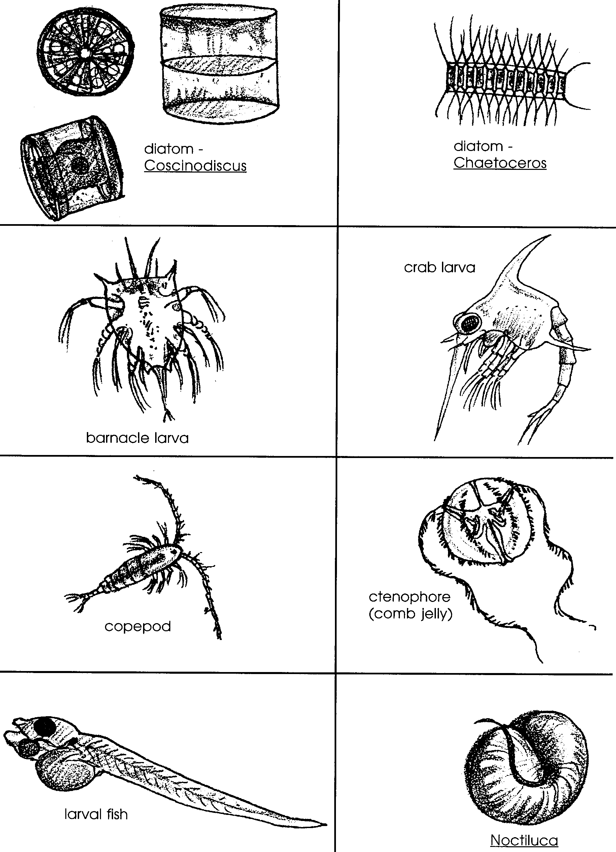

Tiny – But Important

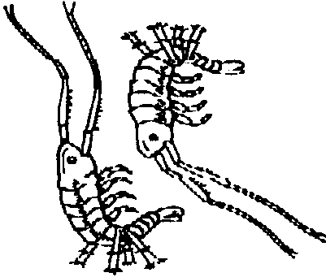
1. Look at these dots closely. Use the magnifying glass. What do you see?

. .

2. Look at the plankton drawings. Choose two. Draw one of them in the first box. Draw the other in the second box.

Box 1 Box 2

3. Now measure the length of each plankton. Use the ruler.
Length of Plankton in Box # 1

Length of Plankton in Box # 2

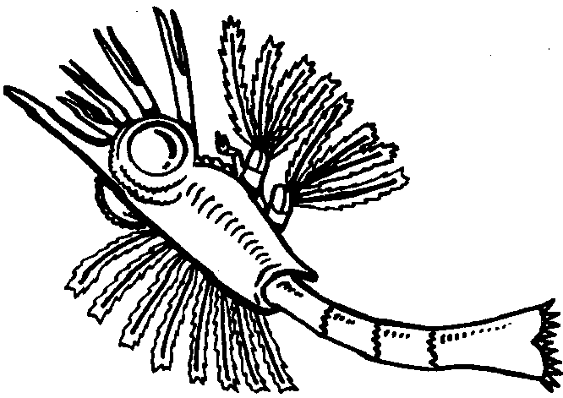
4.

Krill

Length of krill

