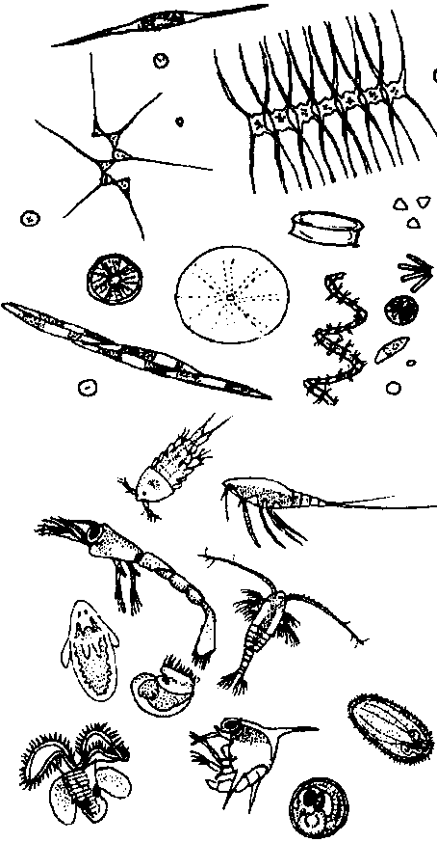
Sea Soup
Lesson by Pat Rutowski, Monterey, CA and Pat Williams, Eugene, OR

Key Concepts
1. Plankton means “wanderer” and refers to any of the myriad animals or plants, either microscopic or macroscopic, that drift with the ocean currents.
2. Some animals live in the plankton for their whole lives while others only live there as larvae or juveniles.
3. Plankton forms the basis of most of the marine food chains and webs.

Background

What is Plankton?
The term plankton, which means “wanderer”, refers to those animals and plants, large and small, which drift in the ocean currents with little or no control over their own direction. The term plankton has come to mean the microscopic animals and plants which make up the sea’s “soup”.

Plankton can be classified in several different ways. Since both animals and plants belong to this group, each has its own name: phytoplankton designates the plants and zooplankton the animals. The two major types of phytoplankton are:
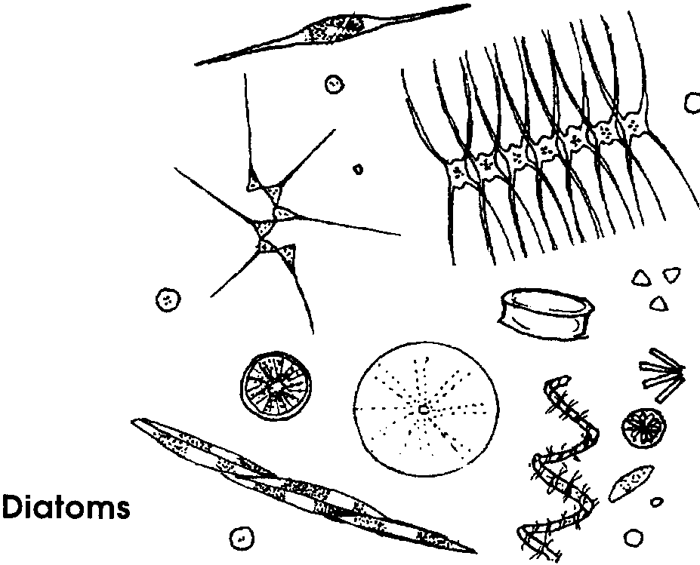
1. diatoms - single-cell plants enclosed in a glass “pill box”. The pill boxes are made of silica dioxide, a major component of glass, and many have elaborate ornamentations. Diatoms may occur in chains or singly.

2. dinoflagellates - possess characteristics of both plants and animals. Many photosynthesize, but some feed on other organisms. They use flagella (tails) to move through the water. Some types are toxic and when in bloom can make shellfish unsafe to eat.
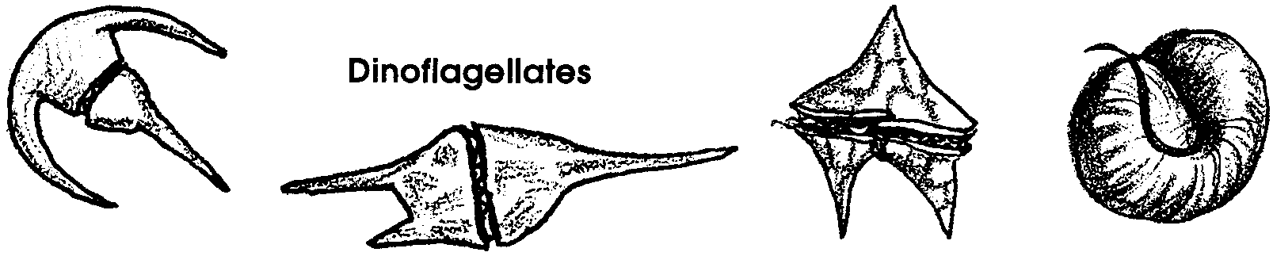
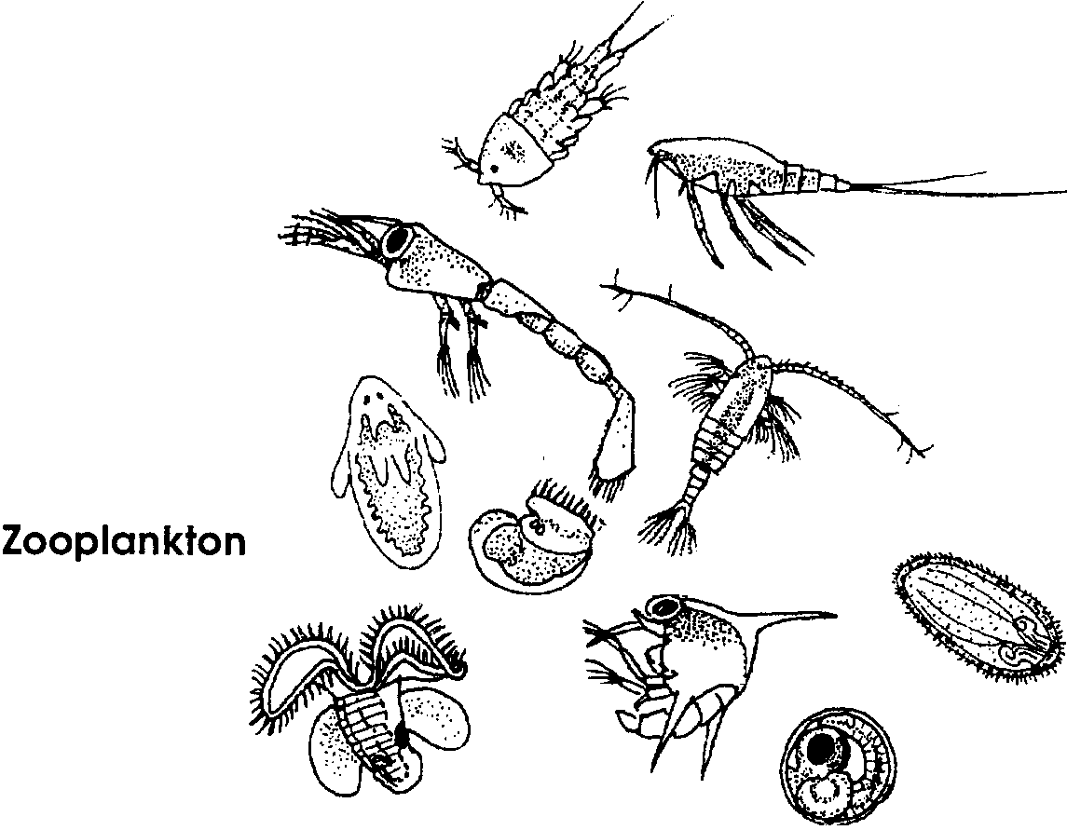

Some of the zooplankton spend their whole lives in the plankton. They are called holoplankton. Meroplankton are the larvae or young of ocean animals.

The Abundance of Plankton
Most productivity in the ocean is in coastal and nearshore areas above the continental shelf where upwelling and river input keep nutrient levels relatively high. Mid-oceanic areas do not receive upwelled nutrients and are thought to be relatively unproductive. The fact that 90% of the world’s commercial fishing catch occurs in 7% of the ocean indicates that the oceans are not uniformly productive.

The number and type of plankton in the water varies seasonally. Since the phytoplankton are plants, light and the availability of nutrients in the water affect their abundance. As the phytoplankton use nutrients, zooplankton populations increase (bloom) and eat the phytoplankton. As zooplankton populations are eaten or die off there is less pressure on the phytoplankton.

Materials

Part 1: Plankton Observations

For the class:

• live plankton sample (see “Preparation” section below)

• a microscope for students to observe plankton (see “Preparation” section below)

Part 2: Dramatizing Plankton

For the class:

• overhead transparency or large poster of the plankton rap

• materials to make plankton puppets or costumes, such as: cloth, wire, paper, cellophane, glitter etc.

• drawings of plankton or books containing drawings

Teaching Hints

Part 1: Plankton Observations

Materials

For the class:
• live plankton sample (see “Preparation” section below)

• a microscope for students to observe plankton (see “Preparation” section below)

Preparation

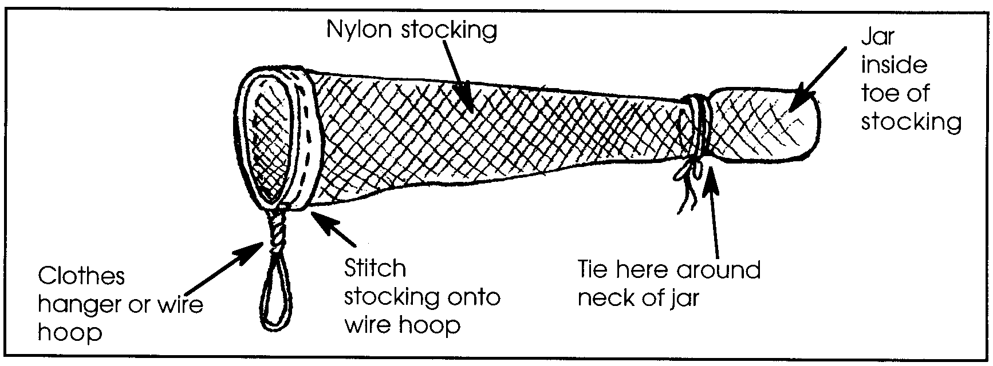
1. Obtain a live plankton sample from fresh or saltwater. Plankton is an exciting and important concept, but too abstract to teach with discussion alone. Collection of a live plankton sample (from coastal waters by a dock, or in fresh water ponds) for student observation is essential. The collection net is quite easily constructed. A very simple net can be constructed with an old pair of pantyhose, a wire ring (from a clothes hanger) and a collecting jar like a baby food jar. The finished product should look something like this:

Tow the net through the water sweeping back and forth, several times. Once the plankton is collected, you will need to keep it in an environment similar to that of the environment from which it was collected; otherwise, it will die. This may mean refrigerating the sample. Do not let too much time pass between collection and observation by students.

2. Obtain microscopes for students to observe plankton. Good dissecting microscopes greatly increase the success of students’ observations. “Discovery Scopes” work quite well, particularly for zooplankton. See the bibliography for details on “Discovery Scopes”.

If you do not have access to good microscopes, try borrowing one or two from a middle school or high school. Dissecting microscopes (with two eyepieces) are easier for young children to use than the compound scopes. If you are lucky enough to have a video projecting microscope they are ideal. The old microfiche readers used in libraries (and which still may be sitting on shelves in storage) work amazing well for plankton observation.

Other ways to share plankton with students include:
• live brine shrimp from the local pet store
• video footage of plankton; included in the “Monterey Bay Aquarium Video Treasury” (see bibliography for details)

Procedure

1. Have students observe and make drawings of the plankton.

2. List students’ observations.

3. Create metaphors with students, describing the plankton. “The plankton look like...
• crystal boxes in a row
• bugs trying to hide
• jewels, etc.”

Part 2: Dramatizing Plankton

Materials

For the class:

• overhead transparency or large poster of the plankton rap

• materials to make plankton puppets or costumes, such as: cloth, wire, paper, cellophane, glitter etc.

• drawings of plankton or books containing drawings
Preparation

l. Make a transparency or write the plankton rap on a chart so all students can read it.

2. Decide on whether you want the students to design their own plankton puppets or costumes using materials you supply or whether you want to give them ready made puppets, costumes, or hats. You may want to enlist the aid of an artistic parent to help lead the fabrication.

Procedure

1. Display the plankton rap and practice the rap with students. This rap introduces them to some of the animals and plants in the plankton and its placement in the marine food web.

2. Cast students as the different types of plankton.
Cast:
diatoms
dinoflagellates
snail larvae
sea star larvae
jellies
chaetognaths (arrow worms)
clam
otter
bat ray
optional: crab larvae
a plankton net

NOTE: If you wish to adapt these plankton to fresh water species, see the activity “Getting to Know Plankton” in Pagoo - FOR SEA Investigating Marine Science Grade 5.

3. Provide pictures of the plankton, if students are to draw their own plankton puppets. Or, distribute the plankton costumes or hats.

4. Choreograph students doing a plankton “dance”, focusing on each cast member as they are discussed in the rap, while you or the students read the rap.

5. Present the plankton performance to another class.
Key Words

chaetognath - a special phylum or group of worms; arrow worms

diatoms - microscopic plant plankton

dinoflagellates - plankton that possess characteristics of both plants and animals

holoplankton - animals or plants that spend entire life in the plankton

meroplankton - animals or plants in spore, egg or larval stages that spend only part of their lives in the plankton

plankton - drifters of the sea, carried by water movement

phytoplankton - plant plankton, consisting primarily of diatoms and dinoflagellates

zooplankton - animal plankton

Extensions

1. Have students write about one of the plankton in the rap and why they would want to be that plankton.

2. To reinforce the importance of plankton in the food chains of the sea, sing the song that follows to the tune of “There Was An Old Lady Who Swallowed a Fly”.

A Food Chain of the Sea

zooplankton: There once was some phytoplankton that lived far from me,
That didn’t eat anything living, oh me.
A food chain of the sea.

zooplankton: There once was some zooplankton that came wiggling by,
Nibbled on phytoplankton without blinking an eye.

phytoplankton: The zooplankton ate the phytoplankton that lived far from me
That didn’t eat anything living, oh me.

all: A food chain of the sea.

shrimp: There once was a shrimp that went swimming that way,
Gobbled up zooplankton as though it were play.

zooplankton: The shrimp ate the zooplankton that came wiggling by,
That had nibbled on phytoplankton without blinking an eye.
phytoplankton: The zooplankton ate the phytoplankton that lived far from me
That didn’t eat anything living, oh me.

all: A food chain of the sea.

herring: There once was a herring that swam in a school,
That chewed up some shrimp using teeth as a tool.

shrimp: The herring ate the shrimp that went swimming that way,
And had gobbled up zooplankton as though it were play.

zooplankton: The shrimp ate the zooplankton that came wiggling by,
That had nibbled on phytoplankton without blinking an eye.

phytoplankton: The zooplankton ate the phytoplankton that lived far from me
That didn’t eat anything living, oh me.

all: A food chain of the sea.

salmon: There once was a salmon that swam in the ocean,
That moved very quickly without too much motion.

herring: The salmon ate the herring that swam in a school,
That chewed up some shrimp using teeth as a tool.

shrimp: The herring ate the shrimp that went swimming that way,
And had gobbled up zooplankton as though it were play.

zooplankton: The shrimp ate the zooplankton that came wiggling by,
That had nibbled on phytoplankton without blinking an eye.

phytoplankton: The zooplankton ate the phytoplankton that lived far from me
That didn’t eat anything living, oh me.

all: A food chain of the sea.

all: The salmon grew sicker and died one spring day,
But the ocean was made richer with his body decay.
New phytoplankton grew where he died in the sea.
That’s the way it’s intended to be,
A new food chain of the sea.

Act out the song as you sing it. First, divide students into five groups and assign each group one of the links in the food chain. Have students rehearse the lines for their link. To create props for each link in the chain:
•phytoplankton - Cut a sponge in half and round the corners. Glue two sections together to form a single diatom or thread sections onto a string to form a chain of diatoms. To show that the diatoms are magnified, have students make a large cardboard magnifier with plastic wrap for the glass to hold in front of the sponge “diatoms.”

•zooplankton - Form a loop with one pipe cleaner. Twist the ends together to form the copepod’s tails. Wrap another pipe cleaner a few times through the top of the first pipe cleaner to form antennas. Use the magnifiers described above to show that the models are much larger than the actual plankton.
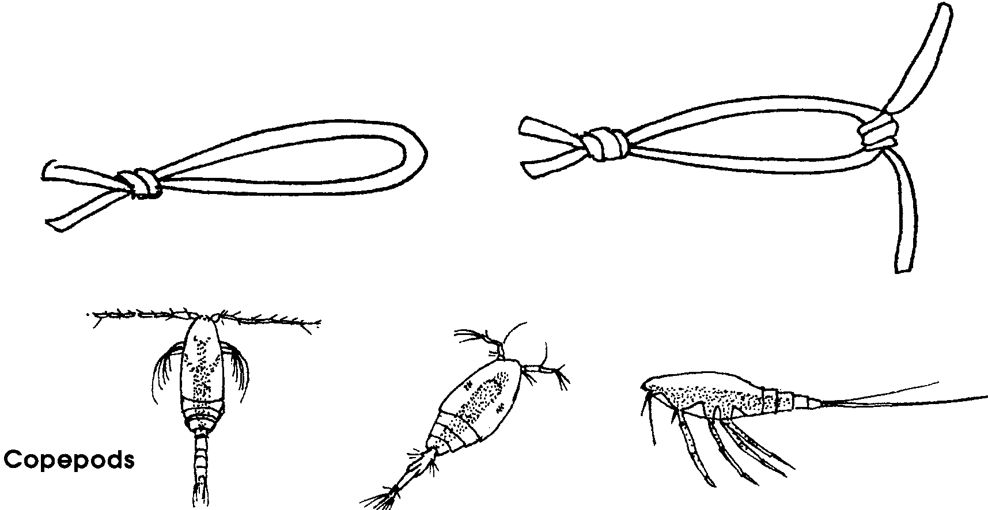

•shrimp - Cook some large shell macaroni. Cut the shell in half the long way and add toothpicks for legs and antennae. The toothpicks should be pushed through both sides of the macaroni and then bent on the side underneath.

•herring and salmon - Make models from stiff paper or make “stuffed” fish.

The idea for adapting “There Once Was a Daisy” (originally appearing in a National Wildlife Federation pamphlet, Predators!) came from Sally Eastham, Oroville, CA.

3. Read The Important Book by Margaret Wise Brown. Have students write why plankton are important, following a format like that in The Important Book.

4. Use the following script to sing and act a “rap” production.
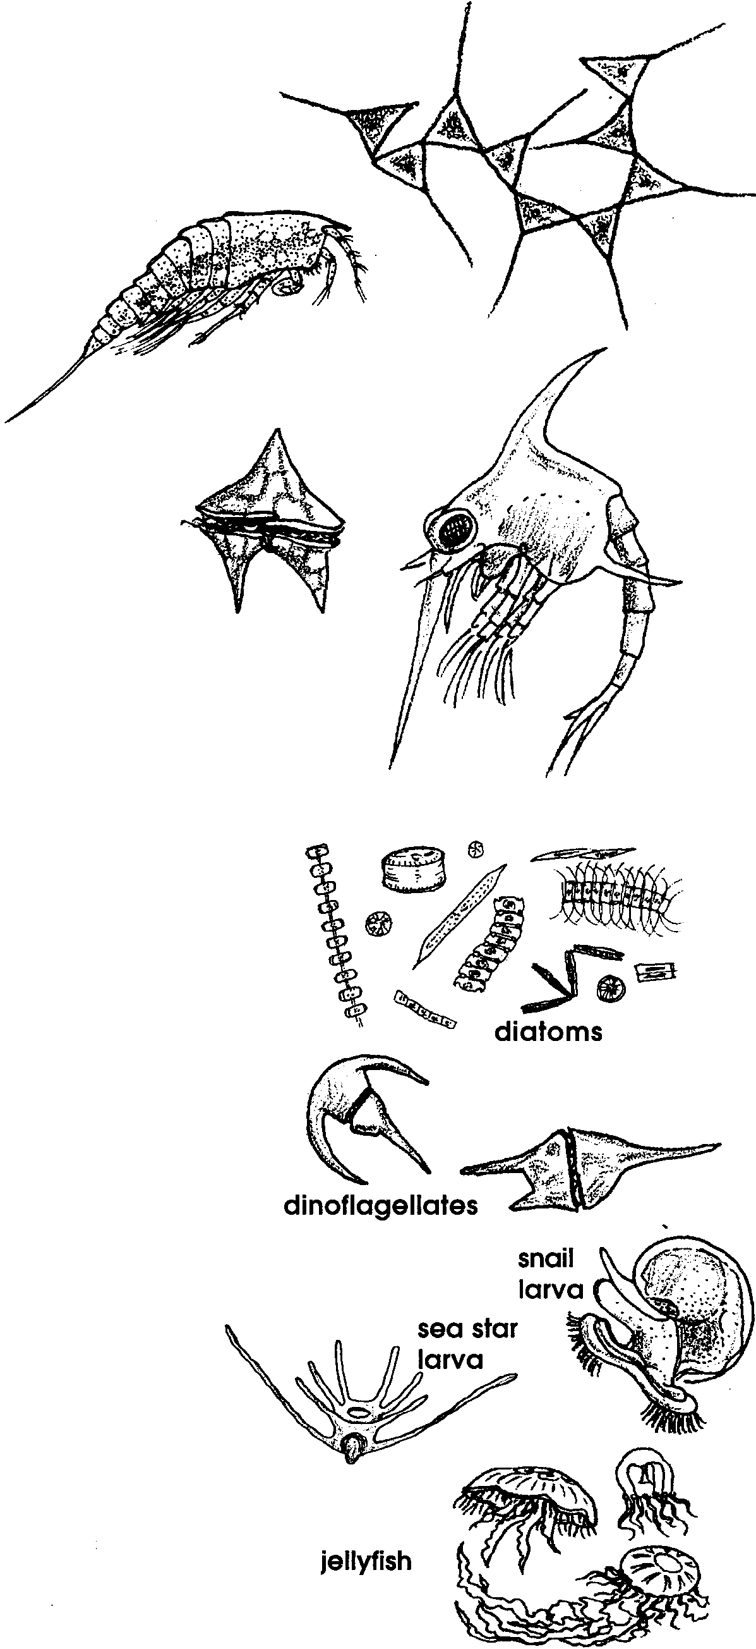
“Sea Soup” (Rap beat)

We’re the wanderers of the sea;
the plankton we are called.
All kinds of plankton live with us,
both plant and an-i-mal.

Some of us are large.

Some of us are small.

Some grow up and go.

Some don’t leave at all.

Together we make up a soup

that feeds the animals of the sea.

I know that this is just our job,

but I sure hope that they don’t get me!

We range the earth’s oceans
and change with the seasons.
Our bodies are bizarre and strange
but we all have our reasons.

We are the beautiful diatoms.
Clothed in boxes made of golden sand
we use the sun to make all our food
like our plant cousins on the dry land.

We are called dinoflagellates.
We are part animal and plant you see.
Two tails help us move to catch prey
but we can also use the sun to eat.

Snails, sea stars and many more start here;

in this the soupy plankton brine.
Their larvae travel the shallow seas
but settle down when home they find.

Tiny jellies live their lives in this soup.
They trail their tentacles in the sea,
their delicate bodies shining like glass,
to catch something that they want to eat.

We’re the chaetognaths, clear and straight.
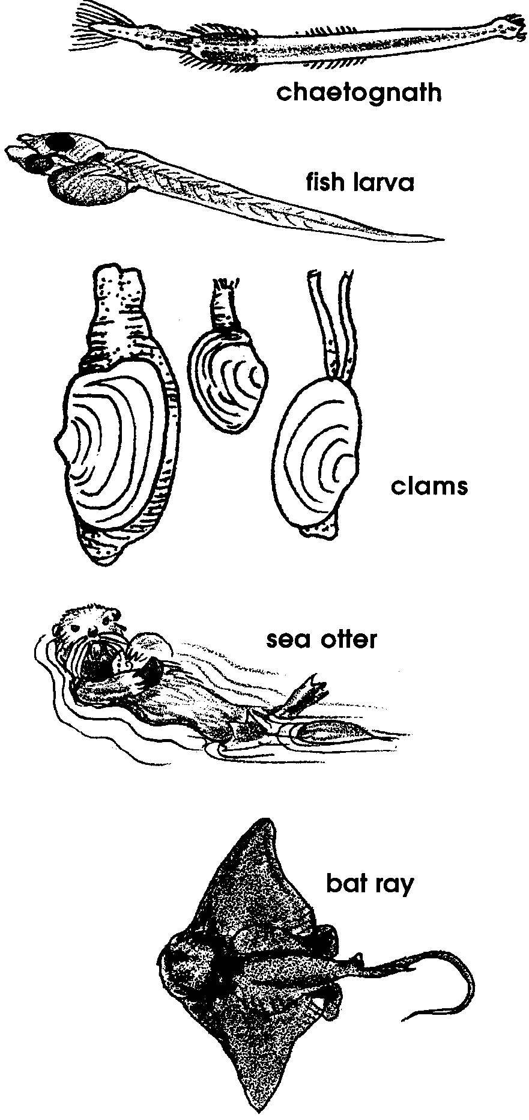
We’re also called terrible arrow worms.
We use bristly jaws to grasp our prey as big as us!
Fish larvae - how they can squirm!

You see all of these plankton
go through the clam’s siphon.
The clams filter out the food
that started with the sun.

Since other animals eat the clams,
like otters and bat rays;
the plankton become most important
to those who live in the water.

We humans can see them, if we like
these plankton oh so small.
If we take a net and scoop them up;
a microscope shows all.
