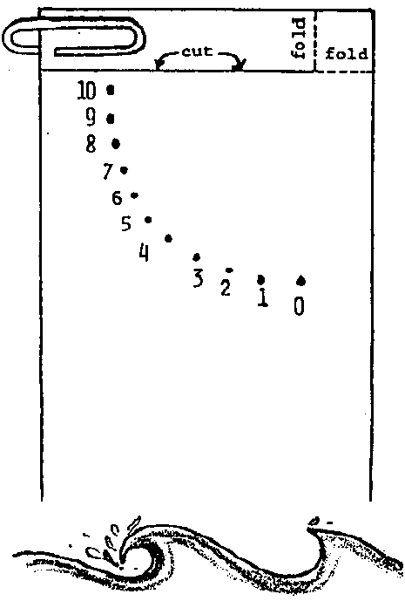
Making Waves
Lesson edited by Jan Bieber, Federal Way, WA and Pat Williams, Eugene, OR

Key Concepts
1. Most waves are formed by winds blowing over the surface of the ocean.
2. The size of wind generated waves depends on the force of the wind, how long the wind is blowing, and the amount of open sea over which the wind can blow.

Background

Waves are an endless source of fascination for everyone, from scientist to surfer to beachcomber. Even the most casual visitor to the beach notices the endless cycle of surge and rush of waves on the shore, and experienced sailors are intimately aware of the wide variety of waves that exist in open water. Not unlike living things, waves can be thought to experience a lifecycle, with stages of birth, growth, maturity, and death.

Ocean waves are generated by three natural causes: wind, seismic disturbances, and gravitational attraction of the sun and moon. Waves caused by seismic disturbances such as earthquakes and volcanic eruptions are called tsunamis and can cause great damage when they hit land.

Most of the waves we see at the beach are wind generated waves. The size of wind generated waves is dependent upon wind speed, the length of time the wind blows, and the distance over which the wind blows. Wind waves often start far out on the ocean when the water is first hit by a breeze or wind. Sometimes this causes a ripple or a roughening of the surface of the water. The little ripples are very important to the starting of waves. The rippling of the water makes it easier for the wind to catch hold of the ripples. More of the energy in the wind pushes the little ripples and waves, forming larger waves. If the wind is strong, the small wave becomes a larger wave that may travel for thousands of miles before crashing on the beach. The highest wind-created wave ever recorded was 112 feet high.

When you look at the waves rolling to the shore, it seems as if the water is actually traveling in toward land. In spite of appearances, very little water is carried forward as the waves move along. Wind blowing over the surface transfers energy to the water through friction. The energy is carried through the water in the form of waves. The wave energy actually passes through the water, rather than pushing the water ahead of it. While a wave may move past a point, the water making up the wave will show no net movement. The water particles in a wave actually tend to move in circles. An observation in support of this fact is made by those swimming in the waves who find that they tend to go around in a circle as the waves pass by - up, forward, down, and back - returning to the starting place.
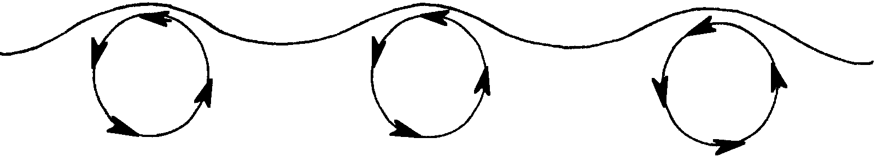
As waves move from deep water to shallow water, their behavior changes radically. As the waves reach shallow water, the portion of the wave near the bottom is slowed. This lets the surface portion race ahead and eventually the wave breaks, or collapses, and the cascade of water we see occurs. Technically, waves “break” at the beach when a wave moves into water shallower than one half of the wave length and the particles of water in the crest have no room to complete their circular movement.

Physically powerful and interesting in their own right, waves are also ecologically important. The breakers are a turbulent mixture of air and water. This mixture helps bring oxygen from the air into the ocean water. Waves also change habitats, batter organisms, and subject organisms to conditions of exposure and wetting.

Materials

Activity 1: “Making Waves”

For the class:

• pitcher for pouring water

• bucket for emptying water

For each group of 2 or 3 students:

• aluminum pie plates, or similar sized, shallow container

• several paper towels

• newspaper or plastic to cover table

For each student:

• soda straw

Activity 2: “Fast As the Wind”

For each student:

• 3" x 5" card (an old post card will do)

• pencil

• paper clip

• scissors

• glue

Activity 3: “Waves in Water”

For the teacher:

• clear glass pan (9" x 13"), filled to a depth of about 1" with water

• drinking straw

• tongue depressor

• putty or clay

• overhead projector

• watch or clock with second hand

Activity 4: “The Ocean Surface”

For each student:

• “The Ocean Surface” reading

Teaching Hints

In “Making Waves”, students investigate the relationship of wind and waves as they generate waves in a model ocean, make and use a simple wind gauge, watch a teacher demonstration of wave patterns, and complete a reading.

Activity 1: “Making Waves”

In “Making Waves”, students make predictions about what will happen when they experiment with water and wind, and then discuss their observations.

Preparation

You may choose to set up the work areas for students, so they can focus on the experiment and not the preparation. Fill each plate to a level l/2" from the top.

Procedures

1. Show students the plate of water. Ask students what they think will happen when air is blown across the water. Record their predictions on the board. Label them as such and discuss the word, “prediction.”

2. Distribute the straws and paper towels. Tell students to blow through the straws across the water (one at a time). As each student takes a turn, have the others observe results.

3. Choose a student from each group to blow on the water very hard, and keep blowing for as long as he or she can. Ask:

“What happens as the air pushes longer and more strongly?”

(The waves keep growing as they cross the pan. They should be highest just before they reach the edge of the pan and disappear. Note that not even a powerful electric fan could make ripples in their pan grow into real waves because the pan does not give the waves enough room in which to grow. Ripples can grow into big waves only when a strong wind pushes steadily against their backs over a long stretch of water.)

4. Since this is a very short activity, take time to discuss observations and to compare students’ observations to their predictions.

Activity 2: “Fast As the Wind”

“Fast As the Wind” provides a simple tool which allows your students to measure the approximate wind speed.

Preparation

Duplicate “Fast As the Wind” student worksheet

Procedures

1. Remind students that waves are formed by the wind blowing on the surface of the water. Blowing over the surface of the oceans, winds start wave trains that may travel for thousands of miles before crashing on the beach. For example, a 112 feet high wave was formed by a wind blowing 60-68 knots over a distance of several thousand miles.

2. You may wish to demonstrate the construction of the gauge before the class begins their construction.

3. Distribute the student worksheet pages and necessary materials.

4. After students complete construction of their wind gauges, have them measure wind speed in the places and at the times noted.
Activity 3: “Waves in Water”

“Waves in Water” utilizes an overhead projector to show wave patterns. Because this experiment involves water and electrical equipment, it should be done by the TEACHER ONLY.

Procedure
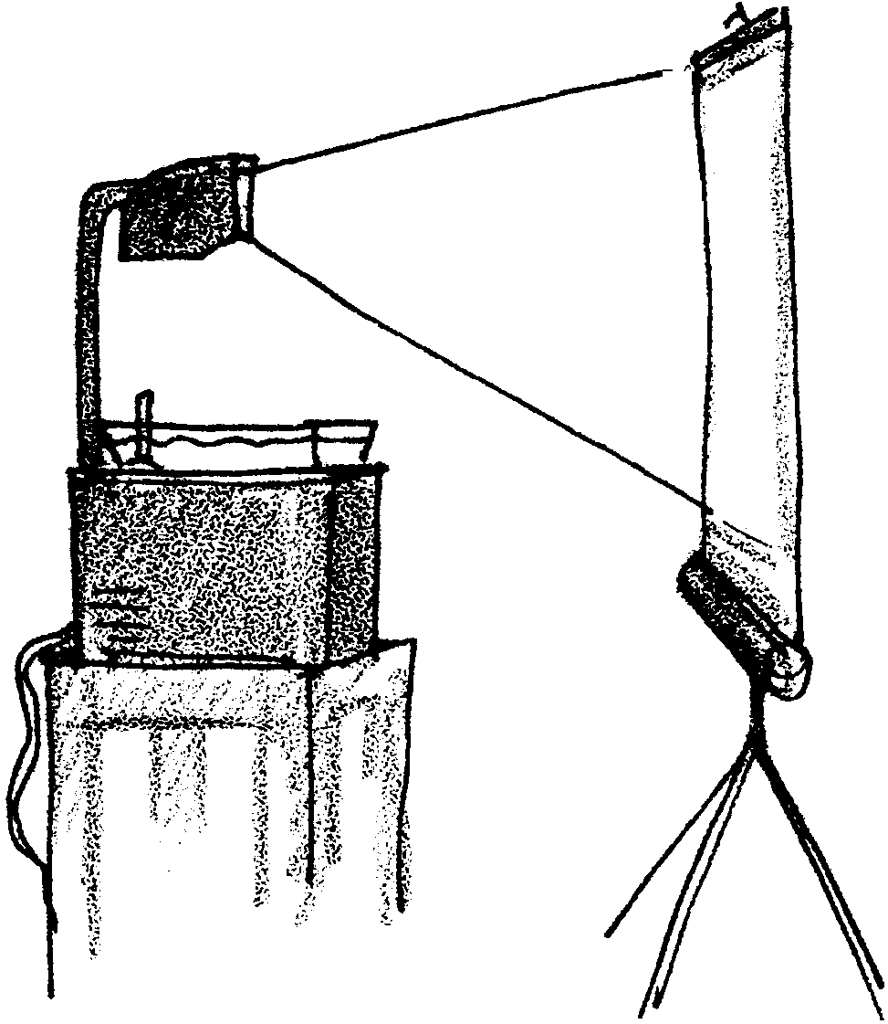
1. Soften a piece of clay or putty and place it on the bottom of the pan near one end. Use the clay to hold the tongue depressor upright.

2. Fill the pan with water.

3. Place the pan on the overhead projector surface.

4. Use the drinking straw to create wind waves by blowing across the surface of the water. Have students observe the formation and travel of the waves.

5. Using the side of your hand, slowly strike the water’s surface at the end opposite the stick. Waves will appear on the projector screen. Have a timer count off 5 seconds. Have students count how many waves pass the stick in 5 seconds. They may count by observing either wave crests or troughs passing the stick. Record the number on the board.

6. Strike the water more quickly and again note the number of waves passing the stick in 5 seconds. Compare this number with the results from step 5. Ask students:

“Which action produces more frequent waves?”

(The more rapid striking of the water produces more frequent waves.)

Tell students that the number of waves passing a point in a given period of time (wave frequency) is influenced by the strength and duration of the wind.

7. Have students suggest alternative ways to generate or disrupt waves (e.g., put a block in the middle of the tray; blow through a paper towel roll, etc.). If possible, try their suggestions and have students observe the results.

Activity 4: “The Ocean Surface”

1. Reinforce concepts with the student reading and worksheet, “The Ocean Surface”.

Key Words

breaker - a wave that breaks or dashes into foam as the bottom of the wave drags on the sea floor and moves more slowly than the top of the wave which eventually cascades downward

wave - disturbance of the surface of water

whitecap - a wave with a broken and foaming white crest

Extensions

1. Try the activity with a long, rectangular cake pan. If possible, find an even larger container and try it again. Discuss with students the effect of container size on waves.

2. To make “waves in a bottle”:

a. Fill a plastic beverage bottle (one with a lid that screws on tightly) about 1/3 full of salad oil. Add drops of food coloring; blue with a touch of green is effective. Fill the rest of the bottle with white vinegar.

b. Gently rock the bottle and watch the salad oil waves.

3. Borrow or purchase a recording of ocean waves crashing. Have students listen to it as they work. After they finish working, ask them to listen to the recording carefully. Discuss the rhythm (timing), volume, and other sounds they notice.

4. Have students read poems such as “Sea Wash” by Carl Sandburg or “Waves of the Sea” by Aileen Fisher. Do the words or rhythm remind them of the sound of waves? Ask them to make sounds like waves crashing and then think of words containing those sounds.

5. Drew Kampion’s book, The Book of Waves: Form and Beauty on the Ocean, explains the phenomena of waves, from their birth in the open ocean, to their demise on the shore, and is recommended background reading for this activity.
Answer Key

“Fast as the Wind”

5. Here is how to measure wind speed with the tool constructed:

a. Hold it with the paper clip pointed to the ground. Face the wind. The paper clip pointer will move in the wind.

b. Read the number the pointer moves to. That is the speed of the wind.
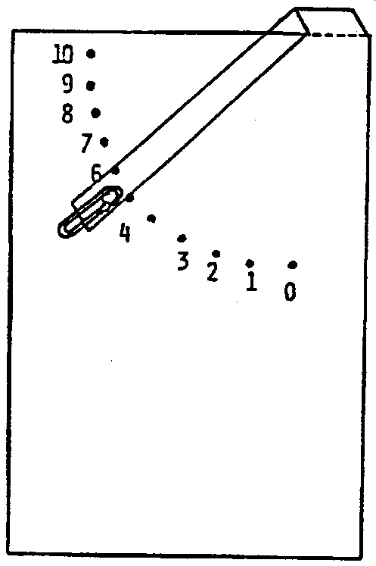

7-10. Answers depend upon observed experimental results.

“The Ocean Surface”

1. The top of the ocean is called the surface.

2. Wind blowing against the surface of the ocean makes rolling waves. The waves travel shoreward, often for considerable distances. As the waves reach shallow water, the portion of the wave near the bottom is slowed. This lets the surface portion race ahead and eventually the wave breaks, or collapses, and the cascade of water we see occurs. These breakers often have “white caps” from the turbulent mixture of air and water.
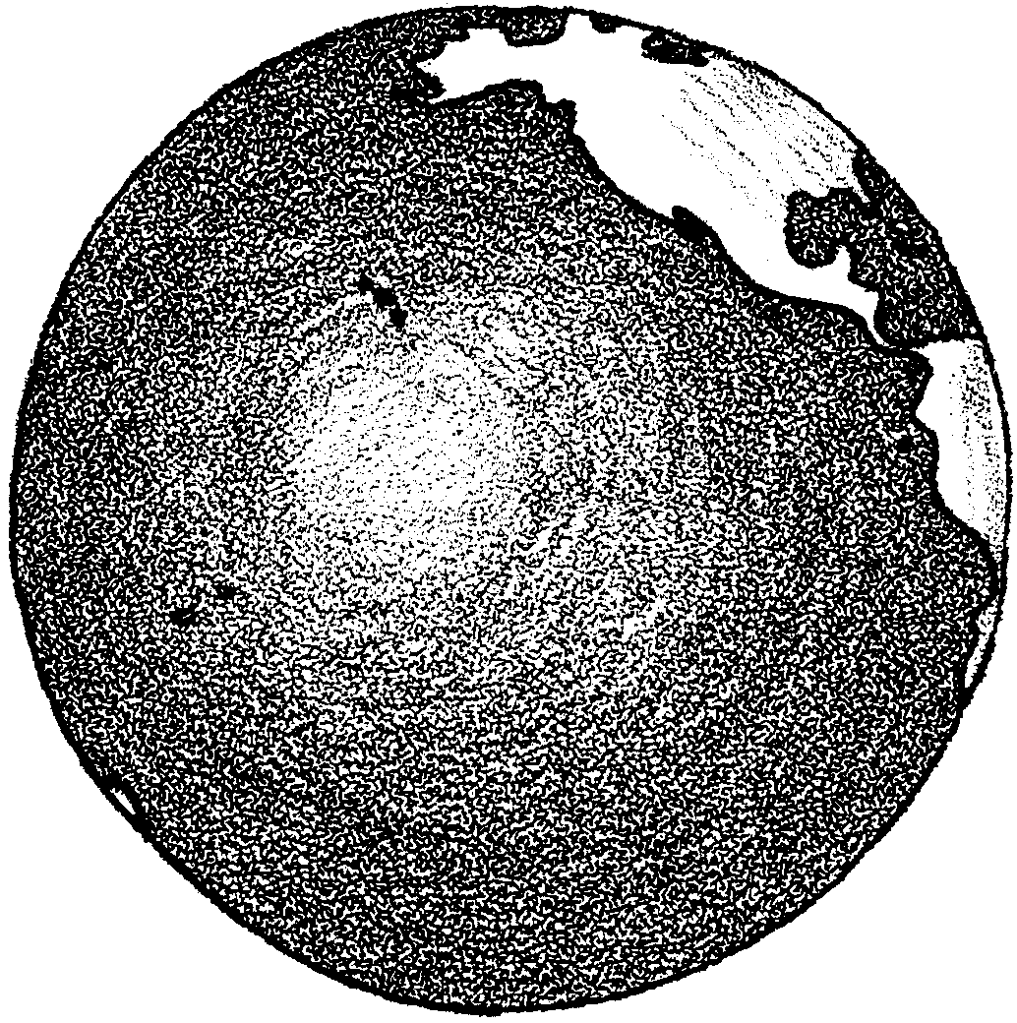
The World Ocean

The earth is a watery planet. You may have seen pictures of the earth taken from space. They show that the earth is a water planet.

1. Look at the map on the next page. Label these oceans:

Atlantic Ocean
Pacific Ocean
Arctic Ocean
Southern (Antarctic) Ocean
Indian Ocean.

2. Color the oceans blue and the land brown.

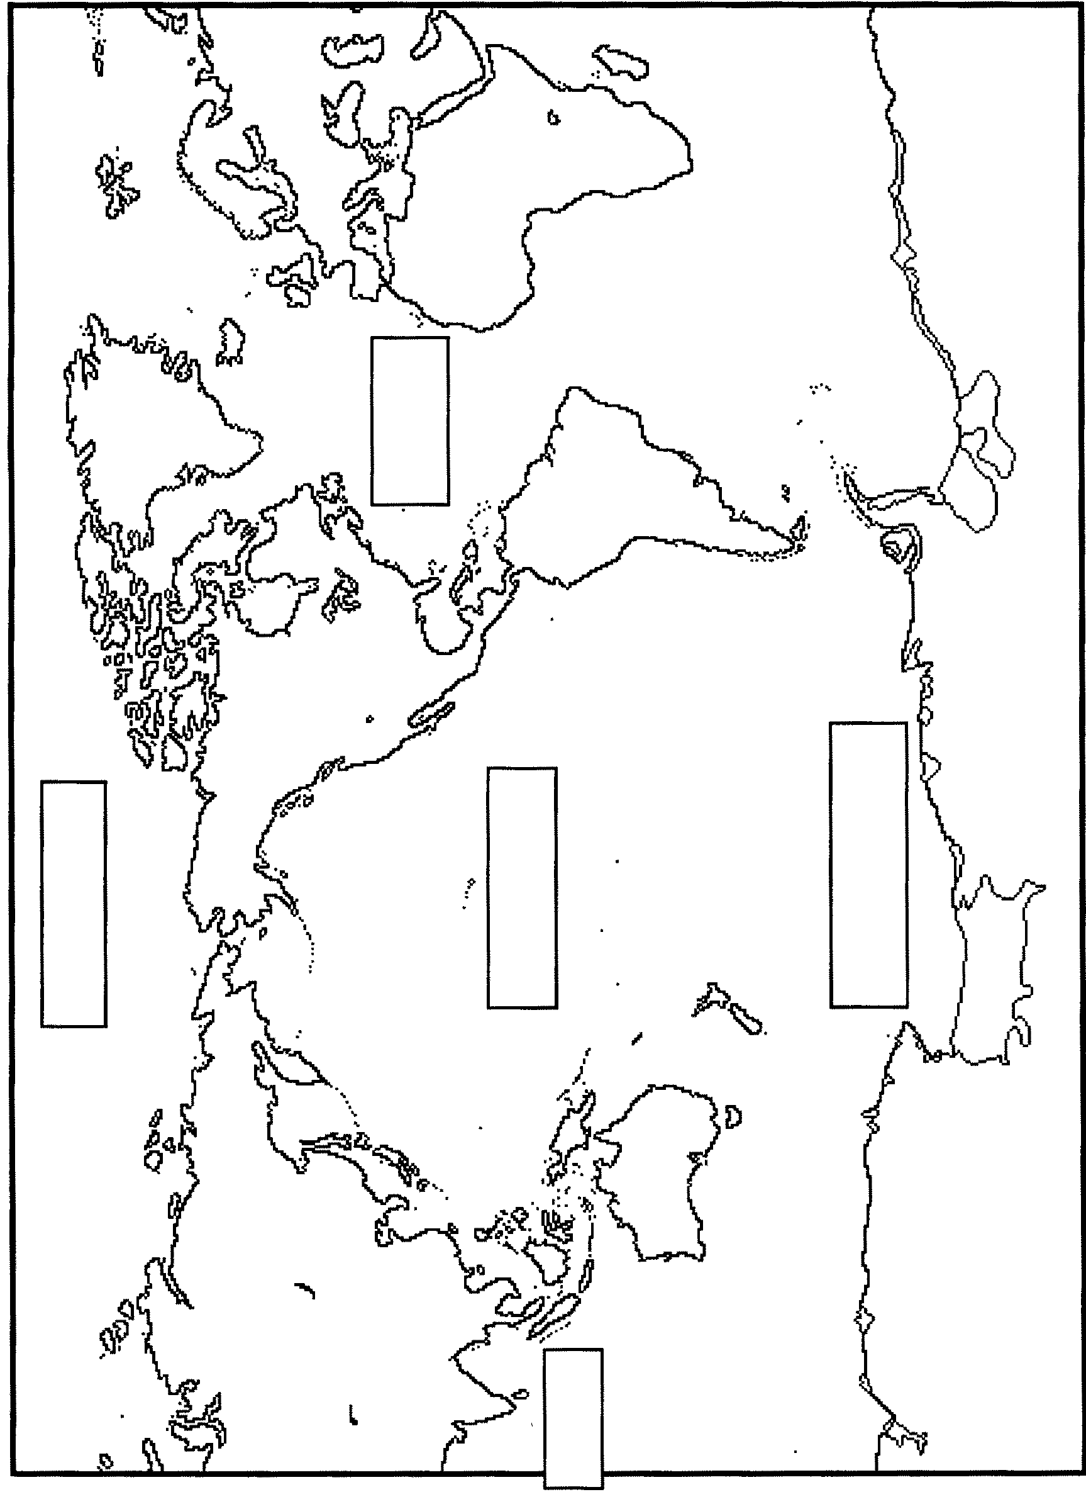
3. Which is the biggest ocean?
Oceans

There is more water than land in the world. The largest bodies of water are called oceans. The names of the oceans are: Arctic, Atlantic, Pacific, Antarctic, and Indian.
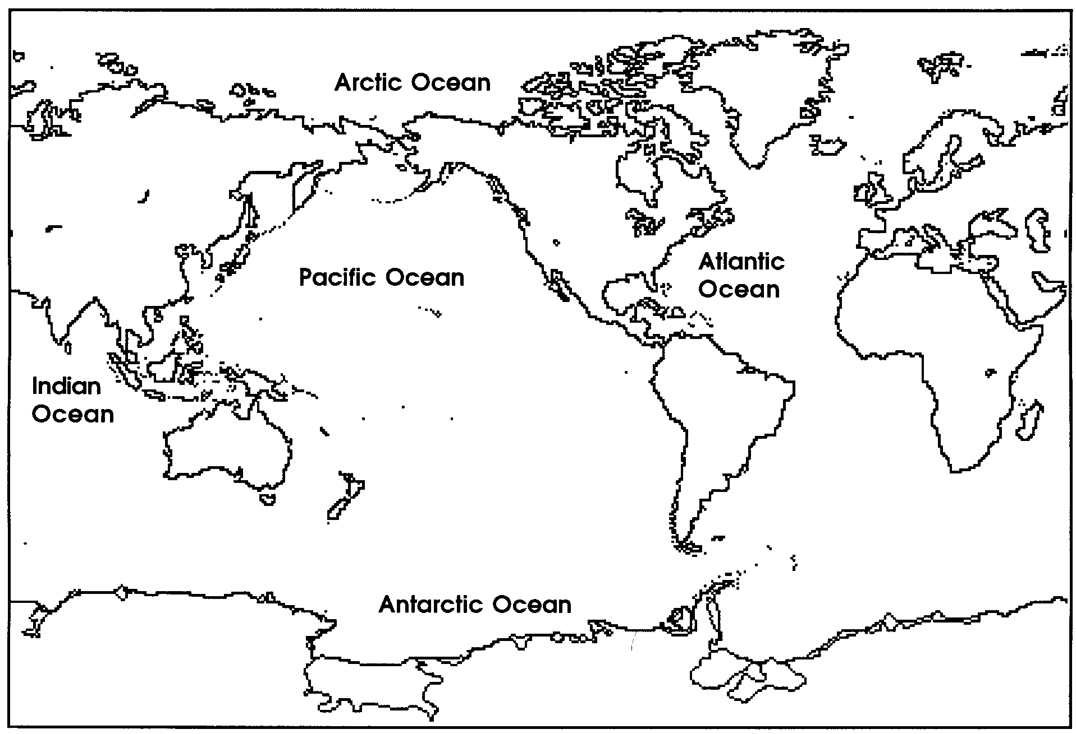
Map of the Oceans

1. What is the name of the ocean closest to where you live?

Ocean waters are salty. We use the same kind of salt on our food.
The oceans sometimes change colors. They may be blue or green. Sometimes the green color comes from tiny plants that live in the water. Clouds in the sky can also change the color of the ocean.

2. The color of the ocean may come from

.

Most parts of the ocean are deep. In some places the oceans are deeper than a mountain is high.

In some places, the oceans are warm. Fish with beautiful colors live there.

3. Think about colorful fish you have seen. Draw one here:

