Icebergs
Lesson by Pat Williams, Eugene, OR

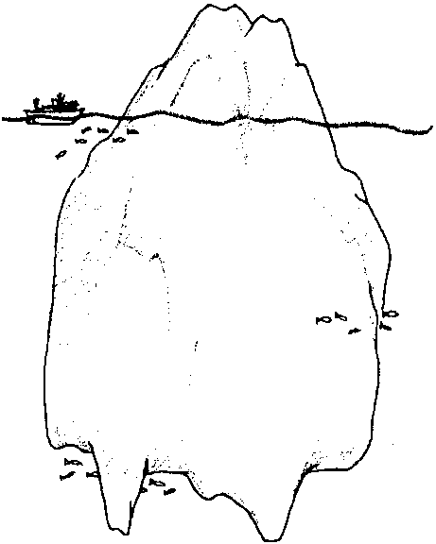
Key Concepts
1. Large quantities of water on the earth exist as a solid in the form of ice and snow, including glaciers and icebergs.
2. Water is unique among liquids in that it becomes less dense as it turns to solid ice, a fact which allows ice to float on liquid water.
3. Water can change from a solid (ice) to a liquid.
4. Ice melts faster when broken into little pieces.

Background

Sea Ice and Icebergs

When we think of the world ocean, often we picture rolling waves as far as the eye can see. While this is an accurate picture, it is not the only one. At the poles, vast reaches of the ocean are covered by ice.

As winter approaches the north or south pole, air temperatures fall so low that seawater begins to freeze, forming a layer of slush. The slush congeals into sheets of new sea ice. In turn, these sheets of ice are broken into “pancakes” by waves and wind. As freezing continues the pancakes unite to form larger masses called floes. Some ice floes move with the currents and wind, shifting constantly. Others remain anchored to land.

Other ice also floats in the sea. In both the northern and southern polar regions, giant masses of ice, called icebergs, break away from glaciers. Icebergs produced in the Arctic drift south as far as New England and into the busy shipping lanes of the North Atlantic. It was one of these icebergs that caused the infamous sinking of the Titanic on its maiden voyage in 1912, killing 1,517 people. Southern hemisphere icebergs are equally daunting. In 1987, an incredible iceberg with a surface area about the size of Delaware broke from Antarctica. It drifted 1,250 miles along the Antarctica coast before grounding two years later. It was estimated that the volume of ice in this iceberg was enough to provide everyone on earth with two glasses of water daily for about 2,000 years!

As ice is formed in the sea, some seawater is trapped in the spaces between the ice crystals. The amount of seawater trapped depends on the speed with which the ice forms. Ice that forms slowly has little seawater trapped inside; it escapes. If the ice forms quickly, more saltwater is trapped. As time passes, the saltwater slowly escapes through the ice, and eventually the ice becomes fresh enough to drink when melted.

The seasonal freezing and thawing of the ice caps at the poles is a significant event for marine life. The retreat of the ice cap during the summer opens up a huge shelf area of shallow water affected by long, sunlit summer days and upwelling of nutrients. These are perfect conditions for abundant growth of plankton. Whales and other marine animals migrate annually to these productive feeding areas.

Properties of Water

Ice is one of the most unique solids known. With the exception of water, as liquids cool and solidify they become more dense. If ice was more dense than water, it would sink. Big deal? The fact that the ice cubes would be at the bottom of a tall cool drink would be the least of our problems. If ice sank, ponds and lakes would freeze solid from bottom to top. The polar ice caps would be solid to the ocean floor and the climate would be altered by these more or less permanent ice bodies. The fact that water expands and becomes less dense as it freezes, allowing ice to float, is very significant indeed!

“Density” is a very difficult concept for primary children, but don’t hesitate to use the term. The concept of density in this lesson is used in a scientific sense: it concerns the number of molecules in a given space. Water in liquid form is more dense than ice because there are more molecules of water in a cubic centimeter of liquid than in a cubic centimeter of ice. The molecular structure changes to a bigger form, resulting in an expanded object which takes up more space and, hence, floats.

Typical seawater freezes at a lower temperature than fresh water (about
– 2 C° compared with zero C° for pure water). The more saline the water, the lower its freezing point.

Materials

Part 1: Observing “Icebergs”

For each pair of students:

• 2 clear, plastic drinking glasses

• tap water (cold)

• ice cube

• salt (2 teaspoons)

• spoon to stir

• a small piece of masking tape

• “Icebergs” activity sheets (optional)

Part 2: Melting “Icebergs”

For each pair of students:

• 2 clear, plastic drinking glasses

• tap water (warm)

• 2 ice cubes

• paper towel

• hammer or hard cover book (to break ice cube into small pieces)

• “Icebergs” activity sheets (optional)

Part 3: Making “Icebergs”: teacher demonstration

• 2 plastic containers (the same exact size) with lids (small yogurt or cottage cheese containers work well)

• container for mixing saltwater (at least twice the volume of the smaller, plastic containers)

• 2 teaspoons of salt

• spoon to stir

• masking tape

Teaching Hints

“Icebergs” continues the discussion of properties of water and phases of matter through two experiments and a teacher demonstration. In the first experiment, students observe ice cube “icebergs” and vary the conditions in which they float. In the second, they compare the melting rates of two ice cube “icebergs”. The teacher demonstration compares freezing rates of salt water and fresh water.
Note that two options are provided for completing the two experiments. Following the suggestions provided in the Procedure section below, you may choose to conduct the experiments in a dialog fashion. Alternatively, you may choose to provide pairs of students with the “Icebergs” activity sheets and have them complete the experiments by reading the printed procedure. Choose the approach which will work best with your class.

Procedure

Begin with a brief discussion about the world’s oceans, focusing on where temperatures might be cold enough for ice to form. Students will likely know that the north pole (you may need to prompt them with questions about reindeer) and the south pole (ask about penguins) regions are cold enough for ice to form. Tell them that in areas where more snow and ice form than melts each year, huge rivers of ice called glaciers may form. Explain that where these glaciers touch the sea, some of the ice breaks off (the process is called “calving”) and floats in the ocean. These floating ice blocks are called icebergs. Reinforce the above by asking in which oceans icebergs might be found. Display pictures of glaciers and icebergs. Explain to students that since icebergs are hard to find, they will be using ice cubes for the experiments that follow.

Part1: Observing “Icebergs”

Materials

For each pair of students:

• 2 clear, plastic drinking glasses

• tap water (cold)

• ice cube

• salt (2 teaspoons)

• spoon to stir

• a small piece of masking tape

• “Icebergs” activity sheets (optional)

1. Have students put one ice cube in a glass and fill the glass with cold tap water. Discuss observations with questions like:

What does the ice cube do in the water? (float)

Is more ice above the water or below the water?
(More ice is below the water than above the water.)

You may have students record their observations by drawing a picture of the ice cube floating in the water.
2. Explain that icebergs are like giant ice cubes. Ask:

What do you think is true for an iceberg; more ice above or below the water?
(Most of the ice in an iceberg is below the water. Considering that the visible portion of icebergs may be as high as a ten story building, icebergs can be huge.)

3. Remind students that real icebergs float in salty seawater. Ask them to predict what will happen when they place the same ice cube in saltwater.

4. Have students fill the other glass with cold tap water to the same level as the first glass. Have them add 2 teaspoons of salt, stirring well to dissolve the salt. Distribute a piece of masking tape to each group to label the saltwater with an “S”.

5. Have students place the ice cube in the saltwater, observe the level at which it floats, and then place it back in the freshwater. Discuss observations. It should be noticed that the ice cube floats a little higher in saltwater. Again, students may record observations by sketching results.

Part 2: Melting “Icebergs”

Materials

For each pair of students:

• 2 clear, plastic drinking glasses

• tap water (warm)

• 2 ice cubes

• paper towel

• hammer or hard cover book (to break ice cube into small pieces)

Explain to students that in this experiment they will observe melting ice cubes. Directions:
1. Fill two glasses with warm water.
2. Get two ice cubes, the same size.
3. Wrap one of the ice cubes in a paper towel.
4. Carefully and quickly pound the ice to break it.
5. Put the pieces of ice in one glass. Put the whole ice cube in the other glass.

Ask questions like:

Which ice melts first?
(The cracked ice melts first.)

Which ice touches more water?
(The cracked ice touches more water. The increased surface area in contact with the water speeds melting.)

How could you make an iceberg melt faster?
(An iceberg would melt faster if it was broken into smaller pieces. This is actually done with explosives by iceberg patrols. Other answers are obviously possible (heating, etc.). Heating is relevant to summer thawing of portions of the polar ice cap.)

Part 3: Making “Icebergs”: teacher demonstration

Materials

• 2 plastic containers (the same exact size) with lids (small yogurt or cottage cheese containers work well)

• container for mixing saltwater (at least twice the volume of the smaller, plastic containers)

• 2 teaspoons of salt

• spoon to stir

• masking tape

Explain to students that this demonstration will explore what happens as water freezes to make “icebergs”. Explain that you will use both salt and freshwater.

1. Fill one container as full as possible with fresh water. Place lid on top and tape in place. Place in freezer.

2. Use same amount of water, but add about 2 teaspoons of salt to the water. Mix well, then pour in second container. Place lid on top and tape in place. Mark this container with an “S” and place in freezer.

3. Have students make predictions.

4. Check the containers after about 3 hours. Which is freezing faster? (Probably the fresh water.)

5. Leave the containers in the freezer over night. Display the two containers and discuss results. Rinse off both chunks of ice. Have a volunteer taste each chunk of ice. The volunteer and the class may be surprised to learn that the saltwater ice chunk does not taste very salty.

Key Words

calve - in this case, to become detached from an ice mass

expand - increase in size or volume

float - to rest on the surface or be suspended in a fluid

glacier - a large body of ice moving slowly down a slope or valley or spreading outward on a land surface

iceberg - a large, floating mass of ice detached from a glacier

Extensions

1. Read the following Eskimo poem:

THE GREAT SEA

The great sea
Has sent me adrift,
It moves me as the weed in a great river,
Earth and the great weather
Move me,
Have carried me away
And move my inward parts with joy.
Eskimo

2. Read a story about the Titanic (see bibliography):
• Exploring the TITANIC by Robert D. Ballard
• The TITANIC Lost and Found by Judy Donnelly.

3. Sing the song, “The Ship Titanic ”, available in many sources (e.g., The Fireside Book of Songs. Simon and Schuster. 1974.).

Answer Key

“Icebergs” student activity sheets

2. a. Yes, the ice cube floats.

b. More ice is below the water than above the water.

c. Drawings will vary.

d. Most of the ice in an iceberg is below the water. Considering the visible top of icebergs may be as high as a ten story building, icebergs may be huge.

i. Drawings will vary.

j. It should be noticed that the ice cube floats a little higher in saltwater.

5. a. The cracked ice melts first.

b. The cracked ice touches more water. The increased surface area in contact with the water speeds the melting.

c. An iceberg would melt faster if it was broken into smaller pieces. This is actually done with explosives by iceberg patrols. Other answers are possible (heating, etc.) but do not follow from the previous discussion. These other answers can, however, be a springboard to further discussion. For example, heating is relevant to summer thawing of portions of the polar ice cap.

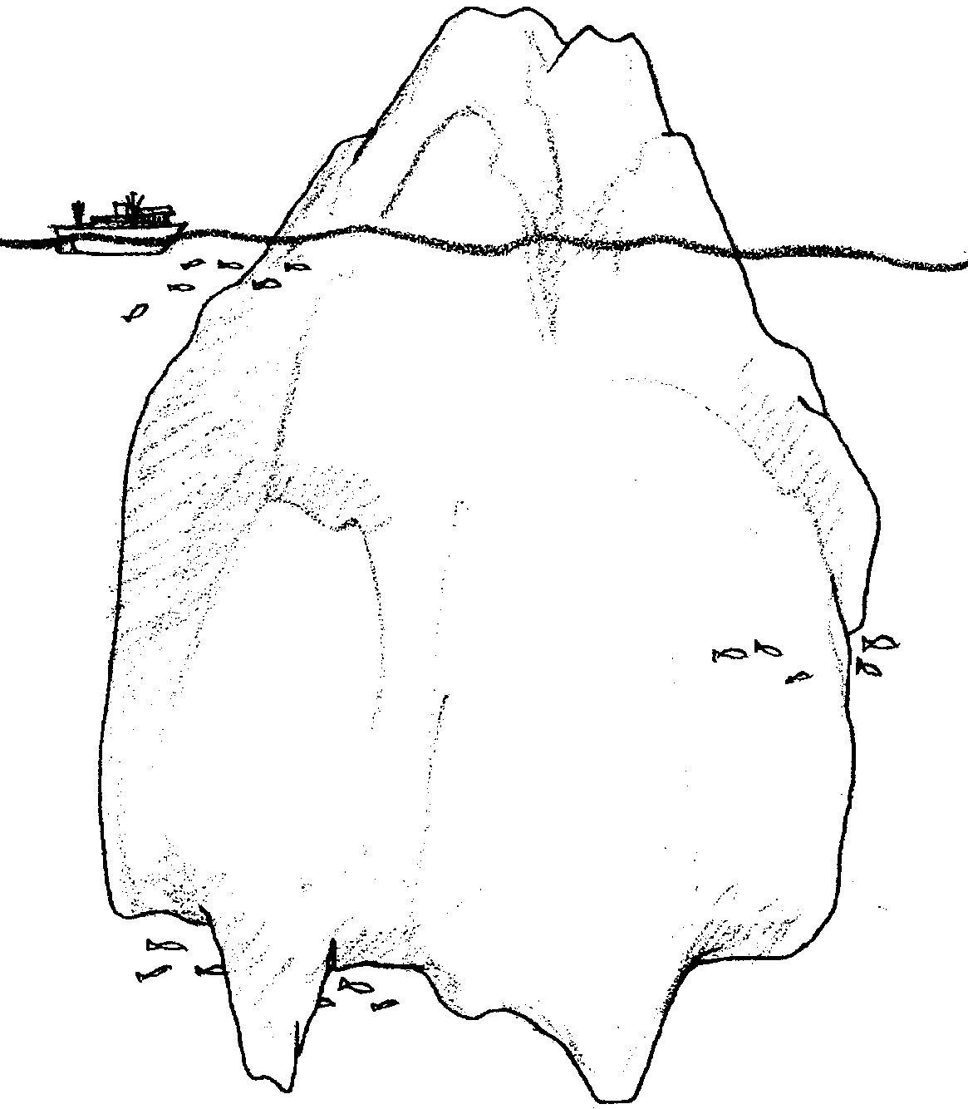
Icebergs

What can we learn about icebergs? Let’s look at icebergs. Icebergs are hard to find. Maybe, we can use ice cubes. You will need these things:

Materials:
two drinking glasses
tap water
ice cubes (2)
salt (2 teaspoons)
spoon to stir
a small piece of masking tape
Here is what to do:

Procedure:
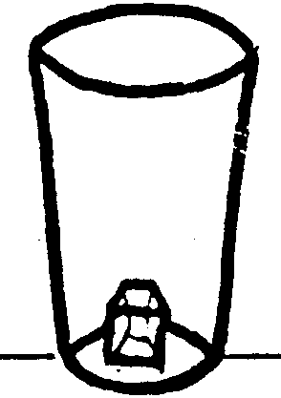
1. Put one ice cube in a glass.

2. Fill the glass with water.
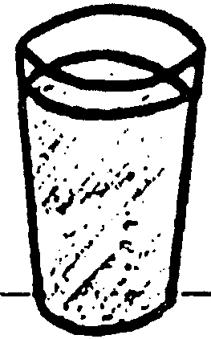

a. Does the ice cube float?

.

b. Is more ice above the water or below the water?

.

c. Draw a picture of the ice cube floating in the water.

d. Icebergs are big ice cubes. In an iceberg, is more ice above or below the water?

.

Real icebergs float in salty seawater. Try your “iceberg” in salt water. First, write what you think will happen.

.

e. Fill the other glass with cold tap water. Add the same amount as the first glass.

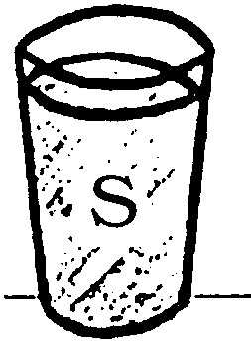
f. Use the tape for a label. Put an “S” on the glass.

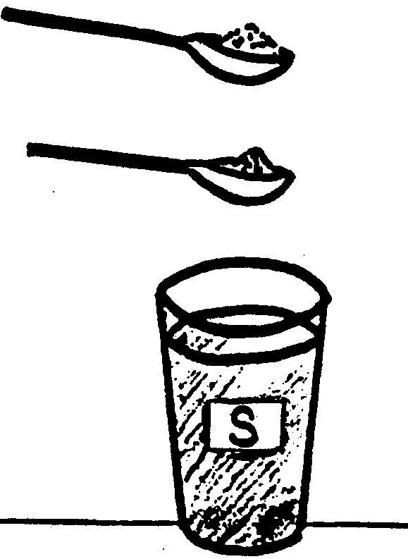
g. Add 2 teaspoons of salt. Stir.

h. Put the ice cube in the saltwater.

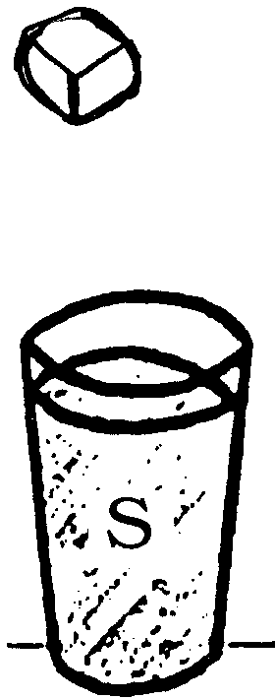

i. Look at the two “icebergs”. Draw what you see.

j. Which “iceberg” floats higher?

.

What else can we learn? Here is what you need:

Materials:
2 drinking glasses
tap water (warm)
ice cubes (2)
paper towel
hammer

Here is what you do:
Procedure:

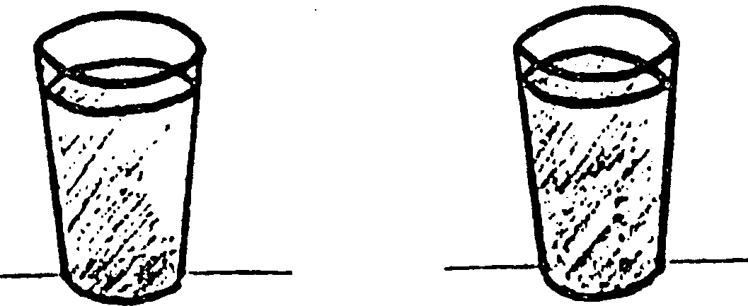
1. Fill the two glasses with warm water.

2. Get two ice cubes. Make sure they are the same size.
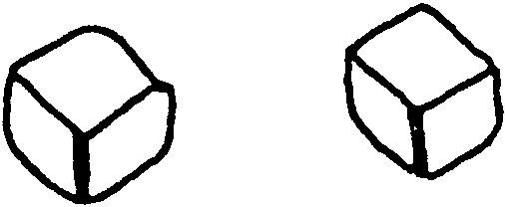
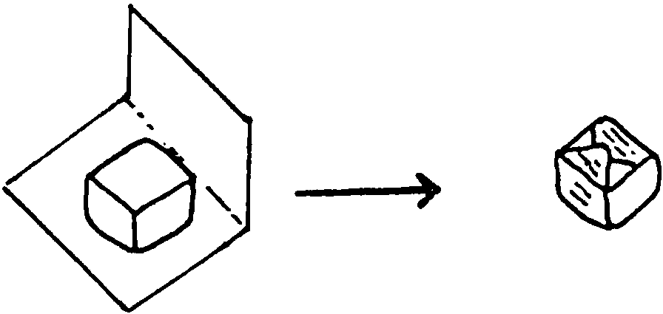
3. Wrap one of the ice cubes in paper.

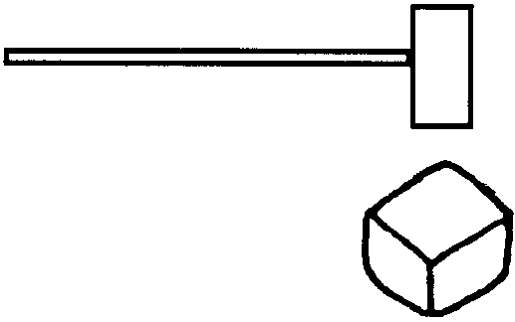
4. Use the hammer to break the ice.

5. Put the pieces of ice in one glass. Put the ice cube in the other glass.
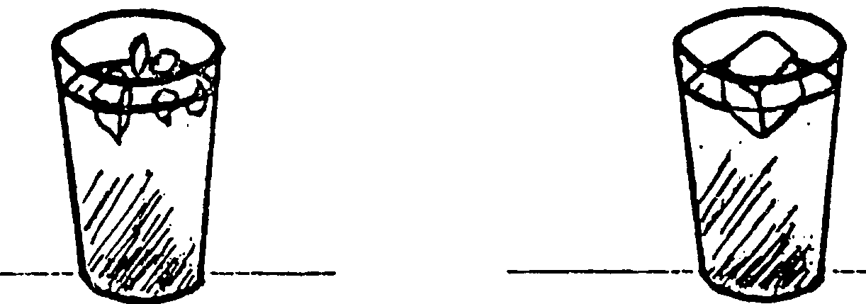

a. Which ice melts first?

.
b. Which ice touches more water?

.

c. How could you make an iceberg melt faster?

.

