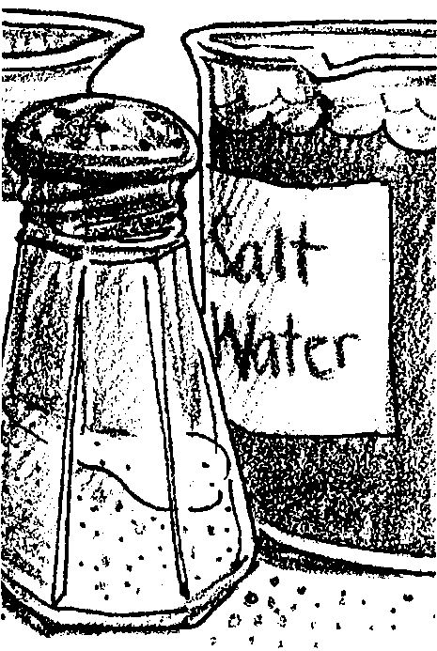
Salt Water

Key Concepts
1. The earth’s oceans are salty.
2. Many things can be dissolved in water.
3. Substances dissolved in water can be retrieved by evaporation.

Background

For billions of years, rains have washed into streams and rivers emptying into the sea. This moving water erodes salts and minerals from rocks and soils. These salts and minerals find their way into the seas. Over time, the concentration of these salts and minerals has increased, creating the salty ocean waters we know today.

Oceanographers measure the water’s salt content, or salinity, in grams of salt per kilogram of sea water (g/kg) which is usually expressed as parts per thousand (‰). Average seawater salinity is approximately 35 grams of salt per thousand grams of water. Salinity values range from nearly zero at river mouths to over 40 parts per thousand in some areas of the Red Sea. Notice the variation of salinity in these bodies of salt water:

Red Sea= 40 ‰
Mediterranean Sea= 38 ‰
“Average” sea water= 35 ‰
Black Sea= 18 ‰
Baltic Sea= 8 ‰

Salinity is altered by processes that add or remove salts or water from the sea. Generally, it is the removal or addition of water, rather than salt, that causes the changes in salinity that we observe. Except in unusual cases, changes due to the addition of salt take a very long time (i.e., tens of thousands of years) to effect. Salinities near shore vary due to the addition of fresh water by rivers and rainfall. Local conditions of temperature and water circulation may also increase or decrease salinity. Salinity also may vary at different depths due to the layering of waters of different densities.

The primary mechanisms of salt and water addition or removal are evaporation, precipitation, river runoff, and the freezing and thawing of sea ice. In spite of the great volumes of water that are moved in these processes, the salinity of sea water in the open oceans is amazingly constant.
As the impact of humans on the global environment increases, it is worth re-emphasizing that water’s unique chemical and physical properties make it a very effective solvent. Almost everything, including pollutants, dissolves in water to some degree. In nature, water usually contains gases and organic compounds, in addition to dissolved minerals. The total of these natural and human-added dissolved and suspended substances affects the properties of ocean water and helps determine the health and survival of marine animals and plants.

Materials

Part One: Tasting Saltwater

For each group of 2 students:

• two clear, plastic drinking glasses

• teaspoon

• table salt, 2 teaspoons

• two drinking straws

• tap water

• masking tape, about 2"

• pie plate, petri dish, or other flat container

Part Two: One Step Further

For the class:

• electric light or heating source (optional, to speed evaporation)

For each group of two students:

• two pans or dishes

Teaching Hints

Underscoring the fact that the world ocean is interconnected, the salinity of sea water in the open oceans is amazingly constant. In “Salt Water”, your students will have the opportunity to experiment with some of the properties of sea water. Stress careful observation and careful procedure for best results. The experiment provides an opportunity to observe apparent changes in matter as the salt dissolves in the water and is later recrystallized.

Use rock, kosher, sea or canning salt which can be found at your supermarket or natural food stores. Regular table salt contains an anti-caking compound that causes the water to become cloudy. Prior to beginning this experiment with your class, dissolve a teaspoonful of your salt in a glass of water to check the clarity of the resulting solution.
Part Two, “One Step Further”, provides for observation of changes in matter as the salt dissolves in the water and is later recrystallized. Clear plastic petri dishes or similar clear containers work well. Aluminum pans also work well; avoid white plastic containers.

Demonstrate how to use a straw as a dropper: Place the straw in the water. Cover the top of the straw with your forefinger. Keep your finger over the top of the straw as you move it to the dish. Lift your finger from the top of the straw to drop the water into the dish.

Duplicate the experiment pages. One set per pair of students is recommended. While students may work alone, pairs or small groups are preferred.

Use caution when you use a lamp for a heat source in the presence of salt water. You may substitute a heater radiator or other heat source if it is more convenient than an electric light.

Plan to take a few minutes to discuss the answers and the basic concepts covered upon completion of the activity.

“More One Step Further....” may be duplicated and sent home as “homework” or you may elect to do it as a class activity. The “Key Words” should be taught if they are unfamiliar to your students.

Key Words

crystals - a body that is formed by the solidification of a chemical element, a compound, or a mixture and has a regularly repeating internal arrangement of its atoms and often external plane faces

dissolve - to separate or disconnect, as when water molecules come between the portions of a salt crystal, separating the parts from one another, and dispersing them within the liquid

evaporation - the process by which a liquid becomes a gas

Answer Key

Part 1

3. The salt disappears (dissolves).

4. Yes, you can taste the salt at the top, in the middle, and on the bottom.

5. a. No, in the unmarked glass you cannot taste salt at the top, in the middle or on the bottom. This glass serves as a control. The salty taste might have come from the glass or from the water, without a control for comparison we could not tell for sure.

b. The water will probably look the same, although some salt has aluminum silicate added to keep it from caking which will make the salt water slightly cloudy.

c. The water in the glasses does not taste the same.

d. The salt makes the difference (everything else was the same).

Part 2: One Step Further . . .

4. There are white spots where the water drops were located.

5. No. The five drops near the “S” will have left a white residue while the other five will have left watermarks or nothing.

6. The spot will taste salty.

7. The salt makes the two types of spots different.

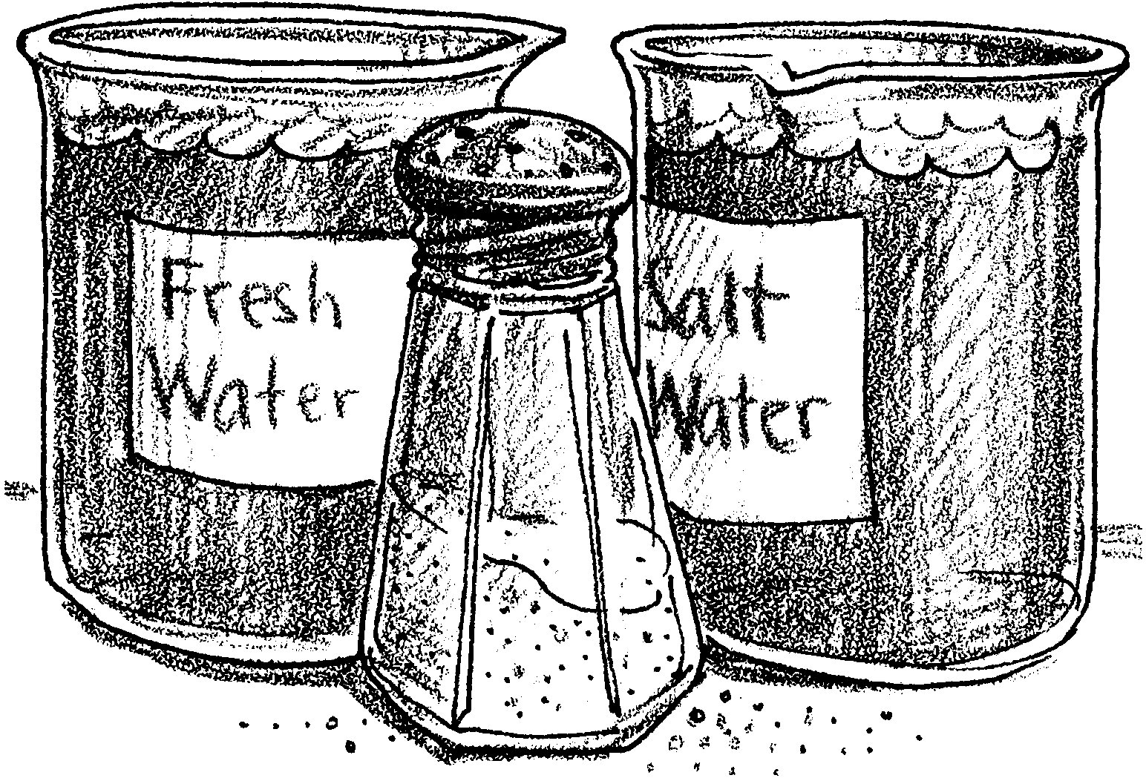
Salt Water

The oceans are full of salt water. Can we make salt water? For this experiment you will need:

Materials:
two clear drinking glasses
teaspoon
table salt
two straws
tap water
masking tape
Here is what to do:
Procedure:
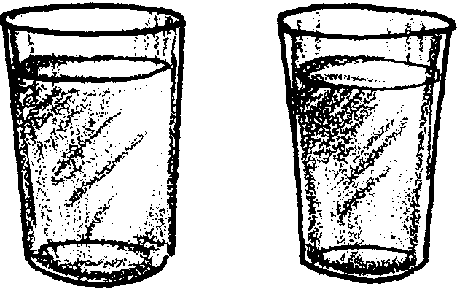
1. Nearly fill the two glasses with tap water. Put the same amount in each glass.

2. Write an “S” on one glass. Use a piece of masking tape.
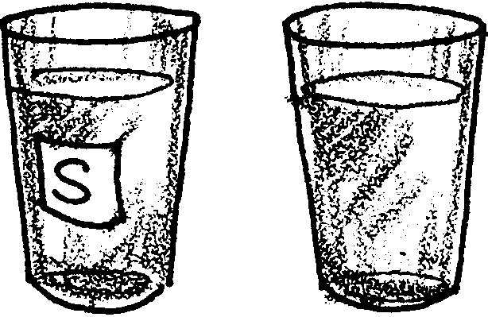

3. Add two teaspoonfuls of salt to the glass with the “S”. Stir it.
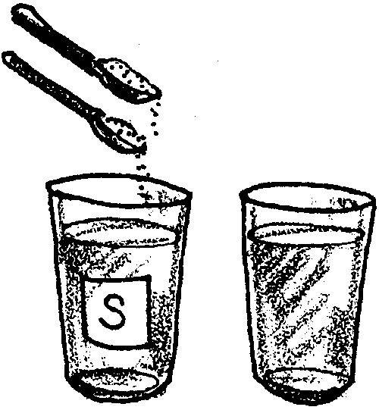

What happens to the salt?

.

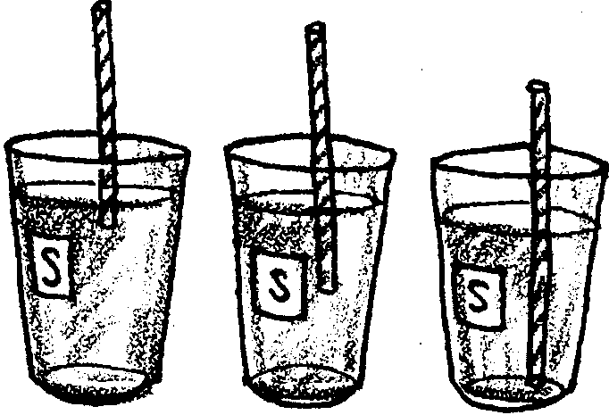
4. Taste the water in the glass with the “S”. Use the straw. Taste it at the top, in the middle, and on the bottom.

a. Can you taste salt at the top? .
in the middle? .
on the bottom? .

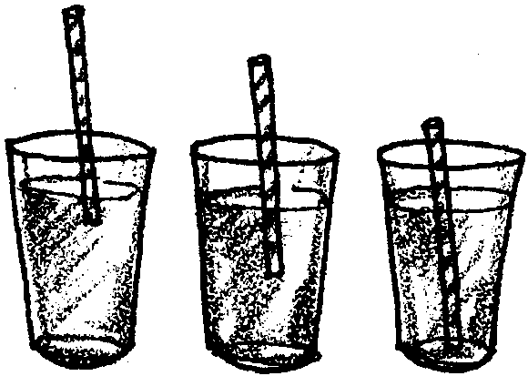
5. Taste the water in the unmarked glass. Use the straw. Taste it at the top, in the middle, and on the bottom.

a. Can you taste salt at the top? .
in the middle? .
on the bottom? .

b. Does the water in the two glasses look the same?

.

c. Does the water in the two glasses taste the same?

.

d. What makes them different?

.
One Step Further......
In our first experiment, we say the salt has dissolved in the water. Can we see the salt again? Try this:

1. Use your straw. Put five drops of salt water from glass “S” on a clean plate. Write an “S” near these drops. Use a piece of masking tape.

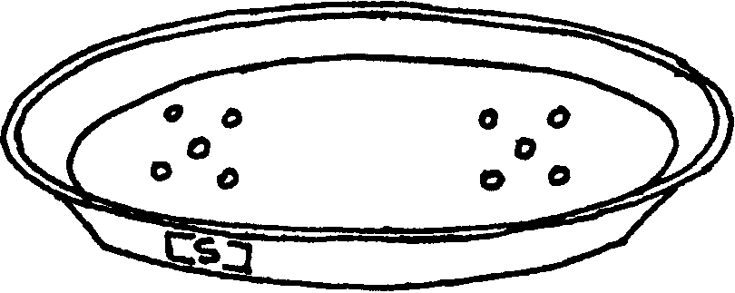
2. Put five drops of plain water from the unmarked glass on the plate.

3. Set the plate under a light or in a warm place.
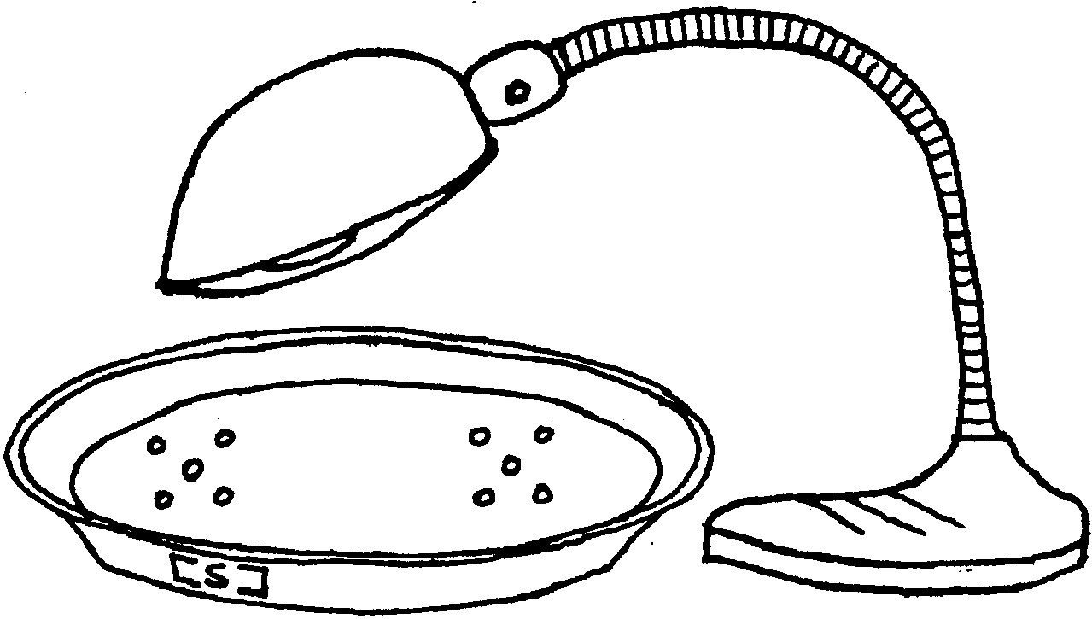

4. Let the water evaporate. What do you see where the drops of water were?

.

5. Are all ten spots the same?

.

6. Lick your finger. Pick up one of the white spots where the water was. How does it taste?

.

7. What makes the spots different?

.
Salty Water – More One Step Further
a take home experiment
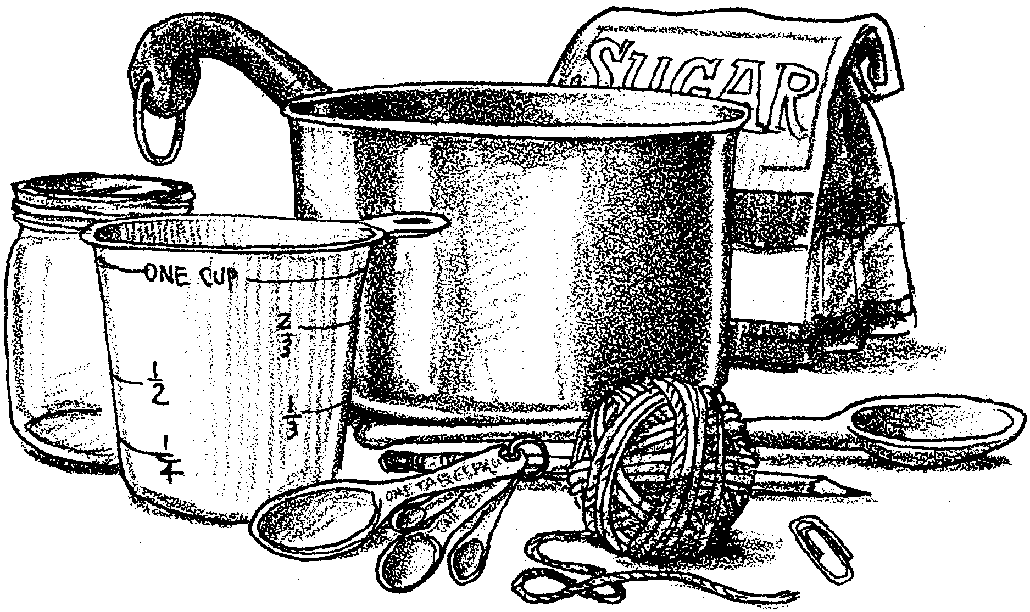

We have experimented with salt dissolving in water. Salt is not the only thing that will dissolve in water. To help your child learn more about dissolving, evaporation, and crystals, try this experiment.

Here is what you will need:

• measuring cup

• water, 1/2 cup

• small saucepan

• tablespoon

• sugar, 1 cup

• wooden spoon

• small glass jar

• piece of string

• pencil

• paper clip

Here is what your child and you do:

1. Put a 1/2 cup of water in the saucepan.

2. Put a tablespoonful of sugar in the water. Stir.

3. WITH ADULT HELP, heat the water slowly.

4. Stir in the rest of the sugar, one tablespoonful at a time, as the water heats.

5. Heat slowly until all of the sugar is dissolved. Keep stirring!

6. Turn up the heat. Heat water to boiling. Boil for one minute while stirring. Remove from heat.

7. Pour the sugar water into the jar. Careful, it is very hot.

8. Tie one end of the string to the paper clip and tie the other end of the string to the pencil.
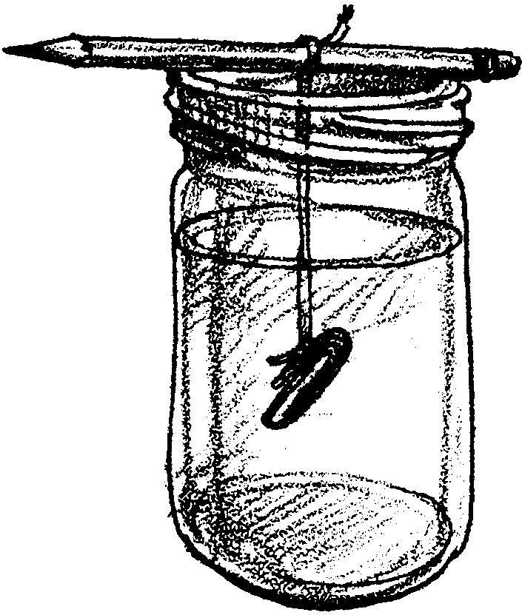
9. Lay the pencil on top of the jar. Hang the string and paper clip in the solution.

10. Put the jar in a cool spot. Do not touch or move the jar for several days. If you let the crystals grow for a long period (over a week) you will get large pieces of rock candy.

11. Remove the candy and observe the shape of the crystal.

12. Can you do the same thing with salt? Try it!

