It's Happening At the Beach
Lesson by Sue Brimhall, Seattle, WA

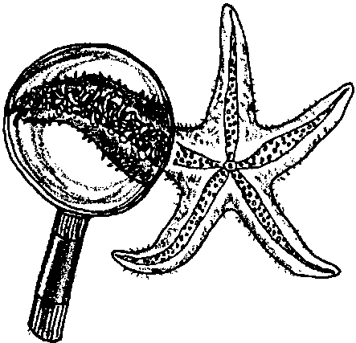
Key Concepts
1. Beach and intertidal areas are unique and fragile environments.
2. Beach and tidepool safety is a must for maximum learning and discovery fun!
3. Learning about intertidal areas promotes an attitude of conservation.

Background

The preceding lesson, “No Place Like Home”, provides critical safety and conservation information. It is very important to discuss these topics before any beach experience.

Getting Started

First, you must decide which beach to visit. If you are lucky enough to have a choice, a rocky shore will probably provide the most varied and abundant life for exploration. Think carefully about the number of students visiting the habitat at once. Minimal impact is important. We can love the beach to death!

Make certain to check the tides when picking a date for your visit. Obviously, a low tide during the time you are at the beach is preferred. Involve students in studying a tide table and analyzing potential dates for a visit.

Recruit adult volunteers to provide a good student-adult ratio. Communicate with students’ parents about the planned trip, stressing proper clothing and foot gear.

It is very important to provide students with the appropriate free exploration time before beginning organized activities. This “mess around” time is critical for students’ interest and motivation for organized activities. The optimum is a short, introductory visit with no or minimal organized activities. An introductory visit could allow for the development of students’ own questions and investigations which can be completed on their next visit to the beach.

Materials

Materials will vary, depending on the nature of the activities planned. Suggestions to consider:

• a first aid kit

• drinking water

• sunscreen

• hand lenses (if possible, each on a separate string, long enough to hang around the neck)

• Discovery scopes or magnifying boxes, if available (see bibliography for source)

• several large pails or plastic containers (A child’s swimming pool works great for careful observation of animals; however, animals must always be returned exactly where they were found.)

• ziplock bags or clear plastic cups (to be used as mini-aquariums for close observation)

• dip nets

• a stake, old broom handle or meter stick (to quantify tidal action)

• a rope or string

• notebooks, clipboard and pencils

• field guides (commercial or students’ own Pagoo Field Guides)

• binoculars

Teaching Hints

“It’s Happening at the Beach” provides a collection of interdisciplinary activities that have been successful with groups of students. We sincerely wish we could credit the originators of these ideas, but tracking the original source is nearly impossible. To all who have contributed these ideas throughout the years, THANKS! Most are very adaptable to other habitats and field sites. Don’t forget the power of choice, allowing students options that address different learning modalities.

Scavenger Hunts

Materials

For the class:

• copies of the scavenger hunt

• clipboards

• garbage bags to collect objects that don’t belong on the beach

Helpful Hints

Scavenger hunts should be created for a particular site if they are animal and plant specific.

Theme oriented hunts can be more generic. For example:

Find something in the intertidal for each letter of the alphabet.

Find an animal that moves using tubefeet.

Find an animal with an operculum.

Find an animal with a radula.

Find three different kinds of seaweed.

Find a piece of algae that has lost its pigment.

Find a holdfast.

Find evidence of predation.

Find evidence of vertebrates in the intertidal.

Find something used to protect the soft body of an invertebrate.

Find something that protects an animal from desiccation.

Find something that does not belong on the beach. (Collect these for removal and disposal at the end of your visit.)

Find four containers that have been manufactured by people.

Theme oriented hunts also lend themselves to many possible answers. It is suggested that an adult or older student accompany each group to check off each item, leaving the organisms right where they are located. To observe the diversity of possible answers for some of the challenges, have students collect the non-living items and share them with the whole group.

Kim’s Game: A Concentration Game

Students observe a collection of found beach objects placed in a grid. Each team is challenged to find the same (or very similar) objects for replication of the grid.

Materials

For the class:

• a master grid containing 16 (or less) relatively common objects found on the beach. It is recommended you do not include living organisms, to model the appropriate handling of organisms in this habitat. Empty shells or other empty body parts are fine.

• grids, each containing 16 sections. One will be the master and each student team will need one. This grid may be created in the sand at the beach. (If you are going to a beach with no sand, draw the grid with a permanent marker on a piece of plastic or tarp, beforehand.)

• an opaque cover for the master grid

• a collection bag or pail for each team as they find objects

• watch or timer

Procedure

1. Before the game begins, the Game Master collects 16 easily found objects from the area. The objects are placed in the master grid unobserved by participants. Cover the master grid.

2. Divide class into teams of about 4 or 5 students.

3. Gather participants around the master grid and give instructions. Explain to students that they will have 2 or 3 minutes to observe and memorize the objects and their location on the grid. Then they will search for the same objects on the beach. Identify each team’s own grid, or a location for them to make their grid in the sand. Stress that the objects must be placed in their grid in exactly the same location as on the master grid. You may place a 15 or 20 minute time limit on the search and placement of objects.

4. Cover the master grid after the designated observation time.

5. One way to evaluate the game is to give 2 points for each correct object placed in its correct position on the grid. One point is earned for a correct object placed in an incorrect position. Points for incorrect objects (similar but not exact) are given at the Game Master’s discretion.

6. This game can continue with the challenge of having students group the objects on their team grid to create a “museum or science center display.”

7. After each team has grouped its objects, gather the entire class at one team board. Have them guess the characteristic by which the objects have been grouped. Once the characteristic is guessed, move the class to the next team’s game board and continue.

Beach Transects

This activity focuses on the distribution of organisms along the beach and reinforces the concept of zonation.

Materials

For the class:

• a rope (about 30 - 40 meters long) marked with a permanent marker at each meter

• clothes hangers with the bottom stretched out to make a diamond shape; need one for each meter or sampling site

• clipboards and pencils for students to record data

• optional - a prepared data sheet

Procedure

1. Choose the area of the beach for the transect and run the transect line from the water’s edge to the high tide mark.

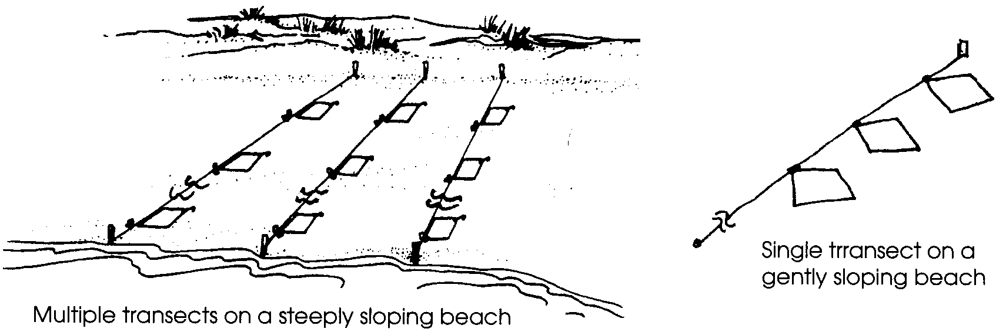
2. Each meter (or every or other meter) can be designated as a sampling site. Place a hanger stretched into a diamond shape at each sampling site to identify the boundaries.

3. Students working in partners are assigned a sampling site (or two) along the transect line. They record the kinds and/or number of animals, plants and any other significant features they find. For each beach zone, students can record census data by indicating how many of the organism were found: none, 1-10, 11-100, or more than 100. Often seaweeds are recorded according to the percentage of the sample site covered by the seaweed (e.g., 50% cover sea lettuce). It may be helpful to provide a data sheet with about 10 common species for the site.

4. The collected data can be summarized on a graph or mapped out on a profile of the beach. Consider returning to a particular beach to conduct a transect at different seasons. The comparison can be very interesting.

For example, Susan Oja and Barbara McMahon of Bainbridge Island, Washington worked with fourth grade students on a year-long project to compare different beaches on the island using the transect method. Enthusiasm for the project caused the beach study to be extended to include a survey of important historical information about each beach studied. The resulting Beach Guide was very informative and useful.

Tide Markers

Vertical - To determine how far out to place a tide marker stake at the beginning of your fieldtrip, think about what the tide will be doing while you are at the beach. If the tide is coming in, you may wish to put your stake near the water’s edge. If it’s going out, you may wish to wade out and put the stake at knee-depth. Push the stake into the sand. Mark where the surface of the water is touching the stake with a rubberband. When the stake is recovered, place a second rubberband at the new water level on the stake. Pull the stake out. The distance between the two rubberbands is the net gain or loss of water during the time the stake was planted.

Horizontal - Begin the fieldtrip by marking the highest point currently reached by the incoming wave wash with two stakes. By the end of the fieldtrip the tide stakes will either be standing above or below the incoming wave wash. Move one of the stakes to the new highest point, in line with the remaining stake. The distance between the two stakes is the horizontal tide change during the fieldtrip. Discuss with students how the slope of the beach can greatly affect these measurements.

Have students write their names in the sand near the water’s edge. Wait 10 minutes or more. What happened to the water in relation to their names?

Tide Pool Clans

Procedure

1. Assign a small group of students or individuals to investigate a “clan” of sea organisms. For example, the chiton clan, the crab clan, the sea star clan, etc.

2. Send students into the tide pools to observe a variety of members of their clan. Encourage students to pay attention to the animal’s observed behaviors and adaptations for staying wet, eating, hanging on (or moving to safety), and protecting themselves. If possible, have students observe their clan members in high and low tide conditions. Observations may be recorded on a data sheet constructed for this purpose beforehand, or on a blank piece of paper on a clipboard.

3. To conclude this activity, have each group pantomime the behaviors and adaptations of their clan. The other students can guess which clan the group observed. You may wish to have two clans join together to dramatize an observed interaction between organisms.

Octopus Race

Idea from Daisy Lee Bitter, Homer, AK

Divide the class into teams of four students. Have each team stand back-to-back with elbows locked. Establish a start/finish line and an obstacle or marker for each “octopus” to run around before returning to the finish line. Then, let the race begin.

Tangled Net (or Web)

Idea from Daisy Lee Bitter, Homer, AK

Divide class into groups of about 6 students. Instruct them to stand in a tight circle formation. Each person will grab a hand of any two different people, excluding the two people immediately adjacent. The hand holding creates the tangled net. The challenge is for each group to untangle the “net” without any person having to let go of the hands they are holding.

Beach Creations

Be aware that most people sincerely want to take something with them from the beach. Make certain you and all the other accompanying adults know the rules regarding collection. There are some beaches where you may take absolutely NOTHING! Remember, even the empty and broken shells, driftwood, etc. are a part of the ecosystem.

To satisfy these cravings, think about projects that have no impact or very minimal impact. As a possibility, recruit one parent whose job it is to video tape every student during the beach experience. You might have a theme video tape. For example, each student could contribute a beach metaphor (e.g., “This seaweed is like a water balloon.”), reading it out-loud on the video tape as he or she points out the seaweed.

Another “very minimal impact” idea is the creation of a giant beach mural. Encourage the use of rocks, driftwood, and the flotsam and jetsam (floating debris) found on the beach. Video tape
(Teaching Hints - cont.)

or photograph the creation for enjoyment after the trip. Let the tide erase the creation.

Other low impact beach creation activities follow:
1. Collages

Collect pieces of driftwood, broken shell or other flotsam to make a collage. Glue the collected items to hard cardboard or a flat piece of driftwood.

2. Sand candles

Dig out a small shape in the sand. Wrap a wick around a stick that is long enough to extend across the top of the hole in the sand. Place the wick in the middle of the shape. Pour melted paraffin wax (if desired, add crayons for color) into the shape. Be very careful melting the paraffin wax; it is very flammable. The outside of the candle, when the wax hardens, will be covered with sand.

3. Sand painting

Draw a simple design lightly on cardboard. Mix glue with an equal amount of water so it spreads easily. Paint a small area with the glue mixture and sprinkle some dry sand on it. Tap and shake off the excess sand. Paint the glue mixture on another area of the design and repeat the procedure. Use food coloring or powdered tempera paints to dye light colored sand. Apply each different color separately, making sure the previous portion is dry.

4. Beach weavings

Use a fallen tree or a low sturdy branch to make a warp-weighted loom. Each person gathers some natural material that will be the weft; that which goes across the warp to make the woven object. If you are taking the weaving away when you leave the beach, weave a few rows with yarn or jute before the seashore weft materials are added.

5. Beach Mobiles

Mobiles can be very effective display pieces. They might be constructed using all driftwood, all dried seaweed, or all pieces of animal shells, etc. Or they might be an aesthetic collection of an assortment of beach debris. This activity may work best if the collecting is done at the beach and the construction of the mobile happens back in the classroom.

Begin with an interesting, relatively thin piece of driftwood or a twig. Tie different lengths of nylon thread or fishing line from it and add the collected pieces to the loose ends of the threads. Some pieces can be glued in place. Make a loop for hanging by tying a long thread to both ends of the wood. Using a trial and error approach, hang the mobile at the balance point.

Additional Interdisciplinary Ideas

1. Tide Pool Analogies

Idea from Gloria Snively, Victoria, BC

Have students sit by a tidepool and create analogies. For example, “Tube feet look like...”. You may give students several beginning statements or allow them to choose their own.

2. Tide Pool Symphony

Each student sits quietly with an ear very close to a rock in the intertidal. The noises are amazing. Have students identify and record the sounds, write a poem, or create another reaction to this sensory experience.

3. Secret Spots

Include a time for students to find their own “secret spot” in the intertidal. “Secret spots” provide a good location for quiet time to focus students for careful observations, creative writing, or reflection.

4. Pick a Pool

Have students find a tide pool and list everything in the pool. Challenge them to find something for every letter of the alphabet.

5. Map a Pool

Idea from The Beach Book by the Western Education Development Group

Pick a tide pool and create a map of the tide pool by measuring the width, depth, and recording the locations of “mountains” and “valleys” in the pool. Name the important landmarks, the tiny, pool “ocean”, the seaweed gardens, and the animal residents and their communities or neighborhoods. Write a touring guide book for the tide pool.

6. Pebbles

Idea from Theresa Peterson, Bainbridge Island, WA

If the beach you are visiting contains an assortment of interesting pebbles, collect a large sampling. Present the pebbles and have each student select a pebble that best represents them. Have them orally discuss why they made the selection they did or write about their selection. This activity can be revealing. Read “pebbles” by Valerie Worth in all the small poems.

7. Holes in the Sand

Investigate holes or patterns in the sand. What makes them?

8. The Temperature of the Beach

Measure the temperature of the dry sediment, wet sediment, air, and water in several different locations. How do the tide pools compare to the ocean water? Are all the tide pools the same temperature? What might account for any differences observed?

9. The Waves Come Crashing

Count the waves per minute crashing against the organisms in the low-tide zone. Approximately how many times an hour, a day, a week, a month, a year do they get slammed by waves?

