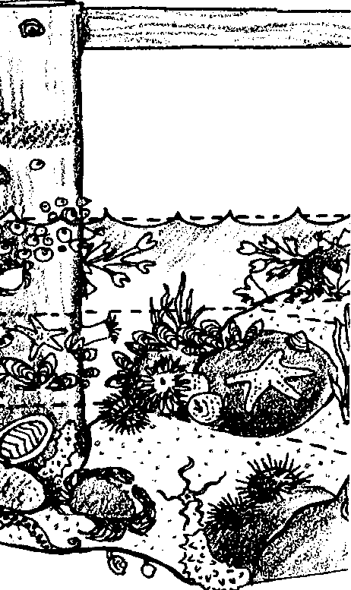
No Place Like Home
Lesson by Sue Brimhall, Seattle, WA

Key Concepts
1. Beach and intertidal areas are unique and fragile environments.
2. Beach safety is a must for maximum learning and discovery fun!
3. Learning about intertidal etiquette promotes an attitude of conservation.

Background

To visit a beach or tide pool with a class is a marvelous adventure - but it also can damage the fragile shore environment! If you do take a class beach-hopping or tidepooling, make sure your impact is minimal and that the students are respectful of the habitat. Provide extensive training for the chaperones, before the fieldtrip, to guarantee a successful learning experience with minimal impact.

Consider alternatives to a whole class field experience. Work with all students in the classroom, motivating, and teaching them about the intertidal habitat. When they are ready, provide information about weekend low tides and encourage students to go with their families beach-hopping or tidepooling. It’s a great PR technique because the students are motivated, highly interested, and knowledgeable.

Beach and Tide pool Safety

Safety issues must be stressed:

• Always face the water! One never knows when a large wave might catch you off guard.

• Be aware of the tides! Be aware of what the water is doing on the beach. Don’t get stranded in an incoming tide.

• Wear sturdy shoes! Shoes will prevent your feet from being cut by sharp shells, barnacles and the pieces of glass found on beaches.

• Watch your step! Algae covered rocks are extremely slippery, making it easy to lose one’s footing.

Tide pool Conservation

Intertidal areas are full of animals and plants that have adapted to unique and changing conditions. Unless we are careful, we can wipe out entire areas of organisms, quickly exposing previously well-adapted creatures to the elements and enemies.

Teaching our students about the life forms and ecology of the intertidal environment is the basis for establishing an attitude of respect for the environment. Dioum’s words express it eloquently:

In the end, we will conserve only what we love.
We will love only what we understand.
We will understand only what we are taught.

B. Dioum

Guidelines for conserving the intertidal areas:

• Replace rocks in their original positions. To avoid crushing animals, set the animals next to the hole left by the disturbed rock. Return the rock to its original position. Place the animals right next to the rock and allow them to move under the rock on their own.

• Gently and carefully handle all marine life. It is even better with the most fragile animals to just observe, without handling the animals.

• Always leave a “handled” animal protected from predators, the sun and air. Cover them with seaweed or put them back exactly where you found them.

• Walk on rocks and sand as much as possible; avoid walking on animals and plants.

• Avoid moving animals from one location to another. They should remain where you found them as that is the habitat for which they are best suited.

• Pack out all litter. Please pick up any litter left by others.

• TAKE ONLY PICTURES, LEAVE ONLY FOOTPRINTS! Empty shells are homes for intertidal animals. In addition, their breakdown provides needed minerals to the water and adds to the accumulating sands. Resist temptation - leave the shells on the beach.

Teaching Hints

In “No Place Like Home”, students investigate proper tide pool etiquette through activities and scenarios. Begin by asking your students for their ideas about beach and tide pool safety and conservation. If they have been to a beach with tide pools, they are likely to know some of the tips. Once their list of safety and conservation tips is recorded, add to and amend their ideas. Make sure the students understand the reasoning for the rules. After a thorough discussion, read aloud each scenario on the evaluation worksheet found at the end of this teacher background section. Have students respond with the related safety rule.

These activities reinforce the conservation rules:

1. Musical Chairs

To get across the concept of loss of habitat, play “Musical Chairs”. The “habitat” for each child is the chair. Once it is taken away, that child has lost his/her home. After the game is over discuss what it felt like to lose their “habitat”. Ask questions like:

How did it feel to be on the alert at every second to keep a “habitat” in view?

How did it feel to attempt to slide into a “habitat” only to have it abruptly taken away?

What things might a tide pool animal do when its habitat is removed?

Do you think a tide pool animal spends energy defending her/his habitat? Explain.

2. Litter It Up

For students to get the feeling of their habitat being inundated with litter, have a little fun. Collect “clean” garbage until you have enough to sufficiently garnish their desks with it. In a shared area, like the sink, spread out enough garbage or debris to interfere with the use of the area so that students are unable to use it without moving the obstacles.

Discuss how they felt and what different behavior they had to resort to because of the litter. Ask questions like:

Did you have to expend energy to avoid or get rid of litter?

How did having litter on your desk make you feel?

Was it difficult to sharpen your pencil because of the garbage piled up?

What type of litter would have been dangerous?

Is litter in the intertidal always harmful? Explain.

Have the students name an item of litter and see if the class can come up with ways the item could be either useful or harmful. Have someone tally the harmful and useful reasons. Compare the results.

3. Mix It Up

The confusion, bewilderment and panic a beach or tide pool creature feels when removed and placed in another part of its habitat can be experienced in this game. Consider carefully if your class can handle and cope with the problems and confusion this game can cause. You may choose to paint the scenario with vivid descriptions and simply discuss what it might have felt like.

The “game” involves the teacher rearranging desks, chairs, books, coats, etc. Rearrange only what you think your students can handle. Do this rearranging before school or at a recess or lunch time so that the students are unaware of the changes until they return. When the students come into class they will get the feeling of being in the right place but totally confused. Let them try to settle things on their own for a few minutes so they can absorb the chaos. Then discuss questions like:

What was different when you came in?

How did this affect your behavior?

Can you explain how you felt when you discovered your desk was not where it was supposed to be?

When might a tide pool animal feel this way?

Do you think this feeling would add stress to the animal’s life?

Do you think this occurrence takes more energy than usual to go about solving the problem? Explain.

How might this stress and increased energy use be avoided?

How can you prevent this from happening to animals in the intertidal environment?

Extensions

1. Have students create their own scenarios about broken safety or conservation rules.

2. As a class, create your own tide pool or intertidal field guide to take to the beach. Make one booklet for each group of students to carry during their beach exploration. A ziplock bag or a waterproof cover may help protect the guides when in use at the beach.

Discuss what kind of information will be useful to include in the field guide. For example, identify an animal’s feeding behavior as: filter feeder, grazer and scraper, predator, or scavenger. Don’t forget to include the seaweeds.

You can be very helpful in the choice of organisms to include in the field guide if you have some familiarity with the beach students will be visiting. Consider a pre-trip visit with a video camera to tape footage of the dominant seaweeds and animals for student reference to create their field guide.

Consider the variety of ways to organize the field guide: by organisms that share similarities (phyla), by zones, etc.

Beach Zone Definitions

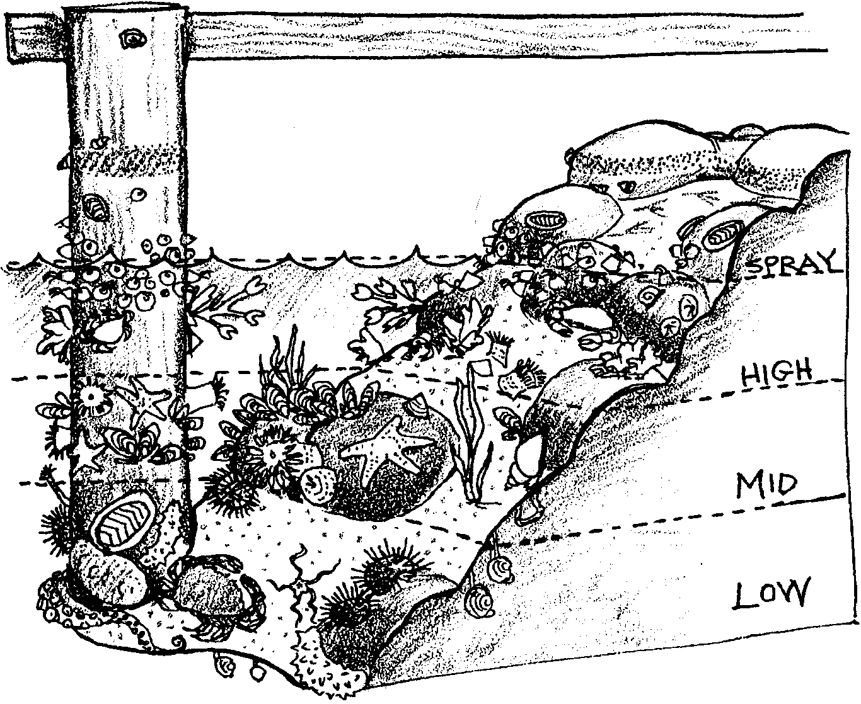
As a prelude to the field trip, you may wish to present students with a list of organisms that are likely to be found at the site they will visit. Have them predict in which zone they think the organism will occur. When they visit the beach, students can then compare their predictions to their observations of the animals. An outline of beach zones follows:

Spray or splash zone - almost completely dry, receiving spray only from storm winds and very high tides. Extends down to about the average of all high tides.

High-Tide zone - only covered with water at very high tide. This is the home of animals accustomed to tolerating more air than water.

Mid-Tide zone - typically covered twice each day and uncovered twice each day. This is the true intertidal zone. Animals in this zone are accustomed to exposure to both air and water.

Low-Tide zone - always covered by water except for a few hours each month. Animals here are accustomed to tolerating more water than air.

Units 2 and 7 in Pagoo, FOR SEA: Investigating Marine Science - Grade 5 provide additional detailed information on beach zonation.

3. Have students make a sign.
• Design a sign to encourage people to follow one of the conservation rules.
• Be sure it is easy to read and understand. (If it “catches” people’s attention, they will take the time to read it.)
• Describe the place where you plan to put the sign. (Remember, you want visitors to the tide pool area to see it.)
• Make the sign and post it. (Be sure you have the permission of the land owner.)

4. Have students start a club.
• Create a club to help protect tide pool creatures and their environment.
• Pick a name for your club.
• Decide how your club can help to enforce the conservation rules at the beach.

5. Have students send a message.
• Write a poem, rap or song including the conservation rules. Make it catchy so people will remember the rules.

6. Have students make a collage.
• Chief Seattle, a Suquamish Indian, said the following.

“Whatever befalls the earth befalls the sons of the earth. If men spit upon the ground, they spit upon themselves. Man did not weave the web of life; he is merely a strand in it. Whatever he does to the web, he does to himself...”

Ask: What do you think he was trying to tell people? Have students express their thoughts about his message by making a collage.
No Place Like Home

Beach and Tide Pool Safety and Conservation Rules Scenarios
Procedure

As an evaluation tool and to reinforce learning, read each scenario aloud, then have students answer the question which follows the scenario.

1. Angela was lying down next to a sparkling tide pool. She was watching a hermit crab lug a piece of meat from one end of the pool to the other. It was fascinating. Suddenly, an incoming wave drenched her from head to toe. What safety rule did Angela forget to follow?

(Be aware of the tides and/or face the water.)

2. Peter had never seen such exciting animals at the beach before. The farther out on the rocks he went, the more unusual animals he saw. Oops! He slipped on some rockweed! Poor Peter landed hands down in a clump of barnacles! Ouch! Those barnacles can really cut! What safety rule did Peter, in his excitement, forget to follow?

(Watch your step.)

3. Laura loved shells. In fact, she had a large shell collection at home. Wow, this beach had tons of beautiful whole shells! Laura quickly set about collecting the prettiest ones. She was so excited! Maybe too excited. She completely forgot to see if the shell was vacant or not. What a surprise! Several of her finds were hermit crabs and whelks, closed up or tucked inside awaiting the high tide.

a. What will happen to the hermit crabs and whelks?

(They will die if removed from their habitat for an extended period of time.)

b. What two conservation rules did Laura break?

(The rules broken: avoid moving animals, take only pictures.)

4. Bob and Luke were having a contest. Each was trying to see how many shore crabs he could find. Under the rocks, the crabs were waiting for the tide and night to appear. Bob and Luke ran from rock to rock, turning the rocks over as they went. They did not take the time to return the rocks. What conservation rule should Bob and Luke learn and follow?

(Replace rocks.)

5. It is best to wear shoes with good soles when tidepooling. Why wear shoes rather than go barefoot?

(Shoes are a good idea when tidepooling because of sharp objects like broken shells, barnacles and pieces of glass that can easily cut barefeet.)

6. It’s fun to look at animals. Afterwards, they should be returned to the same spot. What could happen if you move an animal to another place?

(It may not be able to adapt to the new location. It might at the least cause stress for the creature.)

7. Lots of people go to ocean beach. What might happen if they all left their litter behind?

(Litter on the beach could: injure animals (ingestion or entanglement), take up limited space for animals, deposit harmful chemicals and metals into the water, etc.)

8. At the beach, it’s important to always face the water. Why should you never turn your back to the water?

(Always face the water so that you are not caught by a big wave sometimes called a “sneaker” wave.)

9.a. Do you think it is important to respect the intertidal areas?

(Answers will vary.)

b. Do you think it is important to handle the life there with care?

(Answers will vary.)

c. Please explain your answers.

(Answers will vary.)

10. Oh, no! You see someone breaking the rules of safety and conservation.

a. What would you do if the person was one of your friends?

(Answers will vary.)

b. What if the person was a relative?

(Answers will vary.)

c. What if the person was a stranger?

(Answers will vary.)

