Beach Treasures
Written by Laurie Dumdie, Marine Science Center, Poulsbo, WA

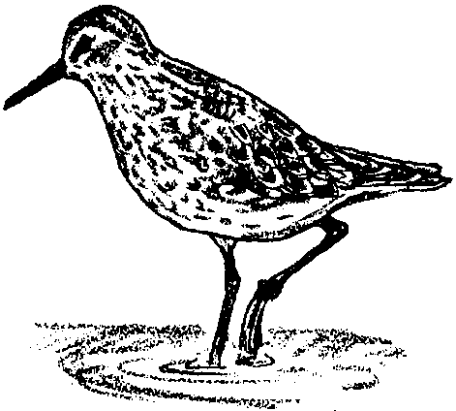
Key Concepts
1. A wide variety of living and non-living materials may be found on ocean beaches.
2. A variety of approaches may be used to categorize and sort a group of items.

Background

Every beach is an unsolved mystery. How does the ocean’s action shape the beach? Where did the material on the beach come from? How far was it transported before it was deposited on this beach? Careful sleuthing provides answers to these and other questions.

Beaches are not permanent features of a shoreline. For example, the profile of a sandy beach changes on a regular basis. The most dramatic changes occur between summer and winter. Smaller summer waves, tend to push sand up the beach. Winter waves, bigger and further apart, tend to remove sand from the beach.

Although it sometimes takes careful examination to locate beach organisms, beaches support a wide variety of animal and plant life. Signs of human life are also common on our beaches, as, unfortunately, many of the waste products of human societies end up there.

Materials

For the class:

• treasure chest of beach objects (at least 32)

• large loops (3)

• butcher paper and marker

For each student

• “Beach Thoughts” activity sheet

Teaching Hints

“Beach Treasures” narrows the focus from the world ocean to an individual beach. Students discuss what they know about beaches and what they want to know about beaches. Then, they observe objects from a particular beach. Finally, they sort and classify beach objects.

If you are fortunate to be located near a beach (ocean, or otherwise), consider a trip to the beach. The items utilized in this activity may be gathered by the class and the activity completed at the beach or, alternatively, back in the classroom. General beach field trip etiquette and guidelines are provided in the next two activities adapted from Pagoo, FOR SEA: Investigating Marine Science - Grade 5.

Procedures

1. Explain that this unit of study focuses on a single beach. Ask how many of the students have visited a local, saltwater beach. Discuss the different kinds of beaches students have visited, including ocean beaches, beaches at a lake or river, etc. Ask students what they know about beaches. Record their responses on a piece of newsprint. Save the list to evaluate changes in student knowledge at the end of the unit.

2. Present to students a treasure chest of assorted beach objects. Explain that all the objects were found on specific beach. Reassure them the chest contains enough objects for each student to participate.

3. Before distributing the objects to students, it may be helpful to gather students in a circle on the floor. Distribute an object to each student for exploration.

4. When most students seem ready, have each student pass his or her object to the person sitting to the right. Establish a set period of time (one or two minutes) for observation of this new object. Continue this procedure for as long as is appropriate.

5. Have students place all the beach objects in the middle of the circle. Begin a discussion about the objects, leading to questions that will help students begin grouping the objects. Help students establish a system for sorting and classifying the objects. One approach for sorting the objects is to identify a single characteristic and sort out the objects possessing that characteristic from all the other objects that do not have that characteristic. For example:

• objects that came from animals / objects that did not come from animals

• objects that are shells / objects that are not shells

• objects that have holes / objects that have no holes

• objects that are brown / objects that are not brown
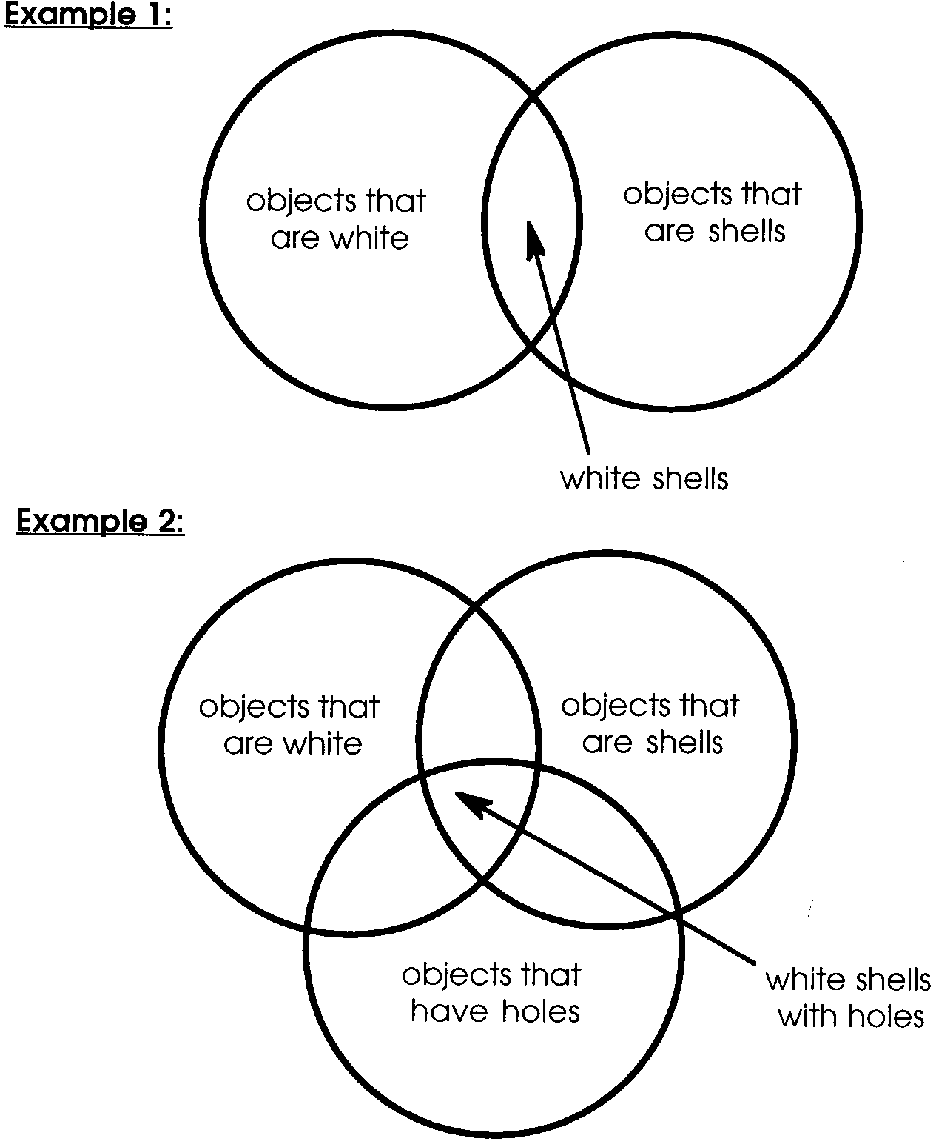
Hula hoops or large loops of strings might be useful for hierarchical classification using Venn Diagrams. For example:

6. Return beach objects to the treasure chest. Ask students what questions they have about the beach. List these questions for easy reference throughout the unit.

Key Word

beach - the materials on a shore of a body of water and which are transported by moving water either along the shore or off and on the shore
Extensions

1. Consider integrating these activities into your language arts instruction. For example, have students write, draw or tell a story about a trip they have made to the beach. Be sure they include any exciting discoveries.

2. Ask students to bring a beach treasure from home to share with the class.

3. Use the student sheet, “Beach Thoughts” to challenge students to think about the use of various senses at the beach.

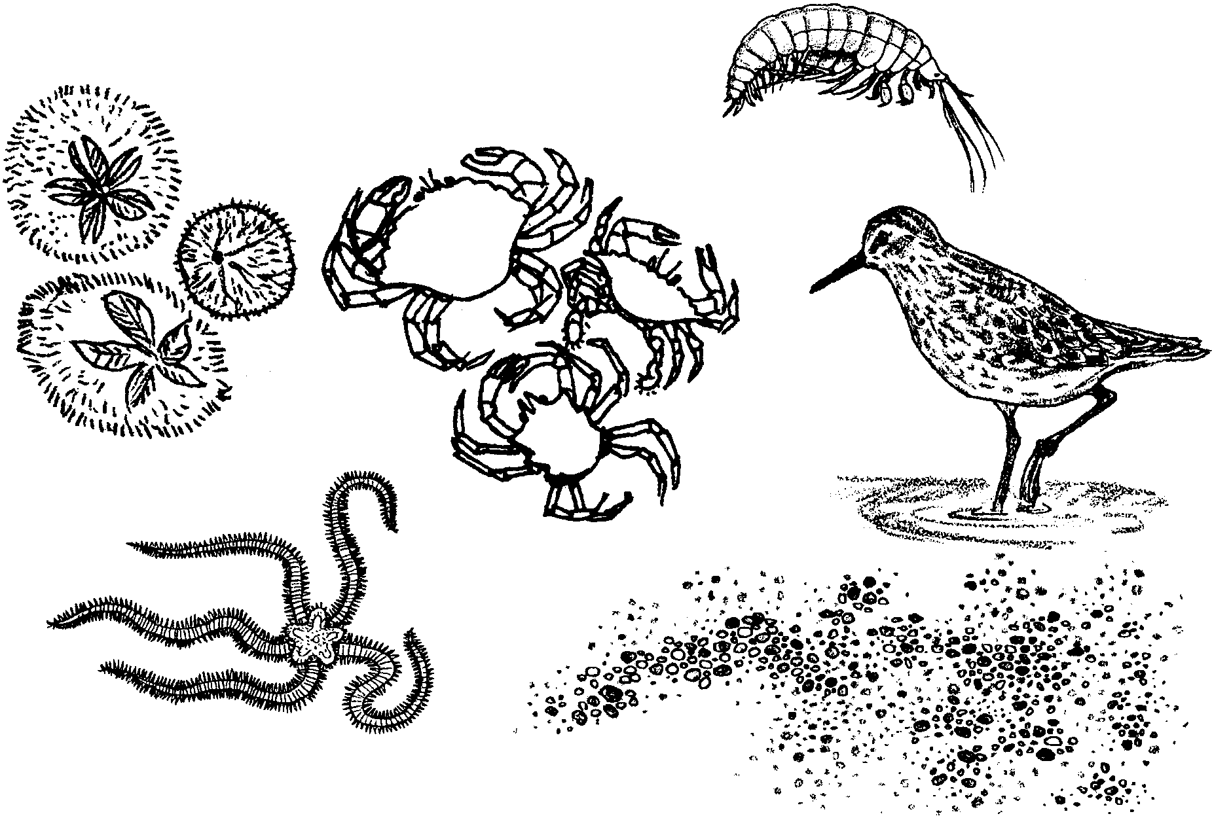
Beach Treasures
Beach Thoughts

Think of the sights, sounds and smells at the beach. Write about them.

Sights I’d See

Sounds I’d Hear

Smells I’d Smell

Look at the words listed above. Use them to write several sentences, a poem or a song about the beach.

