The World Ocean
Lesson by Pat Williams, Eugene, OR

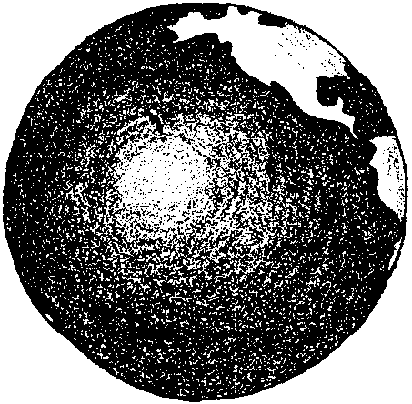
Key Concepts
1. Nearly three-fourths of the earth’s surface is covered by the oceans.
2. The oceans of the world are really one interconnected ocean.

Background

The World Ocean
cc
Ocean water covers 71%, almost three-quarters, of the earth’s surface. Throughout its vast extent, the ocean exhibits a great diversity in depth, temperature, currents, and other physical characteristics. The ocean also exhibits an abundance of life. It is clear that life in the ocean is influenced by these physical factors. Not always as obvious, the plants and animals influence the physical characteristics of the oceans. For example, the oxygen we find dissolved in sea water is a product of marine plants. The relationships between the living and non-living environments of the sea are a wondrous and complex delight.

Although maps name and identify different oceans, the ocean is really one interconnected body of water. The largest of the four major named oceans is the Pacific (50% of the world ocean), followed in descending order by the Atlantic (30%), the Indian and the Arctic. Oceanographers view the world ocean as three fingers (the Atlantic, Pacific and Indian oceans) extending from a common source around Antarctica.

Formation of the Oceans

No one is quite sure how the oceans formed. The question of how the earth got its ocean has long intrigued humans. Throughout history, different cultures have tried to answer this question in different ways. Today, scientists are using new tools and research methods to gather clues that are helping them to create a new “story” of how earth got its ocean. Information comes from a wide variety of sources: from the ocean floor, the surface of the moon, and distant space.

Enough clues have been found to begin to piece together a reasonable story of how earth got its ocean. Evidence from the Earth’s rocks indicates that the earth was formed more than four billion years ago, and that, early on, the earth was molten rock. Steam and gasses escaping from these molten rocks formed clouds around the earth. The clouds eventually turned into rain. The rain continued for millions of years, filling the basins of the planet and forming the world ocean. Today, 97% of the earth’s water is found in the ocean. (Of the remaining water, ice and glaciers comprise 2% and a scant 1% of all the earth’s water is the liquid fresh water so critical for human life.)

Since rain water is fresh, why isn’t the ocean freshwater? Over the eons, moving water eroded minerals from the earth and deposited them in the ocean. These mineral salts remained behind, slowly concentrating, as water evaporated to form rain clouds.

While this presents an encapsulated version of current scientific thought, bear in mind that as new information is collected, our theories of how the earth got its ocean will be revised. Additional information regarding present theories of how the oceans formed may be found in Ocean Studies, Ocean Issues, FOR SEA Grade 8 activities entitled “How The Earth Got Its Ocean”, “Water, Water Everywhere”, and “A Pinch of Salt”.

Materials

For each pair or group of students:

• globe (inflatable globes are inexpensive and readily available in toy stores)

• construction paper “flags” approximately 3" long (5 per group)

• toothpicks (5 per group)

• glue

• modeling clay (a small round ball per group)

For each student:

• “World Ocean” student worksheet, and “Oceans” reading

Teaching Hints

“World Ocean” introduces your students to the marine environment through a look at the interconnected nature of the world’s oceans using globes and maps. While this activity emphasizes the extent of the ocean, other activities in this section focus on the properties of ocean water and the characteristics of the ocean surface. The investigations provide many opportunities to emphasize the relationships between living things and their non-living environment. Start this unit with enthusiasm - it’s contagious.

This activity works best if each pair of students has a globe for observation.
Demonstration and discussion

1. Begin by showing a world globe and asking what it represents. Discuss what is shown on the globe (land, oceans, etc.). Help students find their location on the globe. Ask questions like:

“Do you think there is more land or ocean on the earth’s surface?”
(Rotate the globe so they see the view from Antarctica. Continents and oceans are not distributed uniformly over the earth. The Northern Hemisphere contains most of the land and the Southern Hemisphere is mainly water.)

“Which ocean do we live closest to?”

2. Ask if they know the names of some of the earth’s oceans. List their responses for later reference.

Labelling oceans on globes

1. Demonstrate how to make a construction paper flag using glue and a toothpick.
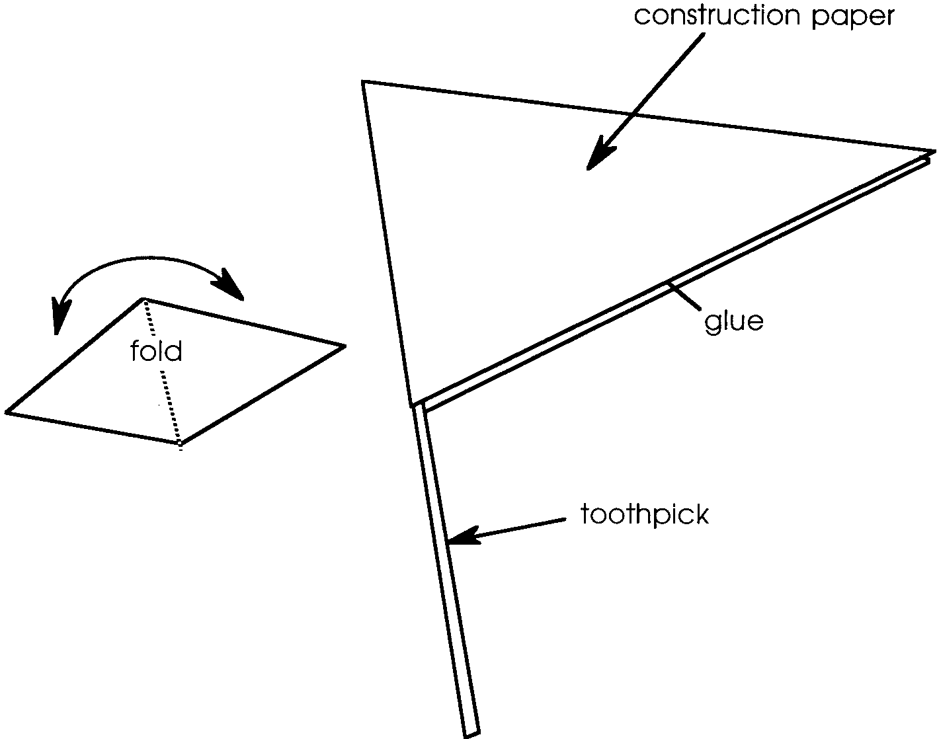

2. Distribute the paper, glue, and toothpicks to each team and have them make a label for these five oceans:

Pacific, Arctic, Atlantic, Indian, and Southern (Antarctic).

3. When the flags have dried, distribute globes. Have students locate each of the five oceans on the globe and put a lump of clay on each ocean (check for accuracy). Have them place the correct flag label on each ocean.

4. Ask the children if they think it is possible to travel around the world without touching land. Have each group test their answer by using a finger to trace a path on the water from flag 1 to 2 to 3 to 4 and back to 1 without crossing land.

Explain that although the different areas of ocean have different names, they’re all connected and really form one big ocean. Relate it to our own bodies; just as we have different parts with different names (arm, leg, head, etc.), each of us has only one body.

5. Review students’ findings. Discuss, restate, and record a general statement like: “The earth has one big ocean and it covers most of the world.”

6. Review concepts with the student worksheet, “World Ocean” and the “Oceans” reading.

Key Words

globe - a spherical representation of the earth

world ocean - the whole body of saltwater that covers nearly three fourths of the surface of the Earth

Extensions

1. Sing along to the tune of “My Bonnie Lies Over the Ocean.”

The Earth is all covered with ocean.
The Earth is all covered with sea.
The Earth is all covered with ocean.
More water than land, don’t you see?

Chorus:
Water, water, there’s water all over
the world, the world
Water, water, there’s water all over
the world.
So salty and cold is the ocean.
So salty and cold is the sea.
So salty and cold is the ocean.
Too cold and too salty for me.

Repeat chorus.

Atlantic, Pacific, and Arctic,
And then there’s the Indian, too.
These oceans all cover our planet.
I named all of them, now can you?

Repeat chorus.

Song used with permission from Naturescope- Diving Into Oceans, Vol. 4, #2.

2. Have students complete the following open ended poem:

Ocean, motion
I’ve got a notion.
I’m going off to sea,
Ocean, motion
I’ve got a notion.
I’m going off to see .

3. This section, like all of the others, contains a list of “Key Words”. These are words which may be unfamiliar to your students. Be aware of these words as you progress. The words are defined, directly or by context, in the text. Science, in general, tends to be heavy in new vocabulary. Marine science is no exception. Many of the activities included in the following sections are designed to reinforce new vocabulary. Reading comprehension depends upon vocabulary development. Eldon E. Ekwall, has some recommendations.* Writing about vocabulary development he states:

Before students can be expected to comprehend adequately, they must develop a vocabulary sufficient to deal with words on the level on which they are expected to read.

A. Whenever new words come up in lessons, stop and discuss them in sufficient detail so that all students develop a concept of their meaning.

B. Appoint a “vocabulary committee” to preview each new lesson prior to class reading to select all words for which they do not know the meaning. Use these words as a guide to the new vocabulary along with the new vocabulary given in the textbook.

C. Develop picture files for each unit in the students’ textbook. Use the pictures to develop the meaning of new words and concepts. These pictures may be placed on a bulletin board or simply shown and discussed as each new unit is introduced.

D. Place pictures on the bulletin board and have students try to find as many words as possible to describe the pictures. If students are able to use a thesaurus, allow them to do so. Place the words under the picture and discuss them every so often.

E. Develop “word awareness” by showing students how often we tend to skip over words for which we do not know the meaning. Promote awareness of new words by getting students to look for new words that they or other students may not know the meaning of. Write the new word the student found beside it.
Carlos’ new word - idealism
Frank’s new word - afterthought

F. Encourage students to use “vocabulary cards”. As students read assignments or any other reading material have them search for new words. When a new word is found, have them write it on a vocabulary card. Then have them write it in the sentence in which it was used and underline the word. Encourage use of meaning context. After they complete their reading, have them look the new word up in the dictionary and write its meaning. Then file the new vocabulary cards in a shoe box and review them periodically.

The amount of vocabulary drill necessary depends upon the particular class. In addition to the activities incorporated into the unit you might want to use one or more of the following ideas to develop vocabulary skills in the marine science area. Vocabulary Activities:

CATCH

Words are printed on the chalkboard or on a chart. The teacher throws a ball to a child who pronounces the first word in the list. If the child can read the word, he throws the ball back to the teacher. If he cannot read it, he passes the ball to the next child, who says the word if he can.

TRAVELING

Word cards are prepared from words in the reading section. These may be placed inside a box which is to represent a trunk or luggage. The first child takes a card and says, “I am going on a trip and I will take ......” (word on card). She places the word card on the board ledge. The next child draws a card and says, “I am going on a trip and I will take” (word on card) “and” (word previously drawn). The others take their turn.

HOME BUILDER

A house with an incomplete roof is drawn. Cards are made to represent the shingles. A word is written on each shingle. The child reads the word and puts it on the house. If the picture of the house is tacked onto a bulletin board, the shingles may be stuck on with pins or thumbtacks. If this is not possible, small pieces of scotch tape may be used. The house may be outlined for bricks in a similar way.

BALLOONS

A clown picture is drawn on the board or on paper. Draw an equal number of balloons on each side on the clown. Print a word on each balloon. A set of colored circles represents the balloons. There should be the same number of circles as balloons. On each circle a word which corresponds to a word on one of the balloons is printed. To play the game, shuffle the circles and take turns reading the words on their circles. When a word is read correctly, the circle is placed over the balloon with the same word. They may be fastened with plastic tape. Each player tries to cover balloons on his side of the clown first. If a player gets a word not contained in the balloons on her side, she must put it on the other side. The player wins when her balloons are covered.

KEEPS

Words from the reading are on cards. One child holds the cards in front of the class, showing one card at a time. He designates which child is to pronounce the word. If that child can say the word, he takes the card.

BASEBALL

Word cards with one word printed on each are shuffled. Divide students into two teams. A scoreboard is made to record the number of runs. A baseball diamond is drawn on paper, on the board, or on the floor. Markers are needed if the game is played on paper or the board. A spinner numbered O - 4 is used. One child from each team spins to decide which team is up first. Highest number goes first. Each team member in turn spins the spinner and draws the number of cards indicated by the spinner. If the player spins a 3, she draws 3 cards. If the player can successfully read all three cards, she moves to third base. If the player can only read one of the three cards, she moves to first base. If the player spins a O, it is an out. Three outs and the other team is up. If a player advances to a base already occupied, the player already on the base automatically advances to the next base.

FOOTBALL

A football field is made of cardboard. Words are printed on cards. The ball is placed on the 50 yard line. The first player reads the word on the first card. If he reads the word correctly, he goes back ten yards. When a child crosses the opposite goal line, his score is 6. If he reads the next word correctly, he adds the one extra point to his score.

PLAYING CARDS

Words are printed on 2 x 3 inch cards which are placed face down on the table. The children take turns drawing cards. When a player takes a card, she reads the word printed on it. If she reads it correctly, she keeps the card in front of her. If she cannot read it, she returns the card, face down, to the bottom of the center pack. The child with the most cards wins.

MATCHING WORDS AND DEFINITIONS

Place slips of paper with the numbered vocabulary words printed on them in envelopes. Also, place a second set of slips, each with a definition for one word, in the envelopes. The definition slips should have a number that corresponds with the word slip; however, the number should appear only on the back. This way students can check on the accuracy of their work when they have finished.

Each student takes an envelope and empties it out on a desk. The student then places the word slips in a column in numerical order, for example:
1. breakers
2. iceberg

Students then try to match the definition slips with the words. If you wish to be sure that each student does each envelope, number each envelope and give students a corresponding number sheet. Then have students check off an envelope's number as they do the words in that envelope.

* Ekwall, Eldon E. 1985. Locating and Correcting Reading Difficulties. Fourth Edition, Charles E. Merrill Publishing Company, Columbus, Ohio. 169 pages.
Answer Key

World Ocean

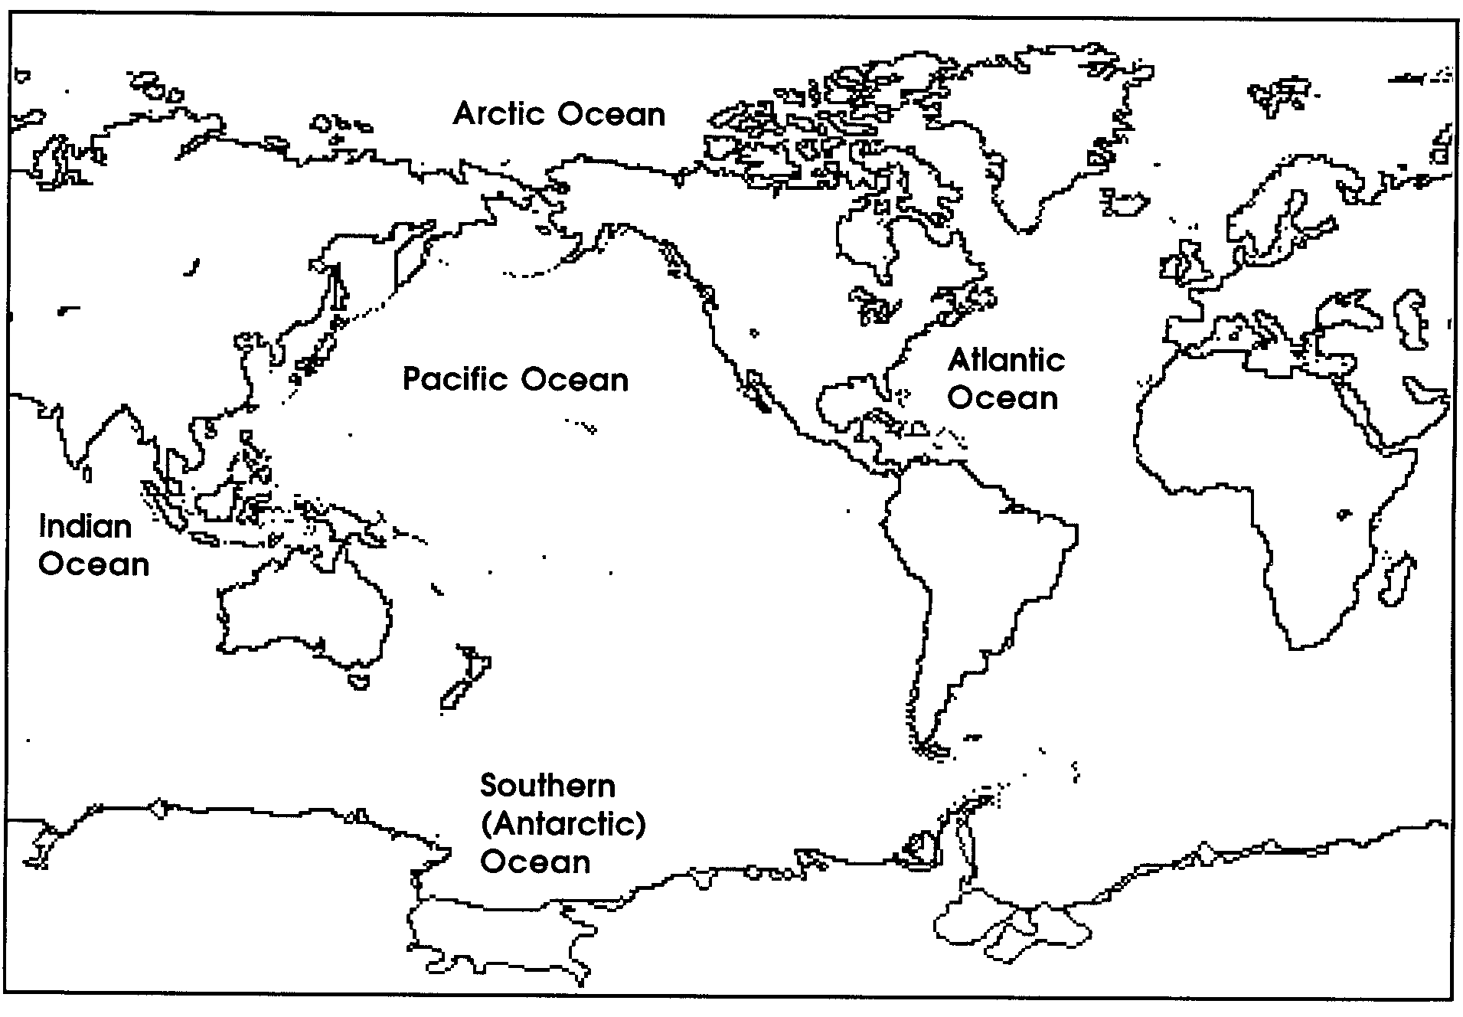
1. A correctly labeled map is shown below:

Some ocean tid-bits for discussion:

Arctic Ocean - north of the Arctic circle

Atlantic Ocean - the shallowest ocean

Indian Ocean - smallest in terms of area, but is quite deep

Pacific Ocean - has more surface area, a larger volume, and a greater average depth than either the Atlantic or the Indian Ocean

Southern (Antarctic) Ocean - ocean surrounding Antarctica

Ocean Depth - average depth is 3-5 km, deep but very thin when compared with the 6,300 km radius of the earth.

3. The Pacific Ocean is the largest ocean. Reinforce the interconnectedness of all the oceans; i.e., the concept of a world ocean.

“Oceans” Reading

1. The answer depends upon your location.

2. The color of the ocean may come from the tiny plants that live in the water or from the clouds in the sky.

3. Drawings will vary depending upon the previous knowledge of each student. This question provides one, rough indication of the information students bring to the study of marine science.

Adapted with permission from: NatureScope - Diving Into Oceans, National Wildlife Foundation, 1988 and The Ocean Book, The Center for Marine Conservation, 1989.
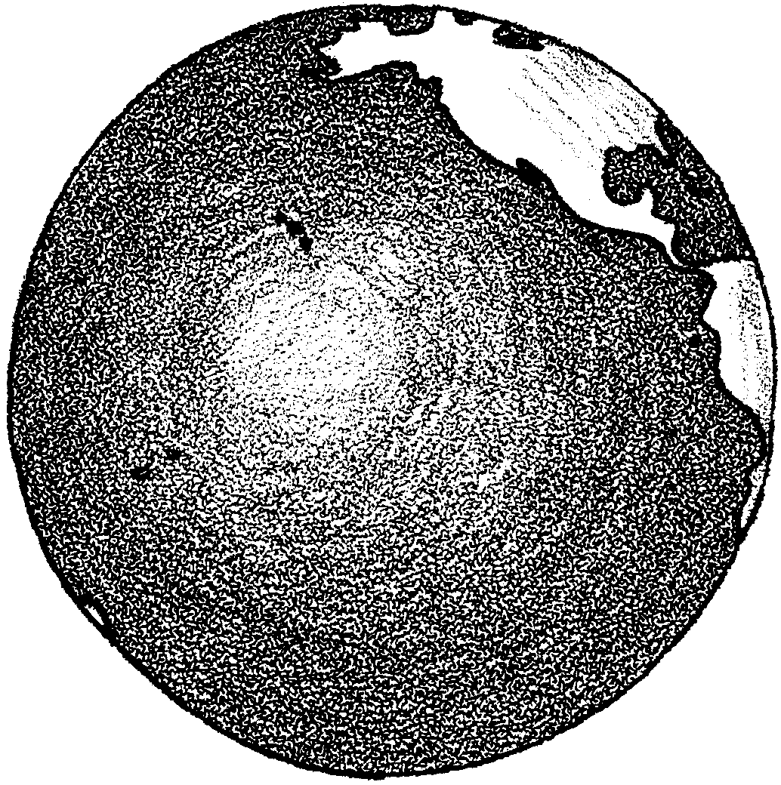
The World Ocean

The earth is a watery planet. You may have seen pictures of the earth taken from space. They show that the earth is a water planet.

1. Look at the map on the next page. Label these oceans:

Atlantic Ocean
Pacific Ocean
Arctic Ocean
Southern (Antarctic) Ocean
Indian Ocean.

2. Color the oceans blue and the land brown.

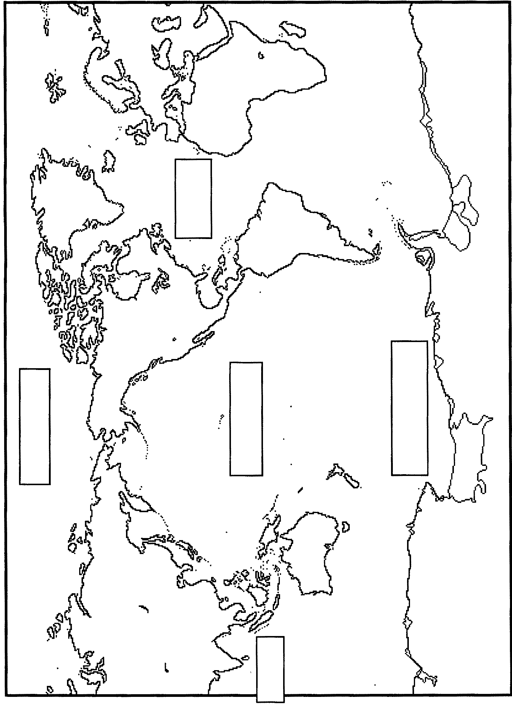
3. Which is the biggest ocean?
Oceans

There is more water than land in the world. The largest bodies of water are called oceans. The names of the oceans are: Arctic, Atlantic, Pacific, Antarctic, and Indian.
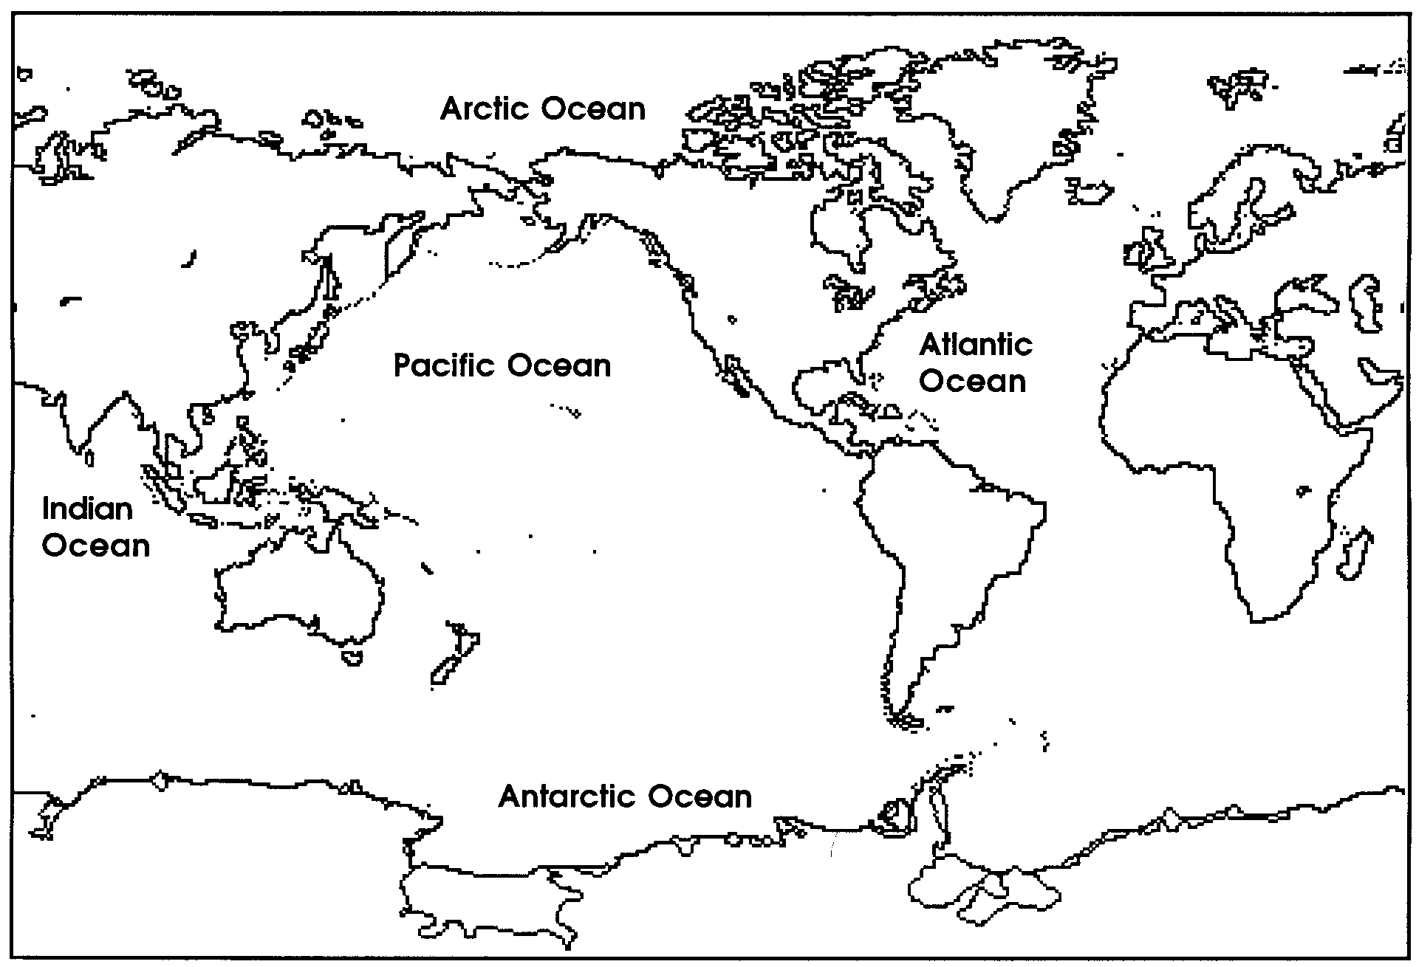
Map of the Oceans

1. What is the name of the ocean closest to where you live?

Ocean waters are salty. We use the same kind of salt on our food.
The oceans sometimes change colors. They may be blue or green. Sometimes the green color comes from tiny plants that live in the water. Clouds in the sky can also change the color of the ocean.

2. The color of the ocean may come from

.

Most parts of the ocean are deep. In some places the oceans are deeper than a mountain is high.

In some places, the oceans are warm. Fish with beautiful colors live there.

3. Think about colorful fish you have seen. Draw one here:

